| Section Metadata | |
| --- | --- |
| style | content |

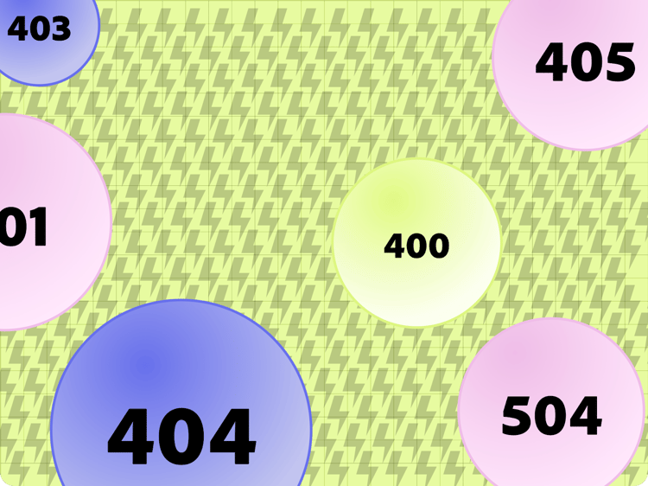

# Backend Errors

In case of an error in a backend request, the [Admin Service](https://www.aem.live/docs/admin.html) returns an appropriate 4xx or 5xx HTTP status code as well as the following HTTP headers in its response:

* x-error: the English error message
* x-error-code: the error code

Each error code maps to a template, which a client can use to process the English error message, for example to translate it into the user’s preferred language or adapt the error message to the context it occurred in.

## Error Codes and Templates

| Table |
| --- |
| |  |  | | --- | --- | | **Code** | **Template** | | AEM_BACKEND_FETCH_FAILED | Unable to fetch '$1' from '$2': $3 | | AEM_BACKEND_NOT_FOUND | File not found: $1 | | AEM_BACKEND_TYPE_UNSUPPORTED | File type not supported: $1 | | AEM_BACKEND_NO_HANDLER | No handler found for document: $1 | | AEM_BACKEND_NON_MATCHING_MEDIA | Unable to preview '$1', content is not a '$2' but: $3 | | AEM_BACKEND_VALIDATION_FAILED | Unable to preview '$1', validation failed: $2 | | AEM_BACKEND_UNSUPPORTED_MEDIA | '$1' backend does not support file type: $2 | | AEM_BACKEND_NO_CONTENT_TYPE | Content type header is missing | | AEM_BACKEND_JSON_INVALD | JSON fetched from markup '$1' is invalid: $2 | | AEM_BACKEND_FILE_EMPTY | File is empty, no markdown version available: $1 | | AEM_BACKEND_FILE_TOO_BIG | Documents larger than 100mb not supported: $1 | | AEM_BACKEND_MP4_TOO_LONG | Unable to preview '$1': MP4 is longer than 2 minutes: $2 | | AEM_BACKEND_MP4_BIT_RATE_TOO_HIGH | Unable to preview '$1': MP4 has a higher bitrate than 300 KB/s: $2 | | AEM_BACKEND_ICO_TOO_BIG | ICO is larger than 16KB: $1 | | AEM_BACKEND_SVG_SCRIPTING_DETECTED | Unable to preview '$1': script or event handler detected in SVG at: $2 | | AEM_BACKEND_SVG_ROOT_ITEM_MISSING | Unable to preview '$1': expected XML content with an SVG root item | | AEM_BACKEND_SVG_PARSING_FAILED | Unable to preview '$1': unable to parse SVG XML | |

| Metadata | |
| --- | --- |
| name | table |