**<Resort Reservation System>**

**Software Requirements Specification**

**<CEN 3031, Fall, 2019>**

**Modification history:**

|  |  |  |  |
| --- | --- | --- | --- |
| Version | Date | Who | Comment |
| v1.0 | Sep 9, 2019 | Dylan Ingram,  Brian Ciszewski | Made initial FXML application. |
| v1.1 | Oct 5, 2019 | Dylan Ingram | Added an H2 embedded database as well as a scene for creating accounts and logging in. |
| v1.2 | Oct 8, 2019 | Alan Norman | Added functionality for validating login credentials and initiating a scene change to the main scene of the app. |
| v1.3 | Oct 10, 2019 | Dylan Ingram | Added a new scene and added the code to complete the scene change. |

**Team Name:** Group 3

**Team Members:**

* Dylan Ingram - [Ddingram5146@eagle.fgcu.edu](mailto:Ddingram5146@eagle.fgcu.edu)
* Garett Flagg - gmflagg7067@eagle.fgcu.edu
* Brian Ciszewski - bpciszewski8245@eagle.fgcu.edu
* Alex Chamorro - aochamorro9756@eagle.fgcu.edu
* Alan Norman - asnorman3604@eagle.fgcu.edu

**Contents of this Document**

Introduction

* Software to be Produced
* Definition, Acronyms, and Abbreviations

Product Overview

* Assumptions
* Use Case Diagram
* Use Case Descriptions

Specific Requirements

**SECTION 1: Introduction**

Software to be Produced:

* The software will be a reservation system for a high end resort. The system will allow users to register accounts, view available rooms and make reservations. The system will track reservations and prevent conflicting stays from being registered. Additionally the system will have extended functionality for staff member. Staff members will be able to view and edit customer accounts and information as well as view and edit the reservations that are made in the system.

Definitions, Acronyms, and Abbreviations:

* None

**SECTION 2:** **Product Overview**

Assumptions:

* The system will run on a computer located on the resort premises with a minimum of a Core i3 processor and 4Gb of RAM.

Use Case Diagram:

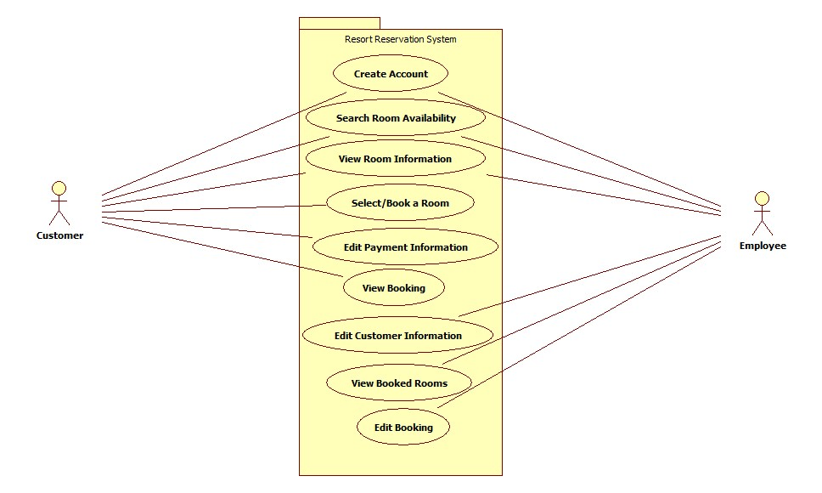

Use Case Descriptions:

* A customer is able to create an account, edit their account information, view rooms and create a booking as well as view bookings they have made previously.
* An employee is able to create an account, search for available rooms, edit information for customer accounts and view and edit bookings in the system.

**SECTION 3: Specific Requirements**

|  |
| --- |
| **No:** 1 |
| **Statement:** The system shall allow a user to create an account in the system with a login and password. |
| **No:** 2 |
| **Statement:** The system shall allow a user to register their name and address into the database. |
| **No:** 3 |
| **Statement:** The system shall allow a user to save their credit card number and billing address into the database. |
| **No:** 4 |
| **Statement:** The system shall allow a user to search for available rooms by date. |
| **No:** 5 |
| **Statement:** The system shall allow a user to search for available rooms by room type. |
| **No:** 6 |
| **Statement:** The system shall allow a user to create a booking for an available room. |
| **No:** 7 |
| **Statement:** The system should allow a user to view a picture of the floor plan for each room type offered. |
| **No:** 8 |
| **Statement:** The system shall allow a manager to view booked rooms. |
| **No:** 9 |
| **Statement:** The system shall allow a user to update the password for their account. |
| **No:** 10 |
| **Statement:**  The system shall allow a manager to edit a customer’s booking to change the assigned room. |
| **No:** 11 |
| **Statement:** The system shall compare user account credentials to the database before being allowed to view account information. |
| **No:** 12 |
| **Statement:** The system shall enforce that only current employees can make new employee level accounts. |
| **No:** 13 |
| **Statement:** The system shall allow user accounts to view their current bookings. |
| **No:** 14 |
| **Statement:** The system shall allow user to cancel current bookings for a cancelation fee. |
| **No:** 15 |
| **Statement:** The system shall allow user to delete their account. |
| **No:** 16 |
| **Statement:** The system shall allow the manager to view all rooms in the database. |

Template created by G. Walton ([GWalton@mail.ucf.edu](mailto:GWalton@mail.ucf.edu)) on Aug 30, 1999 and last updated Aug 15, 2000; updated by A. Koufakou, Aug 2014

This page last modified by <your name here> (<your e-mail address text and link here> ) on <modification date here>