HOUSING MARKET ANALYSIS | NORTH CAROLINA

Create a write-up summarizing your major findings. This should include a heading for each "question" you asked of your data, and under each heading, a short description of what you found and any relevant plots.

1. Most Expensive & Least Expensive County based on Median Housing cost

* Chatham County in Durham-Chapel Hill area is the most expensive county in NC with the highest median price of $ 482,545 in 2019
* Edgecombe County in the Rocky Mount Area is the least expensive county in NC with the consistent low median prices and recorded an all-time low of $ 67,750 in 2019.
* The top 5 counties based on median prices are Chatham, Dare, Orange, Jackson and Transylvania County.

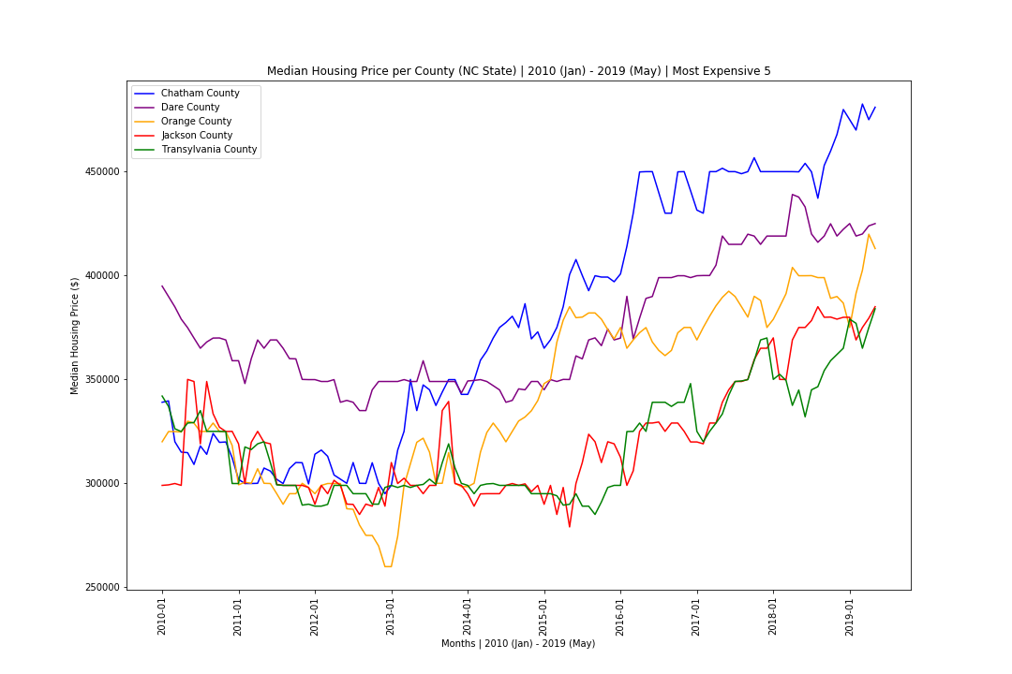

1. Counties showing highest increase/decrease in Housing prices over the years

* Between 2015-01 to 2019-05, average house prices grew on average 26.8% in North Carolina.
* The county with the highest average house price growth was Catawba county (67.8%)
* The county with the lowest average house price growth was Columbus county (-1.4%)
* The top five counties with the highest growth rate are presented in the following bar graph

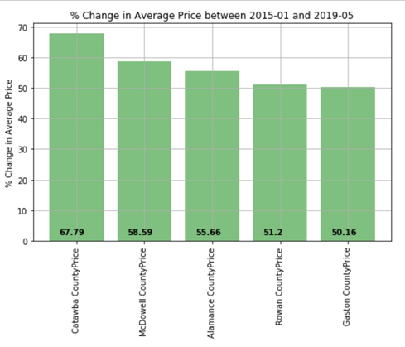

* Most top five counties experienced peak growth between 2015 and 2017. However, most of them slowed down in 2018-2019 - as shown in following graph:

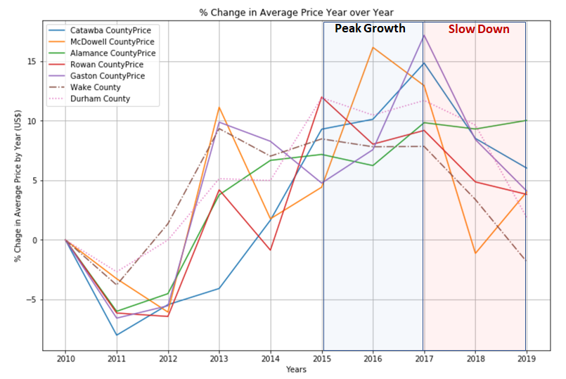

1. Correlation between Number of Houses in the market Vs Pricing & Sales

* Strong direct correlation between the Sales & Price and inverse correlation with the Number of days in the market.
* 

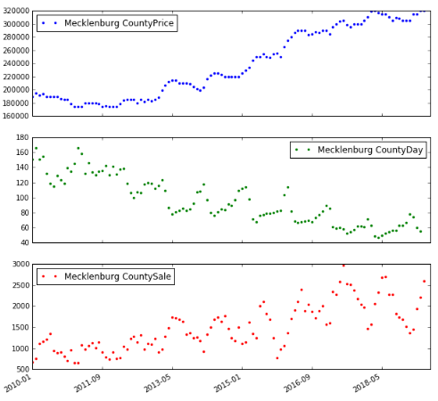

1. Which counties sell the fastest/slowest on Zillow, and how does that compare to the cost

* Time range looked at was 2015-2019 (data does not exist for many counties prior)
* Between 2015-2017, the top 5 fastest selling counties were: 1) Wake, 2) Franklin, 3) Durham, 4) Granville, 5) Mecklenburg
* This shifted in the past few years (2018-2019), where the fastest are now: 1) Durham, 2) Wake, 3) Mecklenburg, 4) Cabarrus, 5) Gaston
* 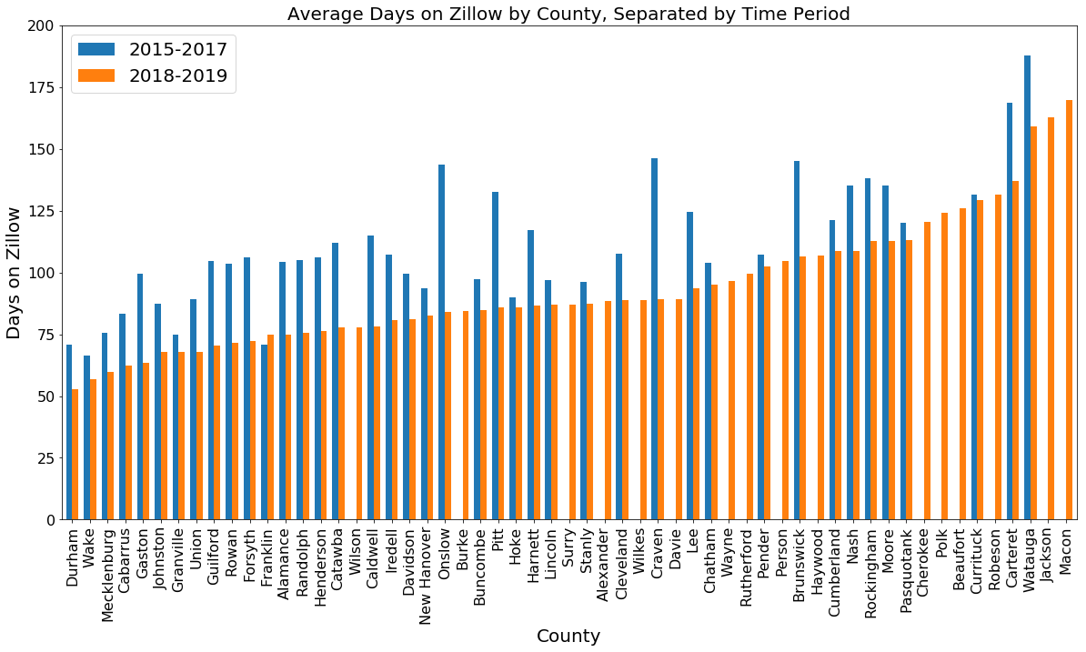
* Across the entire state as a whole, days before sales is trending down