- (i) Data given
Initially
Radius of an object, r₁ = r
Speed of an object, v₁ = v
After changes
Radius of an object, r₂ = 4r
Speed of an object, v₂ = 2v
Required to determine how will acceleration be affected
From the formula
Centripetal acceleration, a = v²/r
a₁ = v₁²/r1 = v₂/r……..eqn (i)
a₂ = v₂²/r² = (2v)²/4r = v²/r……………eqn (ii)
By dividing eqn (ii) by eqn (i)
a₂/a₁ = v²/r x r/v² = 1
a₂ = a₁
Therefore, acceleration won’t be affected when the stated changes are done.
(ii) Consider a free body diagram (FBD) below
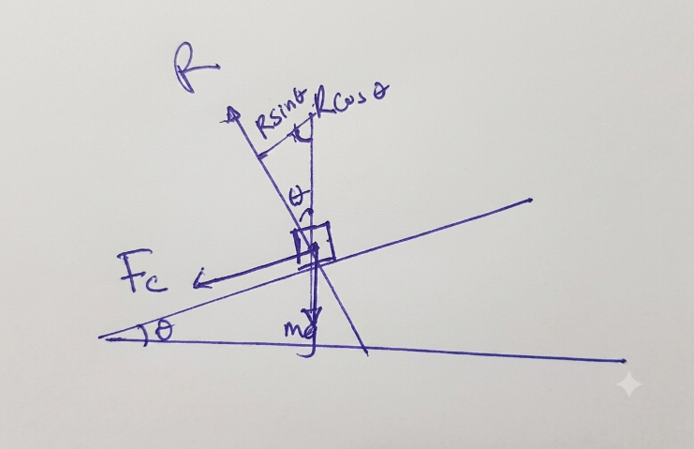

From the figure above
Rcosθ = mg……….eqn (i)
Rsinθ = Fc = mv²/r …….eqn (ii)
By dividing eqn (ii) by eqn (i)
tanθ = v²/rg
v = $√$rgtanθ
where, r = 200 m, g = 9.8 m/s² and θ = 8$°$
v_{max} = $√$(200 m x 9.8 m/s² x tan 8$°$)
v_{max} = 16.597 m/s = 59.7492 km/h
Since the car’s speed (75 km/h) is greater than the maximum speed a car can take around a corner (59.7492 km/h), the car will skid.
(b) solution
From the principle of conservation of energy
Total KE of the body = PE of the body at height h
For disc
$\frac{1}{2}$mv²+ $\frac{1}{2}$Iω² = mgh
But, I = $\frac{1}{2}$mr² and ω = $\frac{v}{r}$
$\frac{1}{2}$mv²+ $\frac{1}{2 }$ x $\frac{1}{2}$mr² x v²/r² = mgh_{d}
$\frac{3}{4}$v2 = gh_{d}
h_{d} = $\frac{3}{4}$ v²/g
For ring
$\frac{1}{2}$mv²+ $\frac{1}{2}$Iω² = mgh_{r}
I = mr²
$\frac{1}{2}$mv²+ $\frac{1}{2}$ x mr² x v²/r² = mgh_{r}
v²/g = h_{r}
Since h_{r} is greater than h_{d}, the ring will rise higher compared to disc.

