FORM FOUR DSM MOCK (2026)
- Multiple choice
(i) | (ii) | (iii) | (iv) | (v) | (vi) | (vii) | (viii) | (ix) | (x)
a | e | d | e | d | c | b | d | a | e

- Data given
Initial velocity, u = 10 m/s
Final velocity at the highest height, v = 0 m/s
Acceleration due to gravity, g = 10 m/s²
Maximum height, h =?
From the principle of conservation of energy
Loss in kinetic energy = Gain in potential energy
$\frac{1}{2}$ mv² = mgh
$h$ = v²/2g = (10 m/s)²/(2 x 10 m/s²) = 5 m.
Therefore, the maximum height is 5 m.
- Data given
Mass, m = 1500 kg
Initial velocity, u = 0 m/s (from rest)
Final velocity, v = 100 m/s
Time taken, t = 20 s
The amount of power developed, P =?
From the formula
Power = $\frac{work done}{time }$ = $\frac{ΔKE}{time }$
Power = $\frac{1}{2t}$m x (v² – u²)
P = $\frac{1}{2 x 20 s}$ x 1500 kg x ((100m/s)² – 0²)
P = 375000 W = 375 kW
Therefore, the power developed by the car’s engine is 375 kW.
- Matching item
List A | (i) | (ii) | (iii) | (iv) | (v) | (vi)
List B | C | H | A | E | F | G

- (a) (i) Because at 25 cm (near point) the image is clearer (large image).
(ii) Uses of simple microscope
- It is used to read small prints
- It is used to view specimen in a laboratory
- It is used to concentrate light rays
- It is used by watchmakers to view small components of a watch
(b) Differences between short and long sightedness people
- The eyeball of a short sightedness person is too long while that of long sightedness is too short.
- The image is formed in front of the retina for a short sightedness person while for a long sightedness person, the image is formed behind the retina.
- Short sightedness person can see near objects clearly but not distant objects while a long sightedness person can see far objects clearly but not near objects.
- Short sightedness can be corrected by using glass with concave lens while a long sightedness can be corrected by using glass with convex lens.
- (a) (i) This is because it will require a long tube of about 10.3 m when water is used as a barometric fluid. Since water has small density (1000 kg/m³) compared to mercury (13,600 kg/m³), a long tube will be required top register the same pressure registered by mercury.
(ii) Consider a figure below
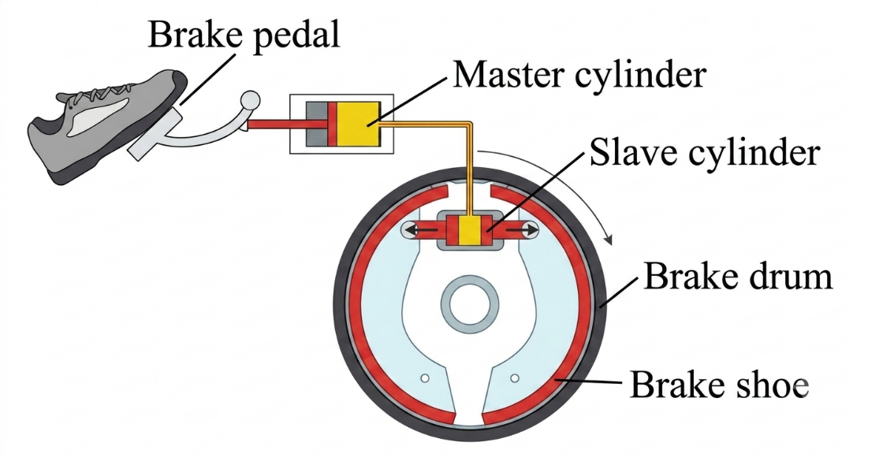

Fig. Hydraulic car brake

When pressure is applied to the brake pedal, it pushes the piston in the master cylinder forward creating pressure in the brake fluid. This pressure is transferred to the slave cylinders where the force is multiplied and pushes the brake shoes against the brake drum that is attached to the wheel of the vehicle. Friction between the brake shoes and the drum slows down the wheel’s rotation.
(b) Consider a figure below
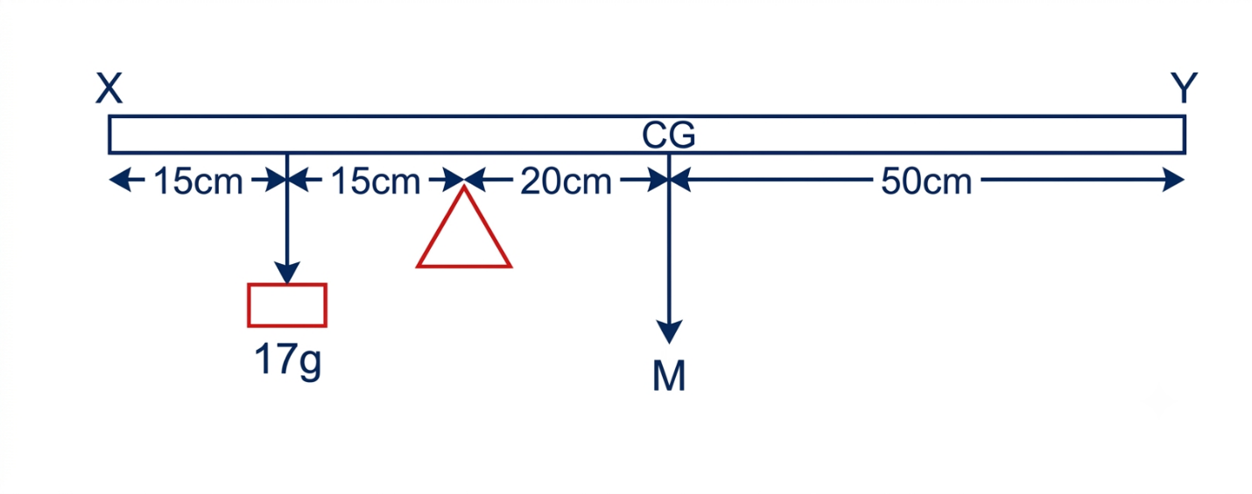
Fig. A metre rule
Let mass of a metre rule be m
From the principle of moment
Sum of clockwise moment = sum of anticlockwise moment
m x 20 cm = 17 g x 15 cm
m = 12.75 g
Therefore, the mass of a metre rule is 12.75 g.
- (a) (i) This is because some effort is used to overcome friction and also in some machines such as pulley system energy is needed to lift the bottom pulleys and the ropes.
(ii) Consider a figure below
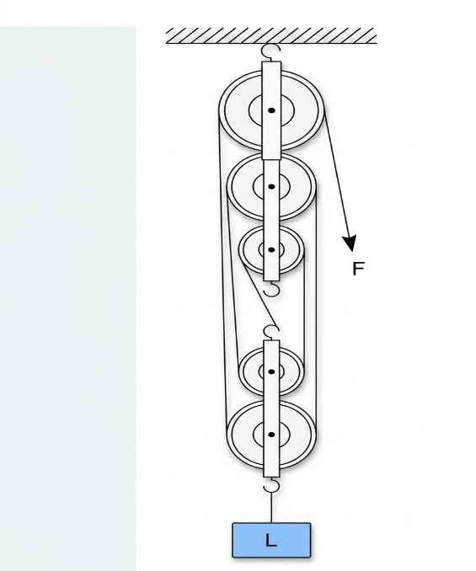
Fig. Pulley system
Data given
VR = number of pulleys = 5
Efficiency, η = 80%
Load, L = 300 N
Effort, E =?
From
η = $\frac{MA}{VR }$ x 100%
80% = $\frac{MA}{5}$ x 100%
MA = 0.8 x 5 = 4
But, MA = $\frac{Load }{Effort}$
Effort = $\frac{Load }{MA}$ = $\frac{300 N}{4}$ = 75 N
Therefore, the effort used to raise the target load is 75 N.
(b) Data given
Mass of gas, m = 12 kg
Time taken, t = 90 s
Average velocity, v = 25 m/s
Force exerted, F =?
From Newton’s second law of motion
F = $\frac{ΔP}{Δt}$ = $\frac{mΔv}{Δt}$
F = $\frac{12 kg x 25\frac{m}{s}}{90 s}$ = 3.33 N.
Therefore, the force exerted on the cylinder is 3.33 N.
- (a) (i) Data given
Original length, l_{o} = 1m
Initial temperature, θ_{o} = 28$℃$
Final temperature, θ₁ = 100$℃$
Δl/l_{o} = $\frac{1.3}{100}$
Required to determine the linear expansivity of the metal pipe, α =?
From the formula
α = $\frac{Δl}{lo x Δθ}$
α = $\frac{Δl}{lo}$ x $\frac{1}{Δθ}$
But, Δθ = 100$℃$- 28$℃$ = 72$℃$
α = $\frac{1.3}{100 x 72℃ }$ = 0.000181/$℃$
Therefore, the linear expansivity of the metal pipe is 0.000181/$℃$.
(ii) Heat loss by convection can be minimized by using vacuuming which involves the removal of any fluid medium within which convectional currents move. Also heat loss by convection can be reduced by filling air cavities with insulating solid materials.
(b) Daily applications of evaporation
- Separation of salt from seawater: Salt from seawater is done by the process of evaporation.
- Drying clothes: The water (liquid) from clothes changes to gas when are heated by sun. This process where liquid changes to gaseous state is called evaporation.
- Cooling of human body: The human body uses evaporation to control its temperature. When it is very hot, sweat glands release water which then evaporates from the skin taking away latent heat of vaporization. This causes cooling of the body.
- In refrigeration: Refrigerators use the cooling effect of evaporation.
- (a) (i) Data given
Speed of sound in water, v = 1500 m/s
Time taken by the echo to be heard, t = 1s
Required to determine the depth of the sea, d =?
From
v = $\frac{2d}{t}$
d = $\frac{vt}{2}$ = $\frac{1500\frac{m}{s}x 1 s}{2}$ = 750 m
Therefore, the depth of the sea is 750 m.
(ii) Temperature, θ = 35 $℃$
Required to determine the speed of sound in air, v =?
From
v = (331.4 + 0.6θ) m/s
v = (331.4 + 0.6 x 35) m/s
v = 352.4 m/s
Therefore, the speed of sound in air at a temperature of 35 $℃$ is 352.4 m/s.
(b) Data given
Original mass of the sample, m_{o} = 800 g
Half-life of the sample, t = 8 days
Required to determine how much of the sample will remain after 40 days
From
$\frac{m}{mo}$ = $(\frac{1}{2}$)^{n}
m = m_{o} x $(\frac{1}{2}$)^{n}
But, number of half-lives = n = $\frac{T}{t}$ = $\frac{40 days}{8 days}$ = 5
m = 800 g x $(\frac{1}{2}$)⁵ = 25 g
Therefore, a mass of 25 g of the sample will remain after 40 days.
- (a) Yes, it is possible to predict the occurrence of an earthquake by checking the following indicators.
- Animal indicator: Between 10 and 20 hours before the occurrence of an earthquake, some animals become highly disturbed and restless. They move in a random manner and in fear
- Water indicator: About one or three days before an earthquake, there is a sudden rise or fall in water levels in wells. The rise can be as high as one metre. The well water may turn muddy.
- Seismo-electromagnetic indicator: Before the occurrence of an earthquake the sub-surface temperature rises. As a result of this, the geomagnetic field is reduced. The reduction in geomagnetic field adversely affects the propagation of electromagnetic waves. This is experienced abundantly on the radio, television and telephone. This is a very reliable indicator.
- Thermal indicator: A few months before the occurrence of an earthquake, the average temperature of the area keeps increasing.
(b) (i) Astronaut needs special space suit because the space suit helps to maintain the atmospheric pressure. It is known that as you go high, the atmospheric pressure keeps decreasing.
(ii) Geocentric theory was accepted at that time due to the following reasons
- Apparent motion: The sun, moon, and stars visibly appear to move across the sky daily.
- Perceived stillness: Earth feels entirely stationary and solid beneath our feet without any noticeable sensation of motion.
- (a) Consider a figure below
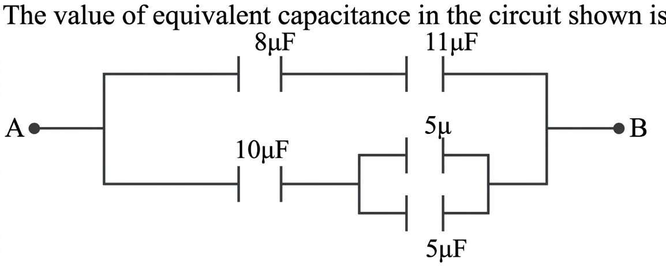
Fig. electric circuit
Since two 5 μF capacitors are parallel to each other
C₁ = 5 μF + 5 μF = 10 μF
Now the obtained equivalent capacitance creates a single capacitor of 10 μF which is in series with 10 μF on the left.
C₂ = $\frac{10 μF x 10 μF }{10 μF + 10 μF }$ = 5 μF
Also, from the provided figure, 8 μF and 11 μF capacitors are in series
C₃ = $\frac{8 μF x 11 μF }{8 μF + 11 μF }$ $≈$ 4.63 μF
5 μF and 4.63 μF capacitors are parallel to each other
C =5 μF + 4.63 μF $≈$9.63 μF
Therefore, the value of equivalent capacitance is approximately 9.63 μF.
(b) This means that an electric iron dissipates an energy at the of 1000 J per second when connected to a 240 V supply.
Data given
Power consumed by refrigerator, P₁ = 400 W
Power consumed by radio, P₂ = 60 W
Time taken = 5 hours
Total power = P₁ + P₂ = 400 W + 60 W = 460 W = 0.46 kW
Energy consumed = Pt = 0.46 kW x 5h = 2.3 kWh.
Cost = price x total units
cost = Tsh 300/kWh x 2.3 kWh= Tsh 690
Therefore, the total cost of running both radio and refrigerator in 5 hours is Tsh 690.
(c) Data given
Resistance of an electric kettle, R = 10 Ω
Mass of water, mw = 2 kg
Initial temperature of water, θ_{o} = 25$℃$
Final temperature of water, θ₁ = 100$℃$
Required to determine the amount of current that will flow in 4 hours (or 14400 s)
From Joule’s law of heating
H = I²Rt
But,
Quantity of heat, Q = mcΔθ
Q = 2 kg x 4200 J/kg$℃$ x (100$℃$ - 25$℃$)
Q = 630000 J
630000 J = I² x 10 Ω x 14400 s
I = $√4.375$ A = 2.092 A
Therefore, a current of about 2.092 A will flow in 4 hours.
- (a) Electrons emitted by thermionic emission from the filament experience the potential difference and are accelerated towards the anode. When they hit the anode, the electrons are stopped and thereby transfer their energy to the electrons of the anode material. The anode material undergoes the re-arrangement of electrons resulting to the emission of X-rays. Only a small percentage of the incident electrons' energy is converted to X-rays. Large percentage of the electron’s energy is lost as heat. The figure below shows x-ray tube with its important parts.
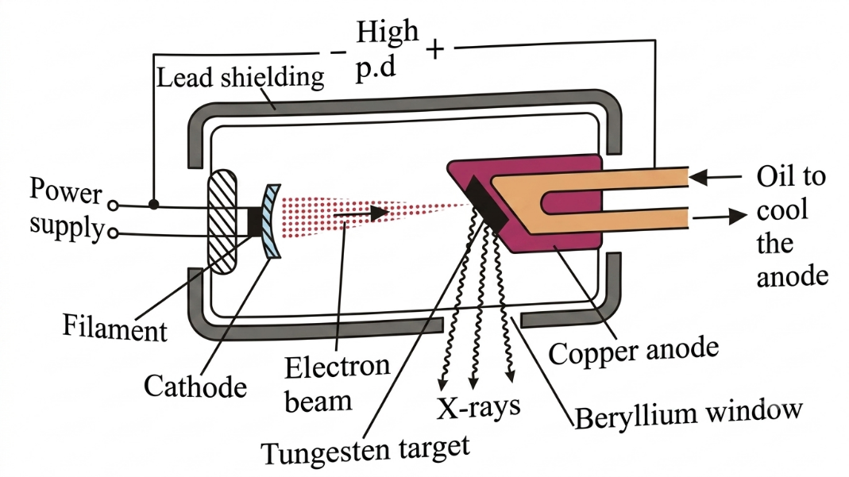

Fig. X-ray tube
(b) Consider a figure below
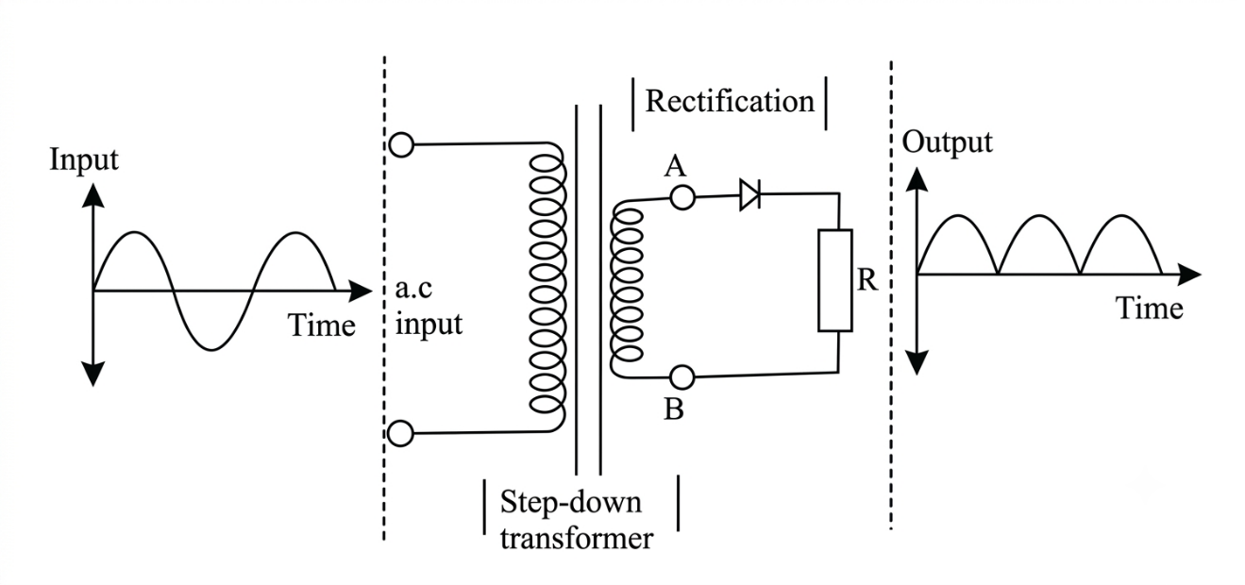

Fig. half wave rectification
When the current at A is increasing in a positive direction, it decreases in negative direction at B. Therefore, during the first half-cycle of the sinusoidal wave form, A is positive and B is negative. The diode is thus forward biased and current flows through the load resistor R. During the second half cycle, A and the anode of a diode are negative, whereas B and the cathode of a diode are positive. The diode is thus reverse biased and the flow of current will be blocked. This is indicated by a horizontal line in the output diagram. The diode, therefore, conducts on every positive half-cycle and hence, half-wave rectification is achieved. The output is d.c and is always positive in value. If the diode is reversed, then the output is negative.
(c) (i) The circuit B will light the bulb because the diode is forward biased. This decreases the depletion layer and hence the current flows in the diode and the circuit is completed while in the circuit A, diode is reverse biased.
(ii) This is because the signal level need not to be precise in digital signal as it can be approximated within a fixed number of digits or bits.
- (a) Data given
Frequency, f₁ = 400 Hz when T₁ = 2 N
- f₂ =? if T₂ = 8N
From
f₂/f₁ = $√$(T₂/T₁)
f₂ = f₁ x $√$(T₂/T₁)
f₂ = 400 Hz x $√$($\frac{8 N}{2 N}$) = 800 Hz
Therefore, the frequency produced when the tension is increased to 8 N is 800 Hz.
- T₂ =? If f₂ = 600 Hz
From
f₂/f₁ = $√$(T₂/T₁)
T₂ = T₁ x (f₂/f₁)2
T₂ = 2 N x ($\frac{600 Hz}{400 Hz}$)2 = 4.5 N
Therefore, the tension needed to produce a frequency of 600 Hz is 4.5 N.
(b) (i) Data given
For primary coil
Vp = 240 V
Np = 1000
Ip = 0.125 A
For secondary coil (The lamp is connected here)
Vs = 12 V
Power of the lamp, P = 24 W
Required to calculate the efficiency of the transformer
From the formula
η = $\frac{Power output}{power input}$ x 100%
Power output = Is x Vs = 24 W
Power input = Ip x Vp = 0.125 A x 240 V = 30 W
η = $\frac{24 W}{30 W}$ x 100% = 80%
Therefore, the efficiency of the transformer is 80%.
- The following are the causes of power loss in transformer
- Copper windings: There are loss of power in the primary winding in the form of heat due to the resistance of the primary coil.
- Flux linkage: The power loss is may be cause by poor magnetic flux linkage between the primary and secondary coils causing flux leakage.
- Eddy currents: Eddy currents induced in the iron core of a transformer are part of the input energy and change into heat. This effect is however reduced by laminating the iron core to reduce the eddy currents.
(c) The following are the factors affecting magnitude of induced e.m.f in a conductor as suggested by Faraday.
- Strength of the Magnetic Field: A stronger magnetic field provides more flux lines per unit area, leading to a larger change in flux when relative motion occurs
- Speed of relative motion: Moving the conductor faster through the magnetic field (or vice versa) cuts magnetic flux lines at a quicker rate, increasing the induced e.m.f.
- Number of turns in the coil: Each turn experiences its own change in magnetic flux; therefore, increasing the number of turns sums up the individual e.m.fs linearly.
- Area of the Coil / Length of Conductor: A larger cross-sectional area or longer conductor length intercept more magnetic flux lines simultaneously during motion.

