FORM FOUR PRE NECTA
- Multiple choice
(i) | (ii) | (iii) | (iv) | (v) | (vi) | (vii) | (viii) | (ix) | (x)
D | B | C | D | C | B | C | B | C | C
- Density of a liquid = $\frac{mass of a liquid }{volume of a liquid }$
ρ = 85 g/100 cm³ = 0.85 g/cm³
Density of a liquid (0.85 g/cm³) is smaller compared to that of water (1.0 g/cm³)
- Total volume = Volume of diluted milk, v_{d} = volume of milk (v_{m})+ volume of water (v_{w})
Density of diluted milk (ρd) = $\frac{mass of diluted milk}{total volume }$
Mass of diluted milk = mass of milk + mass of water
Mass of diluted milk = ρ_{m} x v_{m} + ρ_{w} x v_{w}
Mass of diluted of milk = 1080 kg/m³ x v_{m} + 1000 kg/m³ x v_{w}
1040 kg/m³ = (1080 kg/m³ x v_{m} + 1000 kg/m³ x v_{w})/(v_{m} + v_{w})
1040 (v_{m} + v_{w}) = 1080v_{m} + 1000v_{w}
1040v_{m} + 1040v_{w} = 1080 v_{m} + 1000v_{w}
1040v_{w} – 1000v_{w} = 1080v_{m} – 1040v_{m}
40v_{w} = 40v_{m}
v_{m} = v_{w}
v_{d} = v_{w} + v_{w} =2v_{w}
v_{w}/v_{d} = $\frac{1}{2}$
(v_{w}/v_{d})% = $\frac{1}{2}$ x 100% = 50%
Therefore, the percentage of water by volume in the diluted milk is 50%
- Multiple choice
LIST A | (i) | (ii) | (iii) | (iv) | (v) | (vi)
LIST B | H | A | G | B | D | F

- (a) Yes, because the light is moving from one medium (glass) to another medium (air). Light is said to undergo refraction (changing in direction of light ray) when the medium changes.
(b) Data given
Focal length of the objective lens, f_{o} =12 cm
Focal length of the eyepiece lens, f_{e} = 4 cm
Distance between focal length and eyepiece lens, L = 30 cm
Position of the object, u_{o} =?
Consider a figure below
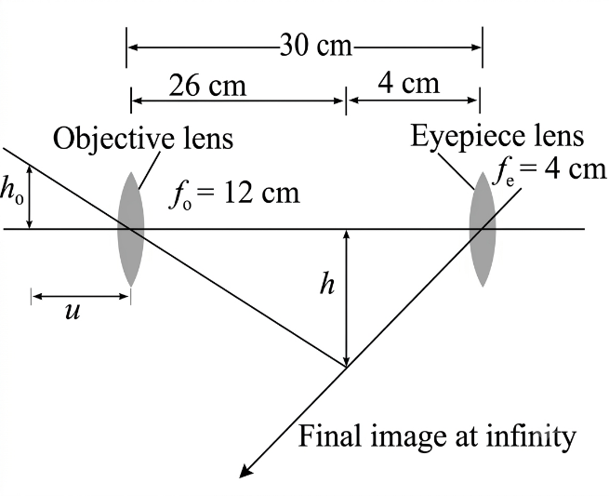
From lens formula
$\frac{1}{f}$ = $\frac{1}{u}$ + $\frac{1}{v}$
For image to be formed at infinity, the image formed by objective lens should be at focal point of the eyepiece lens
This means that, u_{e} = f_{e} = 4 cm
Now, L = v_{o} + u_{e}
L = v_{o} + f_{e}
v_{o} = L – f_{e} = 30 cm – 4 cm = 26 cm
1/u_{o} = 1/f_{o} – 1/v_{o}
1/u_{o} = (v_{o}-f_{o})/f_{o}v_{o}
u_{o} = f_{o} x v_{o}/(v_{o} – f_{o})
u_{o} = $\frac{12 cm x 26 cm}{26 cm-12 cm }$ = 22.29 cm
Therefore, the object is at a distance of 22.29 cm in front of the objective lens.
- (a) This is because water has smaller density compared to mercury and hence it will require a longer tube of about 10.3 m to construct the barometer.
(b) consider a figure below
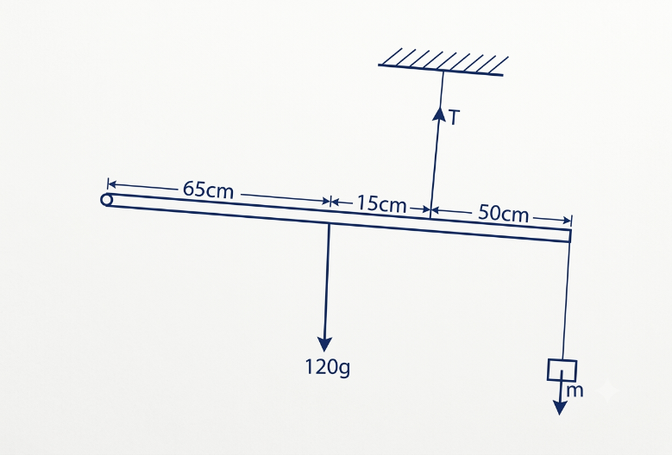
Fig. uniform rod
From the principle of moment
Sum of clockwise moment = sum of anticlockwise moment
m x 50 cm = 120 g x 15 cm
m = 36 g
also, from one of the conditions of a body to be in equilibrium under parallel forces
sum of upward forces = sum of downward forces
T = (120 g + 36 g) x 0.01 N/g
T = 1.56 N
Therefore, the mass that should hung and the tension of the wire are 36 g and 1.56 N.
- (a) (i) Density of an object: Stone has higher density than water and hence sinks while leaf has smaller density compared to water and hence floats on water.
(ii) Volume of displaced water: Leaf displaces large amount of water and hence floats on water while stone displaces smaller volume of water and hence sinks in water.
(b) Data given
Effort, E = 11 N
Effort arm, E_{a} = 0.4 m
Load, L = 40 N
Load arm, L_{a} = 0.1 m
Efficiency =?
From the formula
Efficiency = $\frac{work output}{work input }$ x 100%
Work output = Load x load arm = 40 N x 0.1 m = 4 J
Work input = Effort x Effort arm = 11 N x 0.4 m = 4.4 J
Efficiency = $\frac{4 J}{4.4 J}$ x 100% = 90.91%
Therefore, the efficiency of the machine is 90.91%.
- (a) (i) The function of the bimetallic strip is to make the circuit complete or incomplete by bending towards or away from the contact.
(ii) When temperature is low in a room, the bimetallic strip bends downward to complete the circuit. This turns on the heater.
Assumption: The metal below in bimetallic strip contracts faster than the one at the top.
(b) This is because smoke cools faster. This means the density of the smoke becomes greater than that of air and hence stops rising.
- (a) This is because the space between Earth and other planets is empty (vacuum) so no air molecules to transfer the sound from the planets to the earth. Sound is mechanical wave which requires to material medium to transfer the sound.
(b) Data given
Mass number of lightest isotope, A₁ = 108
Mass number of heaviest isotope, A₂₅ =?
By using arithmetic progression
A_{n} = A₁ + (n–1)d
Where common difference, d = 1
A₂₅ = 108 + (25 – 1) x 1
A₂₅ = 132
Therefore, the symbol of the heaviest isotope is ¹³²₅₀Sn.
- (a) Primary wave because primary wave travels quicker through the earth than secondary waves.
(b) Uses of constellations
- Nomads: Nomads used constellations in travelling with their herds from one place to another, searching for pasture.
- Curiosity of studying nature: constellations as other celestial objects, trigger humankind to explore more about the universe.
- Agriculture: Constellations were used by people to determine when to sow or harvest by observing positions of constellations.
- (a) The leaf’s divergence will decrease because leaf electroscope charges the hand by induction.
(b) Data given
For a single cell
V = E = 6 V (no internal resistance)
I = 3A
From Ohm’s law
R = $\frac{V}{I}$ = $\frac{6 V}{3 A}$ = 2.0 Ω
When another cell with internal resistance (r) is connected in series
E = I(R + r)
When series are connected in series, E = 6 V + 1.5 V = 7.5 V
7.5 V = 3 A x (2 Ω + r)
2.5 Ω = 2Ω + r
r = 0.5 Ω
Therefore, the internal resistance of the cell is 0.5 Ω.
(c) Data given
Power consumed by motor = 0.25 kW
Power consumed by heating element = 3 kW
Time taken by motor = 1.5 h
Time taken by heater element = $\frac{2}{3}$ x 1.5h = 1.0 h
Total energy consumed = Power x time = 0.25 kW x 1.5 h + 3 kW x 1 h = 3.375 kWh
1 kWh = Tsh. 5
3.375 kWh = x
x = Tsh. 16.875/week
For the whole year
= 52 weeks x Tsh. 16.875/week = Tsh. 877.5
Therefore, it will cost Tsh, 877.5 to run the washing machine annually.
- (a) Cathode: Emits electrons when is heated.
Focusing anode: It attracts electrons and focus them into a beam and it also controls the brightness of the image.
Accelerating anode: It accelerates the electrons that are ejected from the cathode.
Vertical (Y) deflection plates: They deflect the electron beam vertically
Horizontal (X) deflection plates: They deflect the beam of electrons horizontally.
Fluorescent screen: it is the display component of the CRT
- It increases the number of electrons ejected from the cathode.
- It accelerates faster the emitted electrons from cathode.
(b) Data given
Half-life, t = 10 min
N/No =1 - $\frac{90}{100}$ = $\frac{10}{100}$
Time taken, T =?
From
N/No = ($\frac{1}{2}$)n
$\frac{10}{100}$ = ($\frac{1}{2}$)n
By applying log on both sides
log 0.1 = n log 0.5
n = $\frac{\log{0.1}}{\log{0.5}}$ $≈3$
But, n = $\frac{T}{t}$
T = nt = 3 x 10 min = 30 min
Therefore, it will take about 30 minutes for a given element to decay.
(c) (i) Doping is the deliberate addition of impurities to a pure semiconductor.
(ii) N-type semiconductor is made when a pentavalent atom such as antimony is added to a pure semiconductor crystal. The four electrons of the antimony form covalent bond with adjacent four atoms of silicon. This leaves an extra electron that becomes a conduction electron.
- Pentavalent atoms such as antimony and trivalent atoms such boron.
- (a) Fundamental note for pipe A First overtone for pipe A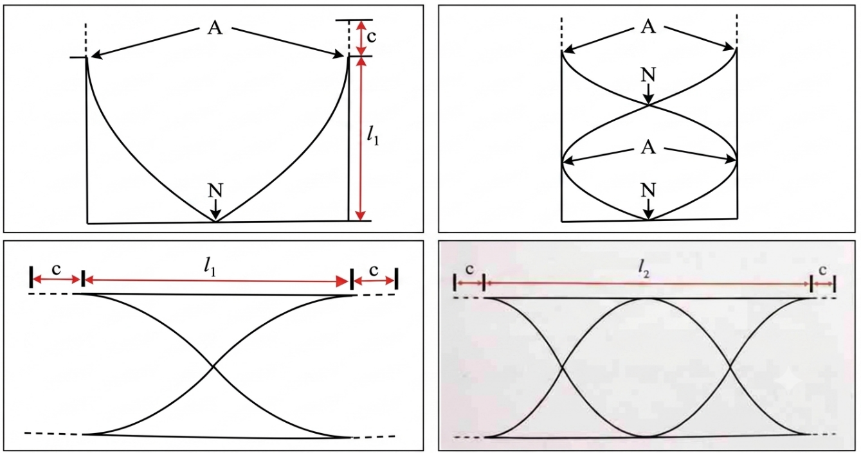
Fundamental note for pipe B First overtone for pipe B
(b) According to Lenz’s law, a secondary magnetic field is produced to overcome a change in magnetic flux, so in order to overcome this effect a work must be done in order to continue the production of e.m.f. This means that work done is converted to electrical energy due to induced e.m.f which agrees the law of conservation of energy.
(c) (i) A represents harmer, B represents gong, E represents soft iron, K represents switch, T represents contact and U represents power supply.
(ii) When the switch is closed a soft iron is magnetized and hence attract the soft iron armature and hence A (harmer) strikes the gong. This produces sound.

Prepared by teacher Alex @ Godegode sec

