F4 KIGOMA MOCK SOLUTION (2026)
- Multiple choice question
(i) | (ii) | (iii) | (iv) | (v) | (vi) | (vii) | (viii) | (ix) | (x)
D | B | D | B | C | A | D | C | A | B

- Matching item question
List A | (i) | (ii) | (iii) | (iv) | (v) | (vi)
List B | C | D | F | E | B | A

- (a) This is because a convex mirror provides a wide field of view while a plane mirror cannot.
(b) Consider a figure below
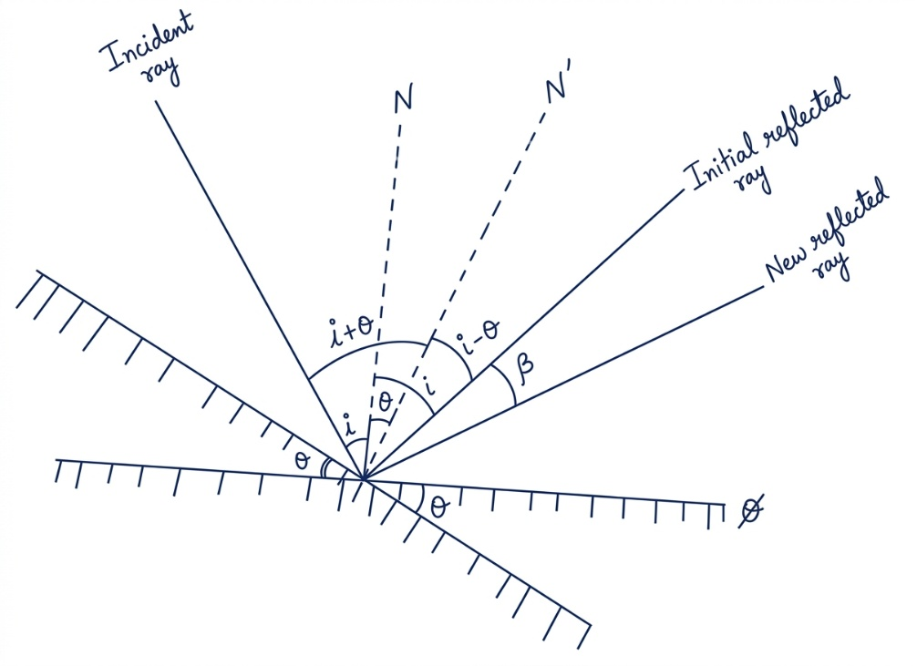
Fig. A rotated plane mirror at an angle θ
From the second law of reflection of light
The angle between incident ray and new normal line (N’) = The angle between normal (N’) and new reflected ray
i + θ = (i – θ) + β
Where β is an angle made when reflected ray rotated
i + θ = i – θ + β
θ + θ = 2θ = β (Hence shown)
- (a) (i) This is because when the fluid is at rest (not moving) there will be no parallel force acting on the liquid surface and therefore, the only force acting on the surface that remains (net force) is a force acting in perpendicular direction.
(ii) This is because the atmospheric pressure depends on the density of air. Since the density of air keeps decreasing with altitude. This causes a rapid decrease in atmospheric pressure too.
(b) Required to determine the coefficient of friction μ_{k}
Consider a figure below
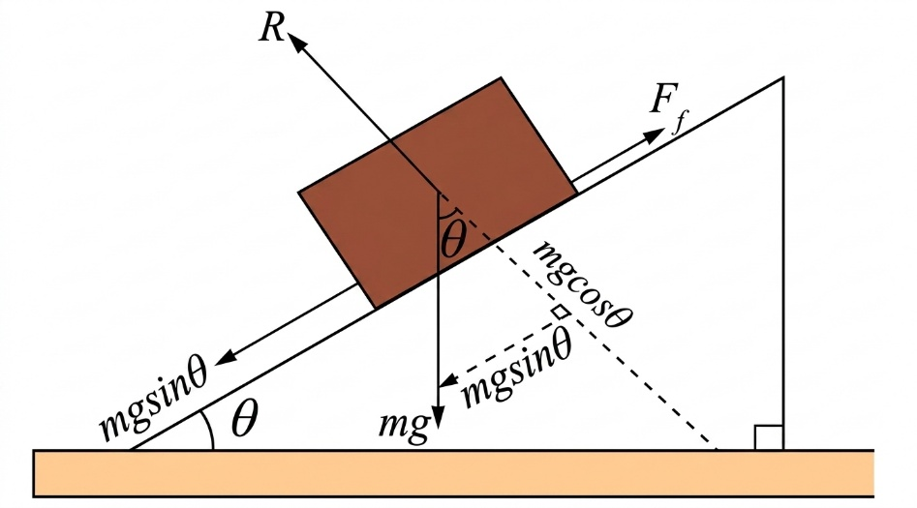
Fig. An inclined plane
For case I: When an inclined plane is smooth (no friction)
From newton’s second law of motion
mgsinθ = ma₁
a₁ = gsinθ
For case II (under friction)
mgsinθ – μ_{k}mgcosθ = ma₂
g(sinθ -μkcosθ) = a₂
a₂/a₁ = $\frac{g(sinθ -μkcosθ)}{gsinθ }$
a₂/a₁ = 1 – μ_{k} x $\frac{1}{\tan{ θ}}$
a₂/a₁ = 1 – μ_{k} x $\frac{1}{\tan{45°}}$ = 1 – μ_{k}
Also, from the second equation of motion
s = ut + $\frac{1}{2}$at²
Since the same distance was coverd in both cases and u = 0 (from rest)
$\frac{1}{2}$a₁t₁² =$\frac{1}{2}$a₂t₂²
But, t₂ = 2t₁
a₂/a₁ = (t₁/t₂)² = (t₁/2t₁)² = $\frac{1}{4}$
Now,
$\frac{1}{4}$ = 1 – μ_{k}
μ_{k} = 1 - $\frac{1}{4}$ = 0.75
Therefore, the coefficient of friction between the body and an inclined plane is 0.75.
- (a) The fixed points of a thermometer include both upper fixed point and lower fixed point. The upper fixed point is obtained by placing the thermometer near the surface of the boiling water until 100 $℃$ is reached. On the other hand, lower fixed point is obtained by immersing the thermometer into a melting ice container until 0 $℃$ is reached.
(b) The two trolleys after collision they moved together with a common velocity because the undergo inelastic collision. In this type of collision, the total of momentum is conserved while the total kinetic energy of trolleys is not conserved.
The principle involved in this situation is called principle of conservation of linear momentum which states that” When no external force acting on a colliding system, the total momentum before collision is equal to the total momentum after collision”
- (a) This is because in a vacuum there is no air resistance to oppose the force of gravity acting on objects. So, both feather and coin will fall down with the same acceleration of about 10 m/s².
(b) Data given
Weight of a rocket on Earth, W_{E} = 10,000 N
Weight of a rocket on planet X, W_{x} = 30 N
Acceleration due to gravity on earth, g_{E} = 10 N/kg
Acceleration due to gravity, g_{X} =?
From
Weight = mass x acceleration due to gravity
Mass of the rocket = $\frac{Weight of a rocket on Eart}{Acceleration due to gravity on earth}$
Mass of the rocket = $\frac{10,000 N}{10 N/kg}$ = 1000 kg (constant on both planets)
g_{x} = $\frac{Weight of a rocket on planet X}{mass of the rocket }$
g_{x} = $\frac{30 N}{1000 kg}$ = 0.03 N/kg
The acceleration due to gravity on planet X is 0.03 N/kg.
- (a) This is because air near the candle is heated and becomes ionized. The ionized air molecules are attracted. If the electroscope is positively charge, the negative charged ions will be attracted toward the brass cap and cancel the positive charge (discharging). This makes the leaf collapses and vice-versa is true.
(b) Data given
Speed of sound in air, v1 = 330 m/s
Speed of sound in a metal, v2 = 5280 m/s
Time interval, Δt = 0.5 s
Let time taken by the sound in air and in metal be t1 and t2, respectively.
Required to find the distance between the two men (d)
From
Speed of sound= $\frac{distance travelled}{time taken}$
For case 1: When sound is travelling through air
v₁ = d/t₁
t₁ = d/v₁
For case II: When sound is travelling through a metal
t₂ = d/v₂
Since sound travels faster in solid in this case metal than in air
This means t₁$>$t₂
Δt = t₁ – t₂
Δt = d/v₁ – d/v₂
Δt = d x (v₂ – v₁)/v₁v₂
d = Δt x v₁ x v₂/(v₂ – v₁)
d = $\frac{0.5 s x 330\frac{m}{s}x 5280\frac{m}{s}}{5280 \frac{m}{s} -330\frac{m}{s}}$ = 176 m
Therefore, the distance between the two men is 176 m.
- (a) The function of the fixed pulley P₂ is to change the direction of the force applied (effort).
(b) Distance moved by effort = x
Distance moved by load W =?
From
VR = $\frac{Distance moved by the effort}{Distance moved by the load}$
VR = number of pulleys
2 = $\frac{x}{Distance moved by the load}$
Distance moved by the load = $\frac{x}{2}$
Therefore, the distance moved by load W is $\frac{x}{2}$.
(c) Required to calculate the effort at C when load is 20 N
From
MA = VR (when friction is neglected)
$\frac{Load }{Effort }$ = 2
Effort = $\frac{Load}{2}$ = $\frac{20 N}{2}$ = 10 N.
Therefore, the effort applied at C is 10 N.
- (a) (i) In the plum pudding model, Thomson proposed that an atom comprises of a number of negative charges enclosed in a sphere of uniform positive charge. The electrons are embedded in a regular pattern as in a plum pudding and that if the electron is disturbed it retains its original position.
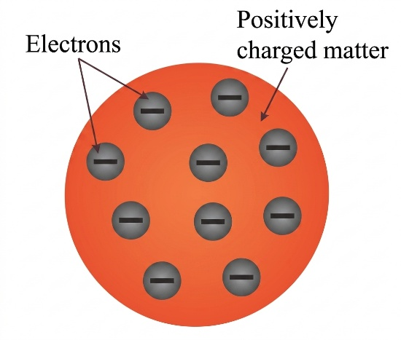
Fig. Plum pudding model
(ii) In the planetary model, an atom is made of a tiny, dense and positively charged core. core. The core is called the nucleus. Any electrons belonging to the atom are assumed to be moving in orbits around the nucleus, in the same manner that the planets revolve around the Sun. Electrons are held to the nucleus by electrostatic force of attraction between the nucleus and the electrons.
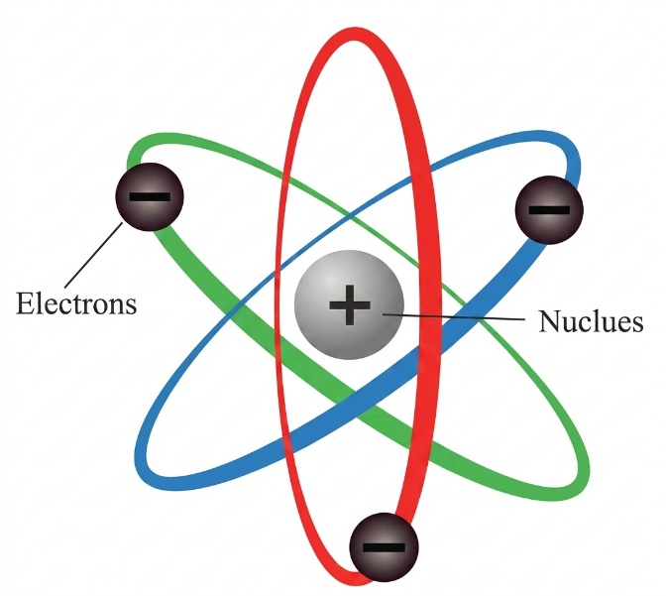
Fig. Planetary model
(b) (i) Part A represents cooling fins, B represents target metal (or anode) and C represents cathode.
(ii) Production of X-rays Electrons emitted by thermionic emission from the filament experience the potential difference and are accelerated towards the anode. When they hit the anode, the electrons are stopped and thereby transfer their energy to the electrons of the anode material. The anode material undergoes the re-arrangement of electrons resulting to the emission of X-rays
(iii) An evacuated tube helps to prevent accelerating electrons from colliding with air molecules.
(iv) Low voltage heats the cathode filament to emit electrons via thermionic emission while high voltage provides a strong potential difference to accelerate the emitted electrons to extremely high speeds toward the target.
(v) Tungsten is the most appropriate metal to be used because it has high melting point so it can withstand high temperature without changing to liquid.
- (a) When iron bar is under absence of external magnetic field, the atomic dipoles in magnetic domain will align random directions that gives a net of zero magnetic fields as shown in the figure below.
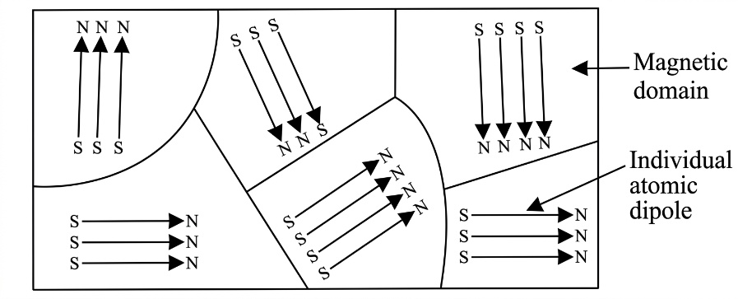
When the iron bar is placed in the presence of external magnetic field, the atomic dipoles in magnetic domain will align in the same direction. This gives a net effect of magnetic field as shown in the figure below
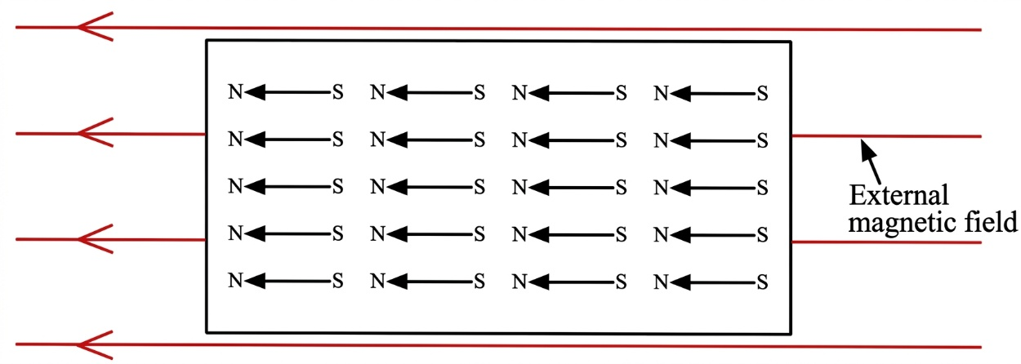
(b) She increased the number of turns in the coil. When a coil with many numbers of turns produces a strong magnetic field than the one with fewer. Apart from increasing the number of turns, magnetism can be increased by allowing high amount of current flowing in the circuit and also by inserting soft iron core in the coil.
(c) (i) According to Lenz’s law of electromagnetic induction the polarity of the induced e.m.f is in such a way that it tends to produce a current which opposes the change in the magnetic flux that produces it. This means that in order to increase e.m.f a work must be done to oppose the secondary magnetic field produced by induced current. So here, a work is converted electrical energy and this agrees with law of conservation of energy.
(ii) This is because the image produced by CRT TV depends on the number of the number of the electrons striking the screen so once the speaker is brought close to the screen, it affects the motion of the electrons and when is removed the electrons continue in its straight line.
- (a) Data given
Resistance of a galvanometer, I_{G} = 5 Ω
Maximum current in galvanometer, I_{G} = 4 mA = 0.004 A
Maximum current to be measured, I = 10 A
Resistance of a resistor R_{S} =?
Since both galvanometer and resistor are connected in parallel
For parallel connection
I = I_{S} + I_{G}
I_{S} = I – I_{G} = 10 A – 0.004 A
I_{S} = 9.996 A
Voltage across galvanometer = voltage across resistor
I_{G} x R_{G} = I_{S} x R_{S}
0.004 A x 5 Ω = 9.996 A x R_{S}
R_{S} $≈$0.002 Ω
Therefore, the resistance of a resistor is about 0.002 Ω or 2 mΩ.
(b) Consider a figure below
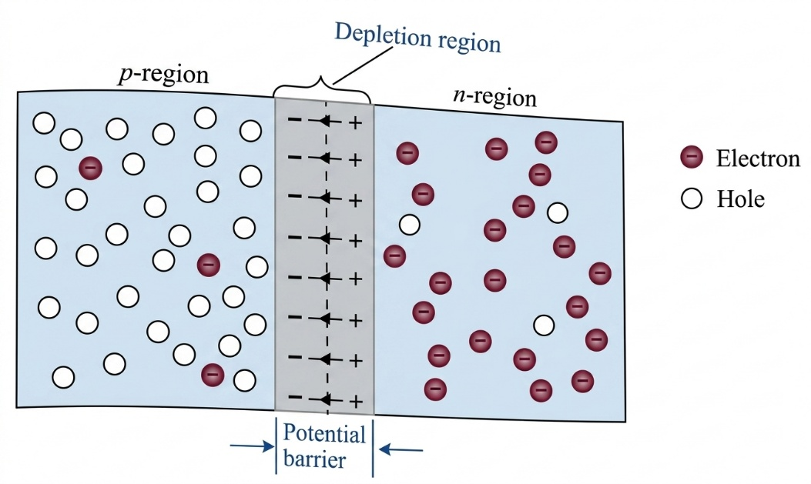
When p-type and n-type semiconductors are sandwiched, a p-n junction is formed, electrons from the n-region near the junction diffuse into the p-region, where they recombine with holes near the junction. This effectively creates a layer of positive ions in n-type region near the junction and a layer of negative ions in p-type region near the junction. A potential difference (p.d) is set up as the end of the n-side becomes positively charged and the p-side negatively charged. This p.d stops further flow of electrons and holes. These two positive and negative charge layers form the depletion region near the junction, the p.d across this layer is called the potential barrier
(c) (i) R₁ and R₂: They provide a constant, fixed base voltage by forming voltage divider network.
(ii) capacitor C_{E}: It allows the alternating current (a.c) signal to pass smoothly to the ground by completely by passing the resistor R_{E}
(iii) Capacitors C₁ and C₂: They provide d.c isolation
(iv) Resistor R_{E}: It keeps the collector current steady, successfully protecting the transistor from overheating.

