FORM ONE MID-TERM MARKING GUIDE
- 1 mark@ 10 = 10 marks
(i) | (ii) | (iii) | (iv) | (v) | (vi) | (vii) | (viii) | (ix) | (x)
C | A | C | A | D | B | C | B | B | C

- 1 mark@ 5 = 5 marks
List A | (i) | (ii) | (iii) | (iv) | (v)
List B | A | D | F | E | C

- (a)
- The instrument used was Vernier Caliper because it has an accuracy of 0.01cm.
(2 marks)
- Required to calculate the volume of the rectangular block
volume of rectangular block = length x height x width. (1 mark)
volume of the rectangular block = 4.00 cm x 2.50 cm x 1.00 cm = 10.00 cm3. (1 mark)
Therefore, the volume of the rectangular block is 10.00 cm3. (1 mark)
(b)
- Liquid A has concave meniscus while liquid B has a convex meniscus. (2 mark)
- Liquid A has concave meniscus because the adhesive force (force of attraction between liquid A molecules and glass molecules) is greater than cohesive force (force of attraction between liquid molecules). On the other hand, Liquid B has convex meniscus because cohesive force (force of attraction between liquid B molecules) is stronger than adhesive force (force of attraction between liquid B molecules and glass molecules. (3 marks)
- (a) This is because a hot soup has lower surface tension which causes it to spread all over the tongue. (5 marks)
(b) Required to calculate the coefficient of friction (μ)
Frictional force = coefficient of friction (μ) x normal force (R)
μ = $\frac{Frictional force}{Normal force}$. (1 mark)
Where, normal force (R) = mg. (1 mark)
μ = $\frac{Frictional force}{mg}$ . (1 mark)
μ = $\frac{26 N}{8 kg x 10 N/kg}$ = 0.325. (1 mark)
Therefore, the coefficient of friction is 0.325. (1 mark)
- (a) This is because honey is more viscous (resistance to flow) than water and hence takes more time to be emptied. (4 marks)
(b) Required to calculate the weight of an object on the moon
From
Weight = mass x g. (1 mark)
Weight on the moon = mass x g_{m}
g_{m} = g_{e}/6 = $\frac{10 N/kg}{6}$. (1 mark)
Where, m = 200g = 0.2 kg (constant). (1 mark)
weight of an object = 0.2 kg x $\frac{10 N/kg}{6}$ = 0.333 N. (2 marks)
Therefore, the weight of an object on the moon is about 0.333 N. (1 mark)
- (a) Upthrust depends on:
- the density of a liquid. (1 mark)
- volume of the immersed object and. (1 mark)
- the acceleration due to gravity. (1 mark)
(b) Required to find the volume of the liquid left in beaker
Final volume = initial volume – transferred volume. (1 mark)
Final volume =120 cm³ – 3 x 25 cm³. (2 marks)
Final volume = 120 cm³ – 75 cm³ = 45 cm³. (2 marks)
Therefore, the volume of liquid left in a beaker was 45 cm³. (2 marks)
- (a) properties of force of gravity
- It is always attractive. (1 mark)
- It operates over very long distances. (1 mark)
- It is the weakest force among all four fundamental forces. (1 mark)
- It is a central force. (1 mark)
(b) Data given
F₁ = 2.0 N
e₁ = 6.0 cm
F₂ = 8.0 N
e₂ =?
From Hooke’s law
F = ke. (1 mark)
F₁/e₁ = F₂/e₂. (1 mark)
$\frac{2.0 N}{6.0 cm}$ = $\frac{8.0 N}{e2}$. (1 mark)
e₂ = $\frac{8.0 N x 6.0 cm}{2.0 N}$ = 24.0 cm. (1 mark)
Therefore, the new extension of the spring is 24.0 cm. (2 marks)
- (a) This is because soap or detergent has ability to lower the surface tension of water. For example, when washing clothes, soap decreases the adhesion forces between the particles of cloth and those of dirt. As a result, the dirt is easily removed since both water and soap particles penetrate the pores of the fabric. (4 marks)
(b) Required to calculate the tension in the string
Consider a figure below
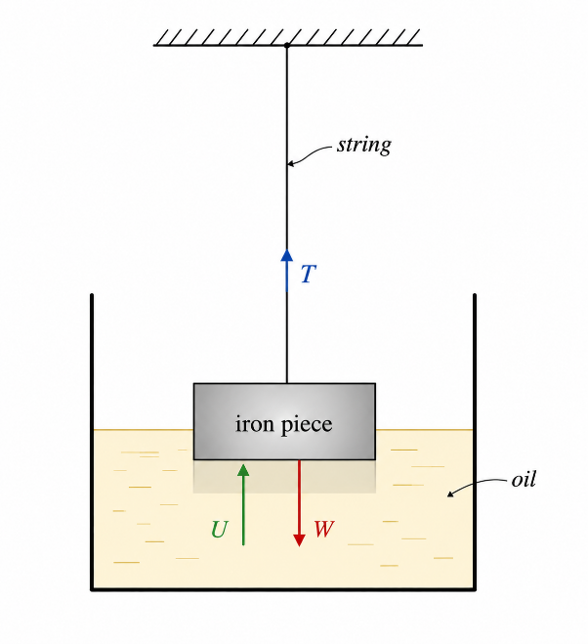 (1 mark)
From the figure above
T + U = W. ($\frac{1}{2}$ mark)
Where T is tension in the string, U is upthrust and W is the weight of an iron piece
W = mass x g = 360 g x 0.01 N/g = 3.6 N.
From Archimedes’ principle
Upthrust = weight of oil displaced
U = mass of oil displaced x g
U = density of oil x volume of oil displaced x g. ($\frac{1}{2}$ mark)
But, volume of oil displaced = volume of iron under oil = $\frac{mass of iron}{density of iron }$
Volume of oil displaced = $\frac{1}{2}$ x (360 g/ 7.8 gcm⁻³) = 23.08 cm³. ($\frac{1}{2}$ mark)
U = 0.9 g/cm³ x 23.08 cm³ x 0.01 N/g = 0.208 N. ($\frac{1}{2}$ mark)
Recall, T + U = W
T = W – U = 3.6 N – 0.208 N = 3.392 N. (1 mark)
Therefore, the tension in the string is 3.392 N. (1 mark)
- (a) This is because a thick handle has large surface area which reduces the pressure exerted by a handle on hand while thin handle exerts high pressure on hand hance discomfort.
(b) Required to find which surface will exert largest pressure
For the largest base area
From
Pressure = $\frac{Force }{Area }$ = $\frac{Weight }{Area}$. (1 mark)
Largest base area = 5 cm x 10 cm = 50 cm² = 0.005 m². (1 mark)
Pressure = 3 N/ 0.005 m² = 600 N/m². (1 mark)
For the smallest base area
Smallest base area = 5 cm x 4 cm = 20 cm² = 0.002 m². (1 mark)
Pressure = 3 N/ 0.002 m² = 1500 N/m². (1 mark)
Therefore, the surface with the smallest base area will exert large pressure (1500 N/m²) than the one with the largest base area 600 N/m². (1 mark)
- (a) Between point O and A, this region represents elastic deformation because in this region extension is directly proportional to the tension. (3 marks)
(b) Hooke’s law states that” provided the elastic limit is not exceeded, the extension is directly proportional to the force applied”. (3 marks)
(c) Point B represents the elastic limit because beyond this point materials do not obey Hooke’s law. (3 marks)
(d) Elastic limit is the maximum point beyond which material cannot return to its original shape when the deformation force is removed. (3 marks)
(e) Between point B and C, the material will show plastic deformation. (3 marks)

