- When an ice is being heated from -5 $℃$ to 0 $℃$, its density slightly increases until it becomes water (liquid) from 0 $℃$ the water starts to contract again and its density increases until reaches a maximum density at 4 $℃$. From 4 $℃$ to 15 $℃$water starts to expand like other liquids and hence its density starts to decrease. This is shown in the graph below
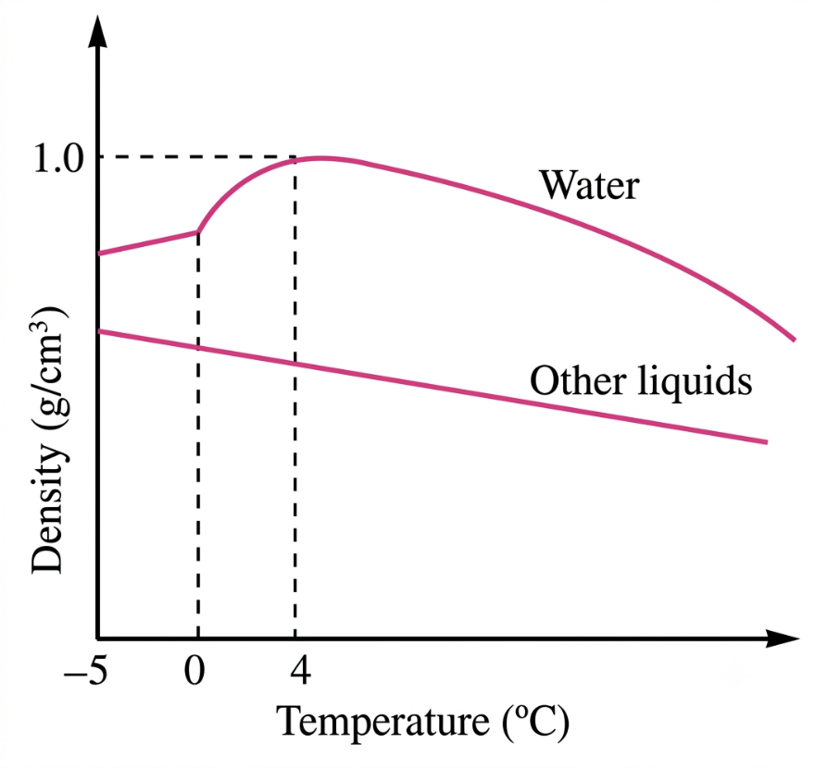
Fig. variation of density of water with temperature
- Solution
Consider a figure below
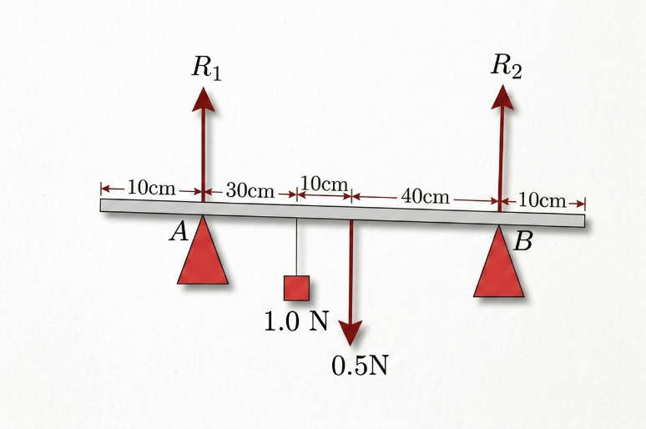
From the conditions for a body to be in equilibrium under parallel forces
- Sum of clockwise moment = sum of anticlockwise moment
By considering knife edge B
R1 x 80 cm = 1 N x 50 cm + 0.5 N x 40 cm
R1 x 80 cm = 70 Ncm
R1 = 0.875 N
- Sum of upward forces = sum of downward forces
R1 + R2 = 1 N + 0.5 N = 1.5 N
R2 = 1.5 N – R1 = 1.5 N – 0.875 N
R2 = 0.625 N
Therefore, the reactions of the supports are 0.875 N and 0.625 N, respectively.

Prepared by teacher Alex @Godegode sec

