- (a) Data given
Length of methanol column, h_{m} = 16 cm
Length of water column, h_{w} = 12.80 cm
- Relative density of methanol, R.D =?
Consider a figure below
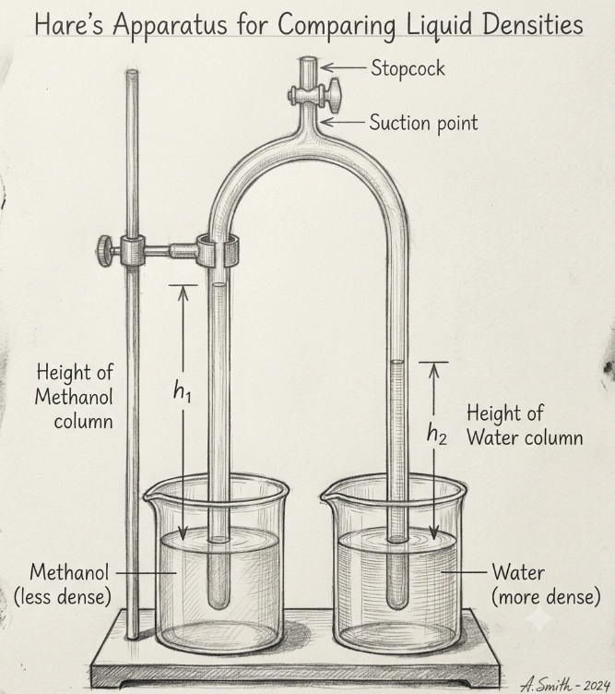
Figure. Hare’s apparatus
Pressure due to methanol column = Pressure due to water column
But, P = ρhg
ρ_{m} x h_{m} x g = ρ_{w} x h_{w} x g
ρ_{m}/ρ_{w} = h_{w}/h_{m}
R.D = $\frac{density of mercury }{density of water }$= hw/hm
R.D = $\frac{12.80 cm}{16 cm}$ = 0.8
Therefore, the relative density of methanol is 0.8.
- New height of the water column (hw) if the height of water column is 21.50 cm?
From
R.D = hw/hm
hw = R.D x hm = 0.8 x 21.50 cm = 17.20 cm.
Therefore, the new height of water column will be 17.20 cm.
(b) Required to calculate the density of the metre rule, ρ =?
Consider a figure below
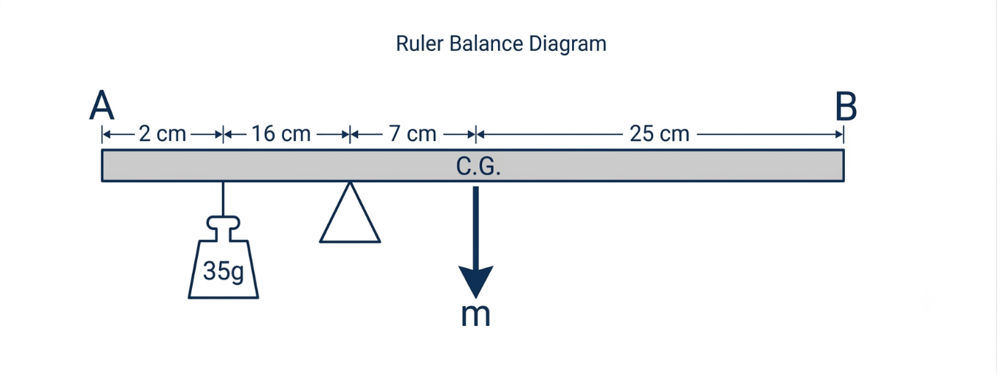
Figure. Half metre rule
From the principle of moment
Sum of clockwise moment = sum of anticlockwise moment
m x 7 cm = 35 g x 16 cm
m = 80 g
But, ρ = $\frac{mass of a substance }{volume of a substance }$
Volume of a metre rule (v) = length x width x thickness
v = 50 cm x 2.5 cm x 0.26 cm = 32.5 cm³
ρ = 80 g/32.5 cm3 = 2.46 g/cm³
Therefore, the density of a half metre rule is 2.46 g/cm³.

