FORM THREE MARKING GUIDE
PHYSICS
- 1 mark@ 10 = 10 marks
(i) | (ii) | (iii) | (iv) | (v) | (vi) | (vii) | (viii) | (ix) | (x)
D | C | D | A | C | D | D | D | A | C

- 1 mark@ 5 = 5 marks
List A | (i) | (ii) | (iii) | (iv) | (v) | (vi)
List B | C | A | B | D | E | F

- (a) consider a figure below
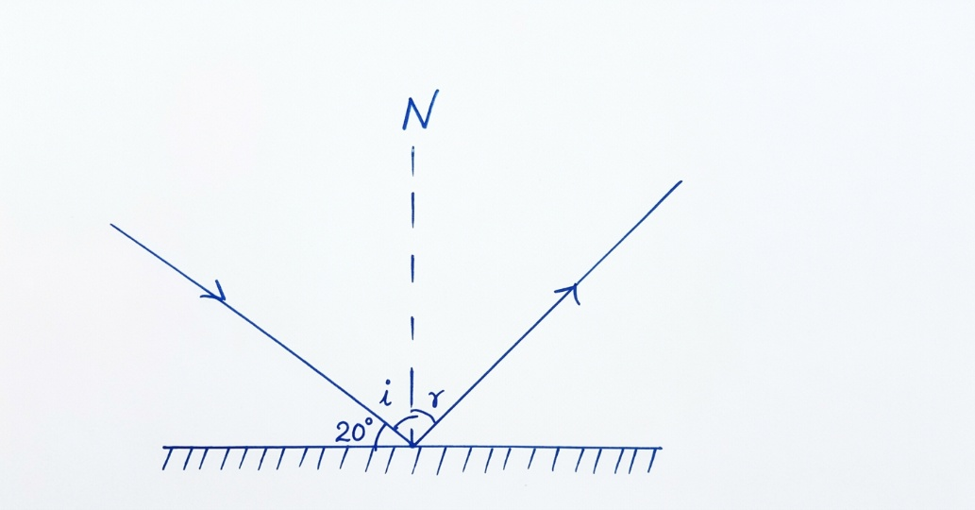 (1 mark)
Fig. reflection on a plane mirror
From the figure above
20$°$ + i = 90$°$
i = 90$°$ - 20$°$ = 70$°$. (1 mark)
From the second law of reflection of light
r = i = 70$°$. ($\frac{1}{2}$ mark)
The angle between incident ray and reflected ray = i + r = 2i = 2 x 70$°$ = 140$°$. ($\frac{1}{2}$ mark)
Therefore, the angle between the incident ray and the reflected ray is 140$°$. (1 mark)

(b) Data given
Volume of the bottle, v_{b} = 100 cm³
Mass of an empty density bottle, m_{o} = 20 g
Mass of density bottle containing charcoal, m₁ = 255 g
Mass of density bottle containing both water and charcoal, m₂ = 289 g
Required to calculate the density of powdered charcoal, ρ_{c}
From the formula
Density of charcoal = $\frac{mass of the charcoal }{volume of the charcoal }$ . ($\frac{1}{2}$ mark)
Mass of charcoal = m₁ – m_{o} = 255 g – 20 g = 235 g. (1 mark)
But, volume of the charcoal = volume of bottle – volume of water
Volume of water = $\frac{mass of water }{density of water }$
Mass of water = m₂ – m₁ = 289 g – 255 g = 34 g. ($\frac{1}{2}$ mark)
Volume of water = 34 g/1 gcm⁻³ = 34 cm³. ($\frac{1}{2}$ mark)
Volume of charcoal = 100 cm³ – 34 cm³ = 66 cm³. ($\frac{1}{2}$ mark)
Density of charcoal = 235 g/66 cm³ = 3.56 g/cm³. (1 mark)
Therefore, the density of powdered charcoal is 3.56 g/cm³. (1 mark)
- (a) Required to find the pulling force (F) and tension of the string in new position (T)
Consider the figure below
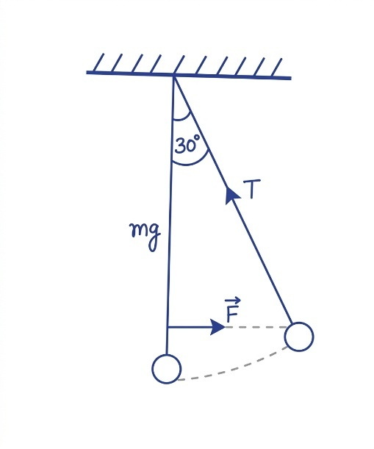 (1 mark)
Fig. suspended mass
From the figure above
tan30$°$ = $\frac{F}{mg}$. (1 mark)
F = 3 kg x 10 N/kg x tan 30$°$ = 17.32 N. (1 mark)
The tension of the string
cos30$°$ = $\frac{mg}{T}$. (1 mark)
T = $\frac{mg}{cos30°}$ = $\frac{3 kg x 10 N/kg}{\cos{30°}}$ = 34.63 N. (1 mark)
Therefore, the horizontal force and tension in the new position are 17.32 N and 34.63 N, respectively. (2 mark)
(b) (i) Electromotive force is the potential difference across the cell terminals when no current flows or no load is connected while potential difference is measured when current flows through the circuit or when a load is connected. (1 mark)
(ii) e.m.f is the energy generated when any other form of energy is transformed into electrical energy while p.d is a measure of how much energy is transferred between two points in a circuit. (1 mark)
(iii) e.m.f has higher value than p.d. (1 mark)
- (a) Land breeze occurs at night; the land loses heat faster than the sea water at night. Thus, air above the sea remains warmer than that of the land. This results in a stream of cool air moving from the land to the sea surface. This is shown in the figure below.
(3 marks)
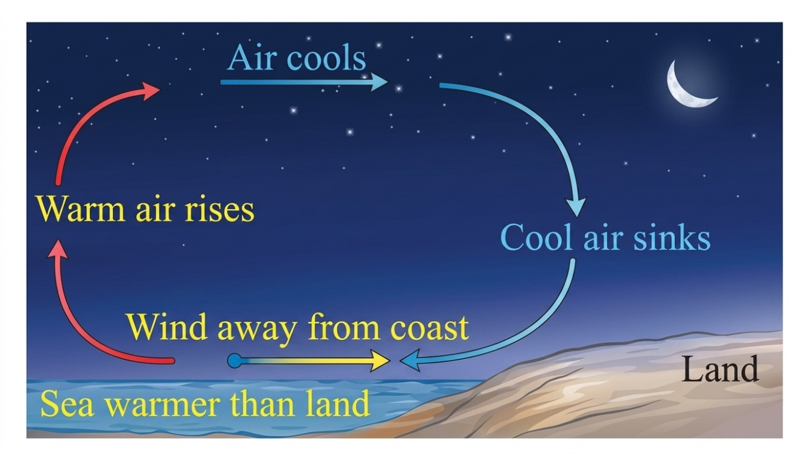
(2 marks)
(b) Data given
$\frac{Δl}{lo}$ = $\frac{0.15}{100}$. ($\frac{1}{2}$ mark)
Initial temperature, θ_{o} = 15$℃$
Final temperature, θ₁ = 100$℃$
Original length, l_{o} = 100 cm
Required to calculate the coefficient of linear expansion, α
From
α = $\frac{Δl}{lo}$ x $\frac{1}{Δθ}$. (1 mark)
Δθ = θ₁ – θ_{o} = 100$℃$ - 15$℃$ = 85$℃$. ($\frac{1}{2}$ mark)
α = $\frac{0.15 }{100 x 85℃}$ = 1.76 x 10⁻⁵/$℃$. (1 mark)
Therefore, the coefficient of linear expansion of copper is 1.76 x 10⁻⁵/$℃$. (1 mark)
- (a) Let the distance between a second 50 g mass and a knife edge be a
Consider a figure below
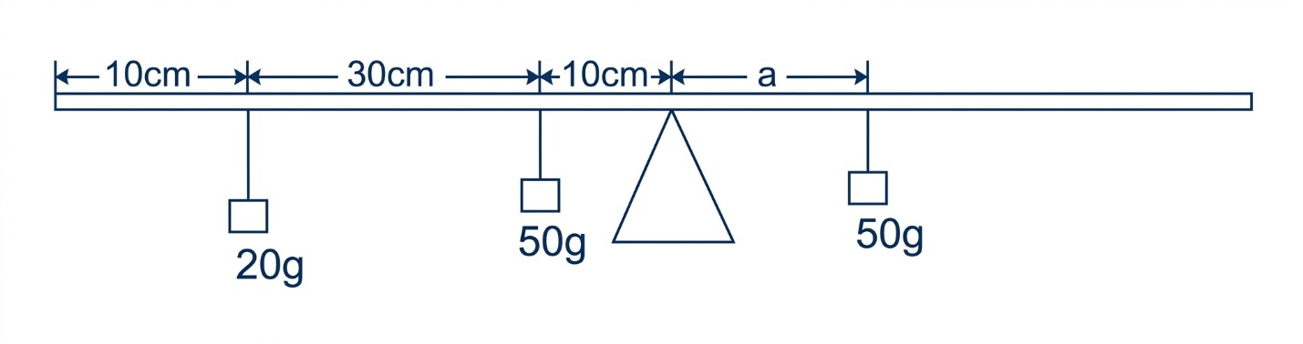
Fig. A metre rule
(2 marks)
From the principle of moment
Sum of clockwise moments = sum of anticlockwise moments
50 g x a = 20 g x 40 cm + 50 g x 10 cm. ($\frac{1}{2}$ mark)
50 g x a = 1300 gcm
a = $\frac{1300 gcm}{50 g}$ = 26 cm. (1 mark)
the distance from 0 mark to the second 50 g = 50 cm + 26 cm =76 cm. ($\frac{1}{2}$ mark)
Therefore, a second 50 g mass must be placed at a 76 cm mark for the metre rule to be at equilibrium. (1 mark)
(b) yes, this is because when an object is at rest the net force is zero (sum of forces in one direction is equal to the sum of the forces in opposite side) which is the condition for a body to be in equilibrium. (4 marks)
- (a) Data given
Load (L) = 150 N
VR = number of pulleys = 4. ($\frac{1}{2}$ mark)
- Required to calculate the effort applied E
From
MA = VR = 4, (when friction is ignored). ($\frac{1}{2}$ mark)
But, MA = $\frac{Load }{Effort}$. ($\frac{1}{2}$ mark)
Effort = $\frac{Load}{MA}$ = $\frac{150 n}{4}$ = 37.5 N. (1 mark)
Therefore, the force required to raise the load was 37.5 N. ($\frac{1}{2}$ mark)
- Required to find the distance moved by load when distance moved by effort is 60 cm
From
VR = $\frac{Distance moved by effort}{Distance moved by load}$. ($\frac{1}{2}$ mark)
Load distance = $\frac{Effort distance}{VR}$ = $\frac{60 cm}{4}$ 15 cm. ($\frac{1}{2}$ mark)
Therefore, the distance moved by the load was 15 cm. (1 mark)
(b) The fixed points of a thermometer include both upper fixed point and lower fixed point. The upper fixed point is obtained by placing the thermometer near the surface of the boiling water until 100 $℃$ is reached. On the other hand, lower fixed point is obtained by immersing the thermometer into a melting ice container until 0 $℃$ is reached.
(4 marks)
- (a) (i) Kongwa district has highest relative humidity because it has highest dew point which means that there is high concentration of water vapour already and hence air temperature must be cooled by a small temperature. (2 marks)
- Mpwapwa district has the lowest relative humidity because it has lowest dew point. This means that there is low concentration of water vapour present in air and hence air must be cooled significantly by a large temperature difference so as to allow air to hold more water vapour. (2 marks)
(b) Consider a table below showing the difference between boiling and evaporation.
S/No | Boiling | Evaporation
(i) | Is vapourisation process where liquid changes into gas system when heated | Is a process for which liquid changes its form into gas even without heating
(ii) | Occurs at a definite temperature which is the boiling point | Occurs at a temperature even below the boiling point
(iii) | Occurs throughout the liquid with the formation of bubbles | Occurs at the surface of the liquid only and no bubbles are formed
(iv) | Has no cooling effect (temperature remain constant) | Has a cooling effect (Temperature decreases)
(v) | Takes place rapidly | Takes place slowly
1 mark @5 = 5 marks
- (a) Data given
Mass of water, mw = 3.0 kg
Initial temperature, θo = 50 $℃$
Final temperature, θ1 = 100 $℃$
The specific heat capacity of water is 4200 J/kg °C.
Specific latent heat of vapourisation of water is 2260 kJ/kg.
Required to calculate the amount of thermal energy required to water to steam
From
Q = Q₁ + Q₂. (1 mark)
Q = mc_{w}Δθ + mLv. (1 mark)
Q = 3.0 kg x 4200 J/kg$℃$ x (100$℃$ - 50$℃$) + 3.0 kg x 2260000 J/kg. (1 mark)
Q = 630,000 J + 6,780,000 J = 7,410,000 J = 7.41 x 10⁶ J. (1 mark)
Therefore, 7.41 x 106 J or 7.41 MJ is required to change a 3.0 kg of water at 50$℃$ to steam at 100$℃$. (1 mark)
(b) Data given
For brass cylinder
Initial temperature, θ_{o} = 100 $℃$
Specific heat capacity, c_{b} = 320 J/kg$℃$
For paraffin
Mass, m_{p} = 150 g
Initial temperature, θ₁ = 11$℃$
Final steady temperature, θ = 20 $℃$
Specific heat capacity, c_{p} = 2200 J/kg$℃$
Required to calculate the mass of brass cylinder, mb
From the principle of conservation of energy
Heat lost by brass cylinder = Heat gained by paraffin
But, Q = mcΔθ
m_{b} x c_{b} x (θ_{o} – θ) = m_{p} x c_{p} x (θ – θ₁)
m_{b} x 320 J/kg$℃$ x (100$℃$ - 20$℃$) = 150 g x 2200 J/kg$℃$ x (20$℃$ - 11$℃$)
m_{b} x 25600 = 2970000 g
m_{b} = $\frac{2970000 g}{25600}$ = 116.02 g
Therefore, the value of m_{b} is 116.02 g.
(c) Calorimeter can reduce the heat loss by using lagging materials and a lid on top as shown in the figure below. (2 marks)
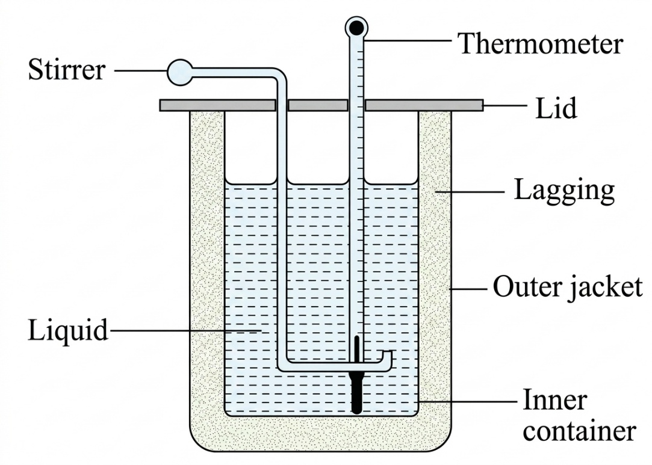
Fig. calorimeter
Diagram = 3 marks
- (a) Data given
Volume of the bubble at the bottom, V₁ = 1.5 cm³
Pressure of the bubble at the bottom, P₁ = P_{a} + P_{w}
Pressure of the bubble below the surface of water, P₂ = Pa = 10 m of water
Depth at which the bubble is, h = 90 m
Volume of the bubble below the surface of water, V₂ =?
From Boyle’s law
P₁V₁ = P₂V₂. (1 mark)
(P_{a} + P_{w}) x V₁ = Pa x V₂. ($\frac{1}{2}$ mark)
But, Pw = ρhg = 90 m x ρg. ($\frac{1}{2}$ mark)
(10 m + 90 m) ρg x 1.5 cm³ = 10 m x ρg x V₂. (1 mark)
$\frac{100 m}{10 m}$ x 1.5 cm³ =15 cm³ = V₂. (1 mark)
Therefore, the volume of the bubble below the surface is 15 cm³. (1 mark)
(b) Required to calculate the frictional force
Consider a figure below
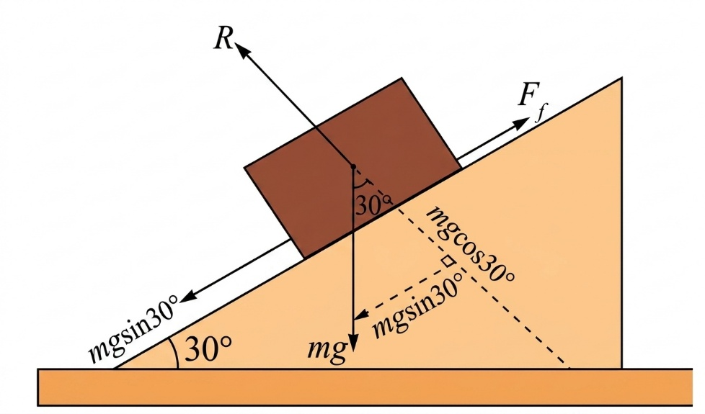 (1 mark)
Fig. An inclined plane
From newton’s second law of motion
Fnet = ma
mgsin30$°$ - F_{k} = ma. (1 mark)
F_{k} = mgsin30$°$ - ma = m(gsin30$°$ - a). (1 mark)
F_{k} = 24 kg x (10 m/s2 x sin30$°$ - 0.25 m/s2) = 114 N. (1 mark)
Therefore, the magnitude of frictional force is 114N. (1 mark)
(c) Required to determine at which the angle begins to slide
Consider a figure below
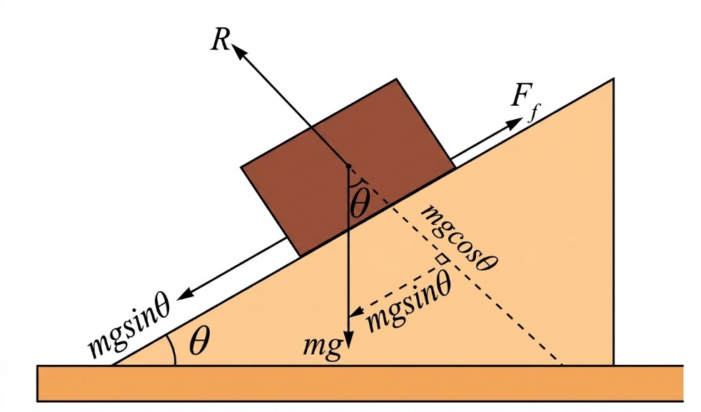 (1 mark)
Fig. An inclined plane
From newton’s second law of motion
Fnet = ma
mgsinθ – Fs = ma, where a = 0 (at rest). (1 mark)
mgsinθ = Fs = μs x R
mgsinθ =μs x mgcosθ. (1 mark)
$\frac{\sin{θ}}{\cos{θ}}$ = tan θ = μs
θ = tan⁻¹μs = tan⁻¹(0.55) = 28.81$°$. (1 mark)
Therefore, the box will begin to slide at angle of 28.81$°$. (1 mark)
- (a) This is because the heat in thick glass is not uniformly distributed. This means that inner wall of the glass expands faster than the outer wall of the glass which causes the glass to break.
(b) Data given
By using Real-is-positive sign convention
Object height, ho = 4 cm
Object distance, u = 6 cm
Focal length (f) = $\frac{R}{2}$ = $\frac{24 cm}{2}$ = 12 cm. ($\frac{1}{2}$ mark)
Required to find the position, height, magnification and nature of the image
From mirror formula
$\frac{1}{f}$ = $\frac{1}{u}$ + $\frac{1}{v}$. (1 mark)
By making v the subject
v = $\frac{fu}{u-f}$
v = $\frac{12 cm x 6 cm}{6 cm-12 cm}$ = -12 cm. (1 mark)
Image size
hi/ho = $\frac{-v}{u}$. ($\frac{1}{2}$ mark)
hi = -ho x $\frac{v}{u}$ = -4 cm x $\frac{-12 cm}{6 cm}$ = 8 cm. (1 mark)
Therefore, the image is formed at 12 cm behind the mirror (virtual image), 8 cm tall and upright. (1 mark)
(b) Data given
Apparent depth = 1.5 m
Refractive index 1.3
Real depth =?
From
η = $\frac{Real depth}{Apparent depth}$. (1 mark)
Real depth = η x apparent depth. (1 mark)
Real depth = 1.3 x 1.5 m = 1.95 m. (1 mark)
Therefore, the real depth is 1.95 m. (1 mark)

