- (i) When both x-rays and cathode rays allowed to pass through the electric field, the x-rays will pass undeflected while cathode rays will be deflected towards the positive plate. This shows that x-rays carry no charge while cathode rays are negative charge in nature. This is shown in the figure below.
(ii) When both x-rays and cathode rays allowed to pass through magnetic field, x-rays will pass undeflected while cathode rays will be deflected towards the north pole of a bar magnet as shown in the figure below
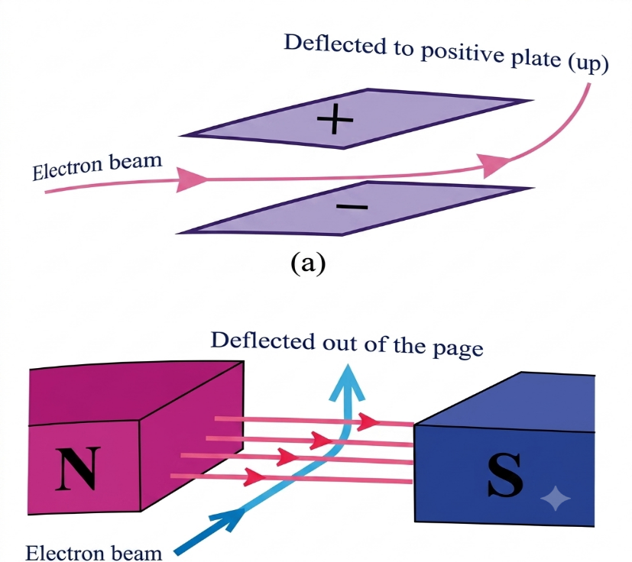
- Data given
For element P
No = 160 c.p.s
Half-life, t_{1/2} = 2 hours
For element Q
No = 160 c.p.s
Half-life, t_{1/2} = 4 hours
Time taken, T = 8 hours
Required to determine the amount of mixture remained after 8 hours
From the formula
N/No = ($\frac{1}{2}$)^{n}
For element P
N = No x ($\frac{1}{2}$)^{n}
Where, n = T/t_{1/2} = $\frac{8 hours}{2 hours }$ = 4
N_{P} = 160 c.p.s x ($\frac{1}{2}$)⁴ = 10 c.p.s
For element Q
n = $\frac{8 hours}{4 hours }$ = 2
N_{Q} = 160 c.p.s x ($\frac{1}{2}$)² = 40 c.p.s
N = N_{P} + N_{Q} = 10 c.p,s + 40 c.p.s = 50 c.p.s
Therefore, the amount of the mixture remained after 8 hours is 50 c.p.s.

Prepared by teacher Alex @Godegode sec

