- (a) (i) Bimetallic strip is made by joining two different metals that expands differently when heated at the same temperature. For example, bimetallic strip can be made by brass and iron or brass and invar.
(ii) When a bimetallic strip made by brass and iron is heated, the bimetallic strip bends towards the iron forming a curve in which brass forms outside part while iron forms the inside part. This is because brass expands faster than iron as shown in figure below.

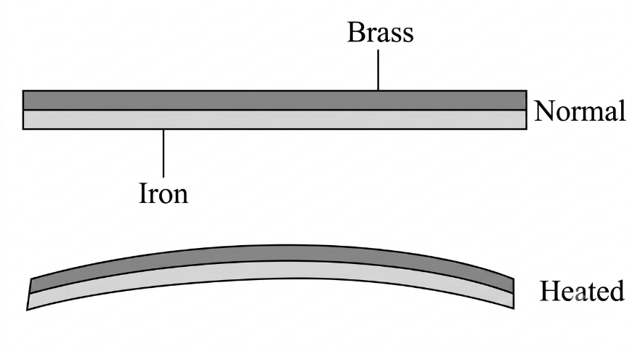
Fig. Bimetallic strip before heating and after heating
(b) Data given
For hot water
Mass, m₁ = 105 g
Initial temperature, θ₁ = 75$℃$
For cold water
Mass, m₂ = 215 g
Initial temperature, θ₂ = 15$℃$
Required to determine the final temperature of the mixture, θ =?
From the principle of conservation of energy
Heat lost by hot water = heat gained by cold water
Assumption: Heat gained by container is neglected
Heat = mcΔθ
m₁ x c_{w} x (θ₁ - θ) = m₂ x c_{w} x (θ – θ₂)
where c_{w} is the specific heat capacity of water
105 g x (75$℃$ - θ) = 215 g x (θ – 15 ℃)
7875$℃$ - 105θ = 215θ - 3225$℃$
θ = $\frac{11100℃}{320}$ = 34.69$℃$
Therefore, the final temperature of the mixture is 34.69 ℃.

