COAST REGION SOLUTION
- Multiple choice
(i) | (ii) | (iii) | (iv) | (v) | (vi) | (vii) | (viii) | (ix) | (x)
D | Free | A | C | E | A | B | D | C | A
- Objects appear closer when submerged in water because when light is travelling from one medium (air) to another medium (water), light tends to bend (undergo refraction).
Additionally, light bends away from normal when travelling from denser medium to a less dense medium (in this case from water to air).
- Data given
By using Real-is-positive sign convention
Object distance, u = 15 cm
Focal length, f = -10 cm
Required to determine the image distance and nature of the image.
From mirror formula
$\frac{1}{f}$ = $\frac{1}{u}$ + $\frac{1}{v}$
By making v the subject
v = $\frac{fu}{u-f}$
v = $\frac{-10 cm x 15 cm}{15 cm-(-10 cm)}$
v = -6 cm
Therefore, the image is formed at 6 cm behind the mirror (virtual) and the image is upright.
- Data given
Mass of water, m = 400 kg
Height, h = 40 m
Time taken, t = 20 s
Power, P=?
From
Power = $\frac{work done }{time }$
Work done = Force x distance
Work done= weight x distance
Work done = mgh
Work done= 400 kg x 10 N/kg x 40 m = 160000 J
Power = $\frac{160000 J}{20 s}$ = 8000 W = 8 kW
Therefore, the power is 8 kW.
- Data given
Fraction remained = N/N_{o} = 1 - $\frac{15}{16}$ = $\frac{1}{16}$
Time taken for the sample to decay, T = 8 min
Half-life, t =?
From
N/No = ($\frac{1}{2}$)n
$\frac{1}{16}$ = ($\frac{1}{2}$)n
($\frac{1}{2}$)4 = ($\frac{1}{2}$)n
n = 4
But, n – $\frac{T}{t}$
t = $\frac{T}{n}$ = $\frac{8 min}{4}$ = 2 min
Therefore, the half-life is 2 minutes.
- Matching items
List A | (i) | (ii) | (iii) | (iv) | (v) | (vi)
List B | B | H | C | D | F | A
- (a) Difference between simple microscope and compound microscope
- Simple microscope uses a single lens while compound microscope uses two lenses (objective lens and eyepiece lens)
- It is used to read small prints while compound microscope is used to study the blood sample.
- Simple microscope provides small magnification while compound microscope provides large magnification.
- Simple microscope is simple to use while compound microscope requires many adjustments.
(b) Data given
By using Real-is-positive sign convention
Focal length, f = 20 cm
v = -4 u (The image is virtual)
object distance, u =?
From lens formula
$\frac{1}{f}$ = $\frac{1}{u}$ + $\frac{1}{v}$
By multiplying u on both sides
$\frac{u}{f}$ = 1 + $\frac{u}{v}$
But, $\frac{u}{v}$ = $\frac{1}{m}$
$\frac{u}{f}$ = 1 + $\frac{1}{m}$
Recall. v =-4u
$\frac{u}{v}$ = -$\frac{1}{4}$
u = f x (1 - $\frac{1}{4}$) = $\frac{3f}{4}$
u = $\frac{3 x 20 cm}{4 }$ = 15 cm
Therefore, the object is placed at a distance of 15 cm in front the mirror.
- (a) This is because aluminium has smaller density compared to steel and also aluminium cannot be affected by rust.
(b) Consider a figure below
Let mass of a half-metre rule be m
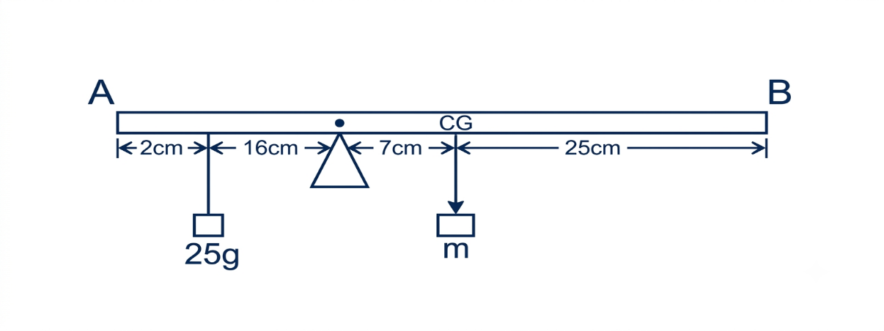

Fig. A half metre rule
From the principle of moment
Sum of clockwise moment = sum of anticlockwise moment
m x 7 cm = 35 g x 16 cm
m = 80 g
Therefore, the mass of a half metre rule is 80g.
- (a) Advantages of ocean tides
- Tides are used for the generation of tidal electricity
- High tides also help in fishing. More fish come closer to the shore during the high tides. This enables fishermen to get plentiful catch.
- High tides help in navigation. They raise the water level close to the shores. This helps ships to move to harbours more easily.
- Marine ecosystem: The rise and fall of ocean tides helps in nutrients mixing and oxygen. This supports marine life.
(b) Consider a figure below
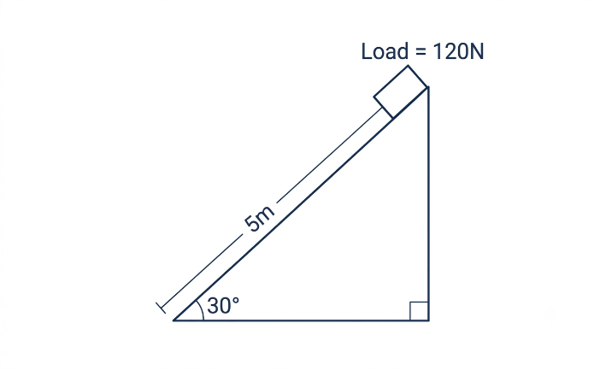
Fig. Inclined plane
Required to calculate the effort, E. If the efficiency is 75%
From The formula
VR = $\frac{Slanted height}{Vertical height }$
But, vertical height = slanted height x sin 30$°$
Vertical height = 5 m x 0.5 = 2.5 m
VR = $\frac{5 m}{2.5 m}$ = 2
Also, efficiency = $\frac{MA}{VR}$ x 100%
75% = $\frac{MA}{2}$ x 100%
MA = 1.5
But, MA = $\frac{Load }{Effort }$
Effort = $\frac{Load }{MA}$ = $\frac{120 N}{1.5}$ = 80 N
Therefore, the effort required was 80 N.
- (a) consider a figure below
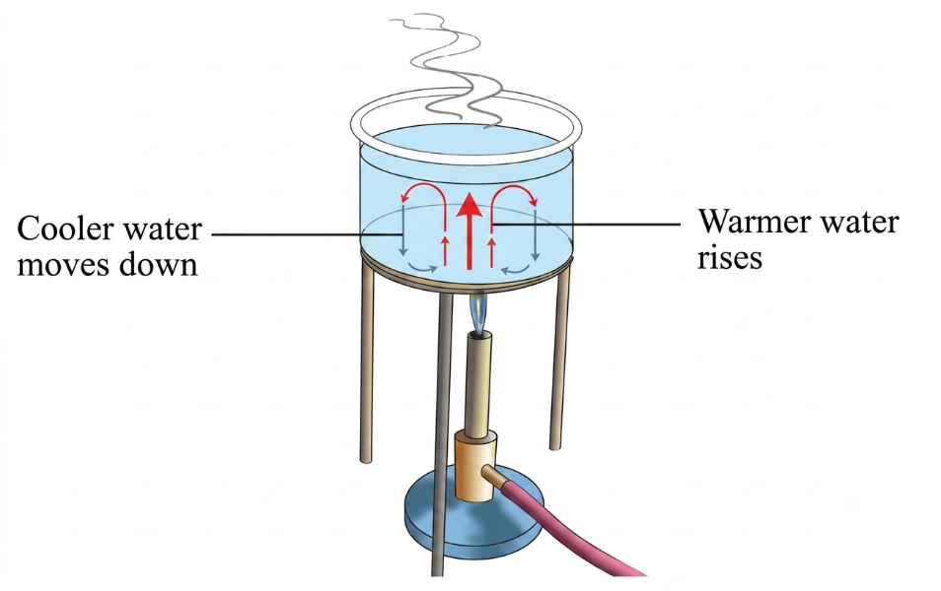
Fig. Heat transfer by convection
Convection is the transfer of heat in fluids (liquids and gases) between regions of different temperatures, and it involves the actual movement of the fluid itself.
When water is heated, the bottom water expands (volume increases). This makes the bottom water less dense and hence rises while the top water (cold water) sinks to replace the warm water. The cold water is also heated and becomes again less dense and rise upward. This creates a convection current as shown in the figure above.
(b) Data given
For aluminium
Mass, m_{a} = 0.5 kg
Initial temperature, θ_{o} = 100$℃$
Specific heat capacity, c_{a} = 900 J/kg$℃$
For Water
Mass, m_{w} = 1.0 kg
Initial temperature, θ₁ = 20$℃$
Specific heat capacity, c_{w} = 4200 J/kg℃
Equilibrium temperature, θ =?
From the principle of conservation of energy
Heat lost by aluminium = Heat gained by water
Assumption: Heat lost to the surrounding is neglected
But, Q = mcΔθ
m_{a} x c_{a} x (θ_{o} – θ) = m_{w} x c_{w} x (θ – θ₁)
0.5 kg x 900 J/kg$℃$ x (100$℃$ - θ) = 1.0 kg x 4200 J/kg$℃$ x (θ - 20$℃$)
450$℃$ - 4.5θ = 42 θ - 840$℃$
θ = 27.74$℃$
Therefore, the equilibrium temperature is 27.74$℃$.
- (a) Alpha particle has least penetrating power which can be stopped by only paper, Bata particle has moderate penetrating power and can be stopped by aluminium while Gamma rays have high penetrating power and can be stopped by lead. The penetration power can be summarized by the figure below.
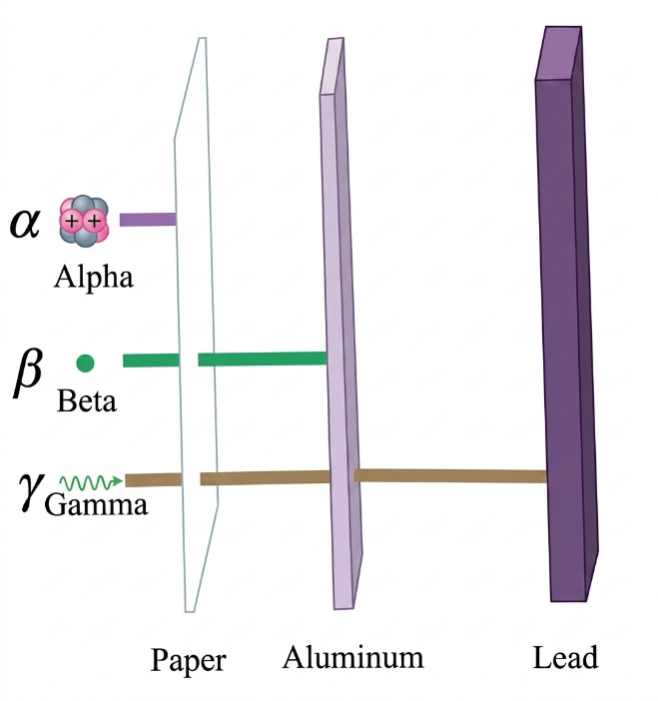

(b) Data given
Beat frequency, fb = 4 Hz
Frequency of the first sound, f₁ = 20 Hz
Frequency of the second sound, f₂ =?
From
fb = f₁ – f₂ if f₁$>$f₂
4 Hz = 20 Hz – f₂
f₂ = 20 Hz – 4 Hz = 16 Hz
Also, fb = f₂ – f₁ if f₂$>$f₁
4 Hz = f₂ – 20 Hz
f₂ = 4 Hz + 20 Hz = 24 Hz
Therefore, the possible values of beat frequencies are 16 Hz and 24 Hz.
- (a) Solutions to global warming
- Use of cleaner alternative sources of energy, such as solar energy, wind energy, biomass and geothermal.
- Government to adopt carbon emissions policies. Carbon pricing policies require companies to pay a price for each tone of released carbon. A carbon tax be imposed on business and individual that works as a sort of pollution tax.
- Put in place energy-conservation measures to reduce the use of fossil fuels. These measures include use of public transport to minimize the number of vehicles on the roads and the use of fuel-efficient cars.
(b) Data given
Half-life, t = 2.0 hours
No = 2400 c.p.s
N = 300 c.p.s
To determine at what time will the sample remain 300 c.p.s
From
N/No = ($\frac{1}{2}$)n
$\frac{300 c.p.s}{2400 c.p.s}$ = ($\frac{1}{2}$)n
($\frac{1}{2}$)3 = ($\frac{1}{2}$)n
3 = n
But, n = $\frac{T}{t}$
T = nt = 3 x 2.0 hours = 6.0 hours
Time = 11:00 am + 6:00 hours = 5:00 PM
At 5:00 PM, the sample will be 300 c.p.s.
- (a) Once a p-n junction is formed, electrons from the n-region near the junction diffuse into the p-region, where they recombine with holes near the junction. This effectively creates a layer of positive ions in n-type region near the junction and a layer of negative ions in p-type region near the junction. A potential difference (p.d) is set up as the end of the n-side becomes positively charged and the p-side negatively charged. This p.d stops further flow of electrons and holes. These two positive and negative charge layers form the depletion region near the junction. The depletion region is formed very quickly and is very thin compared to the n and p regions. The p.d across this layer is called the potential barrier and is about 0.7 V for silicon and about, 0.3 V for germanium. This is shown in the figure below.
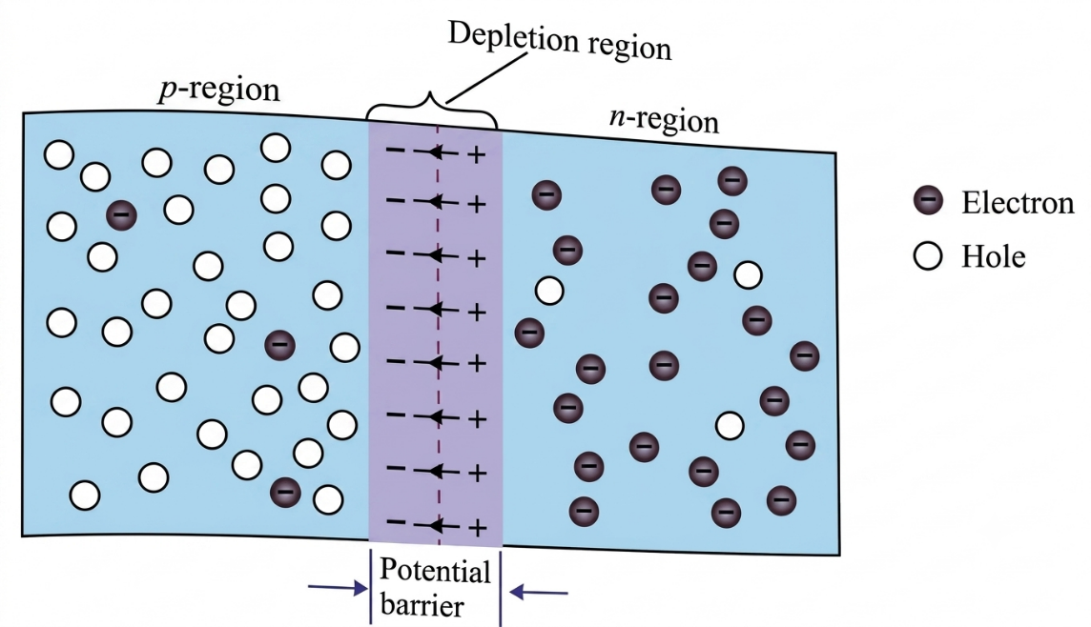
Fig. p-n junction
(b) Properties of semiconductor
- Conductivity of semiconductor increases with temperature unlike materials such as conductors which conductivity decreases when temperature increases.
- The forbidden energy gap is small compared to that of insulators.
- The Conductivity of semiconductors increases when are doped.
(c) Uses of x-rays
- In the medical field X-rays are used in hospitals to obtain diagnostic information and treatment of different diseases. In diagnostic procedure, X-rays are used to detect broken or fractured bones, and some diseases in soft tissues.
- In the industrial field X-rays are used in non-destructive testing to inspect metal casting and welded joints for hidden faults.
- In the research field Researchers use X-rays to investigate the atomic structure of crystalline materials and obtain elemental information from different types of materials. Also, distant galaxies can be observed by detecting the X-rays emitted from the galaxies.
- (a) An ammeter, which measures current, is always connected in series with the circuit component(s) to ensure that the current flowing through the component(s) also flows through, and is measured by, the ammeter. A voltmeter must be connected in parallel with the component across which the voltage is being measured because it has high resistance. These connections are shown in the figure below.
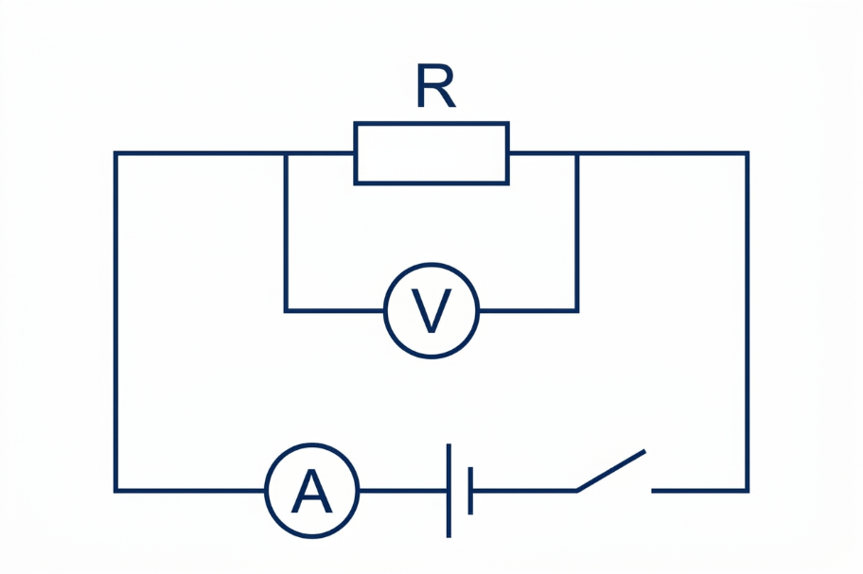
Fig. Electric circuit
(b) Data given
Case I
Current, I₁ = 3 A
Potential difference, V₁ = 2 V
Case II
Current, I₂ = 2 A
Potential difference, V₂ = 3 V
Required to determine the e.m.f and internal resistance of a cell
From
E = I(R + r) = IR + Ir
E = V + Ir
E = V₁ + I₁r
E = 2 + 3r
E – 3r = 2 …………eqn (i)
Also, E = V₂ + I₂r
E = 3 + 2r
E – 2r = 3 …………eqn (ii)
To solve eqn (i) and (ii) by elimination method
E – 3r = 2 …….. eqn(i)
E – 2r = 3 ……. eqn (ii)
Eqn (i) – eqn (ii)
E – 3r -E + 2r = 2 – 3
-r = -1
r = 1 Ω
By substituting the value of r into eqn (i)
E – 3 x 1 = 2
E = 5 V
Therefore, the values of e.m.f and internal resistance are 5 V and 1 Ω.
(c) Data given
Length of the tube, l = 100 mm = 0.1 m
Speed of sound in air of the tube, v = 340 m/s
Frequency of the first overtone, f₁ =?
From
v = fλ
f = $\frac{v}{λ}$
But, First overtone = second resonance
l = $\frac{3λ}{4}$
λ = $\frac{4l}{3}$
f = $\frac{3v}{4l}$ = $\frac{3 x 340 m/s}{4 x 0.1 m}$ = 2550 Hz
Therefore, the frequency of the first overtone is 2550 Hz.
- (a) (i) Factors that determine the magnitudes of induced e.m.f in the loop of wire
- Number of turns: Experiments show that the magnitude of induced e.m.f increases with an increase in number of turns. The higher the number of turns the higher the magnitude of induced e.m.f.
- Area of cross-section: A loop with large cross-sectional area produces higher magnitude of induced e.m.f.
- Speed of magnet: The magnitude of induced e.m.f depends also on the rate at which the magnet is pushed in or pulled out of the loop of the wire.
- Strength of the magnet: The magnitude of induced e.m.f also depends on the strength of the magnet which produces strong magnetic fields.
(ii) This is because when a magnet is brought close to the coil, the magnetic flux changes and according to Faraday’s law of electromagnetic induction. A change in magnetic flux causes induced e.m.f which causes the galvanometer to deflect.
(b) Uses of induction coil
- An induction coil is commonly used in ignition systems of internal combustion engines.
- A smaller version of an induction coil is used to trigger flash bulb tubes used in cameras and strobe lights
(c) (i) Data given
For primary coil
I_{p} = 0.1A
V_{p} = 240 V
For secondary coil
Is =?
V_{p} = 12 V
From
Input power = Output power (No power loss)
I_{p} x V_{p} = I_{s} x V_{s}
0.1 A x 240 V = I_{s} x 12 V
I_{s} = 2 A
Therefore, the ammeter will read a current of 2 A in output part.
- Data given
Input power = 2 x Output power
From
Efficiency = $\frac{output power }{input power }$ x 100%
Efficiency = $\frac{output power }{2 x output power }$ x 100% = 50%
Therefore, the efficiency of the transformer is 50%

Prepared by teacher Alex @Godegode sec (0673495077)

