CSEE PHYSICS SOLUTION 2025
- Multiple choice question
(i) | (ii) | (iii) | (iv) | (v) | (vi) | (vii) | (viii) | (ix) | (x)
A | D | B | D | E | C | A | A | B | C

- Matching items question
List A | (i) | (ii) | (iii) | (iv) | (v) | (vi)
List B | F | H | G | A | B | E

- (a) (i) Concave lens: The image is formed in front of the retina for a person with short sightedness, so concave lens helps to diverge the light rays before reaching the eye.
(ii) Convex lens: The image is formed behind the retina for a person with long sightedness, so convex lens helps to converge the light rays before reaching the eye.
(b) This is because a concave mirror forms a magnified and erect image when the object is close to the mirror (between F and P). This is shown in the figure below.
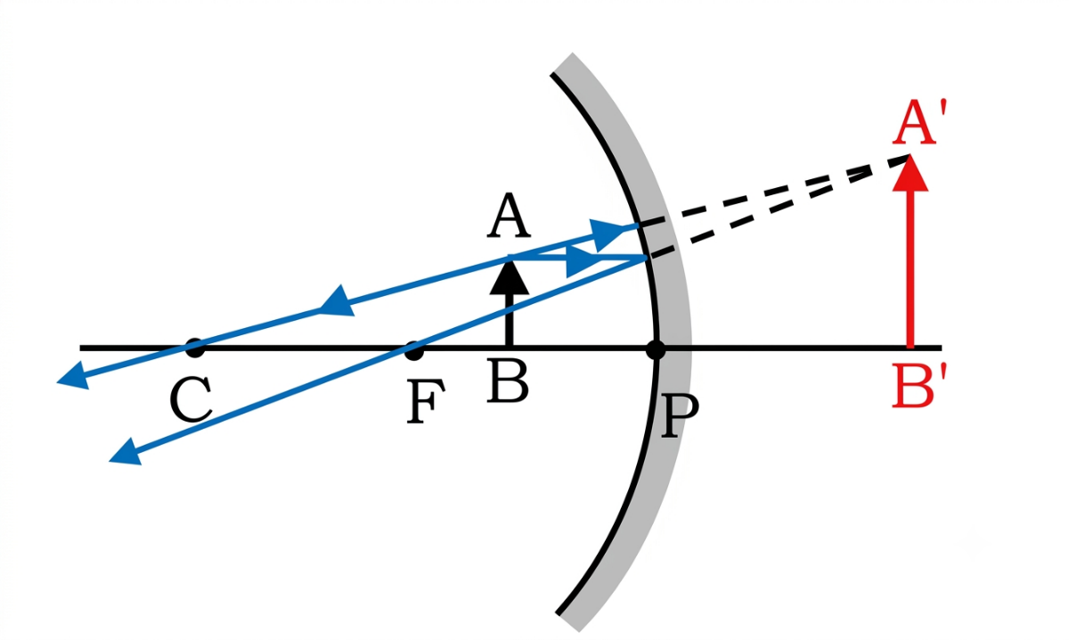

Fig. Concave mirror as shaving mirror

- (a)
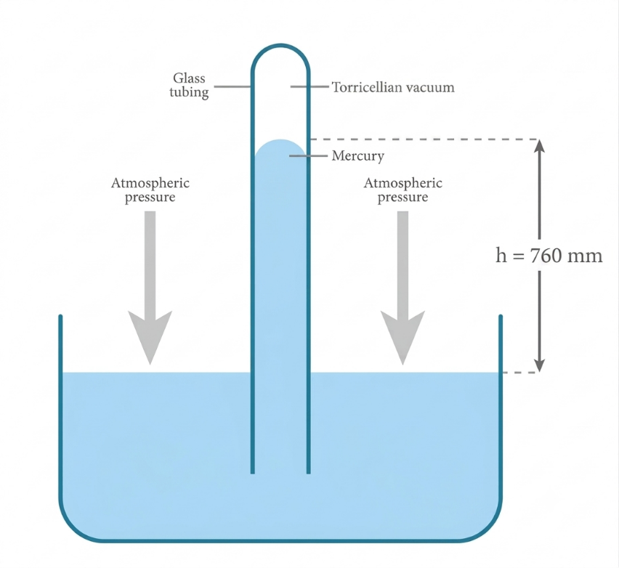
Fig. Simple barometer
(b) Consider a figure below as provided in the question paper

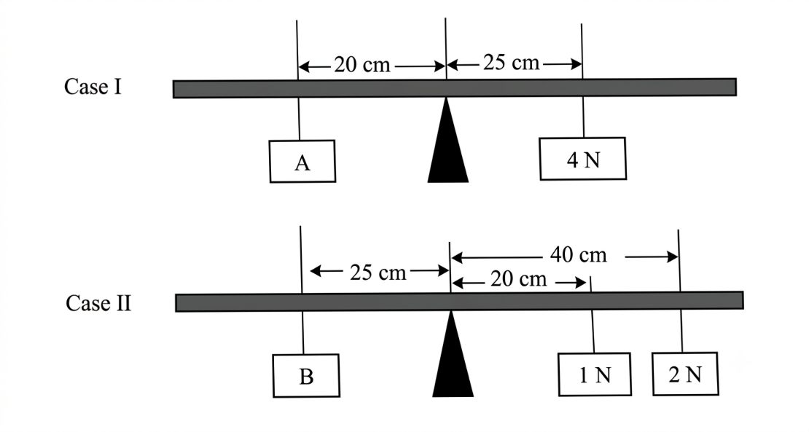
For case 1
From the principle of moment
Sum of clockwise moments = sum of anticlockwise moments
4 N x 25 cm = A x 20 cm
A = $\frac{100 Ncm}{20 cm}$ = 5 N
For case 2
Sum of clockwise moments = sum of anticlockwise moments
1 N x 20 cm + 2 N x 40 cm = B x 25 cm
B = $\frac{100 Ncm}{25 cm}$ = 4 N
A -B = 5 N – 4 N = 1 N.
Therefore, the difference in weight between A and B is 1 N.
- (a) (i) The person bends his knees in order to increase the time of impact while reducing the force of impact.
(ii) Newton’s second law of motion is the law that explains the scenario above. This law states that “The rate of change of momentum is directly proportional to the force applied and takes place in the direction of the force”
F = $\frac{ΔP}{Δt}$
FΔt = ΔP = Impulse.
(b) from the figure provided in the question paper
Sin $θ$ = $\frac{vertical height}{slanted height}$
Sin $θ$ = $\frac{BC}{AB}$
But, VR = $\frac{slanted height }{vertical height }$
VR = $\frac{AB}{BC}$
Sin θ x VR = $\frac{BC}{AB}$ x $\frac{AB}{BC}$
Sin θ x VR = 1
VR = $\frac{1}{\sin{θ}}$ (Hence shown)
- (a) (i) Bimetallic strip is made by joining two dissimilar metals that expands differently when heated in the same temperature. For example, brass and iron.
(ii) When a bimetallic strip made of iron and brass is heated, the bimetallic strip bends towards iron. This is because brass expands faster than iron, so this creates a curve like whereby a brass forms the outward part while iron forms the inside part. This is shown in the figure below.
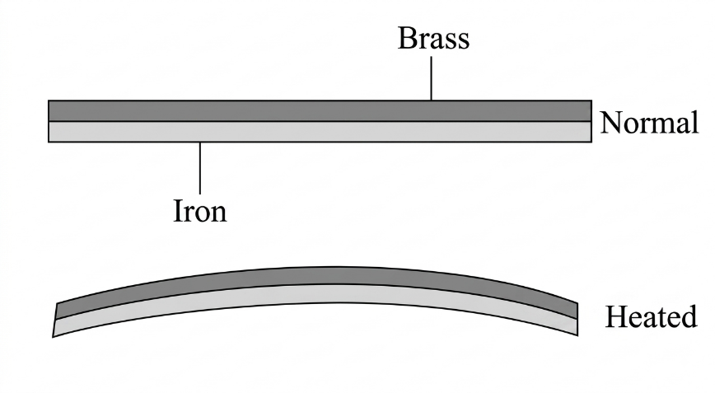
Fig. Bimetallic strip
(b) Data given
Mass of hot water, m₁ = 105 g
Initial temperature, θ_{o} = 75 $℃$
Mass of cold water, m₂ = 215 g
Initial temperature, θ₁ = 15 $℃$
Required to determine the final temperature of water, θ =?
From the principle of conservation of energy
Heat lost by hot water = Heat gained by cold water
But, Q = mcΔθ
m₁ x c_{w} x (θ_{o} – θ) = m₂ x c_{w} x (θ – θ₁)
105 g x (75$℃$ - θ) = 215 g x (θ - 15$℃)$
7875$℃$ - 105θ = 215θ - 3225$℃$
θ = $\frac{11100℃}{320}$ = 34.6875 $℃$
Therefore, the final temperature of water is about 34.69 $℃.$
- (a) The following are the factors that determine the quantity of heat generated by an electric current as suggested by Joule in his law called Joule’s law of heating.
- Amount of current flowing in a conductor: It has been shown that the quantity of heat generated in a conductor is directly proportional to the square of current flowing in a conductor.
H α I²
- Resistance of a conductor: The quantity of heat generated is directly proportional to the resistance of the conductor. This means the higher the resistance of the conductor, the higher the heat is generated.
H α R
- Time taken: The quantity of heat generated in a conductor also depends on how long did the current flow in the conductor. The longer the time, the higher the amount of heat generated.
H α t
By combining these factors, we get H = I²Rt
(b) Data given
V1 = 1.10 V when I1 = 0.20 A
V2 = 1.30 V when I2 = 0.10 A
- Required to determine the internal resistance of the cell, r
From the formula
E = I(R + r)
E =IR + Ir
E = V + Ir
For case I
E = V1 + I1r
E = 1.1 + 0.2r……………….eqn(i)
For case II
E = V2 + I2r
E = 1.3 + 0.1r……………eqn(ii)
Eqn (ii) – eqn (i)
E -E = 1.3 + 0.1r – 1.1 – 0.2r
0 = 0.2 – 0.1r
r = $\frac{0.2}{0.1}$ = 2 Ω
Therefore, the internal resistance of the cell is 2 Ω
- Required to calculate the electromotive force of the cell, E
From eqn (i)
E = 1.1 + 0.2r
E = 1.1 + 0.2 x 2 = 1.5 V
Therefore, the electromotive force of the cell is 1.5 V.
- (a) This is because both Venus and Earth have nearly the same size, mass and density and both terrestrial planets.
(b) (i) Negative effects of volcanic eruption on the earth’s surface
- Damaged landscape: Lava flow alters the original morphology of the land in the area around the volcano.
- Loss of vegetation and wildlife: Volcanic eruption destroys vegetation as the eruption sometimes set the surrounding vegetation on fire. Wild animals and other species are killed by being buried in the lave or being burnt by the forest fire.
(ii)Positive effects of volcanic eruption on the earth’s surface
- Soil fertility: Volcanoes help in soil formation and increase soil fertility by bringing important soil minerals from deep underground onto the earth’s surface.
- Geothermal energy: In areas where magma is closer to the surface, geothermal energy can be harnessed.
- (a) When radiation enters the Wilson cloud chamber, air in the chamber is ionised. The ions produced by the radiation act like condensation centres. The water droplets gather around the ions, thus tracing the path of the ionising radiation. The camera takes photographs ofthe tracks defined by different shapes depending on the type of radiation that entered the chamber. For example, α-particle's track is broad and straight lines, while that of a ẞ-particle appears to be dotted lines tracks. The figure below shows the tracks of α-particle and β-particle in the Wilson cloud chamber.
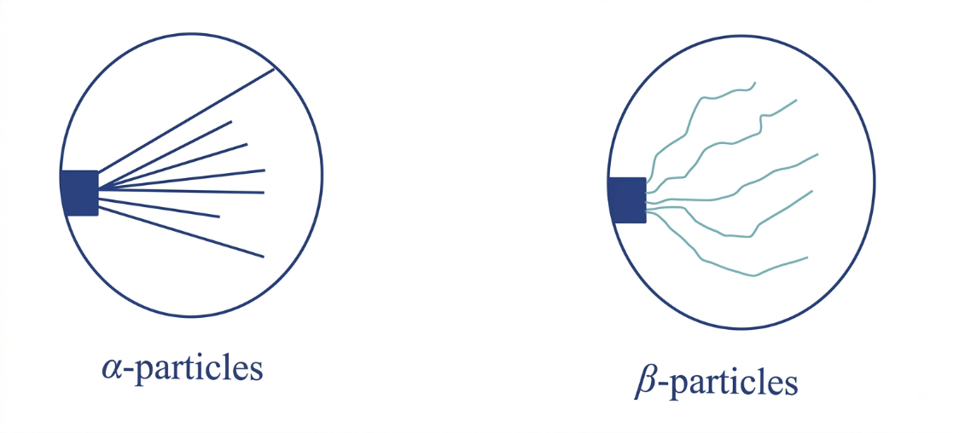
Fig. α-particle and β-particle tracks.
(b) Data given
Initial mass of sample, m_{o} = 20 g
Mass of the sample remained, m = 0.652 g
Time period, T = 150 days
- Required to determine the number of half-lives, n =?
From the formula
m/mo = ($\frac{1}{2}$)^{n}
$\frac{0.652 g}{20 g}$ = ($\frac{1}{2}$)^{n}
By applying log on both sides
log ($\frac{0.652 g}{20 g}$) = n log$\frac{1}{2}$
n = $\frac{\log{\frac{0.652 g}{20 g}}}{\log{\frac{1}{2}}}$ = 4.939
Therefore, the number of half-lives is about 4.939
- Required to determine the half-life of the sample X
n = $\frac{T}{t}$
t = $\frac{T}{n}$ = $\frac{150 days }{4.939}$ = 30.37 days
Therefore, the half-life of the sample X is 30.37 days.
(c) 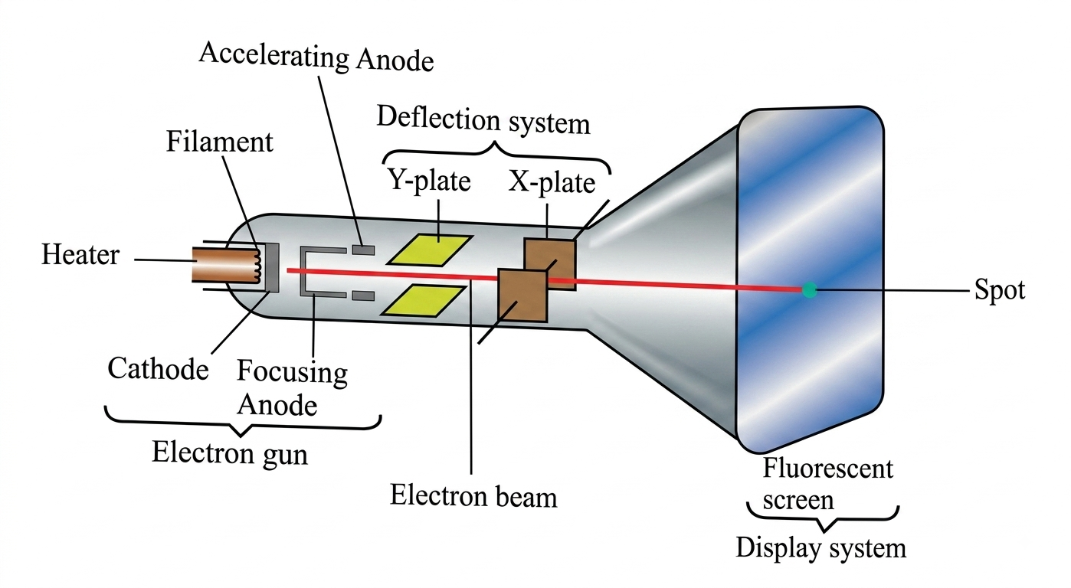
Fig. Cathode Ray Tube.
- (a) Applications of diffraction of waves
- Diffraction is used in measuring the coefficient of thermal expansion, crystallite size and thickness of thin films.
- X-rays diffraction is used to determine the distance between two consecutive atoms of a material.
- Diffraction is used in a hologram to generate a three-dimensional impression of an image.
(b) Data given
When mass (m₁) = 3 g, frequency = f₁
When mass (m₂) = 12 g, frequency = f₂
Required to show how masses affect the frequency
Experiments have shown that f α $\frac{1}{√μ}$
Where μ = $\frac{mass (m)}{length (l)}$
f α $\frac{1}{√\frac{m}{l}}$, since length is constant
f α $\frac{1}{√m}$
f₁$√$m₁ = f₂$√$m₂ = constant
f₁ x $\sqrt{3}g$ = f₂ x $\sqrt{12}g$
f₁ x $√\frac{3 g}{12 g}$ = f₂
f₂ = f₁/2
Therefore, frequency of the vibrating wire decreases when mass increases.
(c) 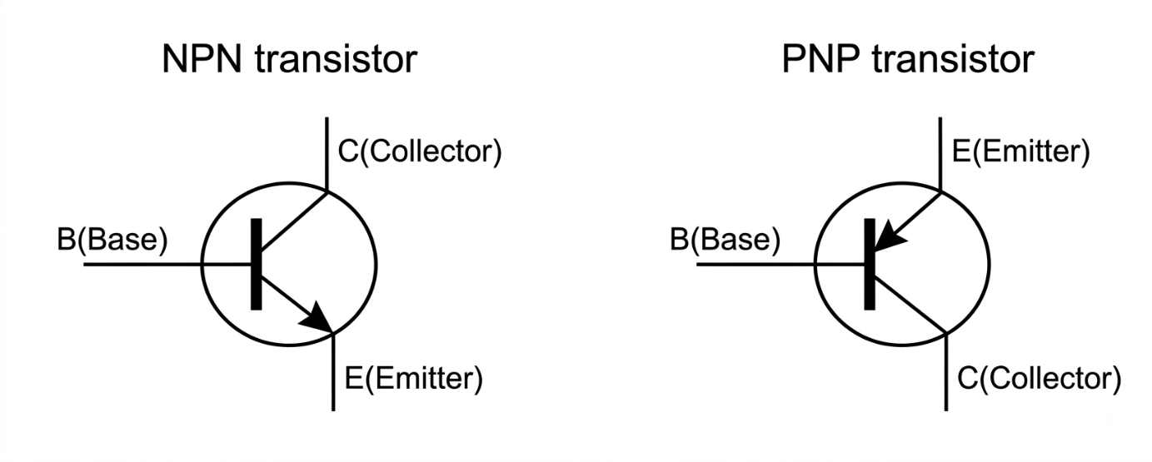
- (a) . When you press the push button, electricity flows through the circuit. This turns the iron core into a temporary electromagnet, which pulls an iron strip and makes a hammer strike the bell. That movement breaks the circuit, stopping the flow of electricity so the magnet turns off. A spring pulls the strip back, touching the contact screw again to restart the loop. This rapid make-and-break cycle repeats over and over to create a continuous ringing sound as shown in the figure below.
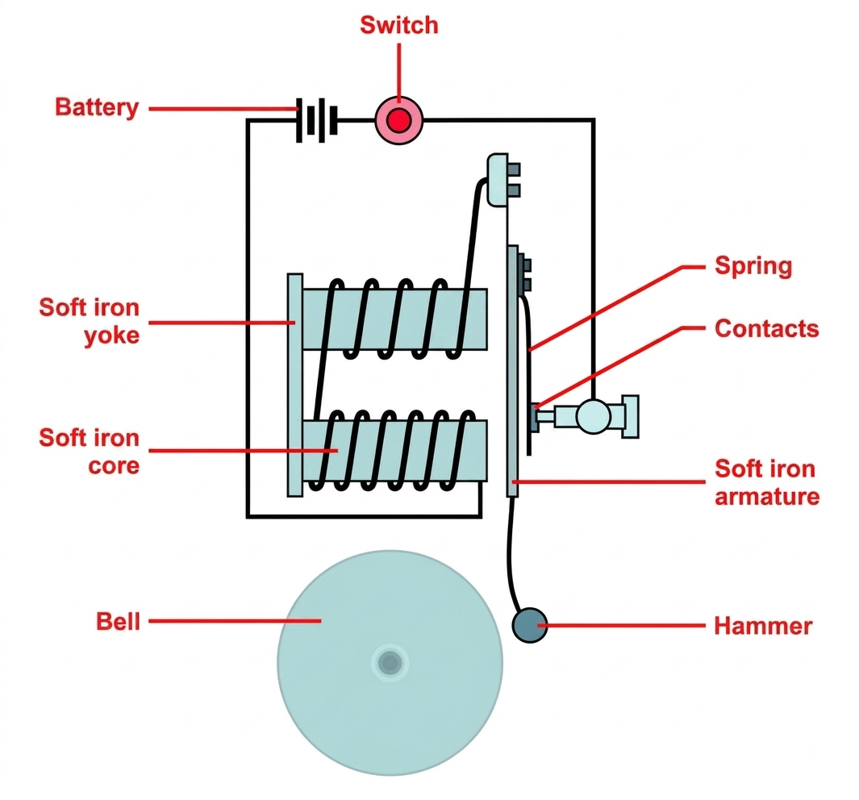
Fig. Electric bell
(b) Consider a figure below
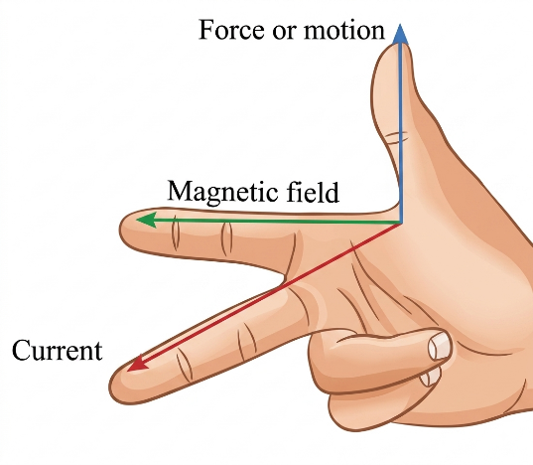
Fig. Fleming’s left-hand rule.
According to Fleming’s left-hand rule which states that “If the thumb, first finger and second finger of the right hand are extended mutually at right angles such that the first finger points towards the direction of the field and the thumb towards the direction of the motion of a conductor relative to the magnet, then the second finger will point towards the direction of induced current”.
- (i) The following are some factors that make efficiency to be less than 100%
- Copper windings: There are losses of power in the primary winding in the form of heat due to the resistance of the primary coil.
- Eddy currents: Eddy currents induced in the iron core of a transformer are part of the input energy and change into heat. This effect is however reduced by laminating the iron core to reduce the eddy currents.
(ii)The following are the factors affecting the magnitude of induced e.m.f of the conductor as suggested by Faraday.
- Strength of the Magnetic Field: A stronger magnetic field provides more flux lines per unit area, leading to a larger change in flux when relative motion occurs
- Speed of relative motion: Moving the conductor faster through the magnetic field (or vice versa) cuts magnetic flux lines at a quicker rate, increasing the induced e.m.f.

