- (a) (i) This is because when a passenger jumps from the boat, he exerts force on boat (action) which in turn the boat pushes the water (backward) and the person (forward). So, in order for a passenger to jump the required distance, he needs to apply more energy in order to compensate the energy wasted when boat pushing water.
(ii) Data given
Mass of bullet, m_{b} = 15 g = 0.015 kg.
Mass of bob, m_{p} = 2.0 kg
Velocity of bob, v_{p} = 0 (at rest)
Velocity of bullet before collision, u_{b} = 600 m/s
Velocity of bullet after collision, v_{b} = $1/2$ x 600 m/s = 300 m/s
Consider the figure below
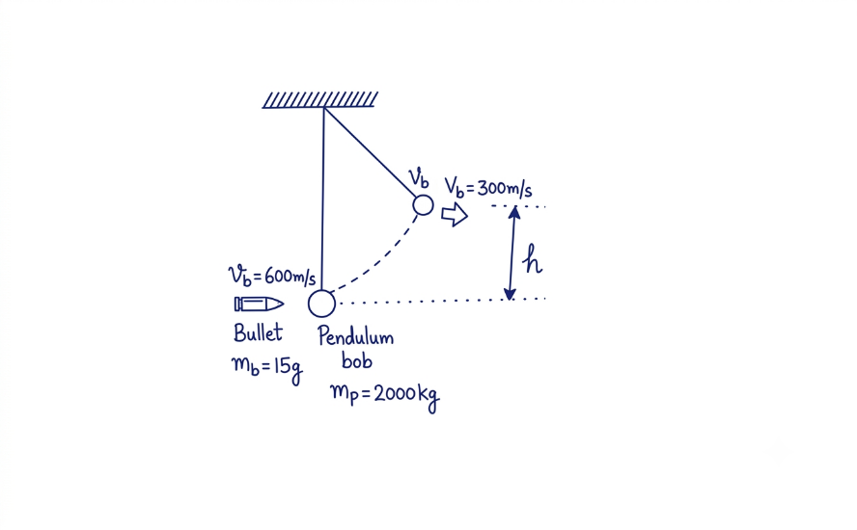
Figure. Collision between pendulum bob and bullet
Required to calculate the maximum height attained by the bob (h)
From the principle of conservation of momentum
Total momentum before collision = Total momentum after collision
m_{b}u_{b} + m_{p}u_{p} = m_{b}v_{b} + m_{p}v_{p}
0.015 kg x 600 m/s + 2.0 kg x 0 m/s = 0.015 kg x 300 m/s + 2.0 kg x v_{p}
9 kgm/s = 4.5 kgm/s + 2.0 kg x v_{p}
$\frac{4.5 kgm/s}{2.0 kg }$ = v_{p}
v_{p} = 2.25 m/s
Also, from the principle of conservation of energy
Kinetic energy of bob = potential energy of the bob at height h
$1/2$m_{p}v_{p}² = m_{p}gh
h = v_{p}²/2g = (2.25 m/s)²/(2 x 9.8 m/s²) = 0.258 m
Therefore, the maximum height attained by the bob is 0.258 m.
(b)Consider a figure below
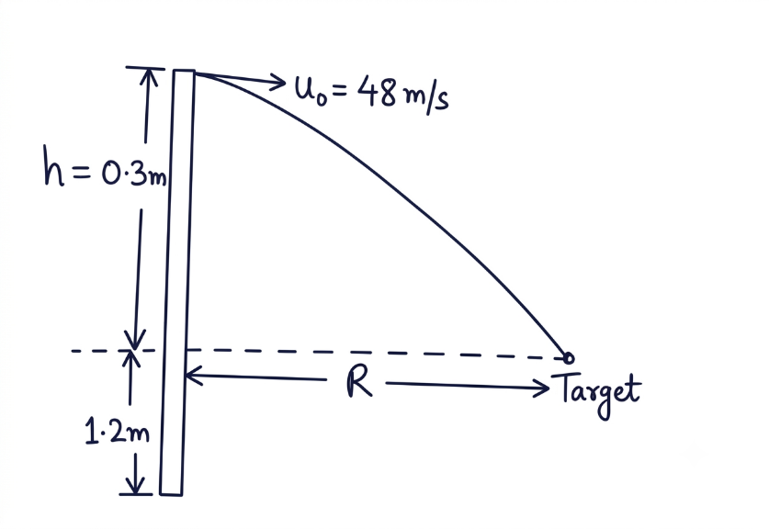
- Required to calculate the time taken to hit the target, t
From the second equation of motion
s = ut +$1/2$at²
s_{y} = -h = u_{y}t + $\frac{1}{2}$a_{y}t²
-h = u sin0$°$t – $1/2$gt²
-0.3 m = - 4,9 m/s² x t²
t = $√\frac{0.3}{4.9}$ s = 0.247 s
Therefore, the time taken to hit the target is 0.247 s.
- Required to calculate the horizontal distance travelled by the arrow, R
From
R = u_{o}cos0$°$t
R= u_{o}t
R = 48 m/s x 0.247 s = 11.856 m
Therefore, the horizontal distance travelled by the arrow is 11.856 m.

Prepared by teacher Alex @Godegode sec

