MTWARA F4 MOCK SOLUTION
- Multiple choice question
(i) | (ii) | (iii) | (iv) | (v) | (vi) | (vii) | (viii) | (ix) | (x)
D | C | A | B | A | D | D | E | A | D

- Matching item question
List A | (i) | (ii) | (iii) | (iv) | (v) | (vi)
List B | F | G | I | H | E | D

- (a) Magnification of an astronomical telescope increases when focal length of an objective lens (f_{o}) is increased when focal length of the eyepiece is kept constant and on the other hand magnification decreases when focal length of the eyepiece lens (f_{e}) is increased when focal length of the objective lens is kept constant.
Magnification of an astronomical telescope = $\frac{fo}{fe}$
(b) Data given
By using Real-is-positive sign convention
Focal length, f = -20 cm = -0.2 m
Object height, ho = 1.6 m
Object width, wo = 2 m
Object distance, u = 6 m
Required to determine the image position and size
From the mirror formula
$\frac{1}{f}$ = $\frac{1}{u}$ + $\frac{1}{v}$
$\frac{1}{f}$ - $\frac{1}{u}$ = $\frac{1}{v}$
v = $\frac{fu}{u-f}$
v = $\frac{-0.2 m x 6 m }{6 m-(-0.2 m)}$
v = -0.1935 m
Also, from
M = $\frac{-v}{u}$ = $\frac{hi}{ho}$ = $\frac{wi}{wo}$
hi =-ho x $\frac{v}{u}$
hi = - 1.6 m x $\frac{(-0.1935 m)}{6 m}$
hi = 0.0516 m
wi = -wo x $\frac{v}{u}$
wi = 2 m x $\frac{_0.1935 m}{6 m}$
wi = 0.0645 m
Therefore, the image is formed at a distance of 0.1935 m behind the mirror (virtual image) and the image size is 0.0645 m wide and 0.0516 m high (diminished).
- (a) The car’s engine is placed over the drive wheel in order to increase the weight (normal force) which increases the friction between the car’s tyres and the ground. This prevents the car from slipping.
(b) Data given
Initial height, h_{o} = 324.00 m
Initial temperature, θ_{o} = 18 $℃$
Final temperature, $θ$₁ = 35 $℃$
Linear expansivity of steel, α = 10.5 x 10⁻⁶/K
New height, h₁ =?
From the formula
α = $\frac{Δh}{ho x Δθ}$
Δh = α x ho x Δθ
But, Δθ = θ₁ – θ_{o} = 35 $℃$ - 18 $℃$ = 17 $℃$= 17 K
Δh = 10.5 x 10⁻⁶/K x 324.00 m x 17 K
Δh = 0.0578 m
h₁ = Δh + h_{o} = 0.0578 m + 324.00 m = 324.0578 m
Therefore, the steel tower will be 324.0578 m high.
- (a) This is because boiling point decreases with a decrease in pressure. When pressure is reduced, the boiling point of water is decreased and hence makes the water start to boil at low temperature than expected one (100$℃$). Additionally, boiling occurs when vapour pressure of water is equal to the external pressure in this case is the air pressure, so once the air pressure is reduced water starts to boil.

(b) Let the distance between a 50 g mass and knife edge be a
Consider a figure below
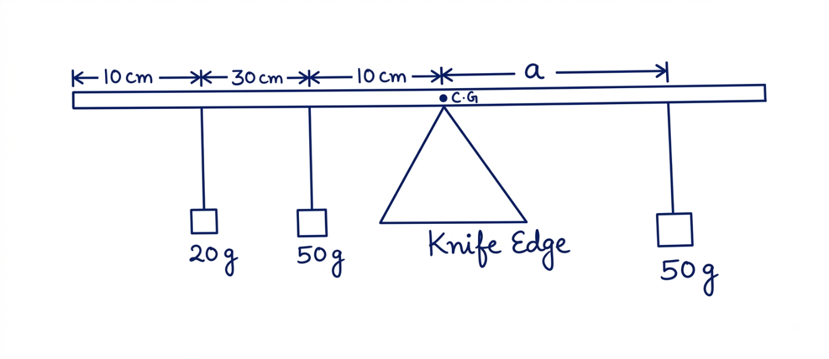
Fig. A uniform metre rule.
From the principle of moment
Sum of clockwise moments = sum of anticlockwise moments
50 g x a = 20 g x 40 cm + 50 g x 10 cm
50 g x a = 1300 gcm
a = $\frac{1300 gcm}{50 g}$ = 26 cm
Distance from 0 mark to a second 50 g mass = 50 cm + 26 cm = 76 cm
Therefore, the 50 g mass must be placed at 76 cm mark.
- (a) (i) A light ball will accelerate more. This is because a ball of small mass (light ball) experience small inertia compared to a heavy one when the same force is applied.
a = $\frac{F}{m}$
(ii) Newton’s second law of motion is the law supporting the above explanation. This law states that” the rate of change of momentum is directly proportional to the force applied and takes place in which the force acts”.
(b) Let the distance between load and fulcrum (Load arm) be La and effort arm be Ea and then consider a figure below
La + Ea = 2.4 m
Ea = 2.4 m – La
Assumption: Lever is very light and hence its weight is negligible

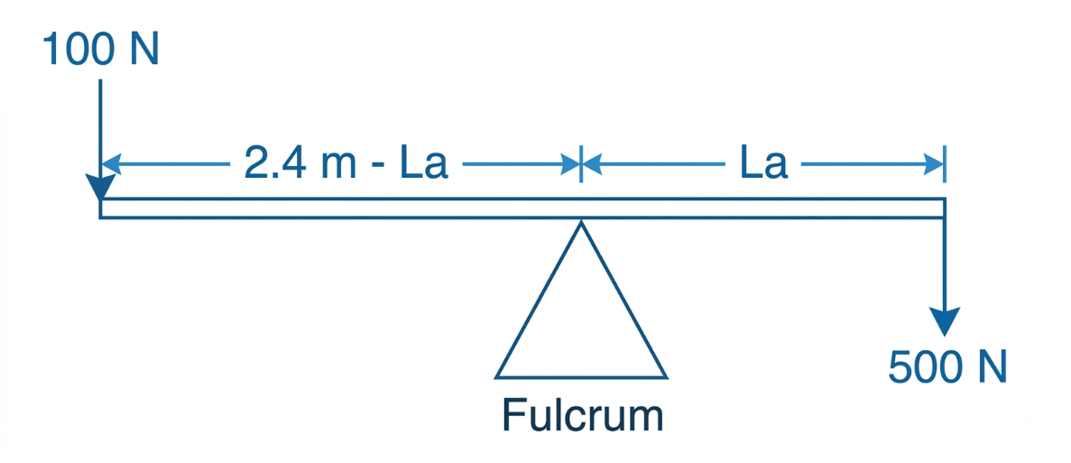
Fig. A lever
From the principle of moment
Sum of clockwise moments = sum of anticlockwise moments
500 N x La = 100 N x (2.4 m – La)
5La = 2.4 m – La
6La = 2.4 m
La = 0.4 m
Therefore, the object should be placed at a distance of 0.4 m from the fulcrum.
- (a) (i) This is because the space between earth and other planet is completely empty (vacuum) and hence no air molecules to transmit the explosion sound. Sound is a mechanical wave which requires material medium in order to propagate.
(ii) Data given
Distance between a person and a cliff, d = 99 cm = 0.99 m
Time taken by an echo to heard, t = 0.6 s
Required to determine the speed of sound in air, v.
From
v = $\frac{2d}{t}$
v = $\frac{2 x 0.99 m}{0.6 s }$ = 3.3 m/s
Therefore, the speed of sound in air is 3.3 m/s.
Note: The speed of sound in air is about 340 m/s (F4 TIE book page 23)
(b) This is because solid particles are held by strong intermolecular force of attraction and hence, they only vibrate at the mean position. Since convection requires the bulky movement of matter, convection cannot occur in solid.
- (a) This is because it is not possible to create an ammeter with zero resistance and a voltmeter with an infinite resistance and hence you can not accurately measure the resistance of a load.
(b) Data given
Total power, P = 5 x 60 W = 300 W = 0.3 kW
Total time taken, t = 3.5 h x 10 = 35 hours
Required to determine the power consumed in kWh
Energy consumed = Power x time
Energy consumed = 0.3 kW x 35 h = 10.5 kWh
Therefore, the energy consumed is 10.5 kWh.
- (a) A cyclist gains speed because the potential energy of his bicycle at the top position was converted to kinetic energy. Additionally, the bicycle will be having high speed (high KE) when it reaches the base of a hill. This is according to the law of conservation of energy.
KE = $\frac{1}{2}$mv² = PE
(b) Data given
Half-life, t = 15.5 hours
Amount of the sample remained undecayed, m = 13.125 g
Time taken for the sample to decay, T = 62.0 hours
- Required to determine the number of half-lives, n
From
Number of half-lives, n = $\frac{T}{t}$
n = $\frac{62.0 h}{15.5 h}$ = 4
Ther number of half-lives is 4
- Required to determine the original amount of the sample, mo.
From
m/m_{o} = ($\frac{1}{2}$)^{n}
m/m_{o} = ($\frac{1}{2}$)⁴ = $\frac{1}{16}$
m_{o} = m x 16 = 13.125 g x 16 = 210 g
Therefore, the original amount of the sample was 210 g.
(c) Production of X-rays Electrons emitted by thermionic emission from the filament experience the potential difference and are accelerated towards the anode. When they hit the anode, the electrons are stopped and thereby transfer their energy to the electrons of the anode material. The anode material undergoes the re-arrangement of electrons resulting to the emission of X-rays. The figure below shows how x-rays are produced in the x-ray tube.
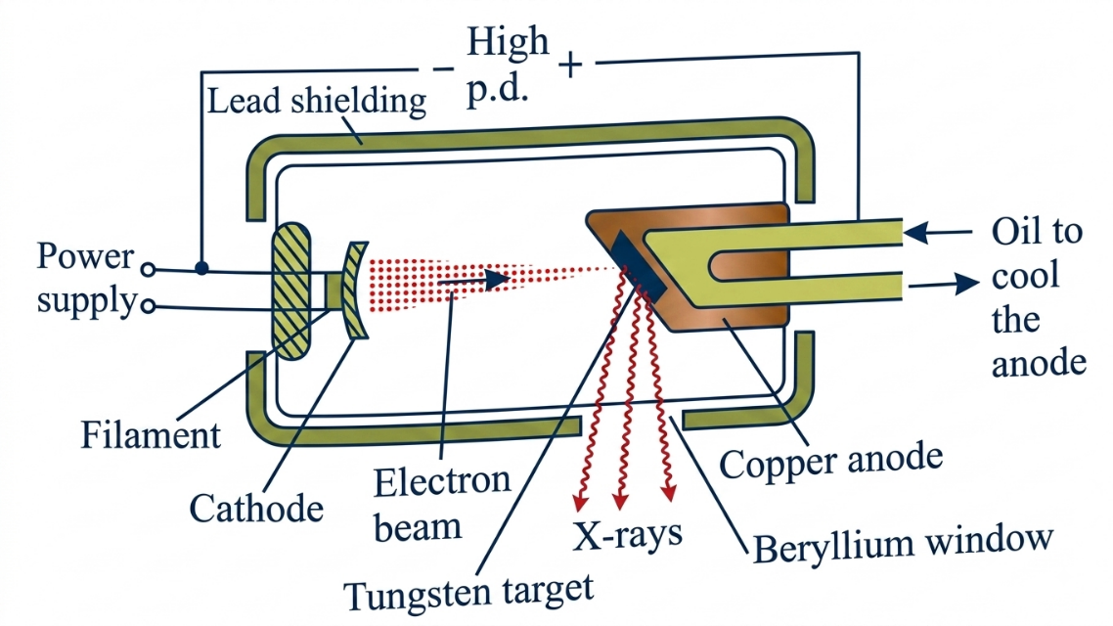
Fig. X-ray tube
- (a) This is because the length of the string is affected by change in temperature. During the day the temperature increases makes the string longer (length increases) by undergoing thermal expansion. Since frequency of the vibrating string depends on the length of the string, the frequency decreases.
f α $\frac{1}{l}$
(b) Data given
f₁ = 400 Hz when T₁ = 2N
Required to calculate;
- The frequency (f₂) when T₂ = 8 N
Since f α $√T$
f₂/f₁ = $√$(T₂/T₁)
f₂ = f₁ x $√$(T₂/T₁) =400 Hz x $√\frac{8 Hz}{2 Hz}$ = 800 Hz
The new frequency will be 800 Hz when tension is 8 N.
- The tension (T₂) needed to produce a note of frequency (f₂) of 600 Hz.
T₂ = T₁ x (f₂/f₁)2
T₂ = 2 N x ($\frac{600 Hz}{400 Hz}$)2
T₂ = 4.5 N.
Therefore, a tension of 4.5 N is needed to produce a note of frequency of 600 Hz.
(c) (i) I_{E} = I_{B} + I_{C}
(ii) Data given
I_{C} = 3 mA
I_{E} = 3.3 mA
Required to calculate I_{B} and current gain (β) for CE amplifier configuration
From
I_{E} = I_{B} + I_{C}
3.3 mA = I_{B} + 3 mA
I_{B} = 3.3 mA – 3 mA = 0.3 mA
Also, β = I_{C}/I_{B}
β = $\frac{3 mA}{0.3 mA }$
β = 10
Therefore, the base current and current gain are 0.3 mA and 10, respectively.
Note: The current gain for CE ranges from 20 to 500 (F4 TIE book page 151).
- (a) Consider a figure below
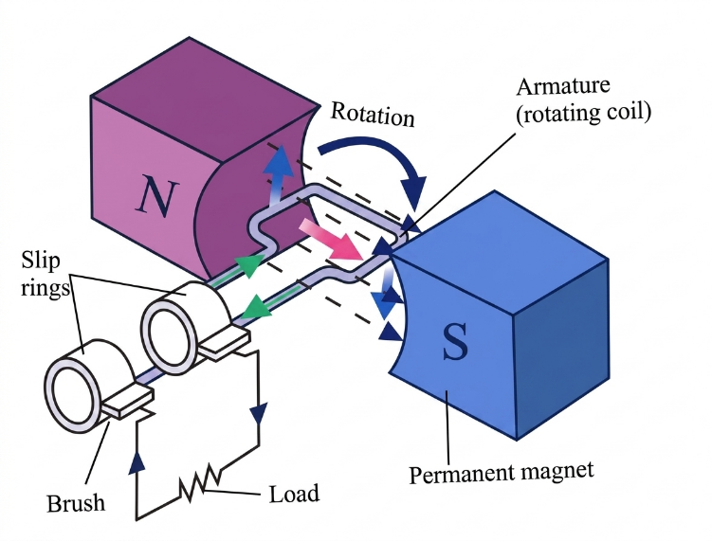
Fig. An ac generator
An a.c generator is designed based on Faraday's Law of electromagnetic induction. It works by rotating a coil at a constant rate in a magnetic field to induce an oscillating e.m.f.
When the coil is vertical, no cutting of the magnetic lines of force takes place. The rate of change of magnetic flux is zero, thus, no e.m.f is induced in the coil.
When the coil is horizontal, the rate of change of magnetic flux is maximum and hence the motion of the coil results to an induced e.m.f in the coil.
(b) (i) No current will be transmitted when direct current is used because transformers work on alternating current (a.c) only.
(ii) There will be a high-power loss due to heat. According to Joule’s law of heating, heat produced in a conductor increases with amount of current passing in a conductor.
(c) Data given
For secondary coil
N_{s} = 10,000 turns
For primary coil
N_{p} = 100 turns
V_{p} = 12.0 V
Ip = 5.0 A
- The transformer is a step-up transformer because the secondary coil has many numbers of turns (10,000) compared to the primary coil which has only 100 turns.
- Required to calculate the voltage across the secondary coil (V_{s})
From the transformer equation
V_{s}/V_{p} = N_{s}/N_{p}
V_{s} = V_{p} x (N_{s}/N_{p})
V_{s} = 12.0 V x $\frac{10000 turns }{100 turns }$ = 1200 V
Therefore, the voltage across the secondary coil is 1200 V.
- Required to calculate the current in the secondary coil (I_{s}) when efficiency of the transformer (η) is 90%
From
η = $\frac{power output }{power input}$ x 100%
η = (I_{s} x V_{s})/(I_{p} x V_{s}) x 100%
90% = (I_{s} x 1200 V)/(5.0 A x 12.0 V) x 100%
0.9A = 20 x I_{s}
I_{s} = 0.045 A
Therefore, the current in the secondary coil is 0.045 A.

