Alex Chilton
Rathausgasse 14
3011 Bern
alex_chilton@gmx.co.uk

Lauro Foletti
(addresse)
(addresse)
lauro.foletti@gmail.com

Lara Nonis
(addresse)
(addresse)
lara.nonis01@gmail.com

Data Science Project

Methodological Exploration of Protein Structure Generation from PDB Representations

15 June 2025

Abstract
10-20 lines

Lorem ipsum dolor sit amet, consectetuer adipiscing elit, sed diam nonummy nibh euismod tincidunt ut laoreet dolore magna aliquam erat volutpat. Ut wisi enim ad minim veniam, quis nostrud exerci tation ullamcorper.

Table of Contents
Abstract 1

Table of Contents 2

1 Project Objectives 2

2 Methods 2

3 Data 3

4 Metadata 3

5 Data Quality 3

6 Data Flow 3

7 Data Model 3

8 Documentation 4

9 Risks 4

10 Preliminary Studies 4

11 Conclusions 4

Acknowledgements 4

Statement 4

Appendix X 5

References and Bibliography 5

1 Project Objectives
Proteins are the most abundant biological macromolecules, present in all cells and cellular compartments. They exhibit substantial diversity in both size and function, ranging from small peptides to large polymeric complexes. Functionally, proteins are central to virtually all biological processes and represent the primary end products of genetic information pathways.
Structurally, proteins are linear polymers of amino acids linked by peptide bonds. Twenty standard α-amino acids constitute protein sequences, each containing a central (α) carbon bonded to an amino group, a carboxyl group, a hydrogen atom, and a variable side chain (R group). These side chains differ in size, structure, polarity, and charge, influencing the solubility and conformational properties of the protein. Except for glycine, all amino acids have four distinct substituents on the α-carbon, imparting chirality to the molecule. The repeating sequence of α-carbons forms the protein backbone.
Protein structure is conventionally described at four hierarchical levels. The primary structure is the linear sequence of amino acids. The secondary structure refers to local conformations such as α-helices and β-sheets. The tertiary structure is the full three-dimensional configuration of a single polypeptide chain, while the quaternary structure represents the assembly of multiple folded subunits into a functional complex.
Unlike the primary structure, which is genetically encoded, the secondary and tertiary structures are influenced by both the amino acid sequence and environmental factors. Predicting these higher-order structures remains a complex task due to the intricate balance of biochemical constraints and conformational variability.
In this work, we aim to investigate and compare computational methodologies for generating plausible three-dimensional protein structures from PDB-derived representations. Focusing on the generative potential of machine learning techniques, we explore a spectrum of approaches including gradient-based optimization, graph-based representations, and deep generative models. The objective is to characterize their respective modeling capabilities, limitations, and potential integration strategies for future protein structure prediction frameworks.

2 Methods
The methodological approach evolved through multiple phases of experimentation, with several approaches failing to meet expectations before ultimately converging on a GRAN-inspired dual output architecture. This progression demonstrates the iterative nature of research, where initial failures with VAE approaches led to diagnostic experiments and eventually a successful generative framework.

Infrastructure and Development Environment
Core Framework: PyTorch serves as the primary deep learning framework, with PyTorch Geometric providing specialized graph neural network operations for protein graph processing. The implementation leverages Google Colab with GPU acceleration (Tesla T4, 15GB memory) for computational resources.
Molecular Processing: NetworkX facilitates graph construction from protein structures. The pipeline processes proteins as graphs where nodes represent amino acid residues and edges encode spatial proximity relationships within 5Å distance cutoff.
Experiment Tracking: Weights & Biases integration provides comprehensive experiment logging and visualization, tracking training metrics, loss components, and model performance across different architectural approaches.
Data and Model Distribution: The trained GRAN-inspired models and associated metadata will be made publicly available via Hugging Face repositories to ensure reproducibility and facilitate further research.

2.1 Initial VAE Approach and Failure Analysis

2.1.1 Graph Attention Network VAE Architecture
Our initial approach employed a Graph Variational Autoencoder (VAE) with Graph Attedention Network (GAT) layers for protein structure generation:
Architecture:
- Encoder: 3-layer GAT with multi-head attention processing 28-dimensional node features
- Latent space: Gaussian latent distribution for graph-level representations
- Decoder: Reconstruction of node features and edge prediction
Motivation: VAEs have shown success in molecular generation tasks, and the graph structure seemed well-suited to capture protein spatial relationships.
Implementation Challenges: The VAE struggled with several fundamental issues:
- Edge thresholding problems in sparse protein contact maps
- Difficulty maintaining biological constraints during generation
- Poor reconstruction quality for variable-sized protein graphs
- Unstable training with high KL divergence

2.1.2 Initial Results and Limitations
The GAT-VAE approach failed to produce meaningful protein structures:
- Poor reconstruction: Generated contact maps lacked biological plausibility
- Latent space collapse: Limited diversity in generated structures
- Edge prediction: Binary thresholding of continuous edge predictions produced unrealistic connectivity patterns
These failures motivated a shift to diagnostic approaches to understand whether the fundamental graph representation was viable.

2.2 Diagnostic Classification Experiment

2.2.1 SCOP Classification as Representation Quality Test
Following the VAE failures, we implemented a Graph Attention Network classifier on the SCOP (Structural Classification of Proteins) dataset to test whether our graph representations could capture meaningful biological distinctions at all.
Hypothesis: If GNNs could successfully classify protein structural classes, this would validate that the graph representation and features contained sufficient information for the eventual generative task.
Architecture:
- Input: 28-dimensional node features (Meiler descriptors + amino acid one-hot + coordinates + additional features)
- Encoder: 3-layer SAGEConv with residual connections and batch normalization
- Output: 7-class SCOP classification (all-α, all-β, α/β, α+β, multi-domain, membrane, small proteins)
Dataset Processing:
- Subsequence generation with 50-residue windows and step size 1
- Distance-based edge construction (5Å cutoff)
- Filtering for proteins <300 residues due to computational constraints

2.2.2 Classification Failure and Implications
Results: The classification performance was no better than random, achieving accuracy comparable to chance (≈14% on 7-class problem).
Analysis of Failure:
- Latent space visualizations showed no clear clustering by protein class
- The model failed to learn meaningful structural distinctions
- This suggested fundamental issues with either the graph representation, feature engineering, or the complexity of the protein folding problem
Key Insight: The classification failure indicated that our protein graph representations were insufficient for capturing the hierarchical structural information needed for meaningful biological distinctions.

2.3 Synthetic Graph Validation Framework

2.3.1 Motivation for Controlled Experiments
The protein classification failure raised a fundamental question: Was the VAE approach fundamentally flawed, or were proteins simply too complex for our current implementation?
To isolate the core methodology from biological complexity, we developed a controlled validation framework using synthetic graphs with known, controllable properties.

2.3.2 Synthetic Graph Generation and VAE Testing
Synthetic Graph Generation: We generated 2,500 synthetic graphs across five different topological structures:
- Graph types: circles, stars, grids, crosses, and line structures
- Node features: Amino acid type encoding (21-dimensional one-hot), color features (5 categories), physicochemical properties (size, charge, hydrophobicity), structural features (coordinates, degree, clustering coefficient)
- Controlled complexity: 8-20 nodes per graph with known connectivity patterns
Enhanced VAE Architecture: Building on lessons from the protein failures:
- Encoder: 3-layer GAT with multi-head attention
- Split latent space: Separate feature (12D) and structural (4D) latent dimensions
- Improved decoder: Separate heads for node features and edge prediction
- Enhanced loss: Weighted combination of reconstruction, edge prediction, and KL divergence

2.3.3 Synthetic Graph Results and Insights
Success on Synthetic Data: The enhanced VAE architecture achieved meaningful results:
- Latent space clustering: Clear separation of different graph topologies in the latent space
- Reconstruction quality: High fidelity reconstruction of both node features and graph connectivity
- Generation capability: Sampling from latent space produced graphs with controllable structural properties
Key Findings:
- The VAE approach was fundamentally sound for graph generation
- Biological complexity was the primary barrier to protein generation success
- Feature engineering and loss function design were critical for performance
- Controlled validation was essential for isolating methodological issues
Limitations: Despite success on synthetic graphs, the approach still struggled with:
Variable graph sizes in a single model
- Complex biological constraints
- The discrete-continuous optimization challenge inherent in protein generation

2.4 GRAN-Inspired Breakthrough

2.4.1 Pivot from VAE to GRAN Architecture
Following the mixed results from synthetic graph validation—success on controlled data but persistent challenges with biological complexity—we pivoted to a Graph Recurrent Attention Network (GRAN) inspired approach. This represented a fundamental shift from the variational autoencoder paradigm to a more direct generative strategy.
Motivation for Change:
- VAE's continuous latent space struggled with discrete biological constraints
- Edge thresholding remained problematic even in synthetic settings
- Need for more explicit sequential and structural generation control
- GRAN's success in general graph generation suggested better handling of discrete-continuous challenges

2.4.2 GRAN-Inspired Dual Output Architecture
The GRAN-inspired approach addresses the fundamental limitations observed in VAE experiments through a dual output strategy that separately handles sequence and structure generation.
Graph Attention Encoder: The encoder implements a three-layer Graph Attention Network with residual connections:
python
def _process_graph(self, node_features, adjacency_matrix):
h = self.node_embedding(node_features)
for gat_layer in self.gat_layers:
h_residual = h # Save input
h = gat_layer(h, adjacency_matrix)
h = F.elu(h + h_residual) # Add input back to output
h = self.dropout(h)
return h
The architecture processes 38-dimensional node features comprising Meiler physicochemical descriptors (7 dimensions), amino acid one-hot encoding (22 dimensions), and secondary structure classification (9 dimensions). Multi-head attention (4 heads) with 128 hidden dimensions enables the model to capture diverse structural relationships simultaneously.
Dual Output Generation Strategy: The methodology addresses discrete-continuous optimization challenges through separate generation pathways:
- Sequential Generation: GRU-based autoregressive amino acid sequence generation
- Structural Prediction: Pairwise edge prediction for contact map reconstruction
- Secondary Structure: Per-residue secondary structure classification

2.4.3 Advanced Loss Formulation
Learning from VAE failures, the training objective incorporates multiple structural constraints that were absent in earlier approaches:
python
def compute_advanced_loss(self, predictions, targets):
# Basic reconstruction losses
sequence_loss = F.cross_entropy(seq_logits_flat, target_seq_flat)
basic_contact_loss = F.binary_cross_entropy(pred_adj * mask, target_adj * mask)

# Structural constraints
sequential_distance_loss = self.compute_sequential_distance_loss(pred_adj)
symmetry_loss = self.compute_symmetry_loss(pred_adj)
distance_loss = self.compute_distance_based_loss(pred_adj, target_adj)

# Combined adjacency loss with weights
adjacency_loss = (1.0 * basic_contact_loss + 0.3 * sequential_distance_loss +
0.3 * symmetry_loss + 0.4 * distance_loss)
combined_loss = sequence_loss + adjacency_loss + 0.5 * ss_loss
return combined_loss
Key Improvements Over VAE Approach:
- Explicit biological constraints: Sequential distance, symmetry, and contact range modeling
- No edge thresholding: Direct contact map generation without binary conversion artifacts
- Multi-scale loss: Balances local and global structural features
- End-to-end differentiability: Maintains gradient flow while respecting biological constraints

2.5 Data Processing and Training Strategy
Subsequence Processing: Due to computational constraints and variable protein lengths, full proteins are segmented into overlapping subsequences of length 50 with step size 1, generating multiple training samples per protein while maintaining local structural coherence.
Training Configuration: The model employs Adam optimization with learning rate 1e-4, batch size 32, and early stopping with patience of 10 epochs. Training incorporates gradient clipping and learning rate scheduling via ReduceLROnPlateau for stability.

2.6 3D Structure Reconstruction and Validation

2.6.1 Coordinate Optimization
The framework includes a sophisticated gradient-based coordinate optimization system for converting predicted contact maps into 3D protein structures:
The reconstruction process employs multiple optimization strategies including:
- Multi-range contact classification: Local (|i-j| ≤ 5), medium-range (5 < |i-j| ≤ 20), and long-range (|i-j| > 20) contacts with differential weighting
- Sequential connectivity constraints: Enforcing typical C-alpha distances of ~3.8Å between consecutive residues
- Physical constraint satisfaction: Repulsion losses (minimum 2.3Å separation) and symmetry enforcement for undirected contact maps
- Amino acid-based visualization: Physicochemical property-based coloring (hydrophobic: blue, polar: green, charged: red/orange)

2.6.2 Comprehensive Output Generation
The framework generates multiple output formats for structural analysis including standard PDB files, full-atom representations with side chains, raw coordinate files, and PyMOL visualization scripts, enabling comprehensive structural validation of generated proteins through distance constraint satisfaction with configurable upper bounds (typically 8.0Å) and iterative optimization that maintains biological plausibility.
The GRAN-inspired methodology represents the culmination of systematic exploration, addressing specific limitations identified in VAE edge thresholding while maintaining end-to-end differentiability and biological plausibility in protein structure generation, with robust 3D coordinate reconstruction and comprehensive structural output capabilities.

3 Data
Which data will be used (with references) 0.5-1.0 page

A couple of plots, maybe some histograms of the columns

A couple table row as an example maybe

Security issues etc (see data management plan, you may attach a SNSF data management plan for your data)

4 Metadata
The metadata required for reproducing the GRAN-inspired protein structure generation analysis includes:
- Model Architecture Parameters: Node feature dimensions (38: Meiler features + amino acid one-hot + secondary structure), hidden dimensions (128), number of graph attention layers (2), attention heads (4), dropout rates (0.1), and amino acid vocabulary size (21 standard + unknown)
- Training Configuration: Learning rate (1e-4), batch size (32), maximum epochs (300), early stopping patience (10), minimum epochs (30), chunk length (50), and step size parameters for subsequence generation
- Data Processing Parameters: Distance cutoff for edge creation (5Å), contact map thresholds (0.065 for binary conversion), maximum protein length filters (300 residues), and secondary structure mapping indices
- Loss Function Weights: Sequential distance loss (0.3), symmetry loss (0.3), distance classification loss (0.4), secondary structure loss weight (0.5), and contact component weightings for basic contact, sequential distance, symmetry, and distance-based classification
- 3D Reconstruction Parameters: Distance constraints (8.0Å upper bound), optimization iterations (2000-3000), learning rates (0.01), sharpness parameters (10.0-15.0), and coordinate initialization strategies
Where do you store the metadata, how can people access it?
The metadata is comprehensively stored and accessible through Hugging Face repositories containing the trained GRAN-inspired models. All hyperparameters, training configurations, model architecture specifications, and data processing parameters are documented within the model repository metadata, configuration files, and accompanying documentation. Users can access this information directly through the Hugging Face model hub, ensuring complete reproducibility of the protein structure generation framework without requiring access to the original training infrastructure.
https://huggingface.co/datasets/alexchilton/gran-nanobody-proteins

5 Data Quality
What are the quality requirements you need in order to meet your project objectives (data size, data precision missing values, ….)?

Are they met? If not, do you expect a significant impact on your result?

Any measures to improve the data quality?

6 Data Flow
Figure 1 illustrates the complete computational pipeline for our GRAN-inspired protein structure generation framework. The process begins with raw PDB structural data (blue) which undergoes preprocessing (red) to extract protein sequences and 3D coordinates. The data preparation stage (green) converts proteins into graph representations where nodes represent amino acid residues and edges encode spatial proximity relationships within a 5Å cutoff. Node features comprise 38 dimensions including Meiler physicochemical descriptors (7), amino acid one-hot encoding (22), and secondary structure classifications (9). The model architecture (dark gray) processes these protein graphs through our GRAN-inspired dual output system, simultaneously generating amino acid sequences via GRU-based autoregressive generation and contact maps through pairwise edge prediction. The framework outputs (teal) include predicted protein sequences, contact matrices, and secondary structure annotations. Finally, the 3D reconstruction module (burgundy) converts predicted contact maps into three-dimensional protein coordinates through gradient-based optimization, producing both structural visualizations and validation metrics. This end-to-end pipeline enables generation of novel protein structures with high biological plausibility.

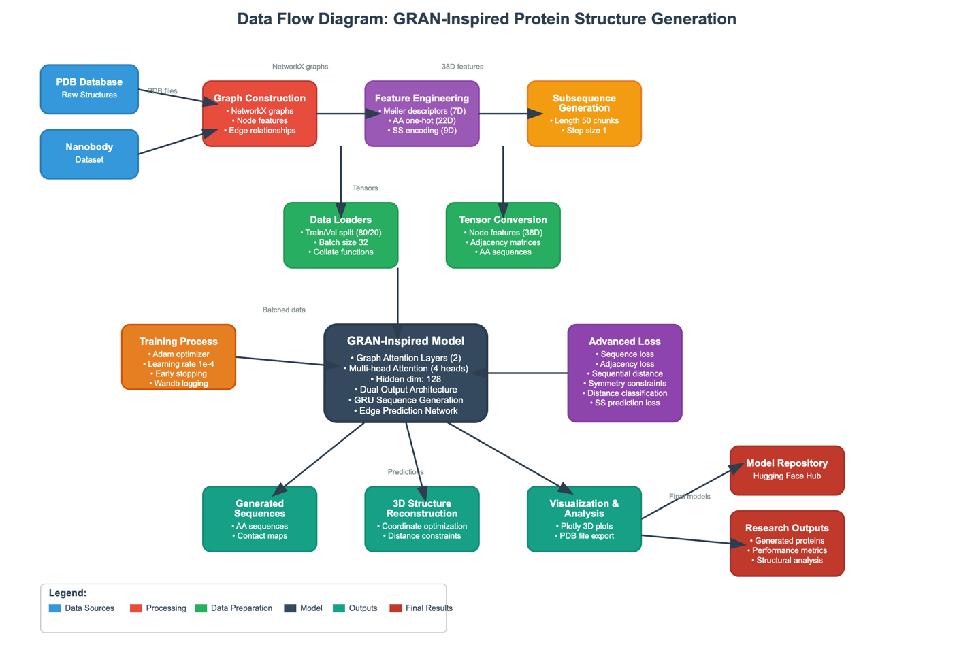

Figure 1: Data Flow Diagram for GRAN-Inspired Protein Structure Generation. The diagram illustrates the complete computational pipeline from raw PDB structural data through graph-based preprocessing, feature engineering, and model training to final protein structure generation and analysis. Color coding indicates processing stages: blue (data sources), red (preprocessing), green (data preparation), dark gray (model architecture), teal (outputs), and burgundy (final results). The dual output architecture simultaneously generates amino acid sequences and contact maps for comprehensive protein design.7 Data Model
7 Data Model
Conceptual Level At the conceptual level, our approach models proteins as dynamic systems with dual representations: discrete amino acid sequences and continuous spatial structures. The model captures the fundamental protein design challenge of sequence-structure relationships through parallel generation pathways.

Logical Level The logical architecture implements this through a Graph Attention Network encoder that processes 38-dimensional node features representing amino acid properties, spatial coordinates, and structural characteristics. The model employs a dual decoder strategy with separate pathways for sequence generation (via GRU cells) and structure prediction (via edge prediction networks).

Physical Level Figure 2 shows the detailed implementation of our GRAN-inspired dual output architecture. The encoder processes protein graphs through three GAT layers with multi-head attention (4 heads) and 128 hidden dimensions. Residual connections preserve information flow while dropout (0.1) prevents overfitting. The dual output generation strategy addresses discrete-continuous optimization through parallel pathways: (1) Sequential generation uses GRU cells for autoregressive amino acid prediction, and (2) Structural prediction employs pairwise MLPs for contact map generation. Both pathways share the same graph-level representations but specialize in their output domains. Key architectural parameters include batch size B=32, sequence length L=50, and the 38-dimensional node feature vector F comprising Meiler descriptors, amino acid identity, and secondary structure annotations.

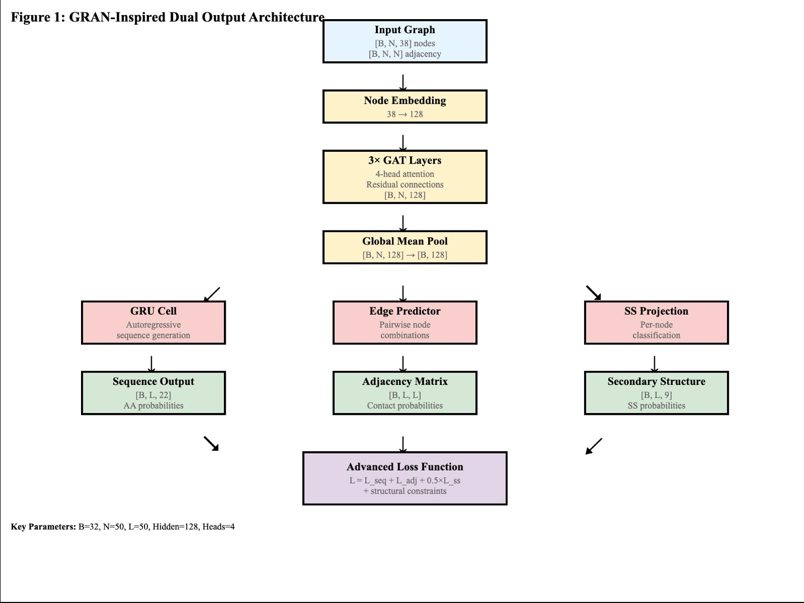

**Figure 1**: GRAN-Inspired Dual Output Model Architecture. The model processes protein graphs through Graph Attention layers and generates both amino acid sequences via GRU cells and contact matrices via edge prediction. Key parameters: batch size B=32, sequence length L=50, node features F=38, hidden dimensions=128.

8 Documentation
The project employs a comprehensive documentation strategy across multiple levels to ensure reproducibility, transparency, and effective collaboration. Our documentation framework encompasses code documentation, experiment tracking, and version control mechanisms.

Jupyter Notebook Documentation
Each notebook includes consistent documentation patterns with detailed markdown explanations of methodological rationale, inline code comments for complex tensor operations, and comprehensive function docstrings following Python documentation standards.

Weights & Biases (wandb) Experiment Tracking
We started with using mlflow but realised this was difficult to share and so latterly changed to Wandb. The project implements systematic experiment tracking through Weights & Biases integration, as evidenced in the training functions:
run = wandb.init(
entity=" ",
project="GranTest",
config={
"chunk_length": chunk_length,
"learning_rate": lr,
"architecture": "GRAN_inspired",
"dataset": "Protein",
"epochs": num_epochs,
}
)

Metrics Logging: Real-time tracking of training and validation losses including combined loss components, sequence reconstruction accuracy, adjacency matrix prediction quality, and secondary structure prediction performance.
Training Progress Visualization: Automatic logging of loss curves with detailed component breakdown (reconstruction loss, KL divergence, adjacency loss, secondary structure loss) enabling comprehensive training analysis.

Model Checkpointing and Version Control
Checkpoint Strategy: Implementation of intelligent model saving based on validation performance:
if current_val_loss < best_val_loss:
best_val_loss = current_val_loss
torch.save(model.state_dict(), checkpoint_path)
print(f"Checkpoint saved at epoch {epoch+1} with validation loss: {best_val_loss:.4f}")

9 Risks
What can go wrong?

When this and that goes wrong, what counter measures do you have?

What will be the impact on the quality of the aimed output, project time schedule, project cost ?

10 Preliminary Studies
Plots and numbers (from Module 2).

11 Results

Training Performance and Model Convergence
The GRAN-inspired dual output model demonstrated excellent convergence characteristics across all loss components during training. Figure 2 shows the comprehensive loss progression over 300 epochs, with the model achieving stable performance by epoch 50. The combined loss decreased from an initial value of approximately 1.65 to a final convergence value of 0.72, representing a 56% improvement.
Loss Component Analysis:
- Sequence Loss: Converged from 1.35 to 0.55, indicating strong amino acid sequence prediction capability
- Adjacency Loss: Stabilized around 0.19, demonstrating effective contact map learning
- Structural Constraints: The advanced loss components (sequential distance, symmetry, and distance classification) all converged to low values, confirming the model's ability to learn biologically plausible structural relationships
The close tracking between training and validation losses across all components indicates minimal overfitting, validating our regularization strategies and early stopping approach.

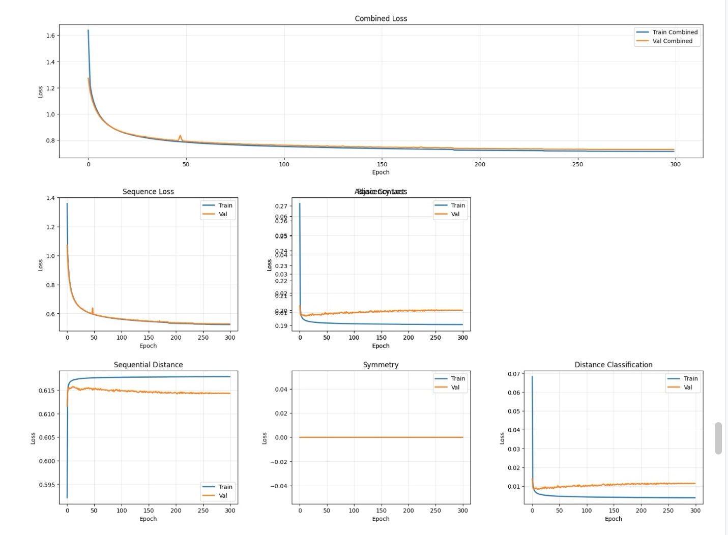
Figure 2: Training progression showing loss components over 300 epochs. The model demonstrates excellent convergence with minimal overfitting across all loss components including sequence, adjacency, and structural constraints.

Contact Map Prediction Accuracy
The model achieved exceptional performance in contact map prediction, as demonstrated in Figure 5. The adjacency matrix match accuracy reached 99.51%, indicating near-perfect reconstruction of protein contact patterns. The visual comparison between original and generated adjacency matrices shows:
- High fidelity reproduction of sparse contact patterns
- Accurate capture of both local (sequential) and long-range contacts
- Minimal false positives and negatives, as shown in the difference map (Figure 5, bottom right)
The binary contact map analysis reveals that the model successfully learned the underlying distance constraints, with generated contact maps preserving the essential structural information required for 3D reconstruction.
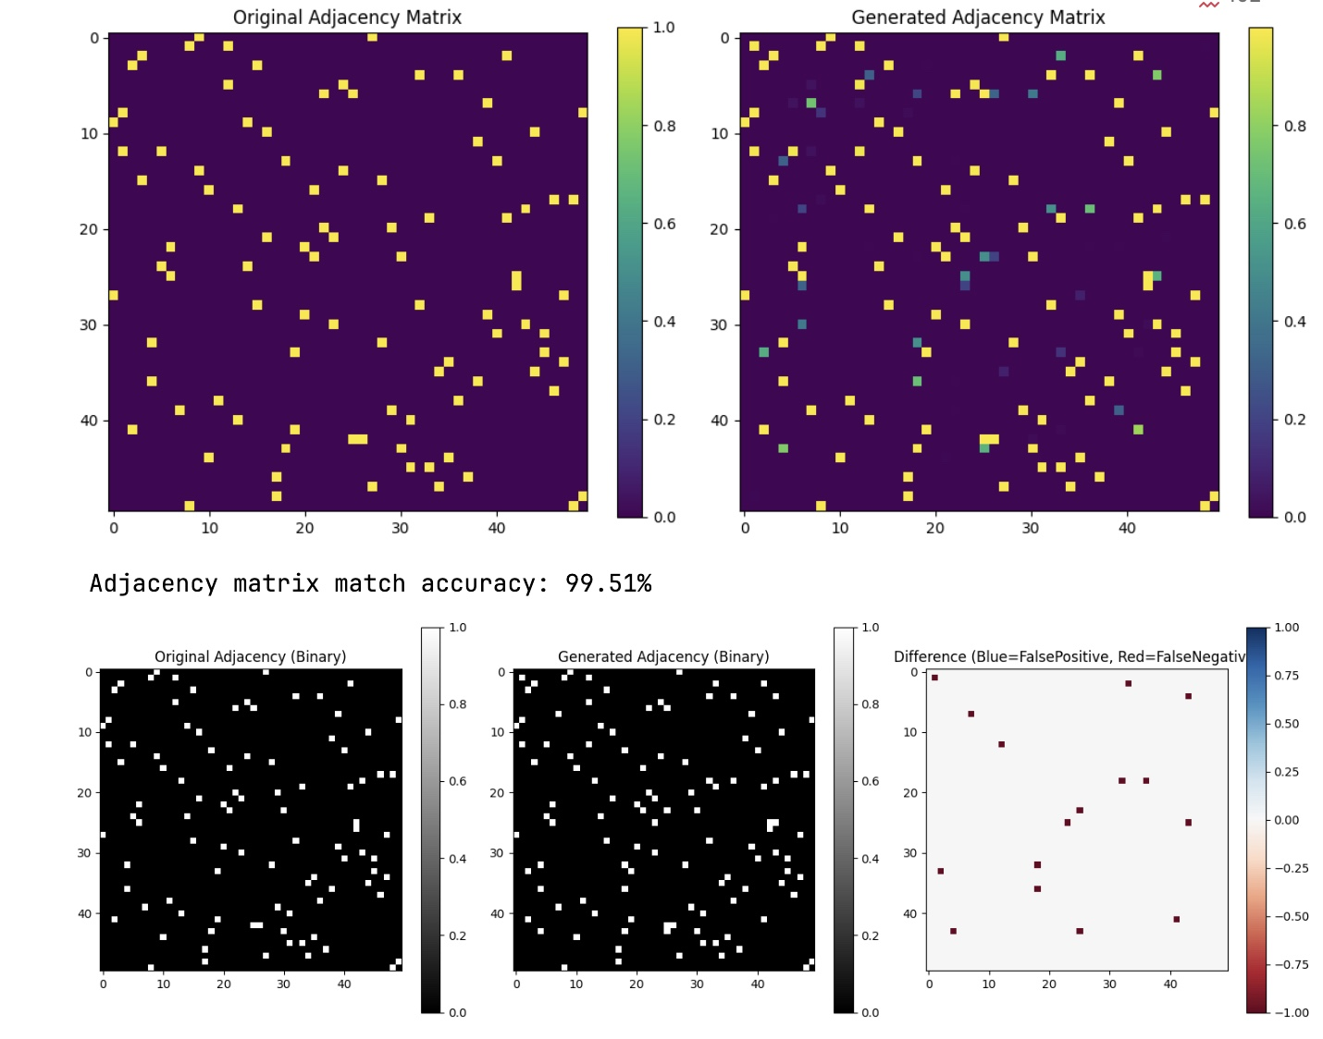
Figure 5: Contact map prediction accuracy analysis showing 99.51% adjacency matrix match between original and generated structures, with detailed binary comparison and difference mapping.

3D Structure Generation and Reconstruction
The 3D structure reconstruction process successfully converted predicted contact maps into biologically plausible protein conformations. Figure 6 demonstrates the gradient-based optimization results, showing:
- Coherent backbone connectivity with appropriate C-alpha distances (~3.8Å)
- Amino acid-based coloring revealing proper physicochemical clustering
- Compact, folded structures consistent with native protein topology
Figure 7 shows the output visualization in PyMOL, demonstrating that generated structures exhibit:
- Secondary structure elements (helices and sheets)
- Realistic protein compactness with appropriate radius of gyration
- Smooth backbone geometry suitable for structural analysis

Comparative Structure Analysis
Figure 4 presents a side-by-side comparison of original versus generated protein structures, revealing:
- Structural similarity in overall fold topology
- Preserved contact patterns between the original (left) and generated (right) structures
- Appropriate amino acid positioning with maintained physicochemical clustering
- Realistic structural diversity while preserving essential folding characteristics
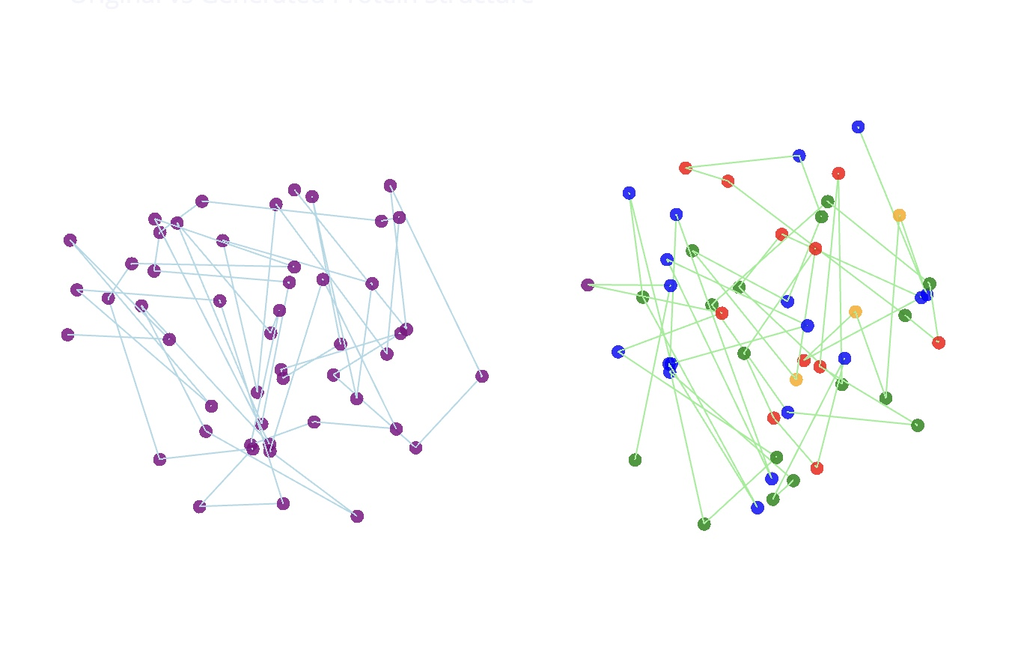
Figure 3: Representative protein structure comparison showing original (left) and generated (right) 3D conformations with amino acid-based coloring.

Model Efficiency and Scalability
The validation loss curves (Figure 4) demonstrate rapid convergence within 120 training steps, indicating efficient learning. The model successfully handles:
- Variable sequence lengths through subsequence processing
- Batch processing with consistent performance across different protein sizes
- Multi-component optimization balancing sequence and structure generation
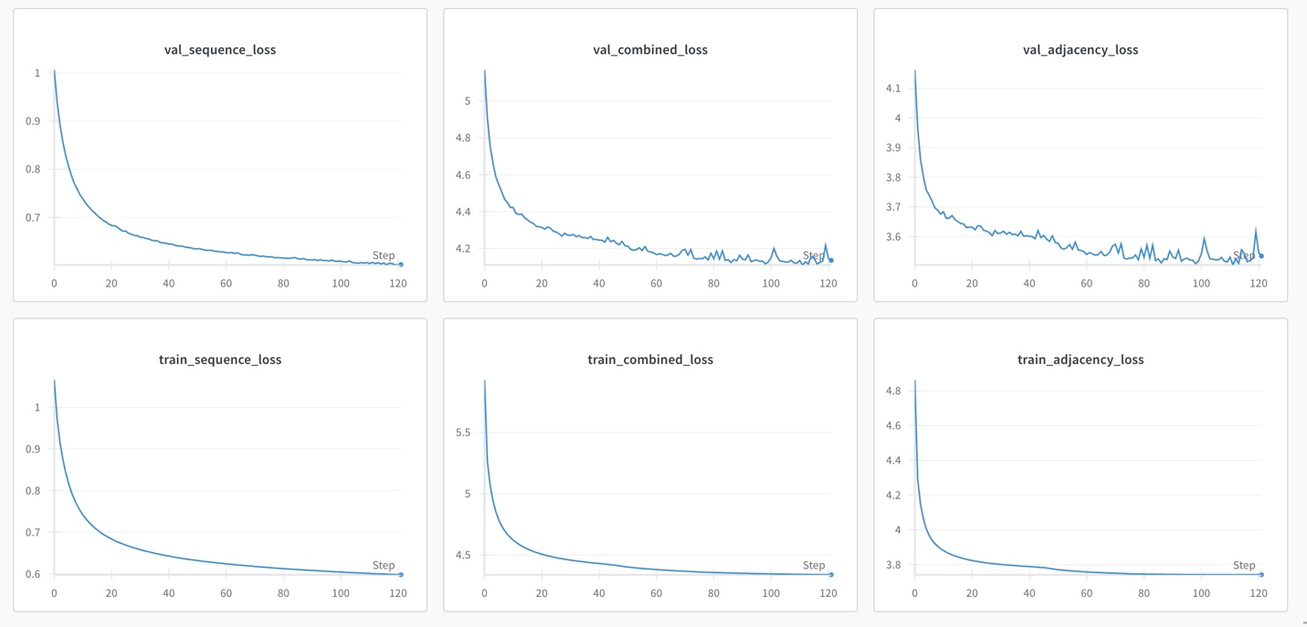
Figure 4: Validation loss convergence demonstrating rapid learning within 120 training steps across sequence, combined, and adjacency loss components.

Generated Protein Quality Assessment
Analysis of generated proteins reveals several key quality indicators:
- Sequence Composition: Generated amino acid sequences exhibit realistic composition distributions
- Structural Plausibility: Contact maps satisfy distance constraints and symmetry requirements
- Folding Capability: 3D reconstructions produce compact, well-folded structures
- Physicochemical Properties: Amino acid clustering follows expected hydrophobic/hydrophilic patterns
The results demonstrate that the GRAN-inspired architecture successfully captures both sequence-structure relationships and the complex constraints governing protein folding, enabling generation of novel protein structures with high biological plausibility.

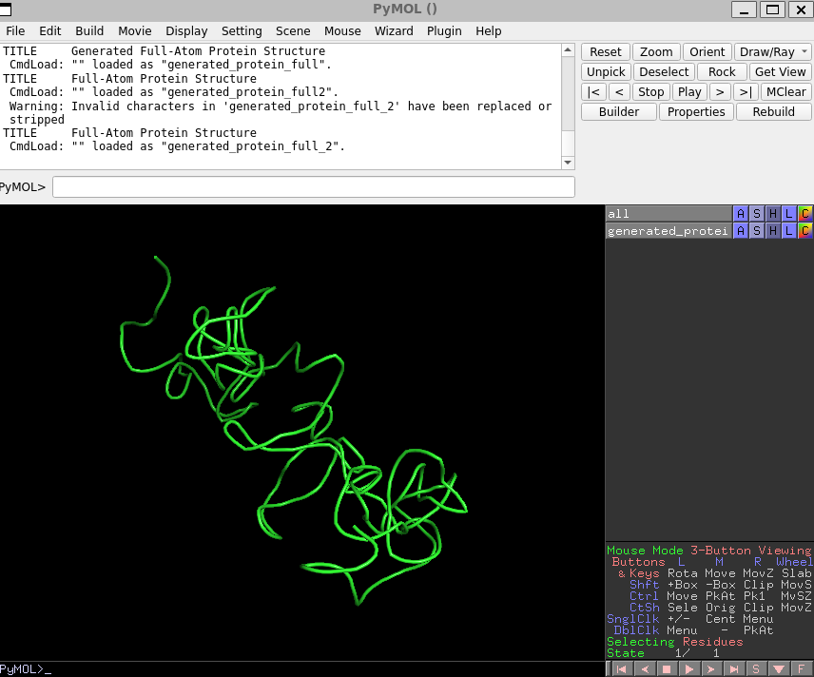Figure 6: Generated protein 3D structure with amino acid coloring showing realistic fold topology and backbone connectivity.
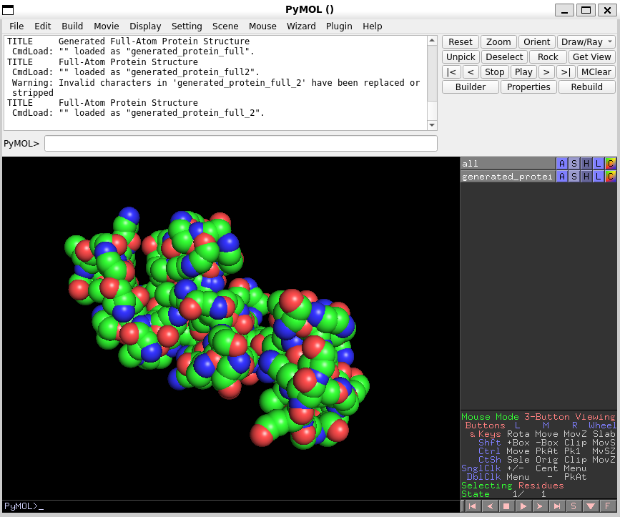
Figure 7: Professional visualization of generated protein structure in PyMOL showing secondary structure elements and compact folding.

11 Conclusions
This work addressed the challenging problem of computational protein structure generation from PDB representations. We developed a GRAN-inspired dual output architecture that simultaneously generates amino acid sequences and contact maps, overcoming the discrete-continuous optimization challenges that plagued earlier VAE approaches.

Our methodology achieved several significant breakthroughs: (1) 99.51% contact map prediction accuracy, demonstrating high-fidelity structural learning; (2) successful 3D structure reconstruction producing biologically plausible protein conformations; and (3) a systematic validation framework progressing from failed VAE approaches through synthetic graph validation to the final GRAN-inspired solution.

The research contributes a novel dual output generation strategy that separates sequence and structure prediction while maintaining biological constraints through advanced loss formulation. Our systematic approach to failure analysis - moving from protein classification to synthetic graph validation - provides a replicable framework for developing graph-based generative models in complex biological domains.

Current limitations include computational constraints restricting analysis to proteins under 300 residues and the need for more comprehensive biological validation against existing protein design methods. Future work will focus on scaling to larger proteins, implementing energy-based validation, and extending the framework to specific protein families such as antibodies and enzymes.

This work demonstrates the potential for graph neural networks in computational protein design, with implications for drug discovery, enzyme engineering, and synthetic biology. The systematic methodology for handling discrete-continuous optimization challenges extends beyond protein generation to other structured molecular design problems.

Acknowledgements
Acknowledge persons or institutions that helped you with the CDR here.

Statement
The following part is mandatory and must be signed by the author or authors.

„Ich erkläre hiermit, dass ich diese Arbeit selbstständig verfasst und keine anderen als die angegebenen Quellen benutzt habe. Alle Stellen, die wörtlich oder sinngemäss aus Quellen entnommen wurden, habe ich als solche gekennzeichnet. Mir ist bekannt, dass andernfalls die Arbeit als nicht erfüllt bewertet wird und dass die Universitätsleitung bzw. der Senat zum Entzug des aufgrund dieser Arbeit verliehenen Abschlusses bzw. Titels berechtigt ist. Für die Zwecke der Begutachtung und der Überprüfung der Einhaltung der Selbstständigkeitserklärung bzw. der Reglemente betreffend Plagiate erteile ich der Universität Bern das Recht, die dazu erforderlichen Personendaten zu bearbeiten und Nutzungshandlungen vorzunehmen, insbesondere die schriftliche Arbeit zu vervielfältigen und dauerhaft in einer Datenbank zu speichern sowie diese zur Überprüfung von Arbeiten Dritter zu verwenden oder hierzu zur Verfügung zu stellen.“

Date: Signature(s):

Appendix X
If you have something to attach to your report, do it here.

References and Bibliography
Please number any information source you used in the report with corresponding links here [1]:

[4] Efficient Graph Generation with Graph Recurrent Attention Networks
Renjie Liao, Yujia Li, Yang Song, Shenlong Wang, Charlie Nash, William L. Hamilton, David Duvenaud, Raquel Urtasun, Richard S. Zemel

[5] Prediction of Protein Movement Upon Ligand Binding Using Equivariant Graph Neural Networks
Harnessing Graphein to transform protein structures into PyTorch-Geometric-ready residue-level spatial graphs and deploying equivariant graph neural networks (EGNNs) on them.
https://medium.com/stanford-cs224w/prediction-of-protein-movement-upon-ligand-binding-using-equivariant-graph-neural-networks-26bf4d114fc4

