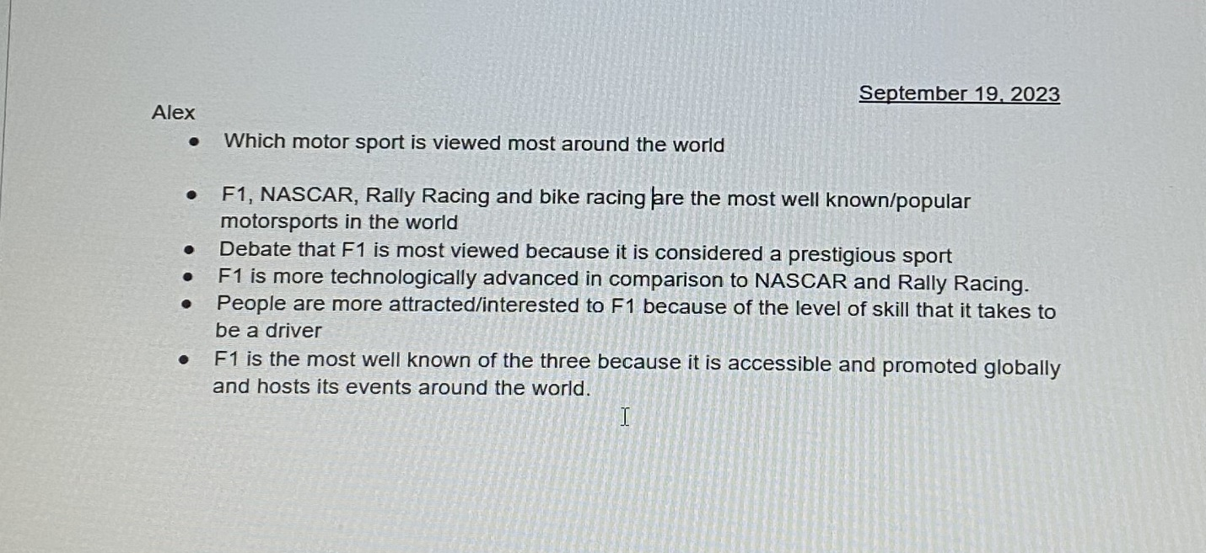Partner name- Joshua

Which motor sport racing is viewed as the most around the world.

The most viewed motorsport racing around the world is F1 followed by NASCAR, Rally Racing and Bike Racing(MOTO GP). F1 racing attracts many viewers by its prestigious class of its own, where only selected car manufacturers can compete and requires large sums of money to win. F1 racing entices fans to watch with advanced technology applied on it’s cars which beats NASCAR and Rally Racing being far more modern and to which get improved upon on every race. F1 fans are treated to a high-level of competition on driving and control skills. Every F1 driver must memorize each twist and turns of each different race circuit. F1 racing is hosted globally which allows fans from different countries to experience and see the racing action in person, in comparison to NASCAR which is hosted mainly in America.