Predictive Modelling and the NHL Entry Draft

Alex Church

100825475

COMP 4905, FALL 2019

Supervisor: Dr. Tony White

Contents

Introduction 1

Background 1

Related Work 3

Objective 8

Methodology 9

Data Collection 9

League Equivalency Factors 11

K-Means Clustering 16

Model Design and Data Pre-Processing 19

Training, Testing, and Model Selection 23

Predicting Whether a Player Will Make the NHL 23

Forwards 24

Defensemen 29

Identifying Top 9 Forwards and Top 4 Defensemen 33

Forwards 33

Defensemen 37

Conclusions and Future Work 42

Works Cited 43

# Introduction

## Background

At the conclusion of every season, the NHL holds its annual Entry Draft, where teams alternatingly select the rights to junior-aged prospects in the hopes of identifying prospective NHL talent. The modern day draft is composed of seven rounds, where each of the 31 franchises are allotted one selection per round, and the annual order of selection is predetermined based on a team’s performance in the NHL season prior. Teams are also permitted to exchange future draft selections via trade at any point. The most recent iteration of the NHL draft was held on June 21-22 of this year, where 217 eligible prospects spanning 12 nationalities were selected collectively by the NHL’s 31 franchises.

Each year, the pool of NHL draft eligible prospects is drawn from a number of junior and professional feeder leagues across the world, all varying in terms of age range and skill level. These feeder leagues can be divided primarily into two main subsets, the first being made up of those based in North America, and the second being made up of their European counterparts. Among the subset of North American feeder leagues, the top developmental leagues in terms of producing the highest volume of draft eligible talent include the National Collegiate Athletic Association (NCAA), the United States Hockey League (USHL/USDP), and the Canadian Hockey League (CHL), which itself is further broken down into three regional leagues – the Ontario Hockey League (OHL), the Western Hockey League (WHL), and the Quebec Major Junior Hockey League (QMJHL). The CHL ranges in age from 16-20, the USHL from ages 16-21, and the NCAA mostly from ages 19-25. North America is also home to the NHL’s two affiliated professional farm leagues - the AHL and the ECHL. However, in order to be eligible to play in either the AHL or ECHL, a player must be signed to a professional contract, meaning teams in these leagues are not permitted to roster draft eligible players.

From the subset of European leagues, the top junior leagues in terms of producing draft eligible players include those located in the Czech Republic (Czech U20), Sweden (SuperElit), Finland (Jr. A SM-liiga), and Russia (MHL). Player ages in these junior leagues again range mostly from ages 16-20. A portion of European draft eligible prospects also hail from a small number of professional leagues. Unlike their counterparts in North America, these professional leagues share no direct affiliation to the NHL and its franchises, and as a result teams in these leagues are permitted to roster players eligible for selection in the NHL draft. Of these professional leagues, the ones that tend to produce the highest volume of draft eligible talent primarily include the first and second divisions in each of Sweden (SHL/Allsvenskan), Russia (KHL/VHL), Finland (Liiga/Mestis), and the Czech Republic (Czech/Czech2), along with the first division leagues in Switzerland (NLA), and Germany (DEL). Together, these represent only a fraction of the dozens of junior and professional leagues from which NHL teams may identify draft-worthy talent in any given year.

In order to be eligible for selection in the NHL’s Entry Draft, a prospect must have turned 18 years of age prior to September 16th of the draft year in question. A first time eligible player can be defined a prospect who either turned 18 years of age between January 1st and September 15th of the year of the draft, or who turned 18 years of age between September 15th and December 31st of the prior calendar year. Any eligible prospects who are older than 18 (based on the above criteria) would have thus been considered eligible for a previous year’s draft, meaning they are only considered eligible for selection in subsequent years so long as their rights are not held by an NHL franchise at the time of the draft. This latter group of prospects is often referred to as over-agers. For the purposes of this study, we will focus only on first time eligible prospects.

Since the introduction of the NHL’s salary cap in 2005, which imposes an upper limit on the amount a team may spend collectively on the salaries of their players, the NHL Entry Draft has gained increasing significance as a means by which teams may attempt to gain a competitive advantage. This is largely due to the fact that, upon signing with the team who drafted them, a player’s first professional contract (known as an entry level contract) is capped using a standard scale. This is significant as the end result is that players on their entry level contracts can often offer franchises better value per dollar than their more tenured counterparts. As players age, and their salaries generally increase, teams are again forced to turn to the Entry Draft in order to replenish their stocks with younger and more cost effective options, creating a cycle where sustained success is often heavily tied to a team’s success at the draft table. Furthermore, once drafted and signed, NHL teams hold the exclusive negotiating rights to a player for the player’s first 7 full professional seasons, or until the player in question turns 27 (whichever of the two events occurs first). This adds even greater weight to the importance of the draft, as once these exclusive negotiating rights expire, smaller market teams may have difficulty retaining the rights to existing players, along with attracting new talent.

## Related Work

It has been widely documented that advanced statistical and predictive analysis have gained a significant foothold in the modern era of major league baseball, but more recently these methods have also become increasingly prevalent in the realms of professional basketball, professional football, and even more recently, in the world of professional hockey. Teams have begun to leverage this kind of advanced analysis more frequently in an attempt to gain new insights, challenge conventional wisdom, and identify areas where marginal gains may still lay unexploited. While it is difficult to speculate on what kind of inroads have been made to-date in hockey’s proprietary domain, there has been a great deal of work published in the public domain that has re-shaped the way many interpret the modern game. In the section to follow, we will briefly touch on some of these works, highlighting those that have focused predominantly on predictive analysis vis à vis the NHL draft and analysis of NHL prospects.

One of earliest such works, and perhaps the most widely cited piece of work in this domain to-date, is the National Hockey League Equivalency model (NHLe) developed by Gabriel Desjardins.[1] Desjardins’ model is largely based on the methodology first presented by Bill James in his 1985 book *Baseball Abstract,* where James detailed a method for predicting how a baseball prospect’s hitting statistics would carry over as they graduate through the various minor league ranks to the major league level.

In the context of the NHL Entry Draft, where prospects can hail from a multitude of feeder leagues that vary greatly in terms of age range and skill level, this type of analysis is especially important. In order to compare prospects from across the wide number of feeder leagues, a method for normalizing player production rates to account for the variance in skill level from league to league is required. The NHLe approach proposed by Desjardins offers a way to do so, by looking at all players who played significant time in a given league one year, and who then went on to play significant time in a different league in the year following that, allowing for direct comparison of their production rates across leagues from one season to the next. Desjardins chose the NHL as his baseline league for which every other league would be measured, and by looking only at the sample of players who jumped from one league directly to the NHL in subsequent seasons, he was able to compute a list of translation factors that provides an estimate of how much a point in each of these leagues would roughly be worth at the NHL level. These NHLe translation factors not only allow us to compare the strength of any given league directly to that of the NHL, but also allow us to indirectly compare the feeder leagues amongst themselves, resulting in the formation of a basic hierarchy that defines the relative strength of every league in the sample. This hierarchy, as defined by Desjardins’ model, is depicted in Figure 1.



Figure 1

Unsurprisingly, Desjardins found that the various professional leagues are much closer in skill level to the NHL than the junior leagues. As an example of how these translation factors might be applied, by using the chart in Figure 1 we would estimate a draft eligible prospect transitioning directly from the OHL to the NHL would retain only 30% of their pre-draft production if they were to make the jump to the NHL the following year, whereas a prospect drafted out of the Czech league would be expected to retain 74% of their production under the same circumstances. It’s easy to see how adding this type of context can be useful when analyzing prospects who come from varying backgrounds.

Aside from the NHLe model, the second most widely cited piece of work in the public domain of NHL Draft analysis is likely the Prospect Cohort Success model (PCS), developed by Josh Weissbock and Cam Lawrence.[2] The idea behind Weissbock and Lawrence’s model revolves around generating a cohort of historical comparables for each prospect, based on a small number of inputs they found to be statistically significant when predicting future NHL success. The predictors they deemed to be statistically significant included age on draft day (defined as the exact age of a player, down to the day), both unadjusted and NHLe adjusted points per game from a player’s 18 year old pre-draft season, league of origin, and height. Using these inputs, they were able to compute the Euclidian distance between each point in their dataset, and then use those distances to group prospects into cohorts based on their nearest neighbours. Then, in combination with known knowledge about the careers of the players in each cohort, Weissbock and Lawrence were able to compute both the probability that any new player assigned to that cohort would go on to play 200 NHL games, as well as their expected career points per game rate at the NHL level if they were to reach that 200 game threshold. The combination of these two metrics can be used in unison to provide an expected value for each prospect. For example, if a prospect is assigned to a cohort that dictates they have a 25% chance of reaching the 200 game threshold, and an expected career points per game rate of 0.45 (or 36.9 points per 82 game NHL season) based on their closest historical comparables, then that player’s expected value would be equal to 0.25 * 36.9, or 9.3.

Weissbock and Lawrence ran tests to compare the predictive ability of their model in comparison to a simple multivariate linear regression model using the same inputs (age, height, and points per game rates). The results showed that their model tended to be a significantly better predictor of whether or not a player would go on to play 200 NHL games if that player originated from one of the CHL feeder leagues, but as can be seen in Figure 2, based on the provided r-squared values the PCS model fared no better than the basic regression model in terms of predicting how many career NHL games any given prospect would go on to play, and in some cases even acted as a worse predictor.[3]

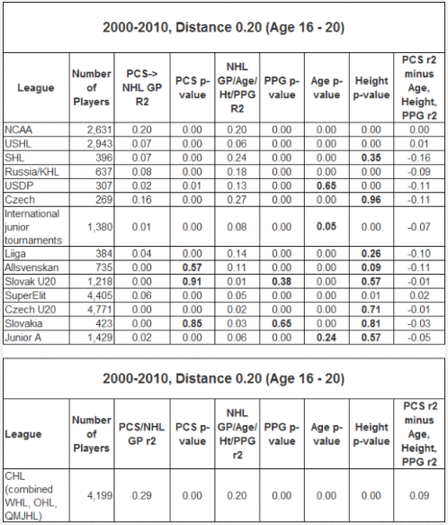

Figure 2

The PCS model did not remain public domain for long though, as it was subsequently purchased and made proprietary by the NHL’s Florida Panthers. Similar models have been developed in the wake of PCS, a small number of which have also been purchased and employed by NHL franchises.[4] Unfortunately, without being privy to the current state of these now proprietary models, or to what degree they are being leveraged by teams as part of their decision making process, it is difficult to assess if the teams employing them have been able to gain a significant leg up on their competition when it comes to identifying prospective NHL talent at the draft table.

# Objective

The goal of our study is to build upon some of the aforementioned works, by incorporating their methodology into a new approach towards classifying which draft eligible prospects boast the greatest probability of going on to succeed at the NHL level.

As an initial step, we wish to improve upon Desjardins’ original NHLe model, by not only sampling players who transitioned directly from any given league to the NHL in subsequent seasons, but also by sampling players who transitioned between intermediate feeder leagues. This should offer a greater sample size to base our NHLe computations off of, allowing us to not only compute more accurate equivalency factors for any given league, but also to compute equivalency factors for a number of additional leagues which Desjardins’ method was unable to account for, due to the lack of direct links between the leagues in question and the NHL. These newly computed league equivalency factors will be used to normalize the pre-draft production rates of all players in our sample, allowing for direct comparison of production rates across leagues.

Next, we wish to build an unsupervised clustering model, similar to the PCS model developed by Weissbock and Lawrence. This will give us a list of closest historical comparables for each prospect in our set. By replicating the PCS methodology, we hope to reassess the validity of whether such an approach can offer any additional predictive insights as to which prospects are most likely to go on to succeed at the NHL level, based only on the career trajectories of their nearest neighbours.

Finally, using our normalized production rates from step one, and our cluster values from step two as input features, along with a short list of additional features such as each player’s height, age, and country of origin, we wish to train and test various supervised classifiers in an attempt to establish a possible upper bound on our ability to predict which draft eligible prospects are most likely to go on to succeed at the NHL level, with success in this case being defined using metrics such as the probability any given prospect will go on to meet a minimum games played threshold, or eclipse a minimum career points per game rate.

# Methodology

## Data Collection

All data collection was done in large part thanks to the API made available by eliteprospects.com. Their extensive database not only offers a wide array of statistics from the NHL level, but also from the various junior and intermediate feeder leagues as well. By querying their API repeatedly and parsing the various responses, we were able to construct a database containing 493,590 unique players spanning 1,321 different leagues.

The database includes basic information such as a player’s name, birthdate, nationality, height, weight, and preferred playing position. It also contains player statistics, broken down both by season and career totals. Figures 3, 4, and 5 offer an example of how the data is stored.



Figure 3

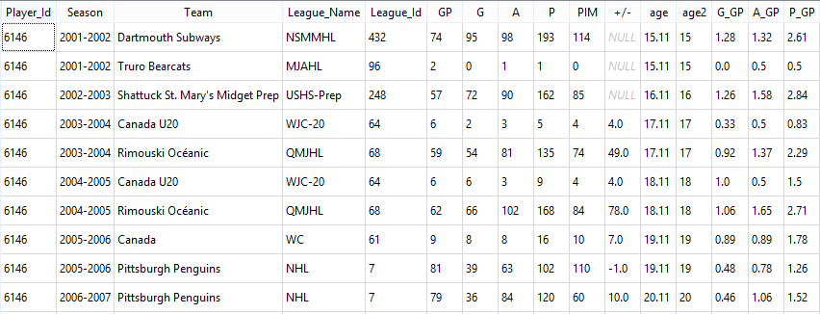

Figure 4

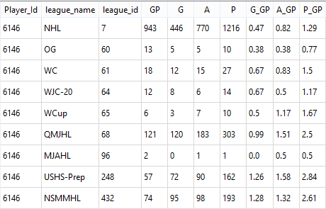

Figure 5

The database also includes additional details regarding each player’s career accolades, such as how many times they were selected to participate in the Under-18 or Under-20 World Junior Championships prior to their first draft eligible season. The idea behind tracking a feature such as this is that it might possibly serve as an identifier for draft eligible players who rank at the top of their junior-aged peer group. Finally, the database includes historical information pertaining to the NHL Entry Draft itself, dating back to the 1995 draft, including all draft selections broken down by year, round, overall selection, as well as the selecting team, and the player selected with each pick.

Additional statistics that could potentially be of use, such as shot totals and ice time figures, are unfortunately not made available by eliteprospects, as only a small number of feeder leagues track and make these figures available to the public. As a result we decided to omit them entirely for the purposes of this study. This alludes to the first major roadblock standing in the way of predictive analysis pertaining to the NHL Draft, which is that the predictive ability of any such models is hindered by the availability (or lack thereof) of model inputs beyond the standard games played, goals, and assists.

## League Equivalency Factors

With our data collection complete, we have what is required to compute our own version of Desjardins’ league equivalency factors, which will be used to normalize the production rates of prospects across the various feeder leagues. Before detailing the methodology behind these computations, it is first important to acknowledge a few of the shortcomings presented by the original NHLe model. While Desjardins’ methodology focused only on players who jumped directly from any given feeder league straight to the NHL, in reality, many players transition between multiple intermediate leagues before finally making the transition to the NHL level. At lower levels of the hierarchy, such as the junior ranks, by looking only at players who jump directly to the NHL we limit our sample by ignoring these intermediate links between the feeder leagues themselves, which often represent the paths most commonly travelled. By factoring in intermediate transitions, not only does it improve our sample size, allowing us to compute a more representative set of equivalency factors, but it also allows us to capture additional leagues that Desjardins’ model was unable to account for, simply due to the inexistence of direct links between those leagues and the NHL.

The first step in computing our equivalency factors is to identify all records in our database for which a player changed leagues in subsequent seasons. Then for each tuple of the form (league *n,* league *n+1*), which represent players who transitioned from one league to the other in consecutive seasons, we calculate how much of our sample’s cumulative points per game rates from year *n* were retained in year *n + 1* when moving between leagues *n* and *n + 1*. This provides an estimate for how much a point in league *n* might be worth in league *n + 1*, and can be computed as follows:

In order to ensure that our sample was not skewed by any outliers, we restrict the query to the subset of leagues for which a minimum of 50 players historically transitioned from league *n* to the league *n + 1* in subsequent seasons. Each player must have also played a minimum of 20 games in both seasons *n*, and *n + 1* in order to be included in the sample.

Next, we construct a directional graph, where each league is represented by a node, and the initial LE factors we previously computed are represented as edge weights between nodes. It is at this point where our methodology begins to encounter some of the issues that plagued the NHLe model, as after constructing the graph, we are left with only 13 of a possible 1,320 leagues for which an out edge exists leading directly to the NHL node. Figure 6 depicts a subset of these 13 leagues, including many of the feeder leagues encompassed by Desjardins’ original work. While the sample may be small, one positive takeaway is that the results seem to corroborate the prior findings of Desjardins, as we observe a similar hierarchy to that depicted in Figure 1.



Figure 6

In order to overcome the issue of sample size, we would like to incorporate all intermediate transitions between feeder leagues into our calculations as well, so that we are no longer limited only to direct links to the NHL node. To accomplish this, we look at the neighbourhood of paths in our graph of length less than or equal to size 3 which conclude at the NHL node. Then we compute our NHLe factors for each league by taking the product of each edge weight along these paths, weighting paths of size 1 more heavily than those of size 2, and paths of size 2 more heavily than those of size 3. As an example, while an edge between the USHL (one of the aforementioned premier North American junior leagues) and the NHL may not exist, an edge may exist in our graph between the USHL and the NHL’s farm league, the AHL. If we assume this edge has weight 0.5, telling us that players from the USHL generally retain 50% of their production when transitioning to the AHL, and we know from our chart in Figure 6 that AHL players typically retain 48% of their production when moving to the NHL ranks, we can thus surmise players from the USHL should be expected to retain 0.5 * 0.48 = 24% of their production if they were to jump directly to the NHL level. We would then repeat this process for all other paths of at most length three that lead from the USHL node to the NHL node, and then calculate a weighted average, leaving us with a final league equivalency (LE) factor for the USHL.

Using this approach, our equivalency factors are re-computed, this time producing a much larger resulting set of 432 leagues for which we now have a means of comparison. A small snapshot of these updated LE factors is outlined in Figure 7. The observed hierarchy is again quite similar to that discovered by Desjardins initially, only now our hierarchy is made up of a much larger subset of feeder leagues.



Figure 7

With our equivalency factors now refined, the next step is to normalize the pre-draft production rates for all players in our database. Because the draft eligibility cut-off specifies an 18 year old birthdate of September 15th for each draft year, meaning players born between September 16th and December 31st will have played three full seasons in the junior ranks before their first eligible draft year, and due to the fact that most prospects do not graduate to the major junior ranks until two years prior to their draft year, in an attempt to bypass this added complexity we will only include a player’s 17 and 18 year old seasons as inputs to our model. This brings us to another one of the main challenges facing this type of predictive modeling regarding the NHL draft and draft eligible prospects, which is that inputs are generally restricted to only one or two years’ worth of meaningful data.

After normalizing each player’s 17 and 18 year old goal and assist rates using our newly generated league equivalency factors, allowing us to account for some of the variance that exists across leagues, there is still the remaining challenge of normalizing production for variance that exist in scoring rates within each league. The motivation in doing so is that even within the same league, scoring rates can vary greatly by era. For example, the QMJHL’s leading scorer this past year finished the season with 111 points, whereas in the 1999-2000 season the leading scorer finished with 186 total points, with a dozen players matching or eclipsing the 111 point mark. It is possible that the talent crop of 1999-2000 was simply more skilled on average than that of the modern era, but it is even more likely that there are additional underlying factors causing these large variations in scoring rates, an example of such being the significant advances of the goaltending discipline over the years.

We can adjust for this type of variance in league scoring rates across era by first computing the all-time average points per game rate for each league, and then comparing the yearly rates (grouped by league and season) against the all-time average for each league in our sample, in order to identify historical trends in scoring rates within leagues. As an example, by using this methodology we can compute that scoring in the QMJHL in the 1999-2000 season was 10-11% higher than the all-time average. Based on this we would regress each player’s production from that season back toward the all-time mean. Using our aforementioned leading scorer from the 1999-2000 season as an example, his era adjusted point total would be equal to 186 * 0.89 = 166 in this case.

Moving forward, this methodology may require some refining itself, as depending on the normality of the distribution in league scoring rates over time, it is possible that the median may lend itself better to these types of adjustments. Though, after some initial testing using both the historical mean and median scoring rates, there did not appear to be any discernable difference in the results.

K-Means Clustering

With our pre-draft production rates both league and era adjusted, next we move on to constructing a replica of the PCS model. In order to do so, an unsupervised k-means clustering approach was selected in order to identify cohorts of comparable players, based on each player’s pre-draft normalized production rates. The reason for selecting the k-means clustering algorithm (aside from the fact that it is relatively easy to implement) is that, similarly to Weissbock and Lawrence’s model, it too uses the Euclidian distance between points as a measure of similarity. The normalized age 17 and age 18 goal and assist rates of each player will serve as our model inputs in this case, and in an attempt to place additional emphasis to the more recent of the observations, the age 18 production inputs will be weighted twice as heavily as the age 17 production inputs,.

It should be noted that this methodology differs slightly from that of Weissbock and Lawrence, who used only a player’s age 18 production rates based on points per game, along with additional inputs such as height and age. While Weissbock and Lawrence found that height and age acted as significant predictors of future NHL success based on their resulting p-values, age 18 points per game rates remained far and away the primary predictor of the three, with age and height adding sharing only a moderate correlation to future NHL points per game rates among their test set.[5] In order to avoid inadvertently over-weighting age and height in our model, they were decidedly omitted. Based on the strong correlation observed between points per game rates at the junior level and points per game rates observed at the NHL level, we have strong reason to believe we will observe similar results to that of the PCS model, despite the slightly different approach taken.

Prior to running the k-means algorithm, it is important to first evaluate whether our data lends itself to clustering, along with estimating an optimal number of clusters to be used based on the underlying composition of the dataset. By mapping our age 17 and age 18 normalized production rates to the 2D plane (Figure 8), it appears as though we cannot generate any meaningful insights at a quick glance.

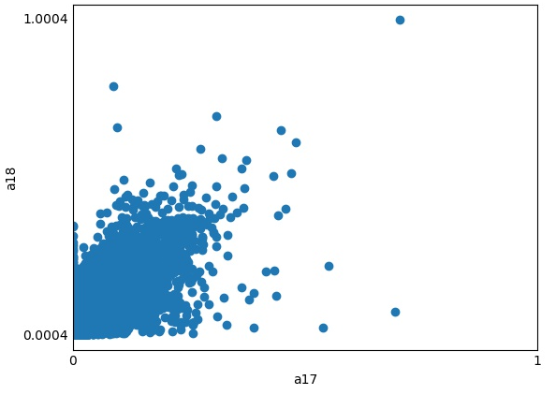

Figure 8

Thankfully there are heuristics that can be used to estimate the optimal number of clusters, instead of relying solely on our intuition. One of the most popular such methods is the elbow method, which computes variance within clusters based on their SSE, and then maps a cost function based on those values, where the optimal number of clusters is said to be the point on the x axis around which a visible “elbow” appears. Figure 9 demonstrates the resulting elbow method when applied to our dataset.

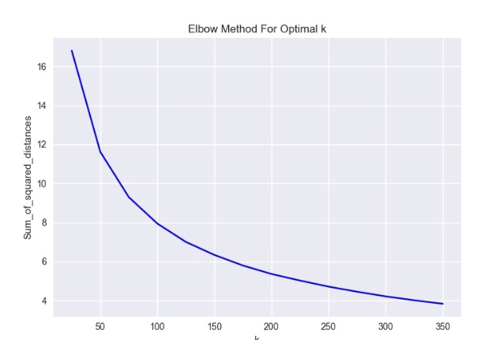

Figure 9

Unfortunately in our case, the results yield no visible elbow, but rather a relatively smooth curve, which again does not bode well for a cluster based approach. However, this does not necessarily mean that our dataset does not lend itself to clustering at all. Instead we can experiment with various levels of clustering to see if any such level of partitioning can yield improved results when training our models, treating the number of clusters as a hyperparameter of sorts.

## Model Design and Data Pre-Processing

With our k-means clustering model ready, and our pre-draft production rates fully normalized, we have all the inputs required to put the finishing touches on the design of our classifiers before moving on to training, testing, and tuning our models in order to analyze their performance. For our purposes, six popular classification models were hand-picked, all of which take varying approaches to the problem of classification. The six selected models include the standard Gradient Boosting classifier, Support Vector classifier, Multilayer Perceptron, Random Forrest classifier, K-Nearest Neighbours classifier, and the Naïve Bayes classifier. Once the top performers have been identified, we may then choose to further refine our approach by trying out various ensembles from among a subset of the best individual performers, or by tuning certain hyperparameters to see if we can possibly improve performance further. Separate classifiers will be trained and tested for both forwards and defensemen, with goalies being set aside for further study at a later date.

The features chosen for our classifiers include:

* Player height
* Player weight
* Age (as of September 15th of the draft year in question)
* Country of origin
* League of origin (age 17 and 18)
* Goals and assists per game (age 17 and 18)
* Binary identifiers indicating whether or not a prospect played in the World Under-18 or World Under-20 Championships at any point prior to their draft year
* The cluster values produced by our k-means model

We will train our models first using unadjusted goal and assist rates, followed by our normalized goal and assist totals, which will hopefully allow us to assess if any additional predictive capability is being added by applying league and era adjustments to scoring totals. Next, we will introduce our k-means cluster values as an additional input feature, using separate runs of 50, 100, and 200 clusters in an attempt to determine if incorporating the results into our models at any level of partitioning adds any gains in performance to the base model.

When training each model, we will apply feature selection where necessary in order to crop out any inputs which may not act as meaningful predictors, and would only serve to add noise if included. At this point, some data pre-processing of our inputs is required as well. Any ordinal inputs, such as goal and assist rates, height, weight, and age must first be standardized in order to normalize their distributions and ensure all ordinal data is scaled in the range 0 to 1. Next, we must apply one hot encoding to any categorical inputs (country of origin, league, cluster values, etc.) that don’t lend themselves to standardization. If this method is not applied to our categorical inputs, we risk having the machine learning algorithms treat the categorical data as it would ordinal data. One hot encoding avoids this error by transforming categorical data to a numeric representation where necessary (most ML algorithms do not possess the capacity to process text inputs), and then by mapping the data to multiple fields (one for each category), where membership to any individual category is indicated using binary classification.

Using our previously defined features, each model will be trained to predict the following binary classifiers:

1. The probability a given prospect will play at least 1 NHL game.
2. The probability a given prospect will play more than 2 full NHL seasons (164 games)

*AND* achieve a career points per game average greater than or equal to 0.33 in the case of forwards, or 0.25 in the case of defensemen.

These points per game thresholds from our second classifier were heuristically selected as a means of classifying “top 9” production among forwards and “top 4” production among defensemen, based on last season’s distribution of scoring by position at the NHL level. I.e., being that the league is composed of 31 teams, we would expect there to be 31 * 9 = 279 top 9 forwards, and 31 * 4 = 124 top 4 defensemen in any given year. Using the points per game rates of all forwards and defensemen who dressed in at least 20 games in the 2018-19 NHL season, the 279th forward and 124th ranked defensemen scored at approximately a rate of 0.33 and 0.25 points per game, respectively, providing us with our thresholds for defining “top 9” and “top 4” production respectively.

Both classifiers are to be trained and tested on a sample from our database composed of 12,149 forwards and 6,109 defensemen, all aged 25 and over. A quick analysis of the sample sets shows that of our sample of 12,149 forwards aged 25 and older, only 1,206 (or just shy of 10%) went on to play just a single game at the NHL level, and of those only 354 (under 3%) went on to become top 9 forwards based on the criteria specified previously. Among our sample of 6,109 defensemen aged 25 and older, only 586 (again, just shy of 10%) went on to play only a single NHL game, and of those only 89 (under 1.5%) went on to produce at the rate expected of a top 4 defenseman.

Based on these figures, we can clearly discern that an imbalance exists between classes in our sample sets. Classic examples of some more common classification problems where imbalance is prevalent include credit card fraud detection, and cancer diagnosis. When data sets exhibit this type of imbalance in classification problems, we can no longer rely on a standard accuracy score as a primary measure of evaluation, defined as , where TN represents true negative predictions, and TP represents true positives. Using our case as an example, where fewer than 3% of our observed sample of forwards go on to develop into top 9 producers at the NHL level, if our classifier were to simply predict that no forward would ever be classified as a top 9 producer, it would exhibit an accuracy score of over 97%, but we would not be left with any meaningful insights. Instead, when dealing with such extreme imbalance we must look to alternative metrics of evaluation, namely precision and recall. Precision refers to the ratio of positive predictions that represent observed positives, and is defined as whereas recall refers to the ratio of observed positives that a model classifies as true positives, defined as The F1 score p a harmonic mean of these two metrics, and is computed as follows:

As a result of the underlying imbalance observed in our sample set, we will rely largely on recall and F1 scores when evaluating the performance of each model.

Along with using alternative metrics for evaluating model performance on imbalanced data sets, there exist certain unconventional sampling methods that can help improve performance in the face of imbalance. The first of these approaches is to oversample the underrepresented class in order to gain an equal representation of each class in the train/test sets, where existing instances are either duplicated, or used as a basis in order to artificially generate new instances. Undersampling can also be employed in an attempt to counteract imbalance. With undersampling, only a subset of the overrepresented class is sampled in an attempt to introduce balance into the class structure. We will test both of these methods when building our models to see if either might be able to offer any additional performance gains above and beyond that of our base models. To implement these methods, we will make use of the Python imblearn library, using the NearMiss approach as a method of undersampling, and the SMOTE approach as a method of oversampling. The SMOTE method achieves oversampling through interpolation (i.e. by artificially generating new instances of the underrepresented class, rather than simply duplicating existing instances).

Before training and testing our models, the final step required is to split our samples into separate train and test sets. In this case, we opted for a standard test size of 30% of the overall sample set. We also opted to split our train/test sets in a stratified fashion in order to ensure both the train and test sets are equally representative of each of our classes.

# Training, Testing, and Model Selection

## Predicting Whether a Player Will Make the NHL

First we want to train our classifiers to predict the probability that a draft eligible prospect will go on to play at least a single game at the NHL level.

### Forwards

As a first step, we train and test each model using our raw unadjusted scoring rates, which yields the results shown in Figure 10. These results will serve as a baseline for our model’s performance, which we can reference as we refine our classifiers at each step.



Figure 10

As can be seen in Figure 10, the Naïve Bayes classifier is the early top performer. However, none of the models demonstrate much in the way of predictive capability, with the aforementioned Naïve Bayes classifier correctly identifying only 79 of a total 362 players from our test set who went on to play in the NHL in any capacity.

Re-training our models using our adjusted scoring figures yields significantly better results, which are displayed in Figure 11.



Figure 11

Again we observe that the Naïve Bayes classifier performs best, but this time all of our classifiers exhibit similar performance across the board. Comparing the results of the Naïve Bayes classifier to those observed using our unadjusted scoring figures, we see that it is now able to correctly predict 190 of the 362 observed positives, though the number of false positives has increased as well. Despite this, we can consider this a marked improvement over our initial results, and conclude that our league and era adjustment do seem to greatly improve our model’s performance.

Next, we retrain and test our models with the cluster groupings added in as additional inputs. In trying out various levels of clustering (n=50, n=100, n=200), we observe that adding in the clustering does not seem to improve performance from the previous step in any significant manner, and in certain cases may just add noise. A snapshot of these results is shown in Figure 12 (n=100 clusters).



Figure 12

Finally, we explore whether or not it is possible to improve our model performance even further by applying both our undersampling and oversampling methods in order to counteract the effects of imbalance in our sample. Figure 13 shows the results after applying the SMOTE oversampling method, while Figure 14 shows the results of applying the NearMiss undersampling method.



Figure 13



Figure 14

At first glance the results seem promising, with both methods outperforming our base model. As we might expect, undersampling manages to capture a slightly larger portion of true positives, but this gain comes at the cost of a significantly larger portion of false positives, leading to lower accuracy across the board, despite exhibiting similar F1 scores to the oversampling method.

At this stage a small number of ensemble methods from among the best performers (Gradient Boosting, Multilayer Perceptron, Random Forest, KNN) were also tested to see if we might be able improve our model’s performance further, but none seemed to offer significant gains. In the end we elect for the league/era adjusted Gradient Booster with SMOTE oversampling applied. This model registered a final F1 score of 89%, recall score of 77%, and accuracy score of 86%. While both our KNN and Random Forest classifiers did grade out better in terms of F1 score, we elect for the Gradient Boosting model due to its higher level of recall. In the end our model was able to correctly identify 280 of the 362 forwards in the test set who went on to play a single NHL game. The cost to achieve this level of accuracy wound up being 431 false positives out of the 3,645 player test set.

Using our model’s results, the top 5 ranked players from our test set are listed in Figure 15. We note that this list is composed of three former 1st overall draft choices (Lecavalier, Thornton, Legwand), along with a 2nd (Van Riemsdyk), and 7th overall selection (Voracek).

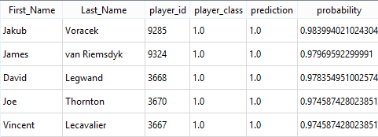

Figure 15

Of course, the model is not without its misses, though at a glance they appear to be few and far between. Figure 16 highlights some of the most notable false negatives. What’s interesting is that NHL teams also seemed to misevaluate the same players in their draft seasons. Langenbrunner and Karlsson were the highest selections of the group, both going in the 2nd round, whereas Gaudreau was not selected until the 4th round, Shaw and Versteeg the 5th round, and Marchessault went unselected entirely, indicating that this group is largely made up of late bloomers whose development trajectory may have been unconventional following their first draft eligible seasons.

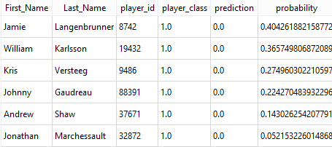

Figure 16

### Defensemen

Next we apply the same methodology to predicting whether any given prospect at the position of defense will go on to play in at least one NHL game. Figure 17 shows the initial baseline results for our model using unadjusted scoring rates.



Figure 17

The initial results are similar to those observed among forwards, with the Naïve Bayes classifier grading out as the top performer, registering an F1 score of 0.34. Next, we apply league and era normalization to see if we observe any increase in model performance as a result.



Figure 18

Figure 18 shows that again by applying our league and era adjustments we greatly improve the collective performance of our models. Whereas the best base model (Naïve Bayes) correctly identified 62 of a possible 176 observed positives, after normalizing scoring rates that total jumps to 92 of a possible 176.

As a next step, we re-train and test our models including our cluster values for cluster levels n=50, n=100, and n=200, in order to assess if including this additional feature might offer any gains in model performance. Figure 19 displays these results in detail for n=100 clusters.



Figure 19

Similar to what was observed with forwards, including our cluster values as an additional parameter does not seem to generate any gains in performance in terms of predicting which defensemen will go on top play at the NHL level. Finally, we move on to applying our oversampling and undersampling methods. These results are show in Figure 20 (oversampling), and Figure 21 (underampling).



Figure 20



Figure 21

These results are again very similar to those observed with our sample group of forwards. The oversampling method appears to outperform the undersampling method both based on F1 score and accuracy. The Random Forest and KNN models achieve the highest F1 scores of the bunch, however we yet again opt for the Gradient Boosting classifier due to its higher recall score, and lower ratio of false positives, concluding that it seems to offer the best tradeoff of all the tested models. The chosen Gradient Boosting classifier with adjusted scoring rates and SMOTE oversampling applied, registers an F1 score of 89%, a recall score of 73% and an accuracy score of 87%.

Taking a quick glance at the model’s output from our test set (Figure 22), the results appear to be promising. The top 10 defensemen from our test set that the model predicted would go on to play in the NHL at any capacity all managed to play at least a single NHL game, and most went on to enjoy successful NHL careers to varying degrees.

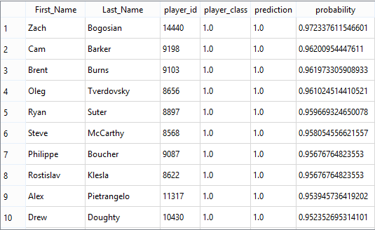

Figure 22

Again, we’d be remiss if we didn’t also cover some of the model’s notable false negatives (Figure 23). The good news is that, similar to what was observed with forwards, these misses appear to be few and far between, and in the case of defensemen, include a list of players who mostly went on to carve out fringe careers at the NHL level.

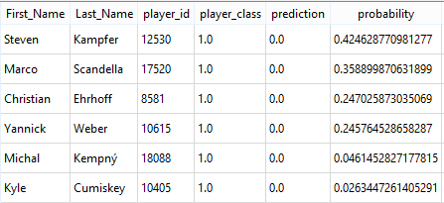

Figure 23

## Identifying Top 9 Forwards and Top 4 Defensemen

In this section we refine the logic of our classifier to make things ever more restrictive. Instead of predicting the probability a prospect goes on to play a single game at the NHL level, we now wish to compute the probability they go on to play more than two seasons (164 games), and achieve a career points per game rate of at least 0.33 in the case of forwards (signifying what we had previously defined as “top 9” production), or 0.25 in the case of defenseman (signifying “top 4” production).

### Forwards

After generating new train/test sets for our second classifier (a step made necessary by the application of stratified sampling earlier on), we begin by testing our models with both our unadjusted (Figure 24) and adjusted scoring figures (Figure 25). 

Figure 24



Figure 25

We again observe significant gain in performance when applying the league and era adjustments to scoring figures. However, despite the improvement in performance provided by using our adjusted figures, the rate or false negatives is still significantly high, with the Naïve Bayes classifier being the only model able to successfully identify more than 50% of the forwards from our test set who went on to become top 9 producers at the NHL level.

Before we test our over and undersampling, we first want to have a look to see if including our clusters will add any additional predictive gains to our new classifier. Figure 26 (displaying the results for n=100 clusters) shows that again we don’t appear to receive any added performance gains by introducing our cluster values into our models, using any level of clustering (n=50, n=100, n=200).



Figure 26

Finally, we employ our oversampling and undersampling methods to see if they might fare any better than our base model. Figures 27 and 28 show that both outperform the base model, with oversampling again appearing to be the most successful predictor, identifying nearly as many top 9 forwards as the undersampling method, while registering far fewer false positives.



Figure 27



Figure 28

It seems that again the Gradient Boosting model offers the best tradeoff between its rate of true and false positives, registering an F1 score of 94%, a recall score of 71%, and an accuracy score of 91%. The model successfully manages to identify 75 of the 106 forwards from our test set who achieved the minimum games played threshold of 165 games, and the minimum career points per game threshold of 0.33. Different ensembles were tested as well, but none offered any significant gains over the performance of the Gradient Boosting model.

A snippet of the top 10 ranked players from our test set, based on the predicted probability that they would go on to become top 9 producers at the NHL level, is shown in Figure 29. Figure 30 shows a snippet of the top 10 false negatives. Both lists present a slightly more mixed bag than we observed with our initial classifier, but that is to be expected seeing as our restrictions are significantly more stringent in this case.

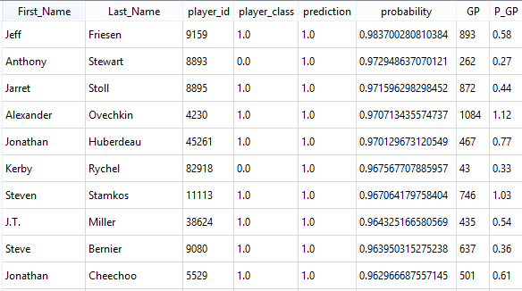

Figure 29

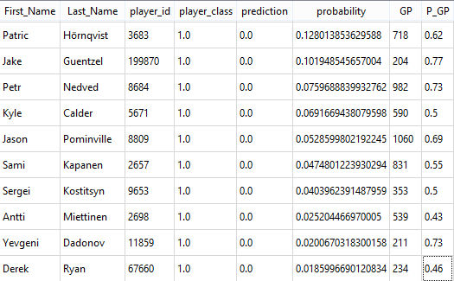

Figure 30

Here we note that our top 10 includes eight 1st round picks, and two 2nd rounder (Stoll, Cheechoo), and only two of the ten players identified went on to be misclassified. Among the biggest misses, again we note that the list is largely made up of late bloomers, including a large number of players who have late birthdays, and/or would go on to be selected in the mid-to-late rounds of the draft, or in some cases (Ryan, Dadonov) would not be selected at all.

### Defensemen

Finally, we move on to modeling the probability that any given defensive prospect will develop into a “top 4” defenseman at the NHL level. Figures 31 and 32 show the results of our base models using unadjusted scoring rates (Figure 31), followed by our adjusted rates (Figure 32).



Figure 31



Figure 32

The best predictor using our base unadjusted scoring rates (our Naïve Bayes classifier) manages to successfully identify only 12 of the 44 top 4 defensemen contained within our test set. Again, adding in our league and era adjustments offers a great improvement, allowing us to now successfully identify up to 28 of the total 44. Next we add in our cluster identifiers to see if they offer any increase in predictive power. Figure 33 shows the results for clustering at level n=100.



Figure 33

Again we observe no improvement by including our cluster values at any level of partitioning (n=50, n=100, or n=200). As a final step, we apply oversampling and undersampling to introduce balance into our train/test sets. Figure 34 displays the results of applying oversampling, while Figure 35 displays the results of applying undersampling.



Figure 34



Figure 35

Based on these results, the Gradient Boosting model employing SMOTE oversampling and using our adjusted scoring rates seems to produce the best results once again. This model was able to successfully predict 30 of the 44 top 4 defensemen, registering an F1 score of 94%, a recall score of 68%, and an accuracy score of 91%.

Looking at the top 10 predictions (Figure 36) and top 10 worst misses (Figure 37), as predicted by our model, we again experience more mixed results than we did when simply classifying which defensemen would make the NHL in any capacity. Of the top 10 players predicted to develop into top 4 defensemen, we observe 4 false positives, whereas our list of biggest misses now includes a number of prestigious names. Though of these misses, we observe a mix of late bloomers, and players who were drafted out of low strength leagues (McDonagh, Leddy), where our model likely discounts their chances based on that fact alone.

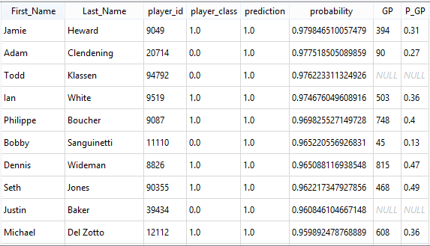

Figure 36

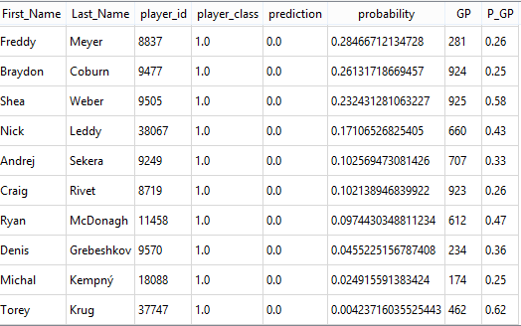

Figure 37

# Conclusions and Future Work

Figure 38 outlines the full performance details of our Gradient Boosting classifiers using SMOTE oversampling and normalized scoring rates. We can conclude that performance is relatively even across the board. As we would expect, predicting which players will go on to play a single game at the NHL level, proves to be more reliable than predicting those who will go on to become top 9 forwards, or top 4 defensemen, but the drop off in predictivity between the two classifiers is not extreme. Furthermore, it appears that predicting which forwards will go on to experience greater success at the NHL level is easier than predicting which defensemen will go on to become impact players.



Figure 38

In the future we would like to extend this work to possibly look at classifying the likelihood that any given goaltending prospect will go on to enjoy success at the NHL level. We would also like to be able to incorporate additional data beyond a player’s age 18 season in order to incorporate over-agers into our projections. This would also allow us to adjust expectations for each player for every subsequent season following their draft year, potentially helping to identify late bloomers, or prospects whose development may be stagnating post-draft. Finally, we would also like to test various additional classifiers. For instance, we could attempt to classify which player’s might go on to become All-Stars at the NHL level.

# Works Cited

Columbus Blue Jackets. (2019). *Blue Jackets announce several changes to Hockey Operations department*. Retrieved from NHL.com: https://www.nhl.com/bluejackets/news/blue-jackets-hockey-operations-department-changes/c-308249804

Desjardins, G. (n.d.). *Projecting Junior Hockey Players and Translating Performance to the NHL*. Retrieved from Behind the Net: http://www.behindthenet.ca/projecting_to_nhl.php

Hohl, G. (2015). *Draft Theory: Height matters, but maybe due to bias*. Retrieved from Canucks Army: https://canucksarmy.com/2015/02/10/draft-theory-height-matters-but-maybe-due-to-bias/

Lawrence, C. (2015). *Prospect Cohort Success – Evaluation of Results*. Retrieved from Hockey Graphs: https://hockey-graphs.com/2015/09/21/prospect-cohort-success-evaluation-of-results/

Saxena, S. (2018). *Precision vs Recall*. Retrieved from Towards Data Science: https://towardsdatascience.com/precision-vs-recall-386cf9f89488

Taylor, S. (n.d.). *Learning the NFL Draft*. Retrieved from https://seanjtaylor.github.io/learning-the-draft/

Weissbock and Lawrence. (2015). *Draft Analytics: Unveiling the Prospect Cohort Success Model*. Retrieved from Canucks Army: https://canucksarmy.com/2015/05/26/draft-analytics-unveiling-the-prospect-cohort-success-model/

Winter, L. (n.d.). *Predicting NBA All Stars*. Retrieved from https://medium.com/better-programming/predicting-nba-all-stars-e03655021f63

1. (Desjardins)
2. (Weissbock and Lawrence, 2015)
3. (Lawrence, 2015)
4. (Columbus Blue Jackets, 2019)
5. (Hohl, 2015)