Robotics Group Coursework II

Task I
Task I asks to develop an algorithm in MATLAB that calibrates a camera given some checkerboard data.The result should include one set of intrinsic parameters as a K-matrix, as well as 6 sets of extrinsic parameters which should include position and orientation.

Firstly, we obtain the coordinates (Xi,Yi) of the corner points in the World frame for a single printout, assuming that the World coordinate frame lies on the checkerboard plane. Also, we obtain the coordinates (xi,yi) of the corner points in the pixel frame for 6 images.

Then, the matrix equation is calculated by a for loop in MATLAB and Solve Ah = 0 using SVD. As in Matlab’s SVD function, ℎ will automatically be the last column of 𝑉 because the singular values will be ordered in a descending order. With this, the matrix 𝐻 is calculated successfully for one image of the checkerboard. Repeat the steps for the six images given.

After obtaining 𝐻’s, we will recover the intrinsic parameters:

Because 𝑟1 and 𝑟2 are vectors of a rotation matrix, we know that they are orthonormal:
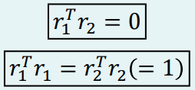
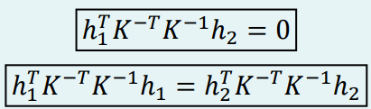
Define:
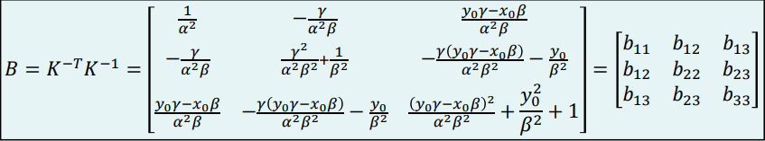

Let the 𝑖th column of 𝐻 be:
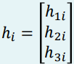
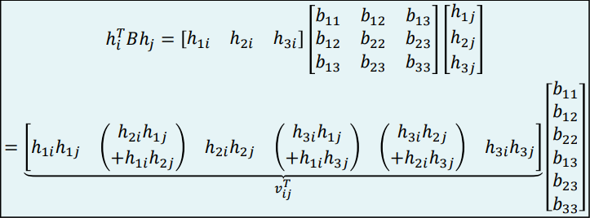
Combining the equations above:
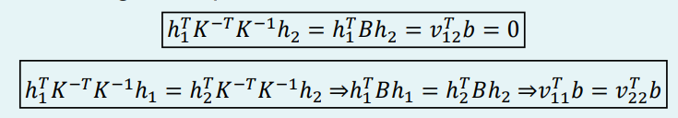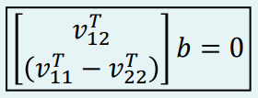
Since we have several H’s, we stack each equation and get:
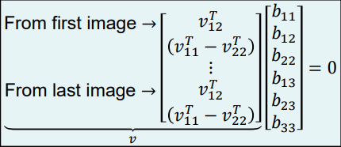
Then again, solve for b using MATLAB SVD, which will also be the last column of V.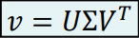
Recover the intrinsic parameters using the below formulas:
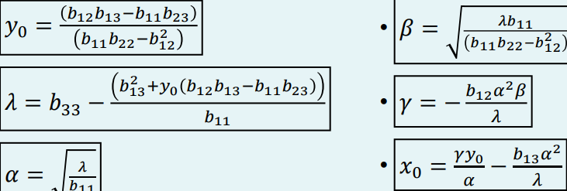
Then, save the K matrix as mat file.
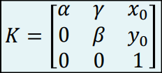
Previously, we have
Now, to guarantee that the above values have the correct scale, we must define a scale:
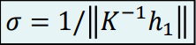
Thus,
