1. Use “[ ]” for names of tables, columns, stored procedures, views, functions etc. (Ex. [TableName])
2. Include the AS keyword for creating aliases, because this makes the code more readable.
3. Avoid the name of a table/column in the plural.
4. CamelCase style for names (ex. EmployeeCity)
5. Use an underscore in a name only if necessary
6. Avoid abbreviations, if you use them, make sure they will be understood
7. Do not start the name with underscore
8. The name of the view starts with vw_, the name of the stored procedure starts with usp_, ufn_ for functions (Ex. ufn_SalaryAverage, usp_WaitStatsInsert, vw_Table1_Table2 ). Put the object name first (in case of db object usage; otherwise, specify the action) and the action second, this way all of the stored procedures for an object will be together.
9. Important comments will be “highlighted” with 1 row of “-----” befor and after or /*** ***/

Ex: a) --------------------------------------------------------------------

--Comment

---------------------------------------------------------------------

b) /*** Comment ***/

1. Multiple line comments will be indicated by /* multi line comm */
2. Alignment:

Ex:

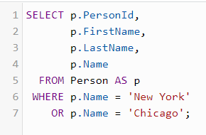

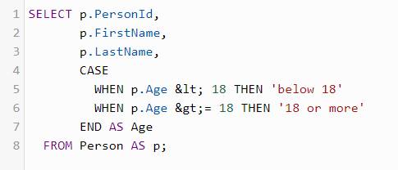

1. If you create a table or a view based on a system table, try to keep the same names for the columns.
2. Constraints should be named by the next rules:

Foreign key 🡪 FK_ColumnName_FirstTable_ReferencedTable

Primary key 🡪 PK_TableName

Check 🡪 CK_SuggestiveName

1. Triggers will be named by the next rule: tr_ObjectName_DMLAction 🡪 Ex. tr_Employee_Insert
2. Indexes will be named by the next rule: ix_ObjectName_ColumnName
   * if there are too many rows, you can skip the object name

Ex.: ix_Employees_EmpId , ix_OrderDetails_OrderNo_OrderDate

1. SQL Agent jobs will be named by the next rule: DBA_ObjectName_JobMainAction_ScheduleOptiona

Ex: DBA_xTrackWMS_FullBackup_Weekly