Managerial Report -Alex Claunch and Finley Hardie

2. Executive Summary

On April 31, a fire consumed part of Superior County, destroying homes and businesses, such as the Superior Building Supply store. The store was severely damaged and had to be shut down for four months (May through August) to repair undergo repair. Superior Building Supply is now disputing with its insurer over lost sales during the four-month shut-down. The dispute is centered on two main issues: (1) determining the sales Superior would have had if the fire had not occurred, and (2) whether Superior can receive extra compensation for over-revenue from business activity boosts in the county due to the fire.

Following the fire, $8 billion in insurance and federal disaster relief funds poured into Superior County. This was used to rebuild homes and businesses, generating a boom in demand for lumber, hardware, and building materials. Consequently, most of the county's lumber and building supply stores experienced their sales soar during the months Superior was closed.

To solve these issues, we conducted a time-series analysis using Superior's sales history for the 48 months prior to the fire and county-level sales history, including the four months following the fire. We utilized multiple regression models, 4 point moving average model, and Naïve model to make the estimate of Superior's sales which would be expected during the time of closure and possible excess sales in the lumber and hardware sector in the county.

Our estimate places Superior Building Supply at losing significant revenue from the four-month closure. Furthermore, there is evidence to suggest that county-wide lumber and hardware sales saw a significant increase due to post-fire reconstruction activities. Based on these findings, we recommend that Superior pursue recovery of a claim for its lost sales as well as a share of the excess fire-related sales that would have been garnered had its store been operational. These results constitute evidence-based data to support Superior's case in its negotiation with the insurance firm.

2. Data Exploration

- Our graphs indicate a seasonal pattern that may have a slight upward trend but is generally horizontal

3. Model Building

Superior Data Analysis
- We used a multiple regression model to
- We decide to use this model because we know it to be accurate and consistent
- Our model has an absolute percent error of about 4 which means 4% error in al of our predictions so our model could be improved

County Data Analysis
- Looking at the county data, we applied three different types of models.
  - Regression
  - 4 period moving average
  - Naive predictions
- Using different models is beneficial to us because it allows us to see how different styles of predictions can give different predictions. Some may be more acurate than others.

4. Accuracy Checking
- In order to know which of our predictive models is the most accurate, we used the method of taking. the mean squared error, mean absolute error, and mean absolute error percentage. You can see our findings below.
- 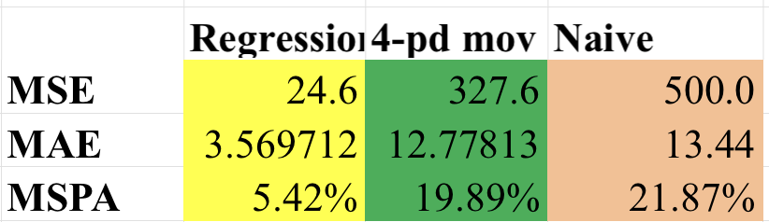
- As you can clearly see, our regression model is the most accurate by far as it beats out our other models in all aspects of accuracy measurement

5. Data Analysis

5.1 Sales Estimate Without Fire
- Had the fire not occurred, we could estimate, in the period the business was shut down, that Superior Building Supplies would have made $13.29 million in profit.
- We used a multiple regression model with dummy variables for months May-March, we then used the linear equation of our regression model to calculate the predicted sales for months May-August.

5.2 County-Wide Sales Estimate Without Fire
- Using a multiple linear regression we found that if the fire had not happened, the county-wide sales would have been roughly 46 million less than the actual sales.
- We also used a 4 period regression model. This technique consists of taking the moving average of the 4 periods before your predicted variable
- The final model we used is by far the least intricate and the least accurate. The naive method consists simply of taking the value from the month (or cell) before from the actual data.
- Refer to the line graphs in the appendix.

5.3 Lost Sales Estimate for Superior (May–August)
- We calculated that there were $1.27 million of lost sales for Superior from May to August.
- We found this my calculating the average market share of SBS in the months before the fire. With this number, we multiplied it with the County actual during the 49th-52nd months which we subtracted the projected from problem 1.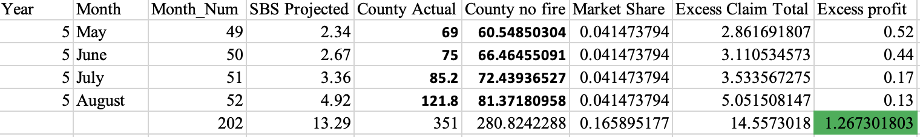

6. Conclusion and Recommendations
Based on our time-series analysis, we estimate that Superior Building Supply lost approximately $13.29 million in sales due to the fire-related closure. Additionally, our analysis suggests that county-wide sales increased significantly due to the post-fire rebuilding efforts, resulting in $1.27 million in additional lost sales that Superior could have captured if it had remained operational. Given these findings, we recommend that Superior Building Supply present the estimated lost sales data to its insurance company as evidence for a higher compensation claim.

7. Appendices

Regression Model for Supperior Regression model for county wide

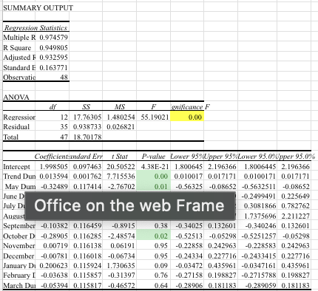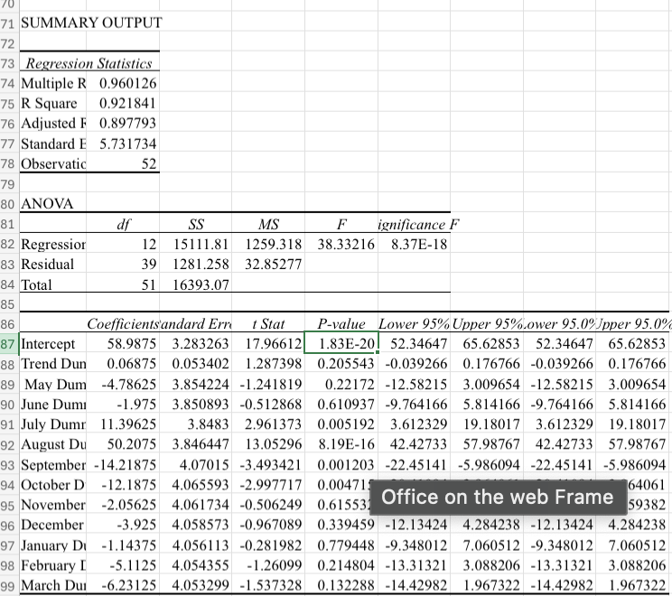

Graphs mention in section 5.

