We have created a financial simulation regarding Franklin Mintage’s retirement portfolio, trying to optimize his retirement savings for the next 20 years, ideally trying to reach a $1,000,000 goal. This report will measure the impact of random variability in salary and portfolio growth. We also tested the projections for Franklin’s portfolio if he decides to work 5 more years, and how that would affect his retirement plan.
Our Key Findings
Baseline Projection:
- Not accounting for variability, Franklin’s portfolio is projected to reach $807,129 in 20 years.
Investment Rate Adjustment (Goal Seek Analysis):
- In order to reach his goal of $1,000,000 in 20 years, Franklin needs to increase his annual investment rate to 8.65%.
Simulation with Variability:
- Salary growth can vary between 0.2% and 5.1% (uniform distribution).
- Portfolio growth generally has a normal distribution (mean: 9.95%, standard deviation: 4.8%).
- The chances of reaching $1,000,000 in 20 years is 18.5%, making it unlikely of reaching his goal in that period of time.
Extended Horizon Analysis (25-Year Projection):
- If Franklin instead works for 25 years, not 20, the probability of his retirement reaching $1,000,000 increases to 99.1%.
Recommendations
- Increase Investment Contributions: Employees should raise their investing rates to higher than 8.65% in order to see returns on their compounding interest.
- Extend Investment Horizons: If able, employees should work more years to see real growth using compound interest.
Conclusion
- This simulation points out the many ways compound interest, along with disciplined financial habits, can pay dividends. By including the various market fluctuations, employees can better understand their risk and adjust their strategies for retirement. Increasing one’s investment rates and extending a couple years into the career, are both effective strategies for seeing long term returns.
Appendix:
Table 1: Baseline Financial Projection
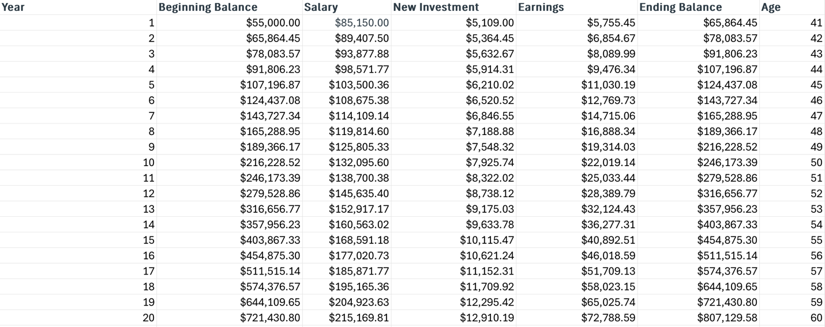
Table 2: Simulated Portfolio Values Over 20 Years
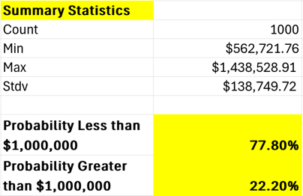
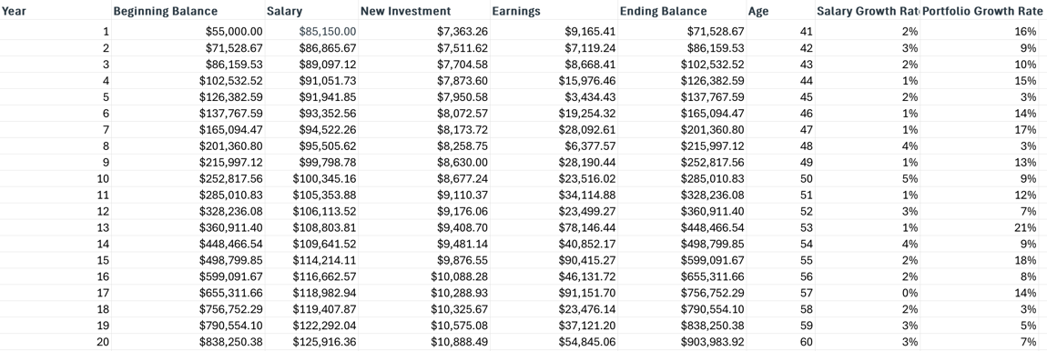
Table 3: Extended Horizon (25 Years) Portfolio Results
