Code includes:

* Sample1_LogReg: Implementation of logistic regression and Bayesian logistic regression
* Sample2_NB_SVM: Implementation of Naïve Bayes and SVM for sentiment analysis. SVM light is used for SVM backend
* Sample3_ExpereimentInfrastructure: Some code I wrote in Matlab to manage experiments with Directed Tabu Search (DTS), a stochastic optimisation procedure
* Sample3_MT_Utils: Sample code from a machine translation task (lattice minimum Bayes Risk (LMBR) decoding). Most of the functions processes paths extracted from SMT lattices using the (good old) *prinstrings* function and calculate n-gram path posteriors
* DecodingStrategies.ipynb is a notebook that contains some LMBR experiments
* Sample4_SS: This is a function I wrote for speech synthesis. It calculates the number of frames to be generated in an utterance and then uses the statistics of duration experts in order to perform frame allocation. While it’s not perfect, it does a pretty nice job (Figures 1 and 2)

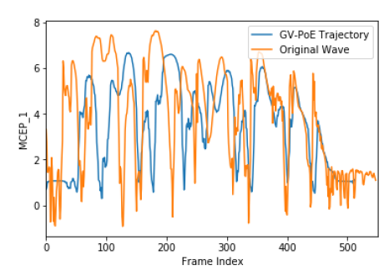

Figure Global Variance Product of Experts trajectory without state alignment

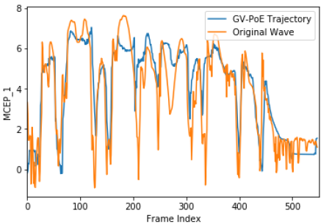

Figure Global Variance Product of Experts trajectory with state alignment