Assignment 7

Processor: Intel(R) Core(TM) i5-8600K 3.60 GHz

Number of cores: 6

Number of logical processors: 6

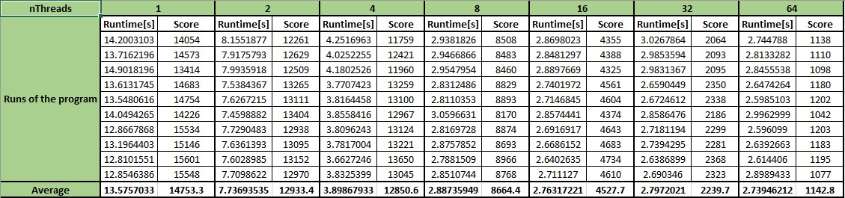

The runtime is decreasing exponentially with the increasing of threads.