НТУУ «КПІ»
ННК ІПСА
Протокол
до лабораторної роботи № 1 з дисципліни
«Комп’ютерні мережі»
Підготував:
студент гр. ДА-82
Мельник О. В.

Київ
2011

Лабораторная робота №1
Тема: Программирование TCP/IP.
Цель:
Ознакомиться с технологией использования протоколов UDP и TCP. Рассмотреть их различия, преимущества и недостатки. Рассмотреть особенности использования этих протоколов на примере программы для пересылки данных между сервером и клиентом.

Задание:
- Написать программу для пересылки данных между сервером TCP и клиентом TCP.
- Написать программу для пересылки данных между сервером UDP и клиентом UDP.
- Проверить ее работу и с помощью анализатора сетевых протоколов сохранить сеанс обмена созданной программы с сервисом.
- Провести анализ сохраненного сетевого сеанса связи с помощью tcptrace и xplot.

Вариант:
6)Переслать 7 чисел типа float.

Приложения клиент и сервер созданы и запущены на ОС семейства Linux и Windows.

// ТСР-сервер Linux

#include <sys/types.h>
#include <sys/socket.h>
#include <netinet/in.h>
#include <stdio.h>
#include <stdlib.h>
#include <iostream>
#include <new>
#include <memory>

int main( )
{
struct sockaddr_in local;
int s; // сокет
int s1; // соединеный сокет
int rc;

local.sin_family = AF_INET;
local.sin_port = htons( 7500 );
local.sin_addr.s_addr = htonl( INADDR_ANY );

s = socket( AF_INET, SOCK_STREAM, 0 );
if( s < 0 )
{
perror( "ошибка вызова socket" );
return 1;
}

rc = bind( s, (struct sockaddr *)&local, sizeof(local));
if( s < 0 )
{
perror( "ошибка вызова bind" );
return 1;
}

rc = listen(s, 5);
if (rc)
{
perror("ошибка вызова listen");
return(1);
}

s1 = accept(s, NULL, NULL);
if (s1 < 0)
{
perror("ошибка вызова accept");
return(1);
}

// получение размера
int* size = new int[1];
float* buf = new float[*size];

rc = recv(s1, size, sizeof(int), 0);
if (rc <= 0)
{
perror("ошибка вызова recv");
return(1);
}
printf("count = %d\n", *size);

// получение данных
for( int i = 0; i != *size; ++i )
{
rc = recv(s1, buf + i, sizeof(float), 0);
if (rc <= 0)
{
perror("ошибка вызова recv");
return(1);
}
printf("%f\n", buf[i]);
}

// отправка данных
for( int i = 0; i != *size; ++i )
{
rc = send(s1, buf + i, sizeof(float), 0);
if( rc <= 0 )
{
perror("ошибка вызова send");
return(1);
}
}
return(0);
}

//-----------------------------------------------------------------------------------

// ТСР-клиент для Windows

#include "stdafx.h"
#define WIN32_LEAN_AND_MEAN
#include <winsock2.h>
#include <Ws2tcpip.h>
#include <stdio.h>

// Link with ws2_32.lib
#pragma comment(lib, "Ws2_32.lib")

int __cdecl main()
{
// Declare and initialize variables.
WSADATA wsaData;
int iResult;

SOCKET s = INVALID_SOCKET;
struct sockaddr_in clientService;

// Initialize Winsock
iResult = WSAStartup( MAKEWORD(2,2), &wsaData );
if ( iResult != NO_ERROR )
{
printf("WSAStartup failed: %d\n", iResult);
return 1;
}

// Create a SOCKET for connecting to server
s = socket(AF_INET, SOCK_STREAM, IPPROTO_TCP);
if (s == INVALID_SOCKET)
{
printf("Error at socket(): %ld\n", WSAGetLastError() );
WSACleanup();
return 1;
}

// The sockaddr_in structure:
// address family, server IP, port
clientService.sin_family = AF_INET;
clientService.sin_addr.s_addr = inet_addr( "192.168.56.102" );
clientService.sin_port = htons( 7501 );

// Connect to server
iResult = connect( s, (SOCKADDR*) &clientService, sizeof(clientService) );
if ( iResult == SOCKET_ERROR )
{
closesocket(s);
printf("Unable to connect to server: %ld\n", WSAGetLastError());
WSACleanup();
return 1;
}

int size = 6;

// Send an initial buffer
iResult = send( s, (char*)&size, sizeof( int ), 0 );
if ( iResult == SOCKET_ERROR )
{
printf("send failed: %d\n", WSAGetLastError());
closesocket(s);
WSACleanup();
return 1;
}

printf("%d floats are to be sent.\n", size);

// Receive until the peer closes the connection
for( int i = 0; i != size; ++i )
{
float f = i;
iResult = send(s, (char*)&f, sizeof(float), 0);
if ( iResult > 0 )
printf("Float sent: %f\n", f);
else
printf("send failed: %d\n", WSAGetLastError());
}

// Shutdown the connection since no more data will be sent
iResult = shutdown(s, SD_SEND);
if (iResult == SOCKET_ERROR) {
printf("shutdown failed: %d\n", WSAGetLastError());
closesocket(s);
WSACleanup();
return 1;
}

float* recvbuf = new float[size];

for( int i = 0; i != size; ++i )
{
iResult = recv(s, (char*)recvbuf, sizeof(float), 0);
if ( iResult > 0 )
printf("Float received: %f\n", *recvbuf);
else if ( iResult == 0 )
printf("Connection closed\n");
else
printf("recv failed: %d\n", WSAGetLastError());
}

// Cleanup
closesocket(s);
WSACleanup();
delete [] recvbuf;
return 0;
}

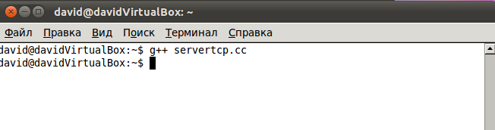

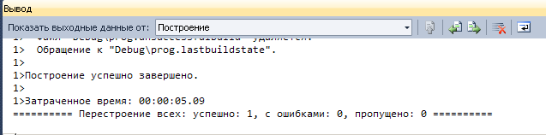

Сначала запущен сервер в режиме ожидания; после принятия соединения происходит обмен:
Успешный обмен через ТСР (Linux server):
Без включенного сервера:
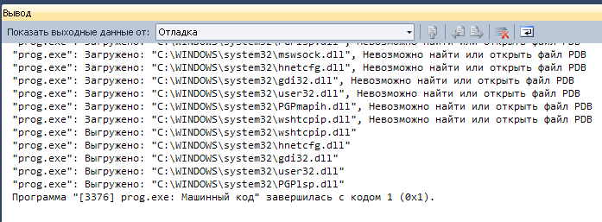

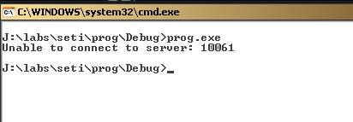

С включенным сервером:

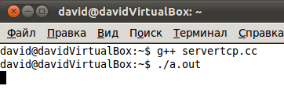
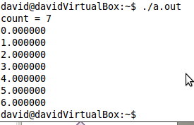
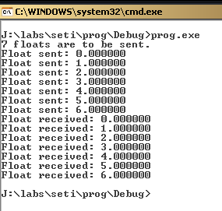

Анализ работы программы произведен:

1) На Linux с помощью утилит tcpdump, tcptrace и xplot.
Перед началом передачи запущен tcpdump в режиме ожидания:

$ sudo tcpdump -n port 7500 -vv -w dump.dmp

Далее данные обработаны tcptrace :
$ tcptrace -l dump.dmp
$ tcptrace -L dump.dmp

и gnuplot:
$ gnuplot a_b_tline.gpl

2) На Windows с помощью утилиты Microsoft Network Monitor.

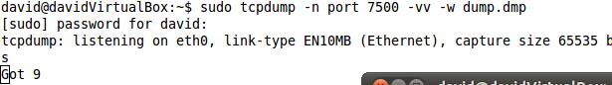

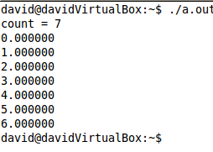

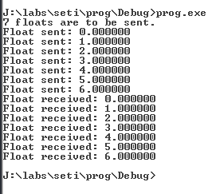

Заголовки пакетов сетевого обмена
1 18:27:30 16.10.2011 4.1123040 NetmonFilter NetmonFilter:Updated Capture Filter: None
2 18:27:30 16.10.2011 4.1123040 NetworkInfoEx NetworkInfoEx:Network info for , Network Adapter Count = 1
3 18:27:30 16.10.2011 4.1123040 System 192.168.56.1 192.168.56.101 TCP TCP:Flags=......S., SrcPort=1329, DstPort=7500, PayloadLen=0, Seq=3483169276, Ack=0, Win=65535 ( ) = 65535 {TCP:2, IPv4:1}
4 18:27:30 16.10.2011 4.1123040 System 192.168.56.1 192.168.56.101 TCP TCP:Flags=...A...., SrcPort=1329, DstPort=7500, PayloadLen=0, Seq=3483169277, Ack=2290759612, Win=65535 (scale factor 0x0) = 65535 {TCP:2, IPv4:1}
5 18:27:30 16.10.2011 4.1123040 System 192.168.56.101 192.168.56.1 TCP TCP:Flags=...A..S., SrcPort=7500, DstPort=1329, PayloadLen=0, Seq=2290759611, Ack=3483169277, Win=14600 ( Scale factor not supported ) = 14600 {TCP:2, IPv4:1}
6 18:27:30 16.10.2011 4.1123040 System 192.168.56.1 192.168.56.101 TCP TCP:Flags=...AP..., SrcPort=1329, DstPort=7500, PayloadLen=4, Seq=3483169277 - 3483169281, Ack=2290759612, Win=65535 (scale factor 0x0) = 65535 {TCP:2, IPv4:1}
7 18:27:30 16.10.2011 4.1132810 System 192.168.56.101 192.168.56.1 TCP TCP:Flags=...A...., SrcPort=7500, DstPort=1329, PayloadLen=0, Seq=2290759612, Ack=3483169281, Win=14600 (scale factor 0x0) = 14600 {TCP:2, IPv4:1}
8 18:27:30 16.10.2011 4.1132810 System 192.168.56.1 192.168.56.101 TCP TCP:Flags=...AP..., SrcPort=1329, DstPort=7500, PayloadLen=4, Seq=3483169281 - 3483169285, Ack=2290759612, Win=65535 (scale factor 0x0) = 65535 {TCP:2, IPv4:1}
9 18:27:30 16.10.2011 4.1132810 System 192.168.56.1 192.168.56.101 TCP TCP:Flags=...AP..., SrcPort=1329, DstPort=7500, PayloadLen=4, Seq=3483169285 - 3483169289, Ack=2290759612, Win=65535 (scale factor 0x0) = 65535 {TCP:2, IPv4:1}
10 18:27:30 16.10.2011 4.1132810 System 192.168.56.101 192.168.56.1 TCP TCP:Flags=...A...., SrcPort=7500, DstPort=1329, PayloadLen=0, Seq=2290759612, Ack=3483169285, Win=14600 (scale factor 0x0) = 14600 {TCP:2, IPv4:1}
11 18:27:30 16.10.2011 4.1132810 System 192.168.56.1 192.168.56.101 TCP TCP:Flags=...AP..., SrcPort=1329, DstPort=7500, PayloadLen=8, Seq=3483169289 - 3483169297, Ack=2290759612, Win=65535 (scale factor 0x0) = 65535 {TCP:2, IPv4:1}
12 18:27:30 16.10.2011 4.1132810 System 192.168.56.1 192.168.56.101 TCP TCP:Flags=...AP..., SrcPort=1329, DstPort=7500, PayloadLen=4, Seq=3483169297 - 3483169301, Ack=2290759612, Win=65535 (scale factor 0x0) = 65535 {TCP:2, IPv4:1}
13 18:27:30 16.10.2011 4.1142570 System 192.168.56.1 192.168.56.101 TCP TCP:Flags=...AP..F, SrcPort=1329, DstPort=7500, PayloadLen=8, Seq=3483169301 - 3483169310, Ack=2290759612, Win=65535 (scale factor 0x0) = 65535 {TCP:2, IPv4:1}
14 18:27:30 16.10.2011 4.1142570 System 192.168.56.101 192.168.56.1 TCP TCP:Flags=...A...., SrcPort=7500, DstPort=1329, PayloadLen=0, Seq=2290759612, Ack=3483169289, Win=14600 (scale factor 0x0) = 14600 {TCP:2, IPv4:1}
15 18:27:30 16.10.2011 4.1142570 System 192.168.56.101 192.168.56.1 TCP TCP:Flags=...A...., SrcPort=7500, DstPort=1329, PayloadLen=0, Seq=2290759612, Ack=3483169297, Win=14600 (scale factor 0x0) = 14600 {TCP:2, IPv4:1}
16 18:27:30 16.10.2011 4.1142570 System 192.168.56.101 192.168.56.1 TCP TCP:Flags=...A...., SrcPort=7500, DstPort=1329, PayloadLen=0, Seq=2290759612, Ack=3483169301, Win=14600 (scale factor 0x0) = 14600 {TCP:2, IPv4:1}
17 18:27:30 16.10.2011 4.1171870 System 192.168.56.101 192.168.56.1 TCP TCP:Flags=...AP..., SrcPort=7500, DstPort=1329, PayloadLen=4, Seq=2290759612 - 2290759616, Ack=3483169310, Win=14600 (scale factor 0x0) = 14600 {TCP:2, IPv4:1}
18 18:27:30 16.10.2011 4.1201170 System 192.168.56.1 192.168.56.101 TCP TCP:Flags=...A...., SrcPort=1329, DstPort=7500, PayloadLen=0, Seq=3483169310, Ack=2290759641, Win=65507 (scale factor 0x0) = 65507 {TCP:2, IPv4:1}
19 18:27:30 16.10.2011 4.1201170 System 192.168.56.101 192.168.56.1 TCP TCP:Flags=...AP..F, SrcPort=7500, DstPort=1329, PayloadLen=24, Seq=2290759616 - 2290759641, Ack=3483169310, Win=14600 (scale factor 0x0) = 14600 {TCP:2, IPv4:1}

Результаты анализа сетевого сеанса программой tcptrace
david@davidVirtualBox:~$ tcptrace -l dump.dmp
1 arg remaining, starting with 'dump.dmp'
Ostermann's tcptrace -- version 6.6.7 -- Thu Nov 4, 2004

9 packets seen, 9 TCP packets traced
elapsed wallclock time: 0:00:10.101135, 0 pkts/sec analyzed
trace file elapsed time: 0:00:00.006681
TCP connection info:
1 TCP connection traced:
TCP connection 1:
host a: 192.168.56.1:4523
host b: 192.168.56.101:7500
complete conn: yes
first packet: Sun Oct 16 17:03:29.396073 2011
last packet: Sun Oct 16 17:03:29.402754 2011
elapsed time: 0:00:00.006681
total packets: 9
filename: dump.dmp
a->b: b->a:
total packets: 5 total packets: 4
ack pkts sent: 4 ack pkts sent: 4
pure acks sent: 2 pure acks sent: 1
sack pkts sent: 0 sack pkts sent: 0
dsack pkts sent: 0 dsack pkts sent: 0
max sack blks/ack: 0 max sack blks/ack: 0
unique bytes sent: 32 unique bytes sent: 28
actual data pkts: 2 actual data pkts: 2
actual data bytes: 32 actual data bytes: 28
rexmt data pkts: 0 rexmt data pkts: 0
rexmt data bytes: 0 rexmt data bytes: 0
zwnd probe pkts: 0 zwnd probe pkts: 0
zwnd probe bytes: 0 zwnd probe bytes: 0
outoforder pkts: 0 outoforder pkts: 0
pushed data pkts: 2 pushed data pkts: 2
SYN/FIN pkts sent: 1/1 SYN/FIN pkts sent: 1/1
req sack: Y req sack: Y
sacks sent: 0 sacks sent: 0
urgent data pkts: 0 pkts urgent data pkts: 0 pkts
urgent data bytes: 0 bytes urgent data bytes: 0 bytes
mss requested: 1460 bytes mss requested: 1460 bytes
max segm size: 28 bytes max segm size: 24 bytes
min segm size: 4 bytes min segm size: 4 bytes
avg segm size: 15 bytes avg segm size: 13 bytes
max win adv: 65535 bytes max win adv: 14600 bytes
min win adv: 65507 bytes min win adv: 14600 bytes
zero win adv: 0 times zero win adv: 0 times
avg win adv: 65529 bytes avg win adv: 14600 bytes
initial window: 4 bytes initial window: 28 bytes
initial window: 1 pkts initial window: 2 pkts
ttl stream length: 32 bytes ttl stream length: 28 bytes
missed data: 0 bytes missed data: 0 bytes
truncated data: 0 bytes truncated data: 0 bytes
truncated packets: 0 pkts truncated packets: 0 pkts
data xmit time: 0.000 secs data xmit time: 0.002 secs
idletime max: 5.5 ms idletime max: 2.1 ms
throughput: 4790 Bps throughput: 4191 Bps

david@davidVirtualBox:~$ tcptrace -L dump.dmp

Warning: You have chosen the option '-L' to plot Time Line Graphs.
This option is yet under development and may not reflect accurate results.
Please take a look at the file README.tline_graphs for more details.

1 arg remaining, starting with 'dump.dmp'
Ostermann's tcptrace -- version 6.6.7 -- Thu Nov 4, 2004

9 packets seen, 9 TCP packets traced
elapsed wallclock time: 0:00:10.096872, 0 pkts/sec analyzed
trace file elapsed time: 0:00:00.006681
TCP connection info:
1: 192.168.56.1:4523 - 192.168.56.101:7500 (a2b) 5> 4< (complete)

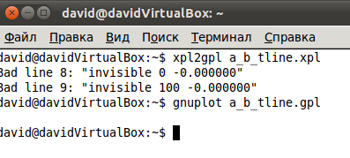

Временную и time sequence диаграммы, полученные с помощью tcptrace и gnuplot.
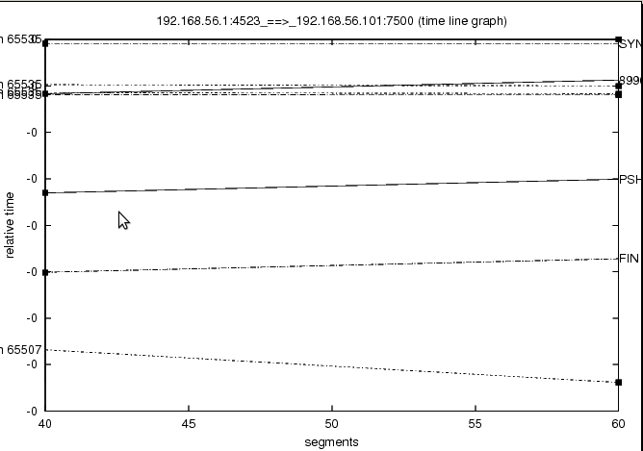

//----------------------------------------------------------------------------------------------------------------------

// UDP-сервер Linux

#include <sys/types.h>
#include <sys/socket.h>
#include <netinet/in.h>
#include <stdio.h>
#include <stdlib.h>
#include <iostream>
#include <new>
#include <memory>
#include <arpa/inet.h>

int main( )
{
struct sockaddr_in serv_addr;
int s;
int rc;
s = socket( AF_INET, SOCK_DGRAM, 0 );
if( s < 0 )
{
perror( "ошибка вызова socket" );
return 1;
}

// Bind the socket to any address and the specified port.
serv_addr.sin_family = AF_INET;
serv_addr.sin_port = htons( 7501 );
serv_addr.sin_addr.s_addr = htonl( INADDR_ANY );

rc = bind( s, (struct sockaddr *)&serv_addr, sizeof(serv_addr));
if( s < 0 )
{
perror( "ошибка вызова bind" );
return 1;
}

struct sockaddr_in cli_addr;
socklen_t clilen = sizeof(cli_addr);

int* size = new int[1];
float* buf = new float[*size];

rc = recvfrom(s, size, sizeof(int), 0, (struct sockaddr *)&cli_addr, &clilen);
if (rc < 0)
{
perror("ошибка вызова recv");
return(1);
}
printf("count = %d\n", *size);

// получение данных
for( int i = 0; i != *size; ++i )
{
rc = recvfrom(s, buf + i, sizeof(float), 0, (struct sockaddr *)&cli_addr, &clilen);
if (rc <= 0)
{
perror("ошибка вызова recv");
return(1);
}
printf("%f\n", buf[i]);
}

// отправка данных
for( int i = 0; i != *size; ++i )
{
rc = sendto(s, buf + i, sizeof(float), 0, (struct sockaddr *)&cli_addr, clilen);
if( rc <= 0 )
{
perror("ошибка вызова send");
return(1);
}
}
return 0;
}

//-----------------------------------------------------------------------------------

// UDP-клиент для Windows

// prog.cpp: определяет точку входа для консольного приложения.
//

#include "stdafx.h"
#define WIN32_LEAN_AND_MEAN
#include <winsock2.h>
#include <Ws2tcpip.h>
#include <stdio.h>

// Link with ws2_32.lib
#pragma comment(lib, "Ws2_32.lib")

int __cdecl main()
{
// Declare and initialize variables.
WSADATA wsaData;
int iResult;

SOCKET s = INVALID_SOCKET;
struct sockaddr_in clientService;

// Initialize Winsock
iResult = WSAStartup( MAKEWORD(2,2), &wsaData );
if ( iResult != NO_ERROR )
{
printf("WSAStartup failed: %d\n", iResult);
return 1;
}

// Create a SOCKET for connecting to server
s = socket(AF_INET, SOCK_DGRAM, IPPROTO_UDP);
if (s == INVALID_SOCKET)
{
printf("Error at socket(): %ld\n", WSAGetLastError() );
WSACleanup();
return 1;
}

// The sockaddr_in structure:
// address family, server IP, port
clientService.sin_family = AF_INET;
clientService.sin_addr.s_addr = inet_addr( "192.168.56.101" );
clientService.sin_port = htons( 7501 );

int size = 6;
int servSize = sizeof(clientService);

// Send an initial buffer
iResult = sendto( s, (char*)&size, sizeof(int), 0, (SOCKADDR*) &clientService, sizeof(clientService) );
if ( iResult == SOCKET_ERROR )
{
printf("send failed: %d\n", WSAGetLastError());
closesocket(s);
WSACleanup();
return 1;
}

printf("%d floats are to be sent.\n", size);

// Receive until the peer closes the connection
for( int i = 0; i != size; ++i )
{
float f = i;
iResult = sendto(s, (char*)&f, sizeof(float), 0, (SOCKADDR*) &clientService, servSize );
if ( iResult > 0 )
printf("Float sent: %f\n", f);
else
printf("sendto failed: %d\n", WSAGetLastError());
}

// Shutdown the connection since no more data will be sent
iResult = shutdown(s, SD_SEND);
if (iResult == SOCKET_ERROR) {
printf("shutdown failed: %d\n", WSAGetLastError());
closesocket(s);
WSACleanup();
return 1;
}

float* recvbuf = new float[size];

for( int i = 0; i != size; ++i )
{
iResult = recvfrom( s, (char*)recvbuf, sizeof(float), 0, (SOCKADDR*) &clientService, &servSize );
if ( iResult > 0 )
printf("Float received: %f\n", *recvbuf);
else if ( iResult == 0 )
printf("Connection closed\n");
else
printf("recvfrom failed: %d\n", WSAGetLastError());
}

// Cleanup
closesocket(s);
WSACleanup();
delete [] recvbuf;
return 0;
}

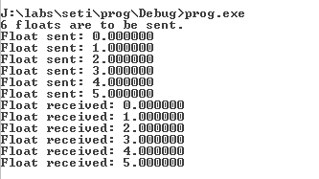

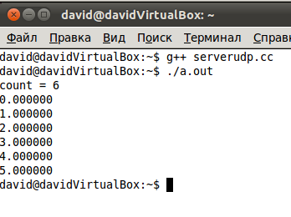
david@davidVirtualBox:~$ tcptrace -l dump.dmp
1 arg remaining, starting with 'dump.dmp'
Ostermann's tcptrace -- version 6.6.7 -- Thu Nov 4, 2004

13 packets seen, 0 TCP packets traced
elapsed wallclock time: 0:00:00.003259, 3988 pkts/sec analyzed
trace file elapsed time: 0:00:00.004399
no traced TCP packets

david@davidVirtualBox:~$ tcptrace -L dump.dmp

Warning: You have chosen the option '-L' to plot Time Line Graphs.
This option is yet under development and may not reflect accurate results.
Please take a look at the file README.tline_graphs for more details.

1 arg remaining, starting with 'dump.dmp'
Ostermann's tcptrace -- version 6.6.7 -- Thu Nov 4, 2004

13 packets seen, 0 TCP packets traced
elapsed wallclock time: 0:00:00.003951, 3289 pkts/sec analyzed
trace file elapsed time: 0:00:00.004399
no traced TCP packets

1 19:17:07 16.10.2011 0.6552730 NetmonFilter NetmonFilter:Updated Capture Filter: None
2 19:17:07 16.10.2011 0.6552730 NetworkInfoEx NetworkInfoEx:Network info for , Network Adapter Count = 1
3 19:17:07 16.10.2011 0.6552730 System 192.168.56.1 192.168.56.101 TCP TCP:[Keep alive]Flags=...A...., SrcPort=NETBIOS Session Service(139), DstPort=50165, PayloadLen=1, Seq=839845351 - 839845352, Ack=1252178448, Win=64579 {TCP:2, IPv4:1}
4 19:17:07 16.10.2011 0.6552730 System 192.168.56.101 192.168.56.1 TCP TCP:[Keep alive ack]Flags=...A...., SrcPort=50165, DstPort=NETBIOS Session Service(139), PayloadLen=0, Seq=1252178448, Ack=839845352, Win=557 {TCP:2, IPv4:1}
5 19:17:12 16.10.2011 5.6562500 192.168.56.1 192.168.56.101 ARP ARP:Response, 192.168.56.1 at 08-00-27-00-E0-4E
6 19:17:12 16.10.2011 5.6562500 192.168.56.101 192.168.56.1 ARP ARP:Request, 192.168.56.101 asks for 192.168.56.1
7 19:17:13 16.10.2011 7.0625000 192.168.56.1 192.168.56.101 UDP UDP:SrcPort = 1640, DstPort = 7501, Length = 12 {UDP:3, IPv4:1}
8 19:17:13 16.10.2011 7.0625000 192.168.56.1 192.168.56.101 UDP UDP:SrcPort = 1640, DstPort = 7501, Length = 12 {UDP:3, IPv4:1}
9 19:17:13 16.10.2011 7.0625000 192.168.56.1 192.168.56.101 UDP UDP:SrcPort = 1640, DstPort = 7501, Length = 12 {UDP:3, IPv4:1}
10 19:17:13 16.10.2011 7.0634760 192.168.56.1 192.168.56.101 UDP UDP:SrcPort = 1640, DstPort = 7501, Length = 12 {UDP:3, IPv4:1}
11 19:17:13 16.10.2011 7.0634760 192.168.56.1 192.168.56.101 UDP UDP:SrcPort = 1640, DstPort = 7501, Length = 12 {UDP:3, IPv4:1}
12 19:17:13 16.10.2011 7.0634760 192.168.56.1 192.168.56.101 UDP UDP:SrcPort = 1640, DstPort = 7501, Length = 12 {UDP:3, IPv4:1}
13 19:17:13 16.10.2011 7.0634760 192.168.56.1 192.168.56.101 UDP UDP:SrcPort = 1640, DstPort = 7501, Length = 12 {UDP:3, IPv4:1}
14 19:17:13 16.10.2011 7.0673820 192.168.56.101 192.168.56.1 UDP UDP:SrcPort = 7501, DstPort = 1640, Length = 12 {UDP:3, IPv4:1}
15 19:17:13 16.10.2011 7.0673820 192.168.56.101 192.168.56.1 UDP UDP:SrcPort = 7501, DstPort = 1640, Length = 12 {UDP:3, IPv4:1}
16 19:17:13 16.10.2011 7.0673820 192.168.56.101 192.168.56.1 UDP UDP:SrcPort = 7501, DstPort = 1640, Length = 12 {UDP:3, IPv4:1}
17 19:17:13 16.10.2011 7.0673820 192.168.56.101 192.168.56.1 UDP UDP:SrcPort = 7501, DstPort = 1640, Length = 12 {UDP:3, IPv4:1}
18 19:17:13 16.10.2011 7.0673820 192.168.56.101 192.168.56.1 UDP UDP:SrcPort = 7501, DstPort = 1640, Length = 12 {UDP:3, IPv4:1}
19 19:17:13 16.10.2011 7.0673820 192.168.56.101 192.168.56.1 UDP UDP:SrcPort = 7501, DstPort = 1640, Length = 12 {UDP:3, IPv4:1}
20 19:17:15 16.10.2011 8.9042960 System 192.168.56.1 192.168.56.101 TCP TCP:[Keep alive]Flags=...A...., SrcPort=NETBIOS Session Service(139), DstPort=50166, PayloadLen=1, Seq=2183463110 - 2183463111, Ack=1384632635, Win=64210 {TCP:4, IPv4:1}
21 19:17:15 16.10.2011 8.9042960 System 192.168.56.101 192.168.56.1 TCP TCP:[Keep alive ack]Flags=...A...., SrcPort=50166, DstPort=NETBIOS Session Service(139), PayloadLen=0, Seq=1384632635, Ack=2183463111, Win=602 {TCP:4, IPv4:1}

Выводы. Основные преимущества, достоинства и недостатки протоколов TCP и UDP.
Протокол ТСР является более надежным, но в то же время медленным в сравнении с UDP. Пакеты, передаваемые ТСР наверняка достигают удаленного пункта назначения. Этот протокол больше подходит для предачи данных между различными сетями через роутеры. UDP является ненадежным в таких случаях, но необходим в ситуациях, когда скорость критична, а расстояние передачи и вероятность потерь невелики.

