HU Extension Assignment 09 E185 Big Data Analytics

Issuded on: April 13, 2013 Due by 17:25PM, April 19, 2013

An illustrative application of Bayes’ Theorem

Suppose we are interested in a rare syntactic construction, parasitic gap, which occur on average once in 100,000 sentences.
Peggy the Linguist has developed a complicated pattern matcher that attempts to identify sentences with parasitic gap. It is pretty good, but it is not perfect: if a sentence has a parasitic gap, it will say so with probability 0.95, if it doesn't, it will wrongly say so with probability 0.005.
Suppose the test says that a sentence contains a parasitic gap. What is the probability that this is true?

Solution
According to the problem, we have:
p(gap) = 1/100000 – the probability of a gap
p(pos | gap) = 0.95 – the probability the system will give the positive result if there is a gap
p(pos | 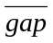) = 0.005 – the probability the system will give the positive result if there is no gap
p(gap | pos) = ? – the probability that a sentence contains a parasitic gap if the system gives the positive result

According to Bayes formula:
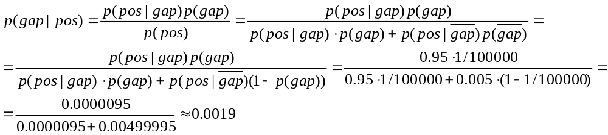

Problem 1. Public officials estimate the incidence of the HIV virus in the general population is about 0.5 percent. A test is introduced which when given to people with HIV correctly identifies the virus 95 percent of the time. The test also gives a false positive 5 percent of the time. That is the test result could be positive even though the person does not have HIV. Of the people who test positive, what percent of them we actually expect to have the virus.
Note on problem 1. The purpose of this problem is to illustrate the benefits and sometimes unexpected results produced by the Bayes theorem.

Problem 2. Please reproduce results for Mahout Recommender as described in lecture note on pages 15 to 19. Once you extract recommendations for several users. Go into ratings.csv file and lower ratings for one of the recommended movies. You can use Vi and globally reduce scores for a selected movie to 1, or 3. Examine whether change of score affected the result of the recommender.

Problem 3. Please reproduce results for Mahout Classifier as described on pages 43 to 48 of lecture notes. Select two or three junk emails from your junk folder and examine how will Mahout classifier treat them.

Problem 4. On Mahout wiki there is a small tutorial on synthetic data ( https://cwiki.apache.org/confluence/display/MAHOUT/Clustering+of+synthetic+control+data ). Please run the tutorial for K-means and one other clustering algorithm of your choice. Compare the results of those two clustering algorithms.

Please describe every step of your work and present all intermediate and final results in a Word document. Please submit to the class drop box. For issues and comments please visit the class Discussion Board or send emails to cscie185@fas.harvard.edu

