HU Extension Assignment 01 E-185 Big Data Analytics
Alexandre de Melo Correia Pinto
Problem 1. When you open R Studio, go to the text editor in the top left corner first. Type all commands in the text editor. Execute one or several commands by highlighting those commands, holding Ctrl key and hitting Return button. In that way you are preserving your work as a script. You are advised to read help pages for all R functions you will use.
a) Ask the system for the current working directory. On your operating system, create a special directory for work with R, something like C:\Code\R or /code/R. Make that directory both readable and writable.

> getwd()
[1] "/Users/alexcp/Dropbox/Courses"

b) Change your working directory to the new directory using appropriate R function. Copy the attached file Smokers.txt to your new directory.

> setwd("/Users/alexcp/Dropbox/Courses/Harvard/cscie185-hw/Assign01")
> getwd()
[1] "/Users/alexcp/Dropbox/Courses/Harvard/cscie185-hw/Assign01"

c) Create a vector vv with elements which repeat numbers 1,2,3 five times, using functions rep() and c(). What is the length of you vector. Do not just tell us, please as R to tell you the length. Save that vector into a file in your working directory using function save(). Initially, name your file vv.RData. Try to
open the file with an editor like Vim or notepad. Please do not change anything in the file.

> vv <- c(rep(1,5), rep(2,5), rep(3,5))
> vv
[1] 1 1 1 1 1 2 2 2 2 2 3 3 3 3 3
> length(vv)
[1] 15
> save("vv", file = "vv.RData")
$ cat vv.RData
?
r?0??b```b`?bf ?? H02?0p???Ê€$??`B??4q4??x?S?$

d) Save your vector vv into another file, called vv.txt. This time turn the ascii parameter of save() function to TRUE. Try reading your file. Could you do it this time?

> save("vv", file = "vv.txt", ascii = TRUE)
$ cat vv.txt
RDA2
A
2
134914
131840
1026
1
262153
2
vv
14
15
1
1
1
1
1
2
2
2
2
2
3
3
3
3
3
254

e) Use R function list.files() to list the content of your working directory.

> list.files()
[1] "e185_Assign01_Intro_to_R.pdf"
[2] "E185_DeMeloCorreiaPintoAlexandreHW01.txt"
[3] "Smokers.txt"
[4] "vv.RData"
[5] "vv.txt"

f) Point function list.files() to any other directory and assign its result to a variable. What is the class of that variable? (Hint, use function class()). What is the structure of variable vv. (Hint, use function str()). What is the mode of variable vv. (Hint, use function mode()).

> file_list = list.files(path = "/Users/alexcp/Dropbox/Courses/Harvard")
> file_list
[1] "Add Course.pdf" "cscie185-hw"
[3] "New Student.pdf" "Syllabus_E185_Spring2013.pdf"
> class(file_list)
[1] "character"
> str(vv)
num [1:15] 1 1 1 1 1 2 2 2 2 2 ...
> mode(vv)
[1] "numeric"

g) Remove variable vv from your workspace. Next, load that variable from file vv.RData. Verify that you got whatever you stored.

> vv
[1] 1 1 1 1 1 2 2 2 2 2 3 3 3 3 3
> rm(vv)
> vv
Error: object 'vv' not found
> load("vv.RData")
> vv
[1] 1 1 1 1 1 2 2 2 2 2 3 3 3 3 3

h) Remove variable vv from your workspace, again. This time, load that variable from file vv.txt. Again, verify that you have recovered your variable.

> vv
[1] 1 1 1 1 1 2 2 2 2 2 3 3 3 3 3
> rm(vv)
> vv
Error: object 'vv' not found
> load("vv.txt")
> vv
[1] 1 1 1 1 1 2 2 2 2 2 3 3 3 3 3

i) Save the content of your text editor as a file with extension R. You can rerun all commands in that file as a script, if you want, one day. You might want to edit the file first, but that is another matter. Provide that file as a part of your submission.

Saved as Problem1.R

j) Close R Studio. Do not forget to save your workspace. Restart R Studio. Convince yourself that all of your variables are there.

[Workspace loaded from ~/Dropbox/Courses/Harvard/cscie185-hw/Assign01/.RData]

> vv
[1] 1 1 1 1 1 2 2 2 2 2 3 3 3 3 3
> file_list
[1] "Add Course.pdf" "cscie185-hw"
[3] "New Student.pdf" "Syllabus_E185_Spring2013.pdf"

Problem 2. Create a vector num of numbers with 8 randomly ordered values between 1 and 20. Use c() function.

a) Turn that vector into another vector of characters cnum using function as.character().

> sample(20, 8)
[1] 2 16 14 5 1 19 18 15
> num <- c(2, 16, 14, 5, 1, 19, 18, 15)
> num
[1] 2 16 14 5 1 19 18 15
> cnum <- as.character(num)
> cnum
[1] "2" "16" "14" "5" "1" "19" "18" "15"

b) Calculate minimum, maximum and mean value of two vectors.

> min(num)
[1] 1
> max(num)
[1] 19
> mean(num)
[1] 11.25
> min(cnum)
[1] "1"
> max(cnum)
[1] "5"
> mean(cnum)
[1] NA
Warning message:
In mean.default(cnum) : argument is not numeric or logical: returning NA

c) Transform vector cnum back into numbers using function as.numeric(). Verify that you got numbers back.

> cnum <- as.numeric(cnum)
> cnum
[1] 2 16 14 5 1 19 18 15

d) Create another vector snum by selecting only those numbers from vector num which are greater than 10.

> snum <- cnum[cnum>10]
> snum
[1] 16 14 19 18 15

e) Create a logical vector lnum which will tell you whether an entry in vector cnum is greater than 10.

> lnum <- cnum>10
> lnum
[1] FALSE TRUE TRUE FALSE FALSE TRUE TRUE TRUE

f) Set 3rd element of vector cnum to NA. Recreate logical vector lnum and report its elements. Recreate vector snum by selecting those elements of vector cnum which are greater than 10. What was the effect of NA.

> cnum[3] <- NA
> cnum
[1] 2 16 NA 5 1 19 18 15
> lnum <- cnum>10
> lnum
[1] FALSE TRUE NA FALSE FALSE TRUE TRUE TRUE
> snum <- cnum[cnum>10]
> snum
[1] 16 NA 19 18 15

The NA propagates on the operations performed, to help reinforce that the observation is inexistent and should not be ignored.

g) Create a character vector cdate with three dates between January 01, 2013 and March 01, 2013. As the format for character representation of dates use “January-01-2013”. Transform that vector into vector ddate of Dates class using function as.Date() and format "%B-%d-%Y". Please read help for as.Dates(). What are the class and mode of vector ddate. Display values of vector ddate. Sort values in vector ddate. Provide the information on the order that sorting imposed, in other words ask R to tell once sorted which elements came first, which second, and so on.

> cdate <- c("January-20-2013", "February-25-2013", "February-09-2013")
> cdate
[1] "January-20-2013" "February-25-2013" "February-09-2013"
> ddate <- as.Date(cdate, format="%B-%d-%Y")
> class(ddate)
[1] "Date"
> mode(ddate)
[1] "numeric"
> ddate
[1] "2013-01-20" "2013-02-25" "2013-02-09"
> sort(ddate)
[1] "2013-01-20" "2013-02-09" "2013-02-25"
> order(ddate)
[1] 1 3 2

Problem 3. Create matrix A with 3 rows and 4 columns. Use small integer values between -3 and 3 for elements of matrix A.

a) Create new matrix B obtained by subtracting -1 from all elements of matrix A.

> X <- c(-3, -2, -3, 0, 3, -2, 3, -1, -1, 2, 3, -1)
> X
[1] -3 -2 -3 0 3 -2 3 -1 -1 2 3 -1
> A <- matrix(X, nrow=3, ncol=4)
> A
[,1] [,2] [,3] [,4]
[1,] -3 0 3 2
[2,] -2 3 -1 3
[3,] -3 -2 -1 -1
> B <- A - 1
> B
[,1] [,2] [,3] [,4]
[1,] -4 -1 2 1
[2,] -3 2 -2 2
[3,] -4 -3 -2 -2

b) Create new matrix C obtained by multiplying by 2 all elements of matrix A.
> C <- 2 * A
> C
[,1] [,2] [,3] [,4]
[1,] -6 0 6 4
[2,] -4 6 -2 6
[3,] -6 -4 -2 -2

c) Create matric TA which is a transpose of A.
> TA <- t(A)
> TA
[,1] [,2] [,3]
[1,] -3 -2 -3
[2,] 0 3 -2
[3,] 3 -1 -1
[4,] 2 3 -1

d) Calculate matrix ATA which is a matrix product of matrix A multiplied by matrix TA from the right. Ask R to tell you dimensions of matrix ATA.
> ATA <- A %*% TA
> ATA
[,1] [,2] [,3]
[1,] 22 9 4
[2,] 9 23 -2
[3,] 4 -2 15
> dim(ATA)
[1] 3 3

e) Calculate matrix TAA whish is a matrix product of matrix TA multiplied by matrix A from the right. Ask R to tell you dimensions of matrix TAA.

> TAA <- TA %*% A
> TAA
[,1] [,2] [,3] [,4]
[1,] 22 0 -4 -9
[2,] 0 13 -1 11
[3,] -4 -1 11 4
[4,] -9 11 4 14
> dim(TAA)
[1] 4 4

f) Determine matrix AAT which is an inverse of matrix TAA. Prove that AAT multiplied by TAA produces a unit matrix. Unit matrix has all elements on the diagonal equal to 1 and all other elements equal to 0.
> AAT <- solve(TAA)
Error in solve.default(TAA) :
system is computationally singular: reciprocal condition number = 2.30319e-18

Since the matrix has a determinant ~ 0, I will change one of the indexes to make it invertible

> TAA[3,2] = 8
> AAT <- solve(TAA)
> AAT
[,1] [,2] [,3] [,4]
[1,] 0.12279238 -0.1492143 -0.04491726 0.2090113
[2,] -0.12418301 0.3071895 0.11111111 -0.3529412
[3,] 0.07898762 -0.1729940 0.04018913 0.1752190
[4,] 0.15394243 -0.2878598 -0.12765957 0.4330413
> I <- AAT %*% TAA
> I
[,1] [,2] [,3] [,4]
[1,] 1.000000e+00 -4.440892e-16 0.000000e+00 0.000000e+00
[2,] -4.440892e-16 1.000000e+00 2.220446e-16 8.881784e-16
[3,] 2.220446e-16 -2.220446e-16 1.000000e+00 -4.440892e-16
[4,] 0.000000e+00 -8.881784e-16 2.220446e-16 1.000000e+00
> round(I)
[,1] [,2] [,3] [,4]
[1,] 1 0 0 0
[2,] 0 1 0 0
[3,] 0 0 1 0
[4,] 0 0 0 1

Problem 4. Load data in attached file Smokers.txt into variable smokers using function read.delim(). Use parameters header=TRUE, instructing R to read column header names from the first row of the file, and sep=”\t”, telling R that file is tab delimited. As a side note, parameter header=TRUE works only if the first row of the data file has one element fewer than the rest of the file.

a) What are the class, mode and str(ucture) of variable smokers.
> smokers <- read.delim("Smokers.txt", header = TRUE, sep="\t")
> class(smokers)
[1] "data.frame"
> mode(smokers)
[1] "list"
> str(smokers)
'data.frame': 48 obs. of 4 variables:
$ Country : Factor w/ 48 levels "Afghanistan",..: 13 26 10 40 5 4 18 27 3 24 ...
$ PercentSmokes: int 40 37 37 37 37 37 36 36 36 36 ...
$ GDPPerCapita : Factor w/ 42 levels "1,000","1,100",..: 24 20 8 7 36 14 18 12 32 22 ...
$ GDPRank : int 146 49 78 82 106 174 55 64 113 148 ...

b) What are the dimensions of variable smokers.
> dim(smokers)
[1] 48 4

c) What are the labels (names of horizontal rows) of variable smokers.
> labels(smokers)
[[1]]
[1] "1" "2" "3" "4" "5" "6" "7" "8" "9" "10" "11" "12" "13"
[14] "14" "15" "16" "17" "18" "19" "20" "21" "22" "23" "24" "25" "26"
[27] "27" "28" "29" "30" "31" "32" "33" "34" "35" "36" "37" "38" "39"
[40] "40" "41" "42" "43" "44" "45" "46" "47" "48"

[[2]]
[1] "Country" "PercentSmokes" "GDPPerCapita" "GDPRank"

> labels(smokers)[[2]]
[1] "Country" "PercentSmokes" "GDPPerCapita" "GDPRank"

d) List values in individual columns of variable smokers.
> smokers
Country PercentSmokes GDPPerCapita GDPRank
1 Cuba 40 4,000 146
2 Kuwait 37 23,100 49
3 Chile 37 12,700 78
4 Russia 37 12,200 82
5 Belarus 37 8,100 106
6 Bangladesh 37 2,300 174
7 Estonia 36 20,300 55
8 Latvia 36 16,000 64
9 Azerbaijan 36 7,500 113
10 Indonesia 36 3,900 148
11 Kazakhstan 35 9,400 90
12 Lithuania 34 15,300 66
13 Argentina 33 15,200 67
14 China 33 7,700 109
15 Ukraine 32 7,800 108
16 Vietnam 32 3,100 160
17 Cyprus 31 23,000 50
18 Slovakia 31 18,200 61
19 Mauritania 31 2,600 169
20 SouthAfrica 30 13,300 76
21 Burundi 30 700 224
22 Nigeria 6 1,500 198
23 ElSalvador 8 4,900 133
24 Ghana 8 2,700 167
25 Afghanistan 9 800 221
26 Ethiopia 9 1,000 211
27 Peru 10 6,600 119
28 Nicaragua 10 3,100 159
29 Togo 10 1,700 191
30 SriLanka 11 4,700 138
31 Ecuador 11 4,500 141
32 Niger 11 1,000 215
33 Panama 12 8,200 104
34 Cameroon 12 2,400 172
35 DominicanRepublic 12 8,400 102
36 Guatemala 12 5,000 130
37 Bolivia 13 3,100 157
38 Nepal 14 1,500 197
39 Honduras 14 3,100 158
40 Tajikistan 14 1,300 205
41 Mali 14 1,300 203
42 Madagascar 14 900 218
43 Benin 14 1,100 209
44 Uganda 15 1,900 186
45 Paraguay 15 4,800 136
46 HongKong 15 37,300 14
47 Malawi 15 600 229
48 Colombia 15 8,600 99

e) You have noticed that R interpreted column GDPPerCapita as a factor, i.e. a low cardinality column that could be represented by a small number of levels. R made a mistake and we want that column to be a set of integers just like column GDPRank. You can remove factors from column GDPPerCapita by using
function droplevels(). Verify that offending factor is gone by redisplaying the structure of variable smokers.

droplevels() does not seem to work. Accomplished the objective by doing the following:

> smokers$GDPPerCapita <- as.numeric(gsub(",","",smokers$GDPPerCapita))
> str(smokers)
'data.frame': 48 obs. of 4 variables:
$ Country : Factor w/ 48 levels "Afghanistan",..: 13 26 10 40 5 4 18 27 3 24 ...
$ PercentSmokes: int 40 37 37 37 37 37 36 36 36 36 ...
$ GDPPerCapita : num 4000 23100 12700 12200 8100 2300 20300 16000 7500 3900 ...
$ GDPRank : int 146 49 78 82 106 174 55 64 113 148 ...

f) Display columns PercentSmokers and GDPPerCapita using bracket notation or [, index] selection.

> smokers[,c("PercentSmokes", "GDPPerCapita")]
PercentSmokes GDPPerCapita
1 40 4000
2 37 23100
3 37 12700
4 37 12200
5 37 8100
6 37 2300
7 36 20300
8 36 16000
9 36 7500
10 36 3900
11 35 9400
12 34 15300
13 33 15200
14 33 7700
15 32 7800
16 32 3100
17 31 23000
18 31 18200
19 31 2600
20 30 13300
21 30 700
22 6 1500
23 8 4900
24 8 2700
25 9 800
26 9 1000
27 10 6600
28 10 3100
29 10 1700
30 11 4700
31 11 4500
32 11 1000
33 12 8200
34 12 2400
35 12 8400
36 12 5000
37 13 3100
38 14 1500
39 14 3100
40 14 1300
41 14 1300
42 14 900
43 14 1100
44 15 1900
45 15 4800
46 15 37300
47 15 600
48 15 8600

g) Use function plot to try to understand whether there is any correlation between variables PercentSmokers (that is the number of people of a country who smoke) and its Gross Domestic product Per Capita. We are just practicing syntax. There may not be any correlation. Please label horizontal and vertical axis and place a title on top of the graph. Represent points on the graph with circles.

plot(smokers$PercentSmokes, smokers$GDPPerCapita, xlab = "Percent of Smokers", ylab = "GDP Per Capita", main = "Percent of Smokers X GDP Per Capita")

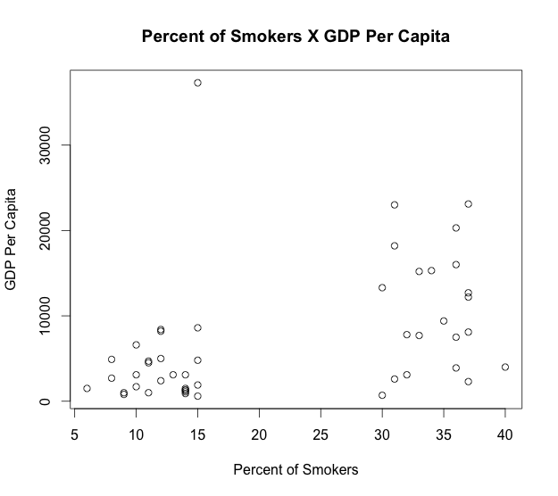

h) Create a histogram displaying the number of countries in GDPPerCapita brackets 0 to 2,000, 2,000 to 3,000, 3,000 to 5,000, 5,000 to 10,000 and 10,000 to 50,000. Label your histogram. Paint the title in purple color.

bps <- c(0, 2000, 3000, 5000, 10000, 50000)
hist(smokers$GDPPerCapita, breaks=bps, main="Histogram of GDP Per Capita", xlab="GDP Per Capita", col.main = "purple")

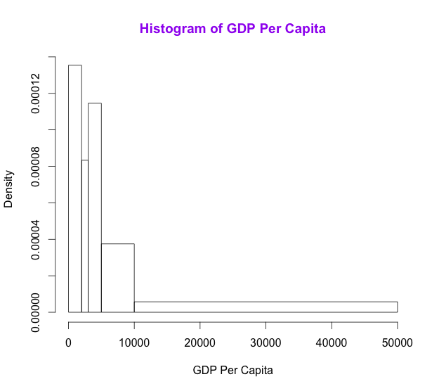

i) Present the same histogram as a pie chart.

> GDP <- smokers$GDPPerCapita
> labels = c("0 to 2000", "2000 to 3000", "3000 to 5000", "5000 to 10000", "10000 to 50000")
> X <- c(length(GDP[GDP < 2000]),
+ length(GDP[GDP >= 2000 & GDP < 3000 ]),
+ length(GDP[GDP >= 3000 & GDP < 5000 ]),
+ length(GDP[GDP >= 5000 & GDP < 10000 ]),
+ length(GDP[GDP >= 10000 & GDP < 50000 ]))
> X
[1] 13 4 10 10 11
> pie(X, labels, clockwise=TRUE, main="Pie Chart of GDP Per Capita", col.main = "purple")

