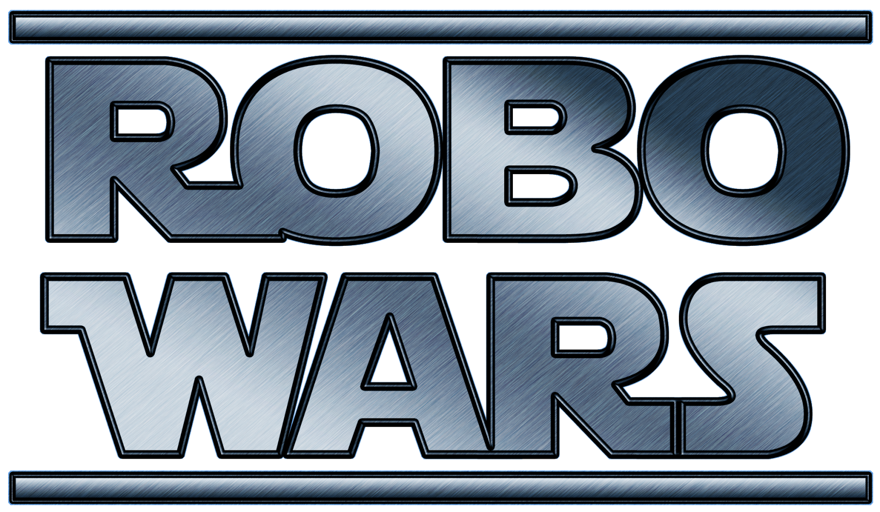

**Project #34**

Supervised By: **Cheryll Schramm**

|  |  |
| --- | --- |
| **Alexander Craig** | **Alexander Dinardo** |
| **Michael Wright** | **Steve Legere** |

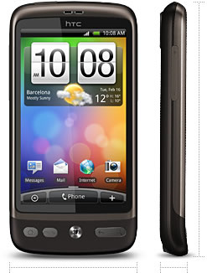**Project Objectives:**

* **To develop a robotics control system which is both intuitive to use, and is implemented on a mobile platform that is widely available and used by the public (Android smartphones).**

* **To experiment with the combination of live video and virtually generated, overlaid imagery to enhance the ease of use and feature set of a robotics control system. This technology is commonly referred to as augmented reality.**

**Project Overview:**

* 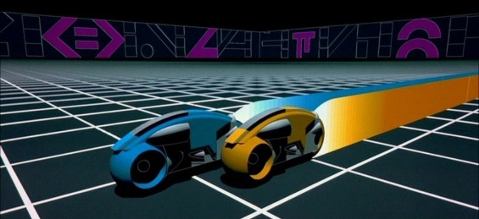**The project aims to create a system which allows remotely controlled robots to share and interact with a simple virtual world, which will be rendered overtop of a live video feed an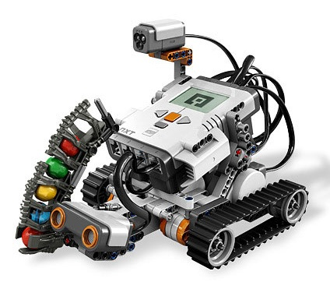d displayed to the remote operators.**

**Contributions:**

|  |  |
| --- | --- |
| **Alexander Craig:**   * **Video streaming** * **Server communication** * **Server-side player and robot management** | **Alexander Dinardo:**   * **Game model implementation** |
| **Mike Wright:**   * **LEGO Mindstorm NXT 2.0 client implementation** * **Dot grid position tracking** | **Steve Legere:**   * **Android client** * **OpenGL rendering** |

**All team members also participated in requirements elicitation and initial system design.**

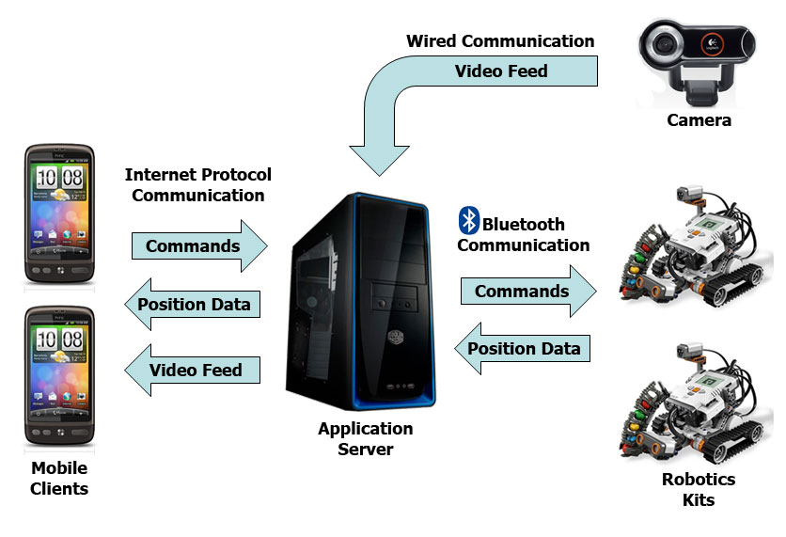**System Architecture:**

**Server Data Flow Implementation:**

* **Robots communicate with the server via Bluetooth through the use of LeJOS open source communication libraries on both the robot and server side.**
* **Smartphones connect to the server through standard internet protocol.**
* **Separate TCP and UDP connections are used for game state data and media streaming.**

**Video Streaming Implementation:**

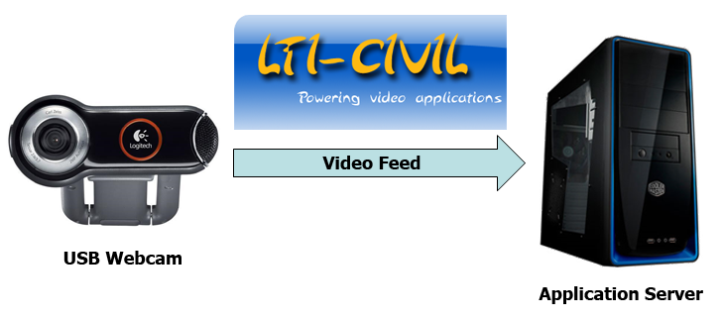

* **The LTI-Civil open source library is used to interface with any standard USB webcam.**
* **The server admin configures the position and heading of the camera, which are used by clients for rendering calculations.**

**Video Streaming Implementation:**

