# *Requirements and Components*

* Wireless connection over LAN or WAN.
* Accelerometer – For robot control.
* Touch screen for user interaction and functionality.
* Media client display and render video feed from webcam

# *Why Android?*

The main reason to choose Android over another mobile platform is that it is open source software. In addition, the documentation available for Android developers is extremely extensive and well laid-out.

As of 2010, Android held 34% of the mobile platform market share in the U.S. – more than any other mobile platform. In one year, its market share increased over 400%, an obvious indication of widespread interest, support and development.

# *OpenGL ES*

* The Open Graphics Library for Embedded Systems (OpenGL ES) is the standard library used in most mobile devices (where supported).
* OpenGL ES, keeping the product in mind, consumes very little power and is very efficient.
* OpenGL is very well documented. Since OpenGL ES currently corresponds to the OpenGL 1.5 standard, any books or documentation at or before this version are all relevant.

# *Hardware*

|  |  |
| --- | --- |
|  | * 1 GHz CPU: Optimal for running intense applications. * WiFi: IEEE 802.1 b/g * Video Formats: 3gp, .3g2, .mp4, .wmv |

The HTC Desire is great to work with as it is fast, responsive, and supports various video encoding formats.

# *System Design*

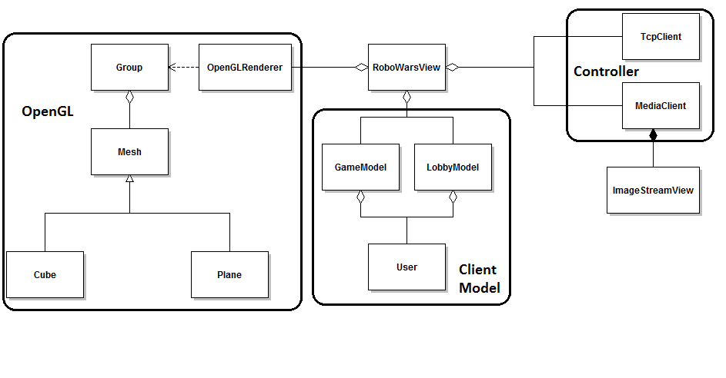

The design is centered on the view class, which acts as a separate thread to draw the application on the phone.

The Media Client communicates with the application server to deliver video feed. All other data – user chat, version information, game updates, etc. – is sent and received over the TCP Client.

# *Augmented Reality*

* Combining real-world video feed with computer-generated graphics to enhance the user’s perception of reality.
* Many real-world applications and possibilities: sports broadcasts, heads-up displays (HUD), digital cameras, etc.
* OpenGL is ideal as it allows the creation of any 3D polygon; very extensive, flexible, and efficient.