
Department of Information Systems
Systems Analysis (INF2009F) – 2023
BUSINESS CASE: Phumla Kamnandi Business Case

TEAM MEMBERS
Student number: CPMMIC001 | Name: Michael Copeman
Student number: CRSALE010 | Name: Alexander Cristaudo
Student number: VLNSHA004 | Name: Shaylin Velen
Student number: WHTALE015 | Name: Alex White
Declaration
- We know that plagiarism is wrong. Plagiarism is to use another's work and pretend that it is one's own.
- This Business Case Document is our own work.
- We have not allowed and will not allow anyone to copy our work with the intention of passing it off as their own work.
Team Member Name…Alex Cristaudo.. Signature:..………….. Date.…/.…/…....
Team Member Name………….….…….. Signature:……..…….. Date.…/.…. /…....
Team Member Name……………...……. Signature:…..……….. Date.…/.…/…....
Team Member Name……………...……. Signature:………….... Date.…/.…/…....

TABLE OF CONTENTS

1. BUSINESS OVERVIEW 2
2. BACKGROUND 3
3. BUSINESS PROBLEMS AND OPPORTUNITIES 3
3.1. Overview of current processes 3
3.2. Problems 3
3.3. Opportunities 3
4. SYSTEM OBJECTIVES 3
4.1. Goal 3
4.2. Objectives 3
5. SYSTEM SCOPE 3
5.1. Major business activities 3
5.2. Statement of Scope 3
6. ALTERNATIVE SOLUTIONS 3
6.1. Solution 1 3
6.2. Solution 2 3
6.3. Solution 3 3
6.4. Comparison of solutions 3
7. RISK ASSESSMENT 3
8. FEASIBILITY ASSESSMENT 3
9. PROJECT SCHEDULE AND RESOURCES 3
10. RECOMMENDATIONS TO MANAGEMENT 3
11. Business Case Evaluation Form – Project Team #30 3

BUSINESS OVERVIEW
Describe the type of business, size and location, brief history, strategic goals.
Phumla Kamnandi Hotels is a group that owns thirty different hotels scattered across South Africa. Each hotel runs independently but is fundamentally linked to the Phumla Kamnandi business, and benefits from the partnership through marketing, customer base, training, and other advantages. Phumla Kamnandi itself operates from their head office in Century City. The strategic goals for Phumla Kamnandi involve moving towards adopting business processes that are standardized across all hotels to establish and propagate the ‘Phumla Kamnandi’ experience.

Potential benefits from adopting this approach include reduction in costs relating to hardware, software, and training. Consolidation of information becomes easier, and each hotel will use the best practices. Other goals involve getting a positive IT ROI and implementing suitable and adaptable practices, optimizing service levels and lower costs, and using the system to provide rich, flexible, and accurate management information.

BACKGROUND
The overall image and the organisational culture of hotels vary significantly. Thus, management has taken the decision to move to standardised business practices to provide similar, high-quality service at every hotel in the group.
Phumla Kamnandi hotels hopes to establish their image in the minds of the customer. They aim to do this by implementing new computer systems across all the hotels in the group. Management means to gain standardised, best-practice business processes. Management also wishes to present similar appearance of accounts and client-facing documents, and a reduction in the total cost of ownership across the whole group.
***What has given rise to this particular project (business merger, introducing new product lines, replacing obsolete technology, coping with business expansion, creating a Web interface, compliance with new legislation, etc)? What does business hope to gain from it? ***

BUSINESS PROBLEMS AND OPPORTUNITIES

Overview of current processes
Describe how the current system works and identify the problem areas. Include an Activity Diagram depicting how a reservation is processed (AS-IS).
Currently there are many potentially automatable processes. There is large potential to save time spent by employees working on manual systems as well as to save money from being lost in unreliable manual accounting processes.
Enquiries and reservations are made by a guest/travel agent contacting via email and phone. Some enquiries may be dealt with by providing the standard procedures otherwise a reservations clerk deal with the enquiry themselves. Should the guest/travel agent place the booking, further details about the person staying are obtained and if the rooms they want are available, the reservation is recorded.
The reservations clerk will also request for a credit card number to make a deposit and ensure the room is secured for that person and Phumla Kamnandi gives their guests up to 7 days to make this deposit. Room service operates by prioritising cleaning a room associated with new guests arriving that day. As part of the room allocation process, each night a list of expected departures and arrivals is produced for housekeeping to use and reception to use to update guest accounts.
When a guest arrives, they fill out registration forms and get a room access key and a guest card which is used to charge fees onto their guest account.
Room servicing cleans, and replenishing consumables such as tea, coffee, soaps, and towels. The linen on a bed is changed weekly and for a new guest or if it is damaged.
The accounting system keeps separate accounts for each room in the hotel which are declared open from check in time and closed once they check out. The software to do these processes differs for each hotel. The hotel also provides services such as laundry, room service, housekeeping and babysitting that can be charged onto a guests account. This is charged onto the guests account by a ‘chit’ system, where a guest signs a voucher for the service which get forwarded to accounts processing. The accounts are updated every night, except for breakfast which is included as the room tariff on the room. The room tariff for accommodation is charged to an account every day and any discounts, promotions and prepayments also get recorded. Guests get charged should they make calls from the phone in their room and reception can print a call summary should the guest request for it.
The hotel follows up with debtors who do not settle their account on check out and monthly statements are sent as reminders, and they follow up on bad debt.
The hotel regularly restocks obsolete, damaged, and lost goods and the hotels opt for bulk orders for any promotional consumables.
Reception and each service point in the hotel accepts cash and at the end of every day, the cash is counted and forwarded to the bookkeeper
The Reservation is processed as depicted in Diagram 1 below

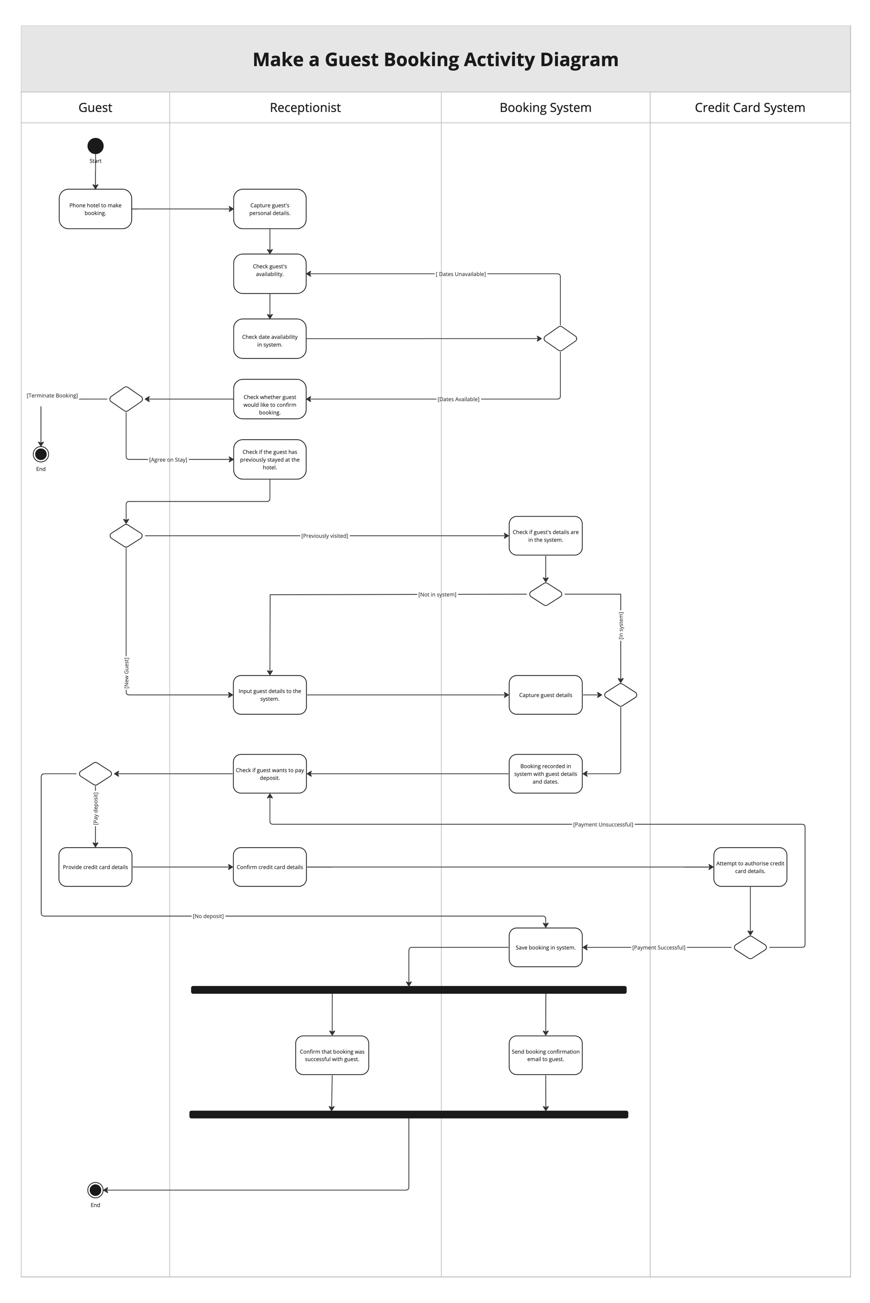

[Diagram 1]

Problems
Accounts
- Accounts are only updated at night. Missed charges occur resulting in financial loss for the business, there also are no real-time updates for guests. Resolving this problem will result in fewer missed charges, more robust data transfer, better real-time data for business analysis and real-time updates for guests.
- The chit system has a high potential for error and fraud. The system is labour intensive and thus, inefficient taking up time and potentially losing the business money through fraud. Resolving this problem will lead to reduced error, more accurate data capture, and preventing unethical activity and fraud.
- Accepting email confirmation without deposits. This leads to lapsed bookings with guests still arriving or bookings where guests do not arrive. Income can be lost and because of poor business image guest numbers may decline. Resolving this problem will lead to a reduced loss of income, better brand image, better communication, and increased customer satisfaction.
Human Resources
- Hotel managers have the power to individually recruit and dismiss staff. This practice is not completely ethical, there can be unfair dismissals and there is a lack of oversight. Resolving this problem will lead to more ethical practices, fewer unfair dismissals, and better oversight.
- Individual hotel managers have too much power over tax and benefits. These are not standardised across the group. There is a lack of division of duties and compliance meaning that the business could be more ethical and less susceptible to fraud. Resolving this issue will result in better ethics and less loss of revenue to fraud through the division of duties and better compliance.
- Training is planned by a specific hotel manager. Thus, training is not standardized across the group. Different training regimes may result in varying customer experiences when interacting with employees, a key issue Phumla Kamnandi is trying to rectify. Reduced efficiency, processes take longer to perform, and troubleshooting takes longer to complete. Training costs are higher as staff need to retrain if they are moved to different hotels. Resolving this problem will mean that we have better training for standard systems. Staff can then work for any hotel since they have the same training for standardised systems. Evaluation of training can be done which allows the training to be adjusted for its shortcomings.
Reservations
- No guest reservation hardware and software standards across the hotel group with poor integration. This causes high costs for training and process inefficiency. Resolving this problem will lead to easier training, improved staff efficiency when conducting business processes (e.g., improved check-in/out times). Potential employee cross-hotel mobility will be greatly increased since there will be less of a learning curve in terms of differences between hotels.
- Manual room reservation registers that are not always up to date lead to over/under booking the hotel. Under-booking the hotel leads to a loss of income when rooms are empty. Overbooking the hotel also means that alternative plans may have to be made for guests which will cost the business more. Resolving this issue will result in a reduced loss of income and increased customer satisfaction.
- No reservation software support. The system has high levels of down-time, reducing efficiency in business processes like managing reservations. Resolving this problem will lead to less down-time, issues can be solved more easily, less inconvenience to guests. Overall, more efficiency and productivity from the software.

Opportunities
- Merge the room access card and guest ID card into one card. Results in fewer items for a guest to look after (less chance of cards being lost) and lower costs of maintaining card supply.
- Implement a unified accounting package and credit control system across the group. This means fewer errors, less complexity in records, more accurate analysis of data, richer data-driven picture of the overall group's functioning while maintaining granular detail.
- Adapt guest accounts system to allow for charging after their stay. Can thus recoup costs if it is discovered that a guest has not been charged for something they should have been charged for, e.g., a broken item or extra meal.
- Automated inventory system for bar fridge requiring guest sign-off. As a result, don't rely solely on bar staff and/or housekeeper's integrity to manage restocking, usage, and billing.
- Allow guests to choose charges to be applied to the room or to guests' cards individually. Enables bill splitting and individuals only being charged for what they have personally used. While groups can still bill together if they want to, e.g., families.

SYSTEM OBJECTIVES

Goal
Many of the labour-intensive processes of the group should be automated and there should be a higher degree of standardisation for processes and training across the group. This will enable more efficient processes, reduced costs, and a more ethical business setup.

Objectives
Objectives are classified under four main groups, specifically: Accounts, Human Resources (HR), Administration, and Reservations.
Accounts
- Phased in for the next accounting year, introduce an accounting system which allows accounts to be updated in real-time after a transaction is made.
- Complete removal of 'chits', forcing payments to be made either in cash or by scanning guest card. Distribute sufficient card scanning hardware throughout hotels to facilitate payments. Remove facilities which allow chit-based payment. Phase in over the next six months.
- Introduce one standard accounting package to be used by all hotels in the group for the next accounting year. Provide short training course as and where phased in.
- Alter the accounts management system group-wide to allow charging onto a guest's account after the closure of their account. This should be phased in within the next accounting year.
Human Resources (HR)
- Introduce a corporate HR to approve of any firing of staff members after a complaint is raised by another member within the next month
- Hire an accountant to manage the tax and benefits of employees by the next accounting year.
- Produce and distribute a standardised training program for all hotels within the next month
Administration
- Over the next two months, replace individual room access cards and guest ID cards with a single card that serves both purposes. This must be done groupwide.
- Introduce group-wide, accessible software support within the next month. (Doesn’t this exist already? “There is also a small but dynamic IT function, which is tasked with rolling out the new technology across the many hotels and supporting the users of IT throughout the group.” - from the case study -> States All of the hotels currently have slightly different ways of operating. All have computers in some form or another, ranging from a single standalone PC in reception (which causes havoc at busy checkout times!) to reasonably sophisticated networked computer systems in 2 of the hotels. There are currently no hardware or software standards across the group, and the support of these installations is problematic in Case Study
- Allow guest to choose charges to be applied to the room or to guests' cards individually. Phase this in within the next month.
Reservations
- Introduce a unified reservation management system across hotels in the group with the same software and hardware. This should be phased in within the next 24 months.
- Implement automated deposit system that reminds a guest 24 hours before their deposit is due, sends a payment link and automatically cancels their booking if it's not paid. This makes the room available for other guests to book. This should be phased in within 2 months.
- Automate room reservation registers using a centralized group database. This should be phased in within 24 months.

SYSTEM SCOPE

Major business activities
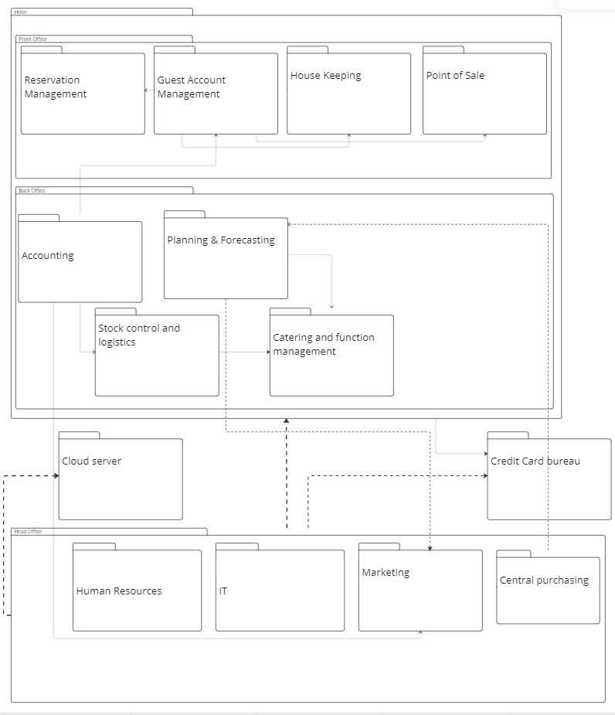

Narrative:
In the TO-BE system for Phumla Kamnandi all data and transactions processed by hotels in the group are stored centrally in the head office system. Crucial parts of data are backed-up to an external cloud server. Purchasing is dependent on planning & forecasting to determine quantities to purchase and expected purchasing costs. Guest account management charges guest accounts based on information received by the point of sale and housekeeping system. Guest account management needs guest information from reservation management. The standardised accounting system used in the back office of every hotel depends on the marketing, guest account management and stock control and logistics to record and report on the financials of every hotel. Stock control and logistics depends on the catering system for stock taking and stock management purposes. The credit card bureau is used an external system to process credit transactions by guests as well as transactions made by the hotel group/ an individual hotel.

Statement of Scope
In Scope
Subsystem: Human Resources
Functionality:
Database storage containing information regarding stakeholders in the business
System for processing payroll and keeping track of employees hired or fired.
Storage for digital legislation related to HR

Subsystem: Reservation management system
Functionality
System to manage bookings
Bookings are made through this system
Updating of hotel capacity and room occupancy

Subsystem: Accounting system
Functionality
Guest accounts processing and recording
Rollbacks of transactions
Closing guest account
Recording inventory purchases and business expenses
Manages financial reports of the business

Subsystem: Central purchasing
Functionality:
Large acquisition recording and reports in the hotel group
More specialised to purchases regarding the entire group rather than a hotel
Database for group recordings
Data for individual hotel financial reports is gathered and processed in this system.

Out of Scope
Subsystem: Marketing
Functionality:
Marketing system determines funds needed for advertising
Responsible for client communication for promotions
Captures promotions created by marketing team and distributes to stakeholders
Subsystem: Guest account management
Functionality:
Charges hotel services and additional client purchases to guest account
Responsible for calculating client bill
Subsystem: Planning & forecasting
Functionality:
Financial planning for the hotel group is done and recorded in this system
Forecasting for future expenses and expected incomes done in this system

Subsystem: Stock control and logistics
Functionality:
Stock purchases recorded in this system
Stock recording and keeping track of stock in storage done in this system
Deliveries and scheduling can also be done using stock control and logistics system.

Subsystem: Catering and function management
Functionality:
Scheduling of events to ensure there are no clashes in times are done on this system
Food supplies for restaurant logged/recorded on this system
Catering management orders food stock using this system

Subsytems: IT
Functionality:
System updates and maintenance stored in the IT system
Software package used to

ALTERNATIVE SOLUTIONS

Solution 1

Introduce a standardised reservation system.

This will involve merging guest ID cards and room access cards into the same card. This will see the chit system integrated into the card. Guests will use one card for charges at the bar and/or entertainment. This can be developed by the hotel group’s IT support team as the process would be less strenuous on resources than if we were to buy a system and it is a relatively straightforward project. This would be completed inhouse and can be integrated nearly immediately by swapping outdated guest cards with the new guest cards. We will also introduce a unified reservation management software platform across the hotel group, based in the cloud. This will be a difficult task to complete inhouse as it requires specialist skills and databases to run and will most likely cost a lot. It would be much easier to subscribe to an existing package which comes with support, regular updates, and quicker setup. Most of the setup process and long-term support will be outsourced to the developer company. There will be a small amount of in-house input to sort out software requirements that are specific to the hotel group and through APIs our card will integrate with this new software platform. The reservation system should automate the allocation of rooms to a guest after a guest has chosen a room. These changes will be phased in hotel-by-hotel over a year.

Solution 2
Revamping of company HR
Introduce a group HR manager to approve of any hiring and firing of staff members after a complaint is raised by another member. This will be for any hotel part of the Phumla Kamnandi Hotel group. They should also run investigations as part of their firing process. Their first task will be to lead the introduction of regularly scheduled training and skills development (three times a year). The HR manager must introduce a standard training curriculum which can be taught by managers and augmented, but not reduced, according to managerial understanding of the specifics of the individual hotel. This curriculum could be created either in-house or potentially follow existing hospitality courses. Since the reservation software and accounting software is purchased, it will likely be better and cheaper to employ current existing courses for those aspects of the training. While, at the same time conducting in-house training on brand specific practices and processes. Some of the training can be made available through videos, but for the most part it will not be automated and provided in person. Any employee should be able to easily transition from one hotel in the group to another. The HR manager should be appointed within a month and the training should start a month later group wide. Staff training already exists “At a staff training seminar, staff are instructed in the 'Phumla Kamnandi' of doing things.” - from the case study. I’m not saying that this whole thing needs to be deleted but maybe adjusted and can be interpreted as increasing the standardization of training and accounting for the removal of the responsibility of training on managers. Maybe we reword it, but we got 10/10 in the workshop for this oh okay then maybe its chilled

Solution 3
Introduce a standardised accounting system
Introduce a standardised accounting system across the group that is based in the cloud and syncs automatically. Since this is a skill-intensive and complex task it would be preferred to subscribe to an existing package that can manage it for us. This means we will benefit from continual support, updates, and setup. It would be a lot more costly to make a system and then must continuously update it. The accounting process through the software will be largely automated as charges will be loaded automatically, the software will sync with the bank account and transactions will be automatically recorded. This should be phased in hotel-by-hotel over a year

Comparison of solutions
How do these solutions differ in terms of their scope, functionality, and ability to fulfil the objectives? Which ones would you exclude one (with reasons) at this stage of the project? And which one would you recommend and why? In the next section, you would proceed to analyse the potential costs and benefits, time frames, level of risk and other feasibility issues for your recommended solution.
All these alternative solutions seem reasonable in their scope and time frame. According to the financial report given by the business, 7% of revenue, which amounts to R49 000 000, a staggering amount of money, is lost due to mis-postings and write-offs on guest accounts. This obviously represents an easy opportunity to increase hotel revenue substantially. It would be best accomplished through a combination of alternative solutions 1 and 3, both of which can be feasibly implemented within a short time frame. Perhaps then it would be most wise to prioritize solutions 1 and 3 over solution 2, which although will be effective in standardizing customer experience it will not have as much of an immediate impact as solutions 1 and 3.

RISK ASSESSMENT
Identify any risks that will need to be managed for the recommended solution. Briefly explain why you consider them to be risks for this project and suggest how they could be contained (mitigating strategies). Order them from highest to lowest risk - a table (risk matrix) is a good way to present this.
Risk | Probability  (0 – 10) | Impact  (0 – 10) | Factor  (0 – 100) | Mitigation Strategy
Worsening of load shedding situation leads to an over reliance on generators to power the technology-based reservation system. | 8 | 8 | 64 | Maintain a non-electricity reliant, manual system which can still be used to keep track of proceedings in the hotel. Then when power returns the system can be updated accordingly.  This can also be avoided by sufficient investment in generators and independent power production solutions like solar panels.
Expected cost of implementation for the hardware exceeds our estimation for those costs. | 6 | 5 | 30 | Compare costs between potential suppliers.
Quality of software outsourced does not meet our requirements and provides less usage than expected. | 3 | 5 | 15 | Develop the outsourced software to adapt to the needs of the hotel group. Do research on the software and its capabilities before finalizing a deal with the supplier of the software. Investigating possible customization of the software according to the needs of the company.
Integration of the guest card system with the accounting system may take longer than expected or cost more than expected. | 4 | 3 | 12 | Phase in integration of the card system over a longer period instead of all at once so the business does not have to.
Loss of customers who preferred the old system and now find the current and new system difficult and dissatisfying to use. | 3 | 3 | 9 | The severity of this depends on how easy and satisfying the new system is to use. The more time spent finding and customizing the correct outsourced software package the less likely customers will be disappointed by the changes.
Cloud has all hotel data stored on it; data can be inaccessible if the supplier has issues. | 1 | 9 | 9 | A server situated at the head office backs up important data for the hotel group periodically.

FEASIBILITY ASSESSMENT
Week 4 Lesson 5 slides. Part of workshop 3. Lost 3 marks, comment:
increased customer satisfaction is an intangible benefit, and more accurate capturing of data is a tangible benefit.
Tutor says we must develop a cost benefit analysis.
Money is always important – and the relative value that the solution will deliver to the organisation is just as important as its initial cost. A cost benefit analysis will estimate both of these aspects; use the problems and objectives that you previously defined to help you identify and quantify the benefits.
In addition, you need to consider other feasibility issues. Is your current hardware and communications infrastructure adequate; do your IT staff have the skills needed for development and maintenance; are your users sufficiently computer literate to be able to use the system without errors? Is the solution in line with corporate strategy and long-term IT plans? For compliance projects, is there a tight deadline and will you be able to meet it?

Technological Feasibility Issues
- The business will have to outsource the reservation management software because the hotel group does not possess the specialised skills to develop/create a standardised system for the whole group. This means that there will be less control and flexibility for managerial discretion in certain situations.
- Some hotels may be affected by poor network connectivity and be unable to handle a fully cloud-based system. This may be due to location or current hardware. Alternative internet provider solutions will need to be examined in tandem with the rollout.
- Since hotels have different hardware systems, some hotels will need to spend money on upgrading their hardware to run the new standardised software.
Schedule Feasibility Issues
- Unforeseen bugs and errors would prevent the continuous roll-out of the system into more hotels, and certain hotels could be held back whilst others move on.
- It will take a long time for all systems to be synced and come online which means that there will need to be continuous group-wide testing after the hotels all have the software which will add even more time to rollout.
- Before the system can be phased out, one needs to be found. This could take quite a long time since the group will need to find the right system for their needs, budget etc.
Organisational and Cultural Feasibility Issues
- For some hotels, the usual customers may prefer non-technological systems. They may be part of more traditional and conservative cultures and be annoyed by a new over-reliance on technology at hotels they once enjoyed. This could result in a loss of customers.
- Some staff members may be resistant to changing a system they are used to; others might not be at the required level of computer literacy. These staff members will need to be assisted and trained to ensure they utilise the new system efficiently.
- Automating large parts of the system may result in a change of jobs and alter managerial procedures. With outsourcing software, less IT workers are required which could also result in job loss.
Resource Feasibility Issues
- There may not be enough time to teach employees how to use the system. Employees and managers may not have the time to teach or be taught the new system. People may just be too busy to enforce such big changes upon them. it could cripple the hotel if the employees do not know how to use the system upon which the hotel is based.
- Related to time is the issue of human energy. Employees and managers may not have the motivation and/or discipline to learn a new system. They may already be too tired from their jobs and adding the extra stress of integrating new technology could be more difficult for the employees than expected.
- Load shedding may cause issues in a technologically reliant system. Hotels without backup generators will be severely debilitated without electricity to power the new system.
Economic Feasibility
Costs | Benefit
One-Time Costs | Tangible
Software Installation. | Reduced loss of income, reduced errors.
Hardware Installation. | Better organisation of guest scheduling and booking.
Initial training of existing personnel. | More accurate capturing of data.
Developing new “chit” system with a unified card. | Lower costs of maintaining card supply
Operational Costs | Intangible
Cost of storing data on outsourced cloud. | Improved staff efficiency when conducting business practices.
Outsourced software’s yearly subscription. | External support provided by the supplier
Maintenance of guest card system. | System issues are solved more efficiently by the company we outsource to
Increased electricity bill because of the use of new technology. | Improved customer satisfaction.

PROJECT SCHEDULE AND RESOURCES
Not applicable for this assignment.

RECOMMENDATIONS TO MANAGEMENT
Outline what has been covered in your investigation, explain the reasoning behind your recommended solution, highlight key risks that will need to be managed, and estimate the project costs and the value of the associated benefits. Then it’s over to management to decide what happens next – go ahead / put the project on hold / keep looking for other possible solutions / cancel the project / etc.
The greatest opportunities to work towards the goal of business standardization have been outlined in this investigation. The current system has much room for improvement in terms of technological, HR and accounting solutions. However, there are risks associated with these solutions, such as underestimates in the costs of implementation, the impact of load-shedding on a technology-based business, and low quality implementations which do not have the desired impact they were intended for.
The greatest focus should placed on the introduction of the described accounting and reservation-system solutions, which will have a significant impact on the current levels of lost revenue within the business. An effective implementation of these solutions could potentially reduce fraud, mis-postings, write-offs and misallocated guest charges by 90%. The ten percent that will still be present will be due to load shedding not allowing the new system to be functional at all times as well as the fact that even with an effective implementation these problems cannot realistically be completely eradicated.
As indicated in

Business Case Evaluation Form – Project Team #30

STUDENT: _______________________STUDENT: __________________________
STUDENT: _______________________STUDENT: __________________________

TOTAL MARK: %
1. Presentation
 | Poor | OK | Good | Excel | Comment | Score
Document Flow | 1 | 2 | 3 | 4
Presentation of diagrams and tables | 1 | 2 | 3 | 4
Spelling and Grammar | 1 | 2 | 3 | 4
Overall Presentation,  Typing and Layout | 1 | 2 | 3 | 4
Ease of Information Absorption | 1 | 2 | 3 | 4
 |  |  |  |  | Out of 20
General Comments

2. Content
 | Poor | OK | Good | Excel | Comment | Score
Overview / Background | 1 | 2 | 3 | 4
Problems, Opportunities | 3 | 6 | 9 | 12
Objectives | 2 | 4 | 6 | 8
Scope | 4 | 8 | 12 | 16
Alternative Solutions | 3 | 6 | 9 | 12
Risk Assessment | 2 | 4 | 6 | 8
Feasibility | 4 | 8 | 12 | 16
Recommendation | 1 | 2 | 3 | 4
 |  |  |  |  | Out of 80
General Comments

