INF2009F – 2023 Business Case: Identifying Scope
Exercise 4 - Package Diagram (14 Marks)
Student Name: Alex Cristaudo | Student Number: CRSALE010
IMPORTANT NOTE:
- Copied or Plagiarised answers will get 0 and student will be referred to Elsje Scott or Ayanda Pekane for further action.
- Please upload your completed exercise on Vula by the 13th of March 2023 at 9am (9:00)
Please revisit the Khwela Womxn Case Study to remind you of the background and the current processes involved.
Draw a package diagram to represent the scope for the proposed system that will automate aspects of Moderator Training, Sister‘hood’ Circle Allocation and related logistics like the further distribution of Circle content via the WhatsApp bot.
Ensure that you indicate the dependencies between subsystems, as well as the existing systems. The diagram below depicts a three-tier layered structure that will include the Presentation Layer, the Business and the Database Layer. Complete the Business layer section of the given Package diagram. Add the necessary external systems that this system might need. Include a narrative to briefly explain your thinking behind the diagram.

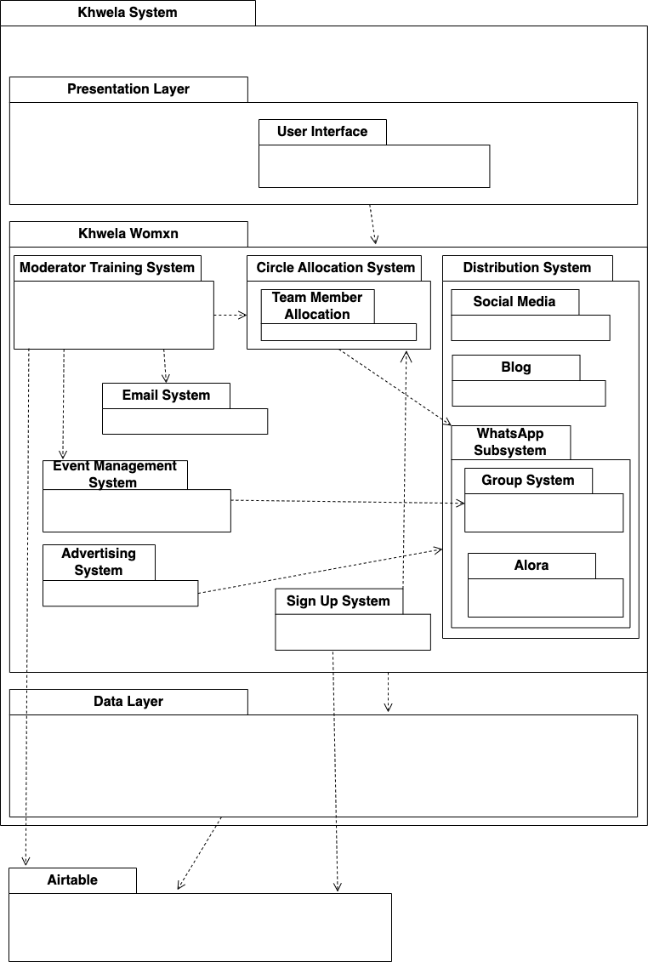
A moderator training system will pull data from the database and assign the person to a circle.
The circle allocation system uses the current circle data and the persons location to assign them to a circle.
The email system is used to send automated emails to get feedback from members from meetings or forms (such as whether they want to create content or not)
The advertising system uses the distribution system to advertise.
The event management system allows team members to create and manage events. This can then use the group system to inform a group about a meeting.
Social media and blog systems deal with operating those respective parts.
The Alora system runs the Alora bot and Group System is used for managing WhatsApp groups.

