Determining g ($m⋅s^{-2}$) from a compound pendulum

Peoplesoft ID: 1873229
Alexander Cristaudo
Student Number: CRSALE010
The Compound Pendulum
Date Performed: 10 May 2022

Introduction and Aim
A compound pendulum constructed out of a stick that oscillates (with a stand in a hole in the stick) at a period $T=2π\sqrt{\frac{I}{mgr}}$ where I is the moment of inertia, r the distance from the hole to the centre of mass, and g is the gravitational acceleration of the object in the Earth’s gravitational field. This means g is the acceleration at which an object falls when released near the Earth’s surface. Simplifying this yields:
$$T^{2}r=\left(\frac{4π^{2}}{g}\right)r^{2}+\frac{4π^{2}}{12g}L^{2}$$
and thus, the aim is to calculate g using this in 2 different ways, and to check if both ways yield values that agree with each other

Method and Apparatus
Apparatus
- A retort stand is with a pin is used to connect to the thin metre stick
- A metre stick is used to swing and oscillate so as to calculate the value for g
  - The metre stick was also used to calculate L, which is the length of the metre stick and calculate r, the distance from the hole to the centre of mass
- Diagram of Apparatus:
Figure 1:
A diagram of the apparatus used to collect data for T (s) and r (m)
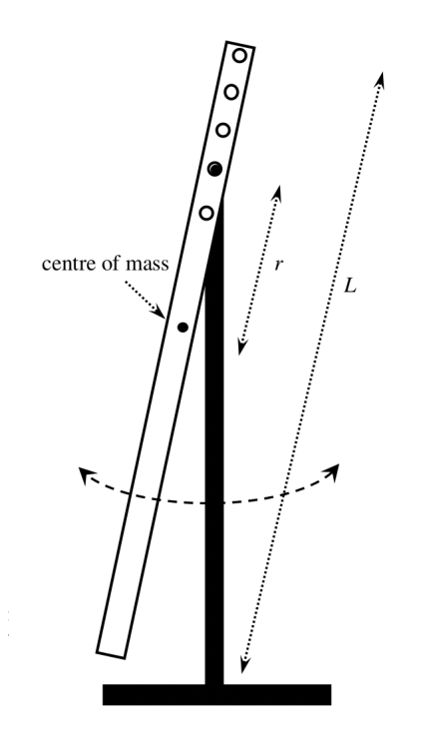
Metre Stick
Pin on Retort Stand
Retort Stand
Hole 4
Hole 3
Hole 1
Hole 2
Hole 5

Method
Firstly, the metre stick was put into the first hole (as in Figure 1) and the value for r was measured. After that, the metre stick was released with a small amplitude (for more reliable results) and as soon as the stick passed the stand, the timer started. After one period was completed (that is, the metre stick passed the stand again from the same direction as it was released), the timer was stopped and this value for T was taken down. This was repeated 5 times so as to get 5 values for T for one r value and these were recorded. Then the metre stick was adjusted to the second hole and the same process was followed (distance measured and then 5 T values are retrieved), and similarly, this was done for the third, fourth and fifth hole

Data and Results
Value for L
The value for L was calculated to be: $L=\left(1.000000±0.000816\right)m$
Calculation:
It was determined that $0.998 ≤L ≤1.002$
and thus, since this is a triangular PDF, $u\left(L\right)=\frac{1.002-0.998}{2\sqrt{6}}=0.000816$
which then gives the result above
Tables
Table 1: showing the raw data collected for T (s) and r (m)
A table showing the values for T (s) for each value of r (m)

r (m) | 0,495 | 0,445 | 0,395 | 0,345 | 0,295
T (s) | 1,67  1,71  1,71  1,68  1,66 | 1,62  1,66  1,67  1,66  1,65 | 1,56  1,52  1,62  1,56  1,66 | 1,52  1,54  1,53  1,5  1,47 | 1,52  1,45  1,5  1,52  1,51

This leads to:
Table 2: each r (m) value and their respective average T (s) value
A table showing the distance r (m) and the period of oscillation T (s) for each distance r

r (m) | 0,495 | 0,445 | 0,395 | 0,345 | 0,295
T (s) | 1,69 | 1,65 | 1,58 | 1,51 | 1,50
Example Calculation:
For r = 0,495:
$$T_{av}=\frac{1,67+1,71+1,71+1,68+1,66}{5}≈1,69$$

This leads to:

Table 3: Calculation of $T^{2}r$ and $r^{2}$are made using the values in Table 2. This is done because if we take $Y=T^{2}r$ and $X=r^{2}$, then since
$$T^{2}r=\left(\frac{4π^{2}}{g}\right)r^{2}+\frac{4π^{2}}{12g}L^{2}$$
we get that $Y = mX + c$ where $m=\left(\frac{4π^{2}}{g}\right)$ and $c=\frac{4π^{2}}{12g}L^{2}$and g can then be calculated using both of these

A table showing the $r^{2}\left(s^{2}\right)$ values and the associated $T^{2}r$($m ⋅s^2)$ values

$$r^{2}\left(s^{2}\right)$$ | 0,245 | 0,198 | 0,156 | 0,119 | 0,087
$$T^{2}r \left(m⋅s^{2}\right)$$ | 1,41 | 1,15 | 0,986 | 0,787 | 0,664

Example Calculation:
For r = 0,495 and T = 1,69
$r^{2}={\left(0,495\right)}^{2}$= 0,245 and $T^{2}r={\left(1,69\right)}^{2}\left(0,495\right)=1,41$

Graphs
Graph 1: The data in Table 3 is plotted to calculate the gradient and intercept

Analysis and Discussion
Calculating g using the gradient
Calculating m using the least squares method gives m = 4.7081
Since $m=\left(\frac{4π^{2}}{g}\right)$, this means $4,7081=\frac{4π^{2}}{g}⇒g=\frac{4π^{2}}{4,7081}≈8,39m⋅s^{-2}$
Now calculating $u\left(m\right)$ using the least squares method gives $u\left(m\right)=0,1644$
Now since $m=\left(\frac{4π^{2}}{g}\right)$, this means $g=4π^{2}m^{-1}$ and thus $\frac{u\left(g\right)}{g}=\sqrt{{\left(-\frac{u\left(m\right)}{m}\right)}^{2}}=\frac{u\left(m\right)}{m}$
So $\frac{u\left(g\right)}{8,39}=\frac{0,1644}{4,7081}⇒u\left(g\right)=0,293$
Finally: $g=\left(8,390±0,293\right)m{⋅s}^{-2}$

Calculating g using the intercept
Calculating c using the least squares method gives c = 0.2414
Since $c=\frac{4π^{2}}{12g}L^{2}⇒$ $g=\frac{4π^{2}}{12c}L^{2}$ so $g = 13,6$
Now calculating $u\left(c\right)$ using the least squares method gives $u\left(c\right)=0,0280$
Furthermore, since $g=\frac{4π^{2}}{12}L^{2}c^{-1}$, this means ${\left(\frac{u\left(g\right)}{g}\right)}^{2}={\left(2\frac{u\left(L\right)}{L}\right)}^{2}+{\left(\frac{u\left(c\right)}{c}\right)}^{2}$ so
$\frac{u\left(g\right)}{g}=\sqrt{{\left(2\frac{u\left(L\right)}{L}\right)}^{2}+{\left(-\frac{u\left(c\right)}{c}\right)}^{2}}$ so
$$u\left(g\right)=g\sqrt{{\left(2\frac{u\left(L\right)}{L}\right)}^{2}+{\left(\frac{u\left(c\right)}{c}\right)}^{2}}⇒u\left(g\right)=13,6\sqrt{{\left(2\frac{0,000816}{1}\right)}^{2}+{\left(\frac{0,0280}{0,2414}\right)}^{2}}$$

$$⇒u\left(g\right)=1,58$$
This gives that $g=\left(13,60±1,58\right)m{⋅s}^{-2}$

Conclusion and Recommendations
Conclusion
These results do not agree with each other thus the aim of this has not been achieved because the values for g are not completely reliable

Discussion
The calculation using the gradient yielded: $g=\left(8,390±0,293\right)m{⋅s}^{-2}$ so
$$8,097 ≤g ≤8,683$$
whereas with the y-intercept, $g=\left(13,60±1,58\right)m{⋅s}^{-2}$ so
$$12,02 ≤g ≤15,18$$
so, these values do not lie within each other. Reasons for this could be the imprecise measurement of T, using a stopwatch that only shows a value to 2 decimal places and relying on the user’s judgement as to when one period is completed

Sources of Uncertainty
- Judgement as to when one period is completed
- Uncertainty associated with the internal calibration of the stopwatch
- Uncertainty associated with the stop watch’s figure
- Judgement of the distance between the centre of mass and the hole (r)

Ways to Improve the Experiment
- Use a more precise timer
- Have some string attached to the timer and the metre stick so as to begin the timer just as the stick is released or some software that tracks when the metre stick passes its initial condition

