Capacitance of a Capacitor

Peoplesoft ID: 1873229
Alexander Cristaudo
Student Number: CRSALE010
The RC Circuit
Date Performed: 20 September 2022
Partner: Michael Haydam

Introduction and Aim
An RC Circuit is a circuit consisting of a resistor, capacitor and, in this case, a frequency generator that drives the current through the circuit. In this arrangement, the resistor controls the charging and discharging of the capacitor. The frequency generator provides a potential difference $V_{in}$, with part of this applied across a resistor, denoted by $V_{R}$. The impedance, equivalent to the total resistance for an RC circuit, is given by:
$$Z=\sqrt{R^{2}+{\left(\frac{1}{ωC}\right)}^{2}}$$
where $C$ is the capacitance of a capacitor, and $ω= 2 πf$, the period of oscillation provided by the frequency generator. The peak current is also provided by $I_{0}=\frac{V_{R}}{R}=\frac{V_{in}}{Z}$. Using this, the following equation forms: ${\left(\frac{V_{in}}{V_{R}}\right)}^{2}={\left(\frac{1}{2πRC}\right)}^{2}{\left(\frac{1}{f}\right)}^{2}+1$. The aim is thus to use the frequency supplied by the frequency generator to calculate $C$ and to calculate $C$theoretically and see if these results agree with each other

Method and Apparatus
Apparatus
- A frequency generator
- An oscilloscope
  - This is used to calculate $V_{in}$and $V_{R}$
- A resistor
- A capacitor
- Wire to connect the resistor and capacitor, as well as connecting the oscilloscope and frequency generator to the circuit
- A digital multi-meter
  - The multi-meter is used to calculate the resistance of the resistor

A diagram of the apparatus used to collect data for $V_{in}$(V) and $V_{R}$ (V)
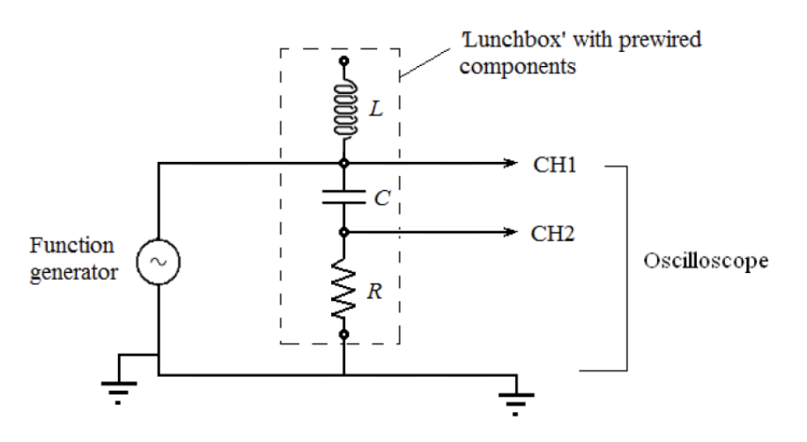
Diagram 1

A diagram of the multi-meter used to measure $R\left(Ω\right)$
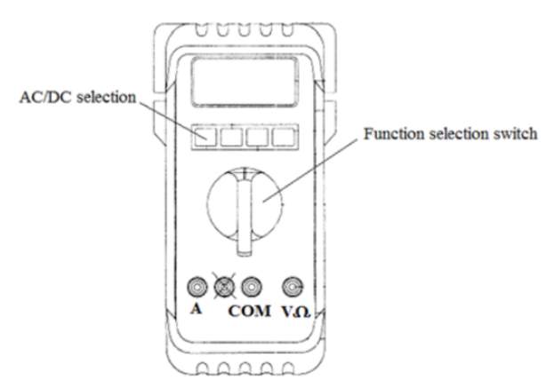

Method
Firstly, 2 leads are used to connect the resistor to the multi-meter. This was done by plugging one lead in COM and the other lead into $VΩ$. Now the other ends of the leads connect to the resistor. The function selection switch was changed to the $Ω$ function to turn the multi-meter into an ohmmeter. The measurement on the multi-meter was recorded after using the range button to get a better approximation for the resistance. After this measurement was made, the circuit in Diagram 1 was constructed. The resistor was connected to the capacitor and the function generator connected to both in series. Both channels from the oscilloscope were used. Channel 1 was connected across the resistor and capacitor (to measure $V_{in}$) and Channel 2 across the resistor (to measure $V_{R}$). Next, the $V_{peak to peak}$ setting on the oscilloscope was turned on by pressing the Measure button and selecting Ch1, then using the multipurpose button to select Peak-Peak. Then the function generator is connected in series to the resistor and capacitor. The peak-to-peak voltage on the frequency generator was set to 8 V. The frequency was then set to any frequency value from 2 to 8 kHz. That is, $2$kHz $≤f≤8$kHz
The oscilloscope then displays $V_{in}$ as $V_{peak to peak}$ for Channel 1 and $V_{R}$ for Channel 2. These values were recorded along with the period on the oscilloscope (Channels 1 and 2 read the same period). The frequency was changed, and the measurements were taken once more for a total of 8 readings.

Data and Results
Value for R
The following value for $R$ was obtained
$$R=\left(218.000±2.180\right) Ω$$

Calculation:
The value for R was measured at $R=218.0 Ω$.
This was a digital reading, meaning this is a rectangular PDF, so
$$u\left(reading\right)=\frac{218.05-217.95}{2\sqrt{3}}=0.02887$$
Along with this, the machine is rated at 1%, so
$$u\left(machine\right)=218.0×1\%=2.180$$
Finally,
$$u\left(total\right)=\sqrt{u{\left(reading\right)}^{2}+u{\left(machine\right)}^{2}}=\sqrt{{0.02887}^{2}+{2.180}^{2}}=2.180$$
Yielding the result above

Tables
Table 1: The raw data collected: $V_{in}$ (V), $V_{R}$ (V) and T(s) are from the oscilloscope and $f$ (kHz) is from the frequency generator.

A table showing the values for $V_{in}$ (V) and $V_{R}$ (V) corresponding to a measured $T$ (s) from the oscilloscope and $f$ (kHz) from the frequency generator

$$f (kHz)$$ | $$T_{o}\left(s\right)×{10}^{-4}$$ | $$V_{in} (V)$$ | $$V_{R} (V)$$
$$2.372$$ | $$4.220$$ | $$8.08$$ | $$0.630$$
$$5.616$$ | $$1.778$$ | $$8.08$$ | $$1.45$$
$$7.951$$ | $$1.252$$ | $$8.08$$ | $$2.04$$
$$4.619$$ | $$2.164$$ | $$8.08$$ | $$1.28$$
$$6.560$$ | $$1.526$$ | $$8.08$$ | $$1.76$$
$$3.121$$ | $$3.204$$ | $$8.08$$ | $$0.900$$
$$7.439$$ | $$1.346$$ | $$8.08$$ | $$1.96$$
$$5.069$$ | $$1.970$$ | $$8.08$$ | $$1.40$$

We convert the frequency from the frequency generator to a period, by $T=\frac{1}{f}$
leading to:

Table 2: The values for $\frac{1}{f}=T$ (s) for the frequency generator
A table showing the frequency (kHz) as a period (s)

$$f (kHz)$$ | $$T\left(s\right)×{10}^{-4}$$
$$2.372$$ | $$4.216$$
$$5.616$$ | $$1.780$$
$$7.951$$ | $$1.258$$
$$4.619$$ | $$2.165$$
$$6.560$$ | $$1.524$$
$$3.121$$ | $$3.204$$
$$7.439$$ | $$1.344$$
$$5.069$$ | $$1.973$$

Example calculation:
For $f=2.372$ kHz, this is $2.372×{10}^{3}=2372$ Hz.
Then $T=\frac{1}{f}=\frac{1}{2372}=0.0004216=4.216×{10}^{-4}$s

This leads to the following ranges for $T_{f}$and $T_{o}$
Table 3: The intervals for the period from the frequency generator ($T_{f}$) (s) compared to the period (s) shown on the oscilloscope ($T_{o}$)

The values for the period (s) from the frequency generator and the period of the oscilloscope (s), with uncertainty applied to the best estimate
$$T_{f}\left(s\right)×{10}^{-4}$$ | $$T_{o}\left(s\right)×{10}^{-4}$$
$$4.174≤T_{f}≤4.258$$ | $$4.136≤T_{o}≤4.304$$
$$1.762≤T_{f}≤1.798$$ | $$1.742≤T_{o}≤1.814$$
$$1.245≤T_{f}≤1.271$$ | $$1.227≤T_{o}≤1.277$$
$$2.143≤T_{f}≤2.187$$ | $$2.121≤T_{o}≤2.207$$
$$1.509≤T_{f}≤1.539$$ | $$1.496≤T_{o}≤1.557$$
$$3.172≤T_{f}≤3.236$$ | $$3.140≤T_{o}≤3.268$$
$$1.331≤T_{f}≤1.357$$ | $$1.319≤T_{o}≤1.373$$
$$1.953≤T_{f}≤1.993$$ | $$1.931≤T_{o}≤2.009$$

Example Calculation:
There are two parts
- The uncertainty of $T_{f}$
For $T_{f}=4.216×{10}^{-4}$, the frequency was $f=2.372$kHz (as by Table 2)
So $f=2372$Hz. The frequency generator was rated at 1%, so
$$u\left(machine\right)=2372×1\%=23.72Hz$$
This was a digital reading, so this is a rectangular PDF so
$$u\left(reading\right)=\frac{2372.5-2371.5}{2\sqrt{3}}=0.2887Hz$$
Thus $u\left(total\right)=\sqrt{{\left(23.72\right)}^{2}+{\left(0.2887\right)}^{2}}=23.72Hz$
Now $T=\frac{1}{f}⇒T=f^{-1}⇒u\left(T\right)=T\sqrt{{\left(-\frac{u\left(f\right)}{f}\right)}^{2}}=T\frac{u\left(f\right)}{f}$
$$=4.216×{10}^{-4}\frac{23.72}{2372}=4.216×{10}^{-6}s$$
So $4.174×{10}^{-4}≤T_{f}≤4.258×{10}^{-4}$

- The uncertainty of $T_{o}$
For $T_{o}=4.220×{10}^{-4}:$
The oscilloscope was used for this and has a rating of 2%, thus
$$u\left(machine\right)=4.220×{10}^{-4}×2\%=8.440×{10}^{-6}s$$
This was a digital reading, so this is a rectangular PDF, so
$$u\left(reading\right)=\frac{4.2205×{10}^{-4}-4.2195×{10}^{-4}}{2\sqrt{3}}=2.886×{10}^{-8}s$$
So $u\left(total\right)=\sqrt{{\left(8.440×{10}^{-6}\right)}^{2}+{\left(2.886×{10}^{-8}\right)}^{2}}=8.440×{10}^{-6}s$
Thus $4.136×{10}^{-4}≤T_{o}≤4.304×{10}^{-4}$

Now we calculate ${\left(\frac{V_{in}}{V_{R}}\right)}^{2}and \frac{1}{f}$ (displayed by the oscilloscope)
Table 3: The values for ${\left(\frac{V_{in}}{V_{R}}\right)}^{2},and (\frac{1}{f})^2={(T}_{o})^2$ (s) calculated using the values from Table 1. We want these values because ${\left(\frac{V_{in}}{V_{R}}\right)}^{2}={\left(\frac{1}{2πRC}\right)}^{2}{\left(\frac{1}{f}\right)}^{2}+1$models a straight line with m = ${\left(\frac{1}{2πRC}\right)}^{2}$
and $Y={\left(\frac{V_{in}}{V_{R}}\right)}^{2}$and $x={\left(\frac{1}{f}\right)}^{2}$

A table showing the values for ${\left(\frac{V_{in}}{V_{R}}\right)}^{2}$ and ${T_{o}}^{2}($s²)

$$T_{o} (s) ×{10}^{-4}$$ | $$V_{in} (V)$$ | $$V_{R} (V)$$ | $${\left(\frac{V_{in}}{V_{R}}\right)}^{2}$$ | $${\left(T_{o}\right)}^{2} (s^{2})×{10}^{-8}$$
$$4.220$$ | $$8.08$$ | $$0.630$$ | $$164$$ | $$17.8$$
$$1.778$$ | $$8.08$$ | $$1.45$$ | $$31.1$$ | $$3.16$$
$$1.252$$ | $$8.08$$ | $$2.04$$ | $$15.7$$ | $$1.57$$
$$2.164$$ | $$8.08$$ | $$1.28$$ | $$39.8$$ | $$4.68$$
$$1.526$$ | $$8.08$$ | $$1.76$$ | $$21.1$$ | $$2.33$$
$$3.204$$ | $$8.08$$ | $$0.900$$ | $$80.6$$ | $$10.3$$
$$1.346$$ | $$8.08$$ | $$1.96$$ | $$17.0$$ | $$1.81$$
$$1.970$$ | $$8.08$$ | $$1.40$$ | $$33.3$$ | $$3.88$$

Example Calculation:
For $V_{in}=8.08$ and $V_{R}=0.630$
$${\left(\frac{V_{in}}{V_{R}}\right)}^{2}={\left(\frac{8.08}{0.630}\right)}^{2}≈164$$
For $T=4.216×{10}^{-4}$ kHz $= 0.4216$Hz
So $T^{2}={0.4216}^{2}=0.178=17.8×{10}^{-2}$ Hz²

Graphs
Graph 1: ${\left(\frac{V_{in}}{V_{R}}\right)}^{2}$plotted against${ \left(T_{o}\right)}^{2}\left(s^{2}\right)$ from Table 3
${\left(\frac{V_{in}}{V_{R}}\right)}^{2}$plotted against${ \left(T_{o}\right)}^{2}\left(s^{2}\right)$(the period displayed on the oscilloscope)
${\left(\frac{V_{in}}{V_{R}}\right)}^{2}$ for the period provided by the generator

${\left(T_{o}\right)}^{2}\left(s^{2}\right)$ displayed on the oscilloscope

Analysis and Discussion
Calculating C using the gradient for Graph 1
Using the least squares method for Graph 1 to calculate $m$:
$$m=\left(89.100±3.615\right)×{10}^{7}$$

Now $m={\left(\frac{1}{2πRC}\right)}^{2}$, so:
$$89.100×{10}^{7}={\left(\frac{1}{\left(2π\right)\left(218.000\right)C}\right)}^{2}⇒\frac{1}{\sqrt{89.100×{10}^{7}}}=436πC⇒C=2.445×{10}^{-8}F$$

To calculate the uncertainty of $C$, first note that:
$${\left(m\right)}^{\frac{1}{2}}=\frac{1}{2πRC}⇒m^{-\frac{1}{2}}=2πRC⇒\frac{1}{2π}m^{-\frac{1}{2}}R^{-1}=C$$
So
$$u\left(C\right)=C\sqrt{\{-\frac{1}{2}\frac{u\left(m\right)}{m}\}^{2}+\{-1\frac{u\left(R\right)}{R}\}^{2}}$$
$$=2.44×{10}^{-7}-3.615×1072×89.100×{10}^{7}$$
$$2+{\left(-\frac{2.180}{218.0}\right)}^{2}=5.58×{10}^{-9}F$$

Concluding that $C=\left(2.4400±0.0558\right)×{10}^{-7}$F

m = 891006515.5891 +/- 36146151.7437 10^8 10^7
c = -0.4969 +/- 2.8029

Checking the Validity of the Result using The Intercept
Using the least squares method for Graph 1 to calculate $c$:
$$c=-0.6376 ±2.8497$$
Mathematically, we need $c=0$, and we have $-3.4873 ≤c ≤2.2121$ so this is a valid result

Calculating the Theoretical Value for $C$

Checking the Validity of the Period displayed by the Oscilloscope
We calculate the uncertainty for the frequency for both the oscilloscope and frequency generator
Example calculation:
Oscilloscope: The oscilloscope is rated at 2%. Thus for

Conclusion and Recommendations
Conclusion

Discussion
The calculation using the gradient yielded: $g=\left(8,390±0,293\right)m{⋅s}^{-2}$ so
$$8,097 ≤g ≤8,683$$
whereas with the y-intercept, $g=\left(13,60±1,58\right)m{⋅s}^{-2}$ so
$$12,02 ≤g ≤15,18$$
so, these values do not lie within each other. Reasons for this could be the imprecise measurement of T, using a stopwatch that only shows a value to 2 decimal places and relying on the user’s judgement as to when one period is completed

Sources of Uncertainty
- Judgement as to when one period is completed
- Uncertainty associated with the internal calibration of the stopwatch
- Uncertainty associated with the stop watch’s figure
- Judgement of the distance between the centre of mass and the hole (r)

Ways to Improve the Experiment
- Use a more precise timer
- Have some string attached to the timer and the metre stick so as to begin the timer just as the stick is released or some software that tracks when the metre stick passes its initial condition

