Alexander Cristaudo

Student Number: CRSALE010

Peoplesoft ID: 1873229

Rolling Ball Laboratory Report

The proportionality between the height of a ball on a slope and the distance the ball travels off the slope

Date Performed: 15 February 2022

PHY1004W

Introduction and aim:

As a ball is released from a slope on a table, at some height h, it will slide off the slope and land on the ground. The distance, d, is the horizontal distance from the edge of the slope where the ball is launched from to where the ball hit the floor. The aim is to conclude whether $h is proportional to d^{2}$ or whether $d is proportional to h^{2}$, in other words the aim is to uncover whether $h∝d^{2}$ or $h∝\sqrt{d}$

Apparatus and method:

Apparatus:

Diagram of the apparatus used

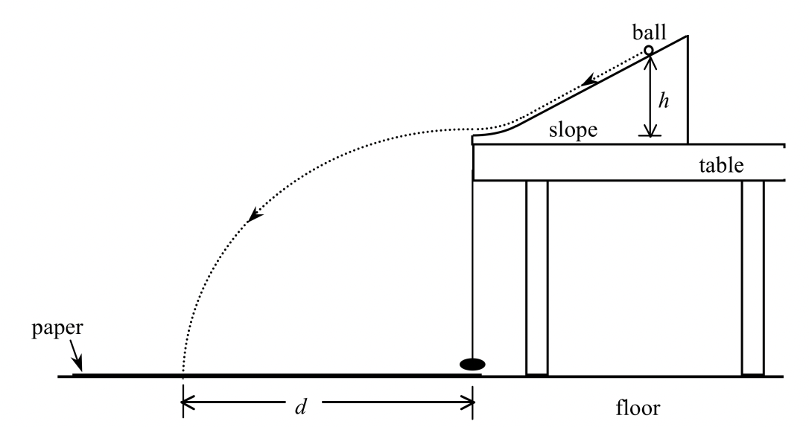
See below
String with object

paper
floor

carbon sheet
tape

- A large piece of paper (equivalent of 2 A4 sheets of paper)
  - This is laid out on the floor to display the exact location the ball hits the floor

- A blue, carbon sheet that is placed on top of the paper (equivalent of 1 A4 sheet)
  - This sheet leaves a blue mark on the piece of paper when the ball hits the sheet, so it is used to indicate where the ball landed

- Tape
  - This secures the paper on the floor and secures the carbon sheet on the paper
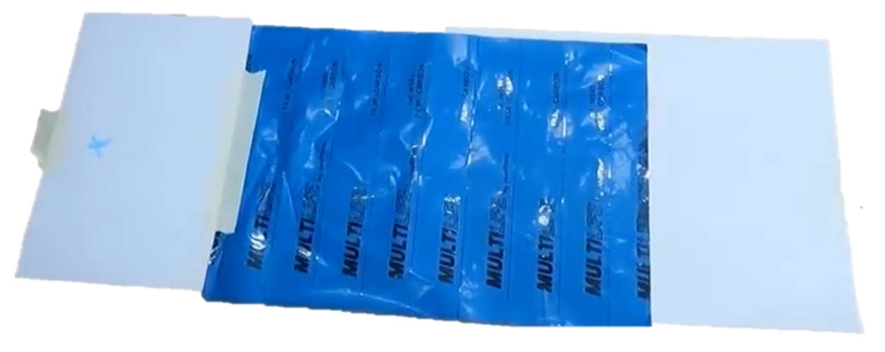
This is the paper secured with tape and the blue, carbon paper on top

- A small, steel ball
  - This is rolled down the slope to measure d and h

- A piece of string with some object tied to the end
  - This is used to track where the ball leaves the slope.

- A wooden slope which has a straightened-out part at the end
  - The slope is used to slide the ball down and the straightened-out part is used to straighten the ball before it slides off the table, eliminating any initial vertical velocity on the ball)
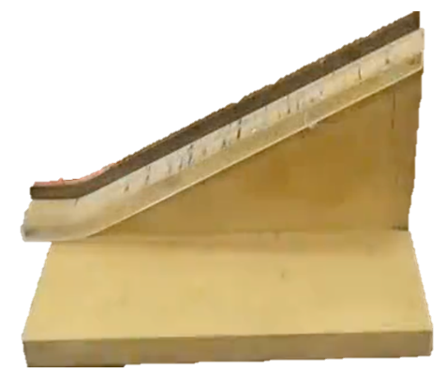

- A table to put the slope on
  - This table provides some constant height the ball is launched from, making it easier to interpret the relationship between h and d

- A metre stick
  - This is used to record the horizontal length d that the ball has travelled and the height h the ball is released from

- A pen
  - Used to mark off locations on the slope as well as the launching position of the ball

- A laptop/piece of paper
  - To record the h and corresponding d values

Method:
The piece of paper was laid on the floor, under and in front of the slope and was then secured with tape. A metallic object on the piece of string was hung from the slope (this was done by hanging the string over the slope and letting it come to rest hanging over the slope) and its location on the piece of paper was marked. The ball was then launched once from the slope to get an idea of where the ball will land, from the middle of the slope and as a result, the blue carbon sheet on top of the paper was placed, with the middle of the sheet placed roughly where the ball landed, and the sides of the sheet were placed such that they were parallel with the balls horizontal path. Tape was then used to secure the carbon sheet. Some spot on the slope was marked with a pen and the vertical distance to this spot was measured and recorded as h on a laptop and a piece of paper. The ball was launched from that spot, with the center of the ball in line with this line (so that the ball is launched from the same position every time) for a total of 5 times. The launching steps was repeated 6 times to get 6 different heights. The carbon sheet was taken off and each spot on the piece of paper was measured and recorded (with its cluster, so the short cluster is marked with the short height). The length measured is the horizontal distance from the center of the blue spot to the spot that the ball is launched from (this is already marked on the sheet of paper)

Data and results:

Tables

Table 1: The measured results of the heights (cm) launched at, and the distances travelled (cm)

The distances (m) measured for a specific height (m)

Height (cm) | Distance (m)
0,037 | 0,277; 0,279; 0,28; 0,28; 0,284
0,045 | 30.6; 30.9; 30.9; 30.7; 31.1
0,055 | 32.9; 33.2; 33.5; 34.5; 34.5
0,067 | 38.5; 38,5; 38.7; 38.9; 38.2
0,08 | 42.6; 42.9; 43.4; 43.5; 43.8
0,096 | 46.8; 47; 46.4; 46.5; 46.7

Table 2: Averaging the distance (m) to a specific height (m)

Example calculation (this same process is used for all the calculations):

For h = 0,037m

d_{av, h=0,037m} = $\frac{0,277+0,279+0,28+0,28+0,284}{5}$ = 0,28m

Average distance (m) travelled from a specific height (m)

Height (m) | Distance (m)
0,037 | 0,28
0,045 | 0,3084
0,055 | 0,3372
0,067 | 0,3856
0,08 | 0,4324
0,096 | 0,4668

Table 3: Comparing the height (m) to the distance² (m)

Example calculation (this same process is used for all the calculations):

For h = 0,037m and d = 0,28m:
d² = 0,28² = 0,0784m
$∴$h = 0,037m and d² = 0,0784

Average distance² (m) from a specific height (m)

Height (m) | Distance² (m)
0,037 | 0,0784
0,045 | 0,09511056
0,055 | 0,11370384
0,067 | 0,14868736
0,08 | 0,18696976
0,096 | 0,21790224

Table 4: Comparing the height (m) to the $\sqrt{Distance}$ (m)

Example calculation (this same process is used for all the calculations):

For h = 0,037m and d = 0,28m:
$\sqrt{d}$ = $\sqrt{0,28}$m = 0,52915026m
$∴$h = 0,037m and $\sqrt{d}$ = 0,52915026m

Average $\sqrt{Distance}$ (m) from a specific height (m)

Height (m) | $\sqrt{Distance}$ (m)
0,037 | 0,52915026
0,045 | 0,55533774
0,055 | 0,58068925
0,067 | 0,62096699
0,08 | 0,65757129
0,096 | 0,68322763

Graphs

Since we want to find out if $h∝d^{2}$ or $h∝\sqrt{d}$ , we want to plot a $d^{2}$ vs h graph and a $\sqrt{d}$ vs h graph. Whichever graph yields a stronger straight-line correlation will be the answer.

Graph 1: $d^{2}$ vs h

Graph 1 is achieved by plotting Table 3

Note: The stronger the linear relationship, the more proportional d² is to h
R² is an indicator of how strong the correlation is, with the higher R² indicating a higher correlation
R² for Graph 1 is 0,9943 which is nearly a perfect correlation

Graph 2: $\sqrt{d}$ vs h

Graph 2 is achieved by plotting Table 4

Note: The stronger the linear relationship, the more proportional $\sqrt{d}$ is to h
R² is an indicator of how strong the correlation is, with the higher R² indicating a higher correlation
R² for Graph 2 is 0,9879

Analysis and Discussion

Both graphs present strong R² values, however Graph 1 has a correlation coefficient of 0,9943 and Graph 2 has an R² value of 0,9879. Graph 1 then clearly has a stronger correlation (0,9943 > 0,9879) since R² is an indication of the strength of the correlation, with 0 $≤$ R² $≤$ 1

From this, it can be concluded that $h$ is proportional to d² but h is not directly proportional to d² as the intercept of the line in Graph 1 is 0,0151 (The equation of Graph 1: y = 2,4513x - 0,0151).
This means as h increases, d² increases by 2,4513h (The gradient of the line in Graph 1 is 2,4513)

Conclusion and Recommendations

Conclusion

The aim was to conclude whether $h∝d^{2}$ or $d∝h^{2}$ and through plotting the graphs of $d^{2}$ vs h and $\sqrt{d}$ vs h and observing which provides a better linear correlation, it is clear then that $h∝d^{2}$ and d is not proportional to $h^{2}$ (as discussed in Analysis and Discussion)

The aim has clearly been met, however only to a moderate extent due to their correlations both being very strong and similar to each other

Sources of Uncertainty:
- Measurements were measured with a ruler, an analogue scale. This means there is an uncertainty associated with the judgement of the reader measuring the distance travelled and the height launched from
- There is an uncertainty in the approximation of the launch location. The exact location will never be launched from again (simply because you can always get closer to the exact location with step closer to the exact location getting smaller)
- Another uncertainty is that the ball seems to be launched from a very similar location (not exact by the point above), but there are sometimes large differences in the lengths measured.
  - An example is at height 5.5cm where 5 lengths are measured, two of such are:
32.9cm
34.5cm
There is 1.6cm between these locations despite the ball being launched from nearly the exact same location

Recommendations
- Use some equipment to keep the ball behind before it is launched to get the launch position closer to the exact initial launch.

