将excel表格导入Neo4j中：

根据教程中的表格（示例.csv），在Neo4j服务器模式中用Cypher语言，创建节点和关系。最后结果显示如下。

问题：1.这个不是自动导入的，需要手动输入cypher语句，那在手动的情况下能否在数据集较大的时候减少工作量？

2.其次，是否有自动导入的？

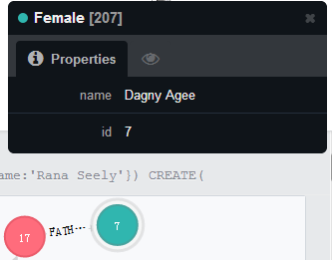

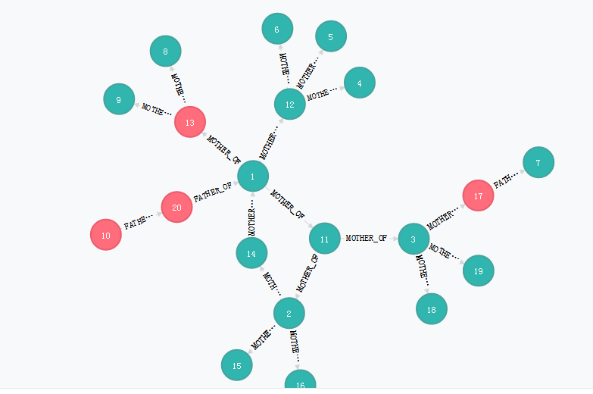

Cypher:

|  |  |  |  |  |  |
| --- | --- | --- | --- | --- | --- |
| CREATE( _0:Female{id:1,name:'Amada Emory'}); | | | | | |
| CREATE( _1:Female{id:2,name:'Rana Seely'}); | | | | |  |
| CREATE( _2:Female{id:3,name:'Detra Thatcher'}); | | | | | |
| CREATE( _3:Female{id:4,name:'Melda Reza'}); | | | | |  |
| CREATE( _4:Female{id:5,name:'Shana Willems'}); | | | | | |
| CREATE( _5:Female{id:6,name:'Sharonda Peele'}); | | | | | |
| CREATE( _6:Female{id:7,name:'Dagny Agee'}); | | | | |  |
| CREATE( _7:Female{id:8,name:'Tisa Woodman'}); | | | | | |
| CREATE( _8:Female{id:9,name:'Shelba Mutchler'}); | | | | | |
| CREATE( _9:Male{id:10,name:'Anderson Spagnola'}); | | | | | |
| CREATE( _10:Female{id:11,name:'Pamala Forward'}); | | | | | |
| CREATE( _11:Female{id:12,name:'Melva Fairchild'}); | | | | | |
| CREATE( _12:Male{id:13,name:'Antione Selman'}); | | | | | |
| CREATE( _13:Female{id:14,name:'Carmelia Cali'}); | | | | | |
| CREATE( _14:Female{id:15,name:'Fairy Daughtery'}); | | | | | |
| CREATE( _15:Female{id:16,name:'Stefany Mcamis'}); | | | | | |
| CREATE( _16:Male{id:17,name:'Kermit Meaney'}); | | | | | |
| CREATE( _17:Female{id:18,name:'Williemae Dossantos'}); | | | | | |
| CREATE( _18:Female{id:19,name:'Marth Sparling'}); | | | | | |
| CREATE( _19:Male{id:20,name:'Jarvis Noland'}); | | | | | |
|  |  |  |  |  |  |
| CREATE _0-[r1:MOTHER_OF]->_10 | | | |  |  |
| CREATE _0-[r2:MOTHER_OF]->_11 | | | |  |  |
| CREATE _0-[r3:MOTHER_OF]->_12 | | | |  |  |
| CREATE _1-[r4:MOTHER_OF]->_13 | | | |  |  |
| CREATE _1-[r5:MOTHER_OF]->_14 | | | |  |  |
| CREATE _1-[r6:MOTHER_OF]->_15 | | | |  |  |
| CREATE _2-[r7:MOTHER_OF]->_16 | | | |  |  |
| CREATE _2-[r8:MOTHER_OF]->_17 | | | |  |  |
| CREATE _2-[r9:MOTHER_OF]->_18 | | | |  |  |
| CREATE _9-[r10:FATHER_OF]->_19 | | | |  |  |
| CREATE _13-[r11:MOTHER_OF]->_0 | | | |  |  |
| CREATE _10-[r12:MOTHER_OF]->_1 | | | |  |  |
| CREATE _10-[r13:MOTHER_OF]->_2 | | | |  |  |
| CREATE _11-[r14:MOTHER_OF]->_3 | | | |  |  |
| CREATE _11-[r15:MOTHER_OF]->_4 | | | |  |  |
| CREATE _11-[r16:MOTHER_OF]->_5 | | | |  |  |
| CREATE _16-[r17:FATHER_OF]->_6 | | | |  |  |
| CREATE _12-[r18:MOTHER_OF]->_7 | | | |  |  |
| CREATE _12-[r19:MOTHER_OF]->_8 | | | |  |  |
| CREATE _19-[r20:FATHER_OF]->_0 | | | |  |  |