Close Approaches

Alex Danici

April 18, 2019

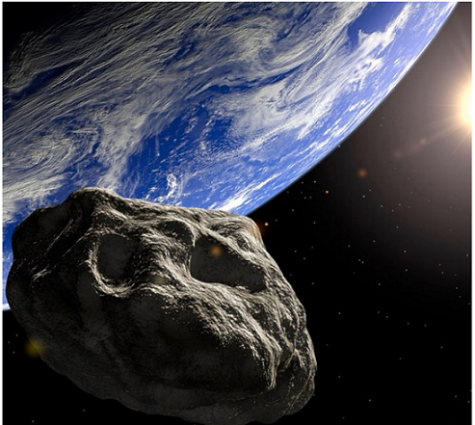

Picture from satelite

## X Object Date minutes Moondist_LD_min Speed_kms  
## 1 1 509352 (2007 AG) 1900-Jan-04 22:25 3.75 8.69  
## 2 2 (2014 SC324) 1900-Jan-11 01:03 15.52 10.65  
## 3 3 4660 Nereus (1982 DB) 1900-Jan-29 18:22 8.08 5.55  
## 4 4 (2015 RW83) 1900-Feb-04 02:31 12.46 3.13  
## 5 5 (2009 BW2) 1900-Feb-04 11:05 6.40 4.27  
## 6 6 (2002 LY1) 1900-Feb-05 22:08 19.08 10.97  
## H..mag. Diam_min Moondist_LD_nom  
## 1 20.1 250 3.75  
## 2 24.3 37 15.55  
## 3 18.2 610 8.09  
## 4 24.1 40 12.63  
## 5 25.1 25 6.86  
## 6 22.3 92 19.09

# NEO Earth Close Approaches

As they orbit the Sun, Near-Earth Objects occasionally approach close to Earth. CNEOS calculates the motion of all NEOs forwards to 2200 A.D. and backwards to 1900 A.D., and determines the times and distances of the Earth close approaches. The results are tabulated [here](https://cneos.jpl.nasa.gov/ca/). You can customize the contents and organization of the table via the Table Settings pulldown lists.

## Including Plots

## Warning: Removed 9 rows containing missing values (geom_point).

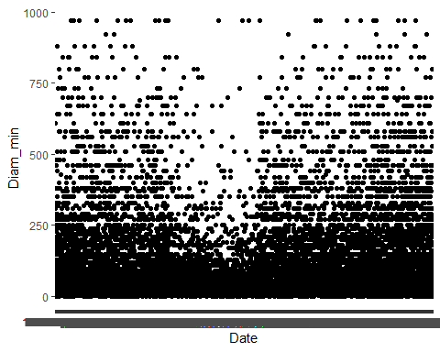

## Result shows clear in the middle one kind of anomaly.

In this plot we can see missing appoaches in the middle. What this mean less activity or missing data. We know from 2005 we started to search more intense for asteroids

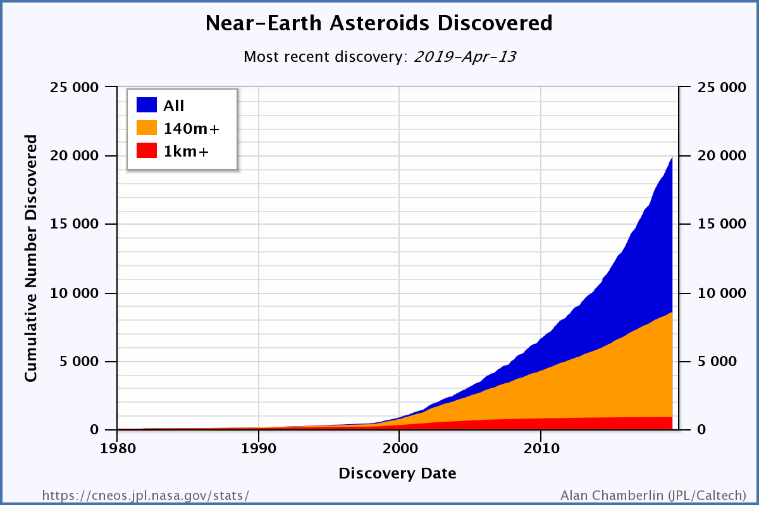

Discoveries of asteroids in years

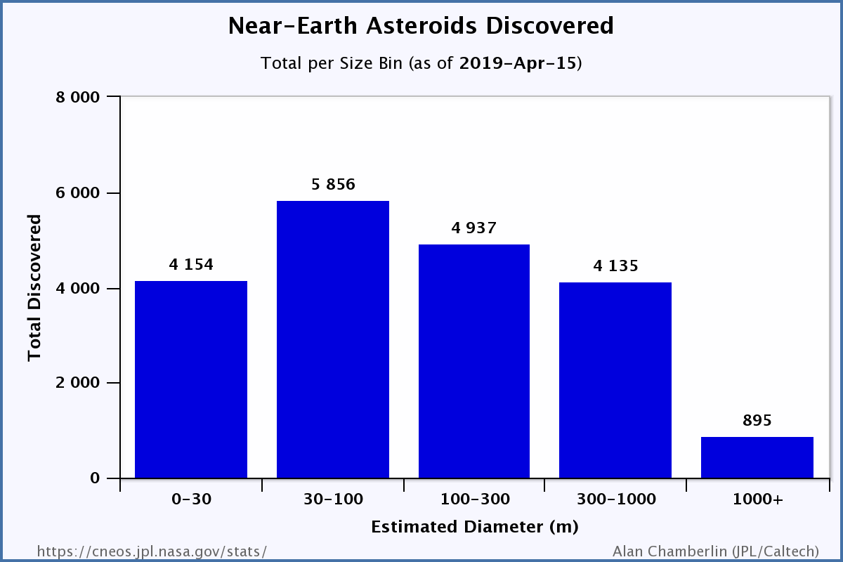

Sizes of asteroids