Alexander DePamphilis
Homework 1 – Basic Git

Problem 1:
The calculated mean of `scores` is 80, meaning the average score of the five exams was 80.
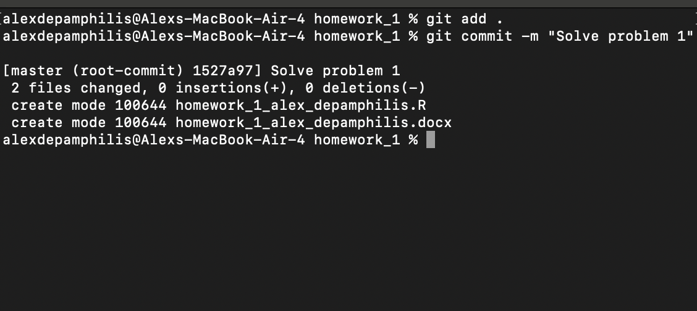

Problem 2:
The calculated median of `scores` was 84, meaning the middle score of the 5 values was 84. The calculated standard deviation was 9.62, meaning the average distance from the mean was 9.62. These are very different measurements, as the standard deviation gives us insight of the range of scores and how far off the average they were, while the median is a straightforward measurement, representing the middle score of all the data points, which was 84 in this case (3rd highest score out of 5).
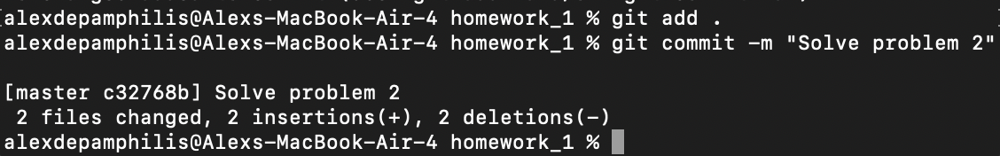

Problem 3:


