Introduction

Welcome to **UX Fundamentals**! This course will serve as an introduction to the world of user experience design, incorporating aspects of experience design strategy, user research, information architecture, and interaction design. It was written by expert UX practitioners, so you can rest assured you’ll get an in-depth look at current, everyday practices in the field. The best way to learn the art of UX design is to practice the art of UX design, so we’ll have you getting your feet wet early on with practical, hands-on projects at the end of every Exercise. By the time you’ve finished with the course, you’ll have created a complete mobile app design of your very own that you can show off to friends, family, and potential employers alike. Excited? We sure are!

In this Exercise, we'll introduce you to the field of UX design and the design thinking process. Towards the end of the Exercise you'll find an instructional video taking you through the first design task you'll complete for this course - a competitive analysis.

Before diving straight into the everyday work of a UX designer, let’s take a moment to explore the fascinating origins of user experience as a field.

History of UX



Cars and vans being transported in 1950

The concept of user experience is older than most people think. In the late 19th century, great thinkers and industrialists like Frederick Winslow Taylor and Henry Ford began integrating basic experience design principles into their production processes. Taylor and Ford’s goal to maximize the efficiency of human productivity led them to explore new ways for workers to interact with complex tools in an effort to streamline the production process. Engineers of the time were being saddled with building increasingly more complicated technological systems, to the point where their abilities to build these complex systems exceeded their ability to explain how they should be used.

Thus, a turning point was reached in the middle of the 20th century. Simply building sophisticated functionality was no longer enough. A new role was necessary—the designer. Designers were tasked with building intuitive interfaces that could translate complex systems into useful, usable, and desirable experiences.

For example, Paul Fitts, a psychologist and pioneer in human factors and ergonomics, was contracted for his deep understanding of how humans interact with systems to redesign airplane cockpits and improve aviation safety—a move that’s saved thousands, if not millions, of lives. As progressively more advanced technology migrated out of factories and the military and into the hands of consumers, it became more important than ever to simplify user interfaces and empower people to complete desired tasks.

“If I were to sum up the history of UX in a few short sentences, it might go something like this: villains of industry seek to deprive us of our humanity. Scientists, scholars, and designers prevail, and a new profession flourishes, turning man’s submission to technology into technology’s submission to man. Pretty exciting stuff.”  
LEAH BULEY, [THE USER EXPERIENCE TEAM OF ONE](http://rosenfeldmedia.com/books/the-user-experience-team-of-one/)

Despite its strong presence in the manufacturing industry, user experience didn’t emerge as a recognized field until the late 1900s. The term “user experience” was formally coined by Don Norman upon arriving at Apple Computer in 1993 as a user experience architect, making it the first known use of the term in a job title. Since then, the field, along with our ability to create powerful technology, has grown immensely. Although the phrase was inspired by people in technology, the principles of **experience design** themselves can be employed at all stages of a customer’s interaction with a product or service, including physical stages. The growing relevance of design can be seen in big businesses and startups alike, and [UX designers are in high demand](https://www.roberthalf.com/creativegroup/blog/hot-job-ux-designer).

People experience complicated products and services every day. These products and services typically reflect the complexity of the technology or internal structure of the organization. Our job as experience designers is to understand not only the technology, but also the organizations and people who use them, in order to design the most intuitive, compelling, and valuable products and services possible. It’s our mission to design for everyone and to add real value to people’s lives.

What Is UX?

“User experience encompasses all aspects of the end-user's interaction with the company, its services, and its products.”  
DON NORMAN

**User experience**, commonly abbreviated as **UX**, is any experience or interaction a user has with a product or service, as well as everything around it—customer service, technology, packaging, community, emails... everything! From a digital perspective, UX involves designing content, information, and interfaces in a way that provides value to and generates loyalty with users. In reality, however, UX encompasses all aspects of the user’s interaction with the company and its services and products. The goal of **user experience design (UXD)** is to improve things like utility, ease of use, and efficiency in a user's interaction with a product or service.

While you can take many different avenues to explore the massive field of user experience, in this course we'll focus on mobile applications as a medium for learning some of the most important concepts and techniques within UX. We’ll talk more about the app you’ll be creating later on.

UX Is Not UI

You may have heard the term UI come up in conversations about UX. **User interface (UI)** refers to the actual interface of a product or service as opposed to the holistic end experience someone has with a product or service (i.e., UX). For example, the UI for the Lufthansa site pictured below is the actual interface a customer uses to interact with Lufthansa’s service both visually and physically, from the button sizes to the images, fonts, and even colors. Thousands of micro-decisions made by a UI designer—typically utilizing a software program like Photoshop or Sketch—go into creating those pixel-perfect interfaces.



Source: [Calvin Pedzai](https://www.behance.net/gallery/12230719/Lufthansa-flight-tracking-app-IOS7)

In contrast, UX is more overarching. The focus here is on the context in which we expect someone to use the Lufthansa application. UX designers have to distance themselves from the screen and focus on what it is users want to accomplish, as well as their current circumstances. For example, is the customer in a rush at the airport and trying to check into a flight? UI is a specialized skillset of its own and is typically considered a subset of UX, so not all UX designers are UI designers, but all UI designers (we hope) employ the UXD principles discussed in this course to solve real problems for real people.

“UX is focused on the user’s journey to solve a problem; UI is focused on how a product’s surfaces look and function.”  
KEN NORTON, PARTNER AT GOOGLE VENTURES, EX-PRODUCT MANAGER AT GOOGLE

For a more detailed explanation, as well as examples and definitions of UX and UI, check out this article: [What’s the Difference Between UI and UX?](https://www.usertesting.com/blog/2016/04/27/ui-vs-ux/).

UX Quadrant Model

Now that you’ve gotten a taste of what UX, UI, and UXD are all about, let’s take a look at the broad disciplines covered under the umbrella of user experience design. The **quadrant model** (pictured below) organizes UX design into four main disciplines or “quadrants.” Most UX designers have a broad understanding of all four quadrants but only focus on one or two. We’ll take another look at this model when it comes time to discuss your design profile at the end of the course.

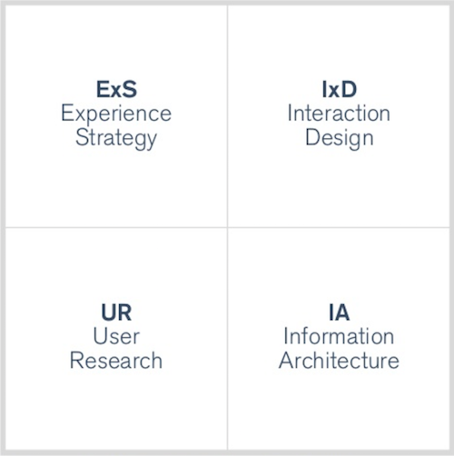

Warren Hutchinson originally created this model. [Jason Mesut](https://www.slideshare.net/planstrategic/ux-hiring-hq) has since built on the Quadrant Model showing Experience Strategy (ExS), Interaction Design (IxD), User Research (UR), and Information Architecture (IA).

Though you’re just getting started in your UX design studies, you might already have an idea of where your strengths lie. Take a look at the diagram above and descriptions below and see if any quadrant in particular appeals to you. Each of these quadrants will be explored in more detail throughout the course.

Experience Strategy

The best UX designers are adept at integrating business, technical, and design strategies to bring value to not only the customer using the service, but also the business providing the service.

User Research

As stated by Hoa Loranger at the Nielsen Norman Group, one of the leading UX and UI consulting firms in the U.S., “[UX without user research is not UX](https://www.nngroup.com/articles/ux-without-user-research/).” The ultimate goal of the UX designer is to utilize qualitative and quantitative data to determine a problem and formulate a solution. Many large companies and startups proceed blindly without any real interaction or feedback from current or potential customers. Good research can often mean the difference between a meaningful experience that solves an actual human problem and a dissatisfying experience that fails to address a real human need.

Information Architecture

Humans have been trying to record, categorize, and store information since the dawn of communication. With the invention of the internet in 1989, we’ve marched faster still towards this new “Age of Information.” Information architects have used a number of different techniques to facilitate the effective, accessible, and meaningful organization of information in the digital age. This is why we can successfully navigate stores and digital devices to find what we need, when we need it.

Interaction Design

Armed with user feedback, interaction designers aim to create seamless interactions between a system and its users. In technology, this interaction is commonly facilitated by a digital interface. The goal of **interaction design** is the synthesis of experience strategy, user research, and information architecture into one intuitive design. This design should facilitate the efficient completion of core tasks, providing value to the people interacting with your product or service.

Interaction designers must have a deep understanding of how users interact with their products and services. The ultimate goal for them is to reduce friction between the user and the product or system being designed.

Keep in mind that there are considerably more sub-disciplines within these four areas that allow us to create even more compelling experiences. That’s part of what makes this field so exciting—you can focus on a variety of areas and determine what most appeals to you.

SUB-DISCIPLINES OF UX  
For a taste of which sub-disciplines exist, take five minutes and review Magnus Revang’s [UX Wheel](http://userexperienceproject.blogspot.de/2007/04/user-experience-wheel.html). The UX Wheel outlines the various disciplines within UX and puts them into the context of [Peter Morville’s Honeycomb Model](https://www.usability.gov/what-and-why/user-experience.html).

Design Thinking at Work

Now that you have a broader understanding of where UX has come from and the breadth of the field itself, let's take a look at how UX design works in an actual business setting. One popular approach is design thinking. Coined by Peter Rowe and pioneered by IDEO and the Stanford Design School, **design thinking** is a helpful framework for how to approach real problems from a design perspective.

“Design thinking begins with skills designers have learned over many decades in their quest to match human needs with available technical resources within the practical constraints of business. By integrating what is desirable from a human point of view with what is technologically feasible and economically viable, designers have been able to create the products we enjoy today. Design Thinking takes the next step, which is to put these tools into the hands of people who may have never thought of themselves as designers and apply them to a vastly greater range of problems.”  
TIM BROWN, CHANGE BY DESIGN

The ultimate aim of design thinking is to reconcile people’s desires with technical feasibility and business viability. As UX designers, we’re always trying to engage directly with real people and develop a deep understanding of their goals and needs. To borrow an analogy from Tim Brown, CEO of IDEO and author of [Change by Design](https://www.amazon.com/Change-Design-Transforms-Organizations-Innovation/dp/0061766089?ie=UTF8&*Version*=1&*entries*=0), design is not simply a link in the chain, but the hub at the center of a holistic business strategy that includes customer desirability, technical feasibility, and business viability.

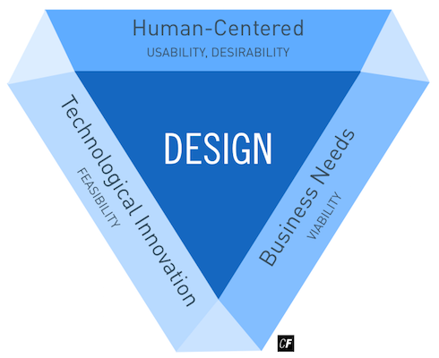

When you transform this idea into a process for tackling real-world problems, you get something like the following diagram:

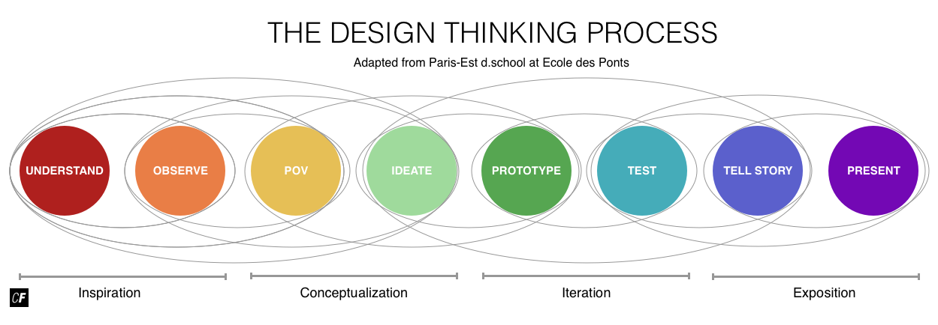

Adapted from [Paris-Est d.school at Ecole des Ponts](http://www.dschool.fr/en/design-thinking/)

You’ll notice that the steps in the design thinking process are represented from left to right, but it should be expressed that the process is never completely linear. This is where the lines you see between each circle come into play. Discovery of new information during the process can alter or rearrange the order of the steps. That being said, the use of these steps as a general guideline for taking a product from conception to implementation will help ensure that you produce a well-designed, user-centered product or service.

These steps will closely reflect the structure of this course. We’ll be following the design thinking process as we work through your project to ensure you get a solid feel for how it would work in the real world. Currently, for example, we’re making our way through the “understand” phase. After this Exercise, you’ll not only be comfortable with the basics of user experience design and design thinking, but also have a better understanding of the goals, industry, and competitors of your upcoming course project.

Let’s take a look at how the rest of the steps relate to the real-world design tasks we’ll be tackling throughout this course.

Design Thinking Tasks

There are so many methods and techniques at your disposal when it comes to design thinking that it can be easy to find yourself feeling overwhelmed. As this is just an introductory course, we recommend that you focus on the tasks we’ve outlined below to avoid getting lost in the greater complexity of the industry. We’ve put them in chronological order, mirroring the steps in the design thinking process (refer to the image above).

These tasks are standard practice for UX designers and will provide a solid foundation for further education. Once you feel comfortable with each of the techniques, feel free to practice them “in the wild” with your own projects and professional pursuits.

Research and Competitive Analysis [Understand]

One of the first steps in the design thinking process is research—that is, getting to know the problem space you're operating within. It's important to get a feel for what kinds of issues are related to the problem you're investigating and to take a look at what solutions to similar problems have already been proposed. You can learn a great deal from looking at your competitors while conducting a **competitive analysis**, an assessment of the strengths and weaknesses of your competitors.

In terms of features/elements to examine, this will vary greatly depending on the type of app you are looking at. An ebook reading app has very different features than a map app, for example. A few common elements you can look at across various types of apps include but are not limited to:

* Launch experience (splash, onboarding, sign up/log in)
* Navigation
* Buttons (placed clearly, readable)
* Options/Settings (placed clearly, too many/few options)
* Difficulty/ease of task completion

In this course, we'll be looking at competitors who've made mobile apps similar to the one we'll be designing. You'll then be able to use this knowledge to implement positive features in your own designs (while avoiding the negative features). You'll get a chance to start practicing this skill right away in the Task for this Exercise.

For a deeper understanding of how to conduct a competitive analysis, take a look the instructional video below. In it, your instructor, Claire, will conduct a competitive analysis of an alarm clock app.

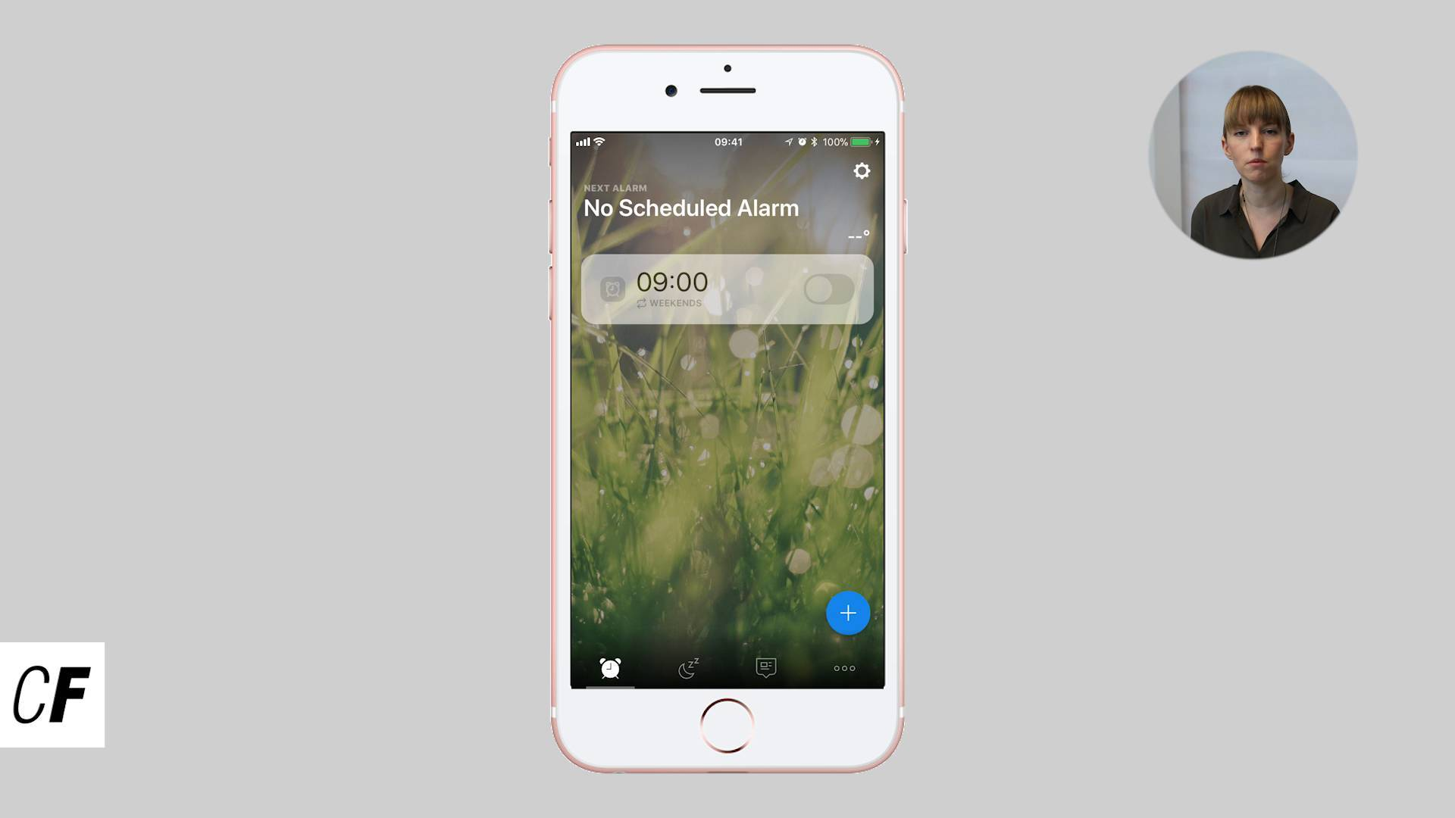

User Interviews [Observe]

As the name suggests, this is a user research method aimed at gathering qualitative information directly from those engaged with your product or service. There’s no testing involved—only conversation. By developing an effective script of questions and recording the results, you can get honest, direct feedback from your current or potential users. We’ll focus on how to formulate effective questions, as well as best practices for the interview itself. After conducting the interviews, you’ll organize the information to help you move forward with persona creation.

Personas [POV]

Using feedback from users (that you acquired via your interviews), you’ll be able to identify your users’ goals and create personas. User personas help us better understand user demographics, needs, goals, emotions, behaviors, fears, and limitations.

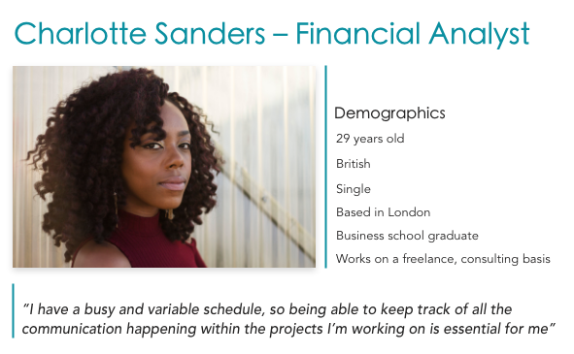

User Flows and Card Sorting [POV]

Once you understand what your users are trying to accomplish, you can map out user flows. User flows outline the journey the user takes through a system when completing tasks and transactions. To help you figure out what these flows would look like, we'll also talk about information architecture and techniques such as card sorting.

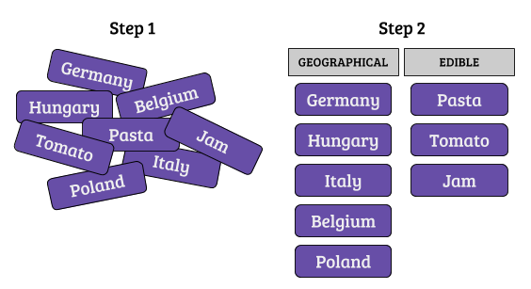

An example of Card Sorting

Wireframing and Prototyping [Ideate and Prototype]

With user flows in hand, you now know what steps are necessary for users to complete tasks via your product or service. The next step is to visually brainstorm solutions for each of those steps. You’ll create **wireframes**, which are initial blueprints for your designed solution, as well as **prototypes**, which are quick implementations or models of a final product created to test user experience at an early point within the project timeline.

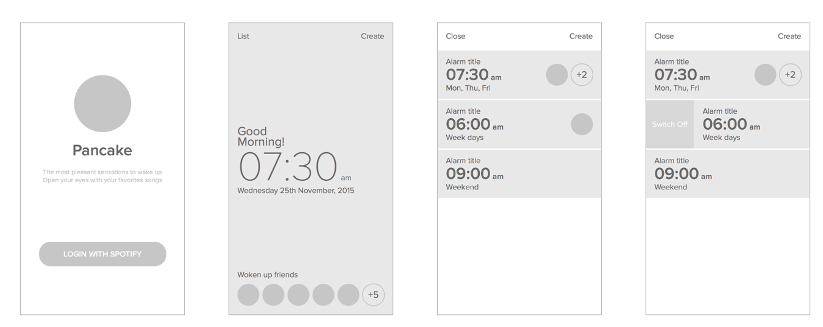

Usability Testing [Test]

Once you have a prototype, you can conduct usability tests to better understand how people interact with your product or service. The tests typically focus on the primary tasks identified in the strategy and persona stage. Will users be able to complete their key tasks using your prototype? That’s for you to find out!

Design Presentation and Critique [Tell Story and Present]

John Maeda, author of [The Laws of Simplicity](http://lawsofsimplicity.com/), states: “Design is a solution to a problem. Art is a question to a problem.” As designers, it’s critical that we propose real solutions to real problems based on solid design principles and a deep understanding of our users. In this step, we’ll discuss how to defend design decisions in the form of a presentation while still being open to critique and feedback.

Summary

In this Exercise, we’ve learned about the basics of UX, UI, and UX design. UI design focuses on the interface a user interacts with, while UX design looks at a user’s complete experience with a product or service. We’ve also explored the quadrant model and saw that there are countless possibilities for specializing in a particular area of UX.

UX designers use frameworks such as the design thinking process to solve real-world problems. Competitive analyses, user interviews, persona creation, card sorting, wireframing, prototyping, and usability testing help to create successful, well-designed products and services. Now, you can start tackling these tasks yourself as you learn the processes, principles, and proficiencies that make up user experience design. Ready to start thinking like a UX designer?

To put some of what we learned about design thinking into practice, we'll start by conducting a competitive analysis for your app—part of the “understand” phase. While you look at some of your app's competition, remember to think in terms of the users: is the app useful, is it easy to use, and does it accomplish the users' goals? Don't forget to watch the video shared in the Research and Competitive Analysis [Understand] section of this Exercise to help you with this Task.

Resources

For a more visual explanation of UX, check out the [7 Best UX Infographics](https://www.usertesting.com/blog/2015/06/19/7-brilliant-ux-infographics/), with special attention to Jesse James Garrett's [Elements of User Experience](http://www.jjg.net/elements/pdf/elements.pdf) (a key contribution to the field back in 2001). You can also peruse the links below for some different points of view on UX and its history:

* [The Fascinating History of UX Design: A Definitive Timeline, by CareerFoundry](https://careerfoundry.com/en/blog/ux-design/the-fascinating-history-of-ux-design-a-definitive-timeline/)
* [Where UX Comes From](http://www.uxbooth.com/articles/where-ux-comes-from/)
* [A Short History of User Experience](http://blog.uxeria.com/en/a-short-history-of-user-experience/)

Lastly, if you missed any of the links in the Exercise, we’d recommend you check them out now:

* [Hot Job: UX Designer](https://www.roberthalf.com/creativegroup/blog/hot-job-ux-designer)
* [UI vs. UX: What’s the Difference Between User Interface and User Experience?](https://www.usertesting.com/blog/2016/04/27/ui-vs-ux/)
* [UX Without User Research Is Not UX](https://www.nngroup.com/articles/ux-without-user-research/)
* [The User Experience Wheel](http://userexperienceproject.blogspot.de/2007/04/user-experience-wheel.html)
* [User Experience Basics and the User Experience Honeycomb](https://www.usability.gov/what-and-why/user-experience.html)

#### Task

* [DIRECTIONS](https://careerfoundry.com/en/course/ux-fundamentals/exercise/intro-to-ux#directions)
* [SUBMISSION HISTORY](https://careerfoundry.com/en/course/ux-fundamentals/exercise/intro-to-ux#step_submission_history)

 Estimated Task Time: 4 Hours.

Now that you’re more familiar with what goes into UX design and the role of UX designers, let’s start practicing the “understand” stage of the design thinking process by doing an informal evaluation of some competitors. Competitors for what, you ask? Your course project!

##### Course Project

For your course project, you’ll be working on a mobile application for learning vocabulary. Taking a new course is exciting, but it can be intimidating at the same time. With so many new concepts and terms to learn, it can feel a bit overwhelming. In this project, we’ll redesign the experience of memorizing and understanding new concepts, techniques, and terms by exploring how people learn vocabulary and designing a mobile app to address their goals and problems.

Vocabulary learning ranges from learning words for a new language to saving key terms from a business or UX design course. You'll most likely want to look at **flashcard apps**, but it's up to you to decide the educational context and what kind of vocabulary learning app you'd like to design.

Before moving on, please download and review the complete [Project Brief](https://coach-courses-us.s3.amazonaws.com/public/courses/ux-fundamentals/UX%20Fundamentals%20Project.pdf). You’ll be working on the app throughout the course, so don’t worry about having everything figured out quite yet. Keep the brief in hand as you progress through each Task.

As a designer, it's important to keep the project brief in mind, as it's often easy to get distracted and forget the main direction of what you're delivering. You'll also find additional helpful information about the project requirements and your target users.

Sound like fun? Let’s get started with our very first Task.

##### Exploring Vocabulary Learning Apps

Let's practice the “understand” stage of the design thinking process by doing an informal competitive analysis of a few existing mobile applications for learning vocabulary. This will give us a better idea of the field and what’s already out there (our competitors). Competitive analysis is often one of the first steps of design research. It gives us a chance to better understand the problem we'll be tackling throughout the rest of the course and gets us thinking about some solutions that have already been proposed to address the problem.

If you're unable to download applications to your phone, you can try out a mobile app emulator like [BlueStacks](http://www.bluestacks.com/" \t "_blank) on your computer or tablet.

DIG DEEPER!  
Each Exercise’s Task will build on the previous Task as we build your course project. Take each Task one at a time and really focus on doing quality work. If you have extra time, read additional resources and keep revising your Task until you’re confident and proud of the work you’ve produced. For tips on how to present your work, head to your Course Prep!

**Directions**

1. Identify 3 mobile applications that focus on learning new vocabulary, such as flashcard apps. Download the applications to your phone.
2. Collect a few screenshots of each of the 3 mobile apps you downloaded.
3. Write down the positive and negative features of each app. Focus on attributes like how easy the apps are to use and whether the features of the apps accomplish the goals of the app and its users. Here are some questions to consider:
   * Why do you think this is a successful product (or not) in terms of meeting the goals of its users?
   * What do you think the designers did to make it a successful product (or not), again in terms of the users?
   * How do you feel using this product? How would you make it better? Be as specific as possible here.
4. Think about how the positive and negative attributes you've pointed out are related to what you've learned about UX and UI in this Exercise. Do the apps meet the goals of user experience design? Are you pointing out UX or UI features of the apps? Summarize your thoughts below your analyses for the three apps.
5. Submit a PDF that includes both your analyses and summary. Each analysis should include screenshots of the app in question, several positive and negatives attributes, and your thoughts on whether each app was successful in terms of meeting the goals of its users.

**Bonus Task**

Analyze additional vocabulary-related mobile apps.

HEADS UP!  
In the next Task, you'll conduct user research by interviewing potential users. This means you'll need to take some time to recruit participants. To give yourself a head start, we recommend you begin reaching out to your interviewees as soon as possible. They can be family, friends, colleagues, or anyone who'd be willing to participate in an interview for your project. As you're building an educational app, try to make sure your participants have engaged in some sort or educational or vocabulary-learning activity within the past few months, and are familiar with using smart phones.