

|  |
| --- |
| Exercise 1: Competitor Research  Vocabulary Learning Apps |
|  |
| 2019 March 23  Submitted by: Minal Bombatkar |

# Vocabu words- Vocabulary Builder English Words Learning offline

The apps I will be looking at are:

1. 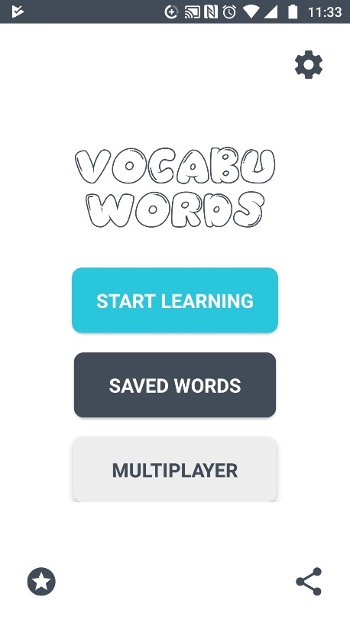Vocabu words is app that lets you learn new English words using its interactive Flashcard Quiz format and improve your English Vocabulary.
2. Positives-
3. It will work offline as well as online

* After onboarding It will direct to the page where it will ask to   
   start from level which you want
* To the point

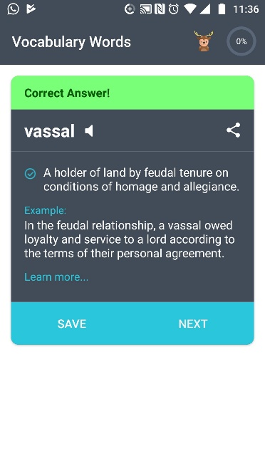 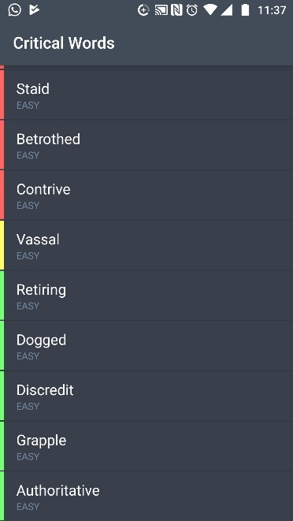

* The best thing about Interface is so simple
* On top left corner of the app there is progress bar. Shows users achivements
* With the sharing option, user would share the Vocaburary with Friends
* It shows list of words, out of which user would choose and see the meaning
* Navigation Buttons – Are simple to use and undertand
* Pronunciation Button- User would lessen the correct pronunciation of the words
* Free version purchase
* Advertise free

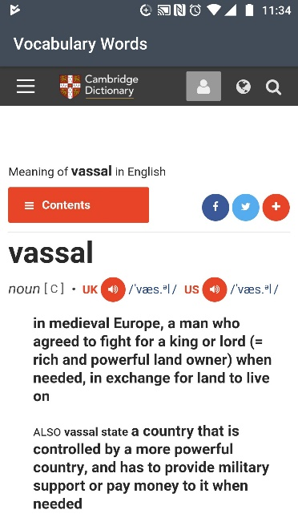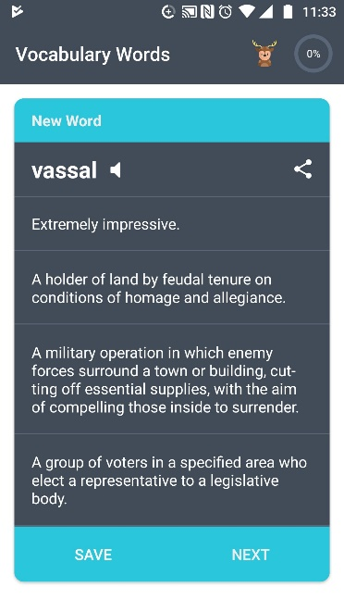

Negatives-

* There are 3 sections after onboarding app, Start learning, Saved word, Multiplayer
* But still, Multiplayers option is unlaunched, so why it is there?
* After clicking on learn more section, it will redirect to other website and not sticking with app if user using it online
* No login page available
* Home page logo is different than inside logo
* While playing it shows(animal) Deer logo and on home page it has this logo
* Missing of search option
* Speaker is not working with some words.

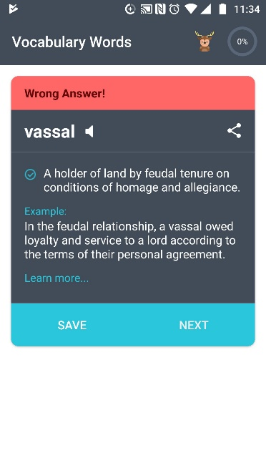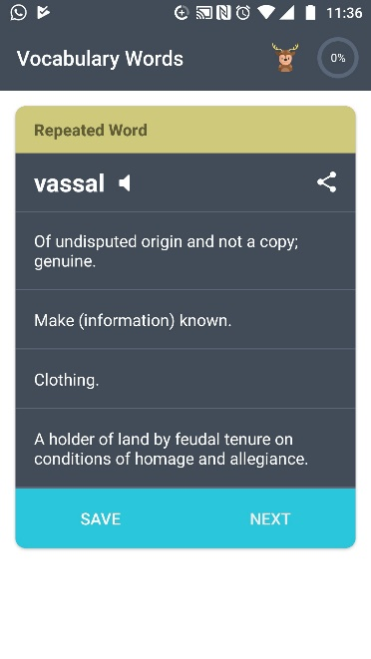

Summary-

Definitely not best but either more improvement is required. It is up to point where user need to find some words to looking for or going to learning anything. Good for best Vocabulary practice but not for language learning. Like sentence creation or grammar.

Duolingo: Learn Languages Free

It is a free platform that includes a language-learning app, as well as a digital language proficiency assessment exam. As of it offer 85 different language courses in 24 languages. The app has about 300 million registered users across the world.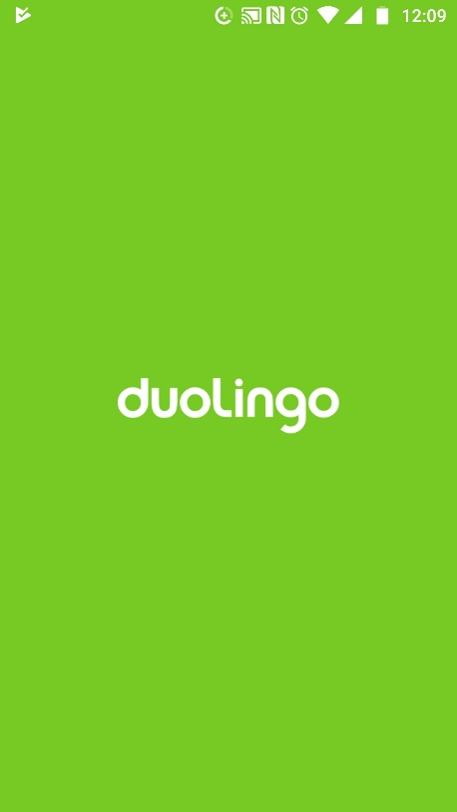

Positives-

* + Interface- Duolingo’s design is clean, intuitive, and highly engaging, with a straightforward interface and built-in gamification elements. Especially important for first-timers, Duolingo goes out of its way to make language learning fun and un-intimidating.
  + Resources - In addition to interactive lessons, Duolingo offers practice quizzes, explanations, a grammar guide. Which encourage learners to follow and translate real-world dialogue.
  + Free- Many language learning courses offer free versions, but Duolingo is the “most” free every student has unlimited access to the app and all course material. A premium subscription eliminates advertisements, but these are already limited and unobtrusive.

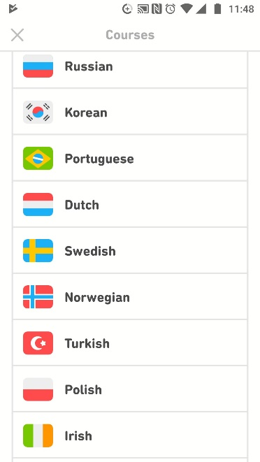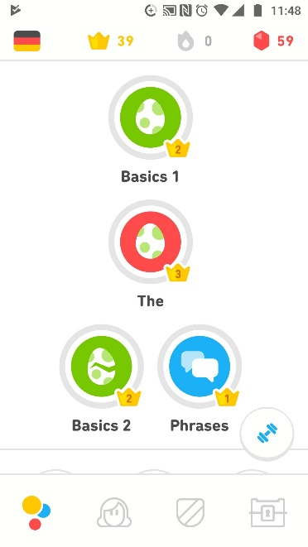 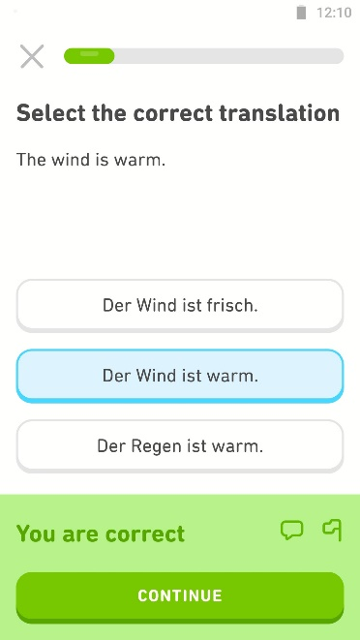

Negatives

* + Mobile- Duolingo’s mobile app is not nearly as effective as the web version. discouraging use.
  + Awkward sentences. A common criticism against Duolingo is occasionally awkward sentence constructions, i.e., sentences you’d probably never use in the real world. On one level, this is a natural part of language learning — you’ve got a limited vocabulary and have to start somewhere — but it does result in some impractical lessons.
  + The voices are lower than the "ding!"

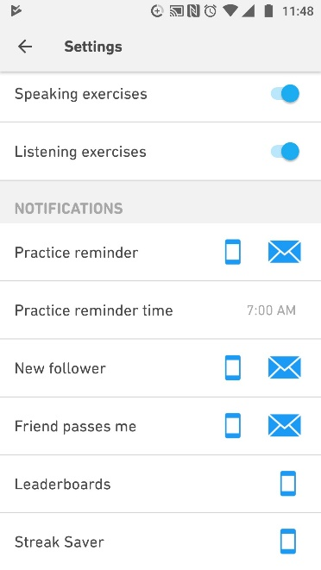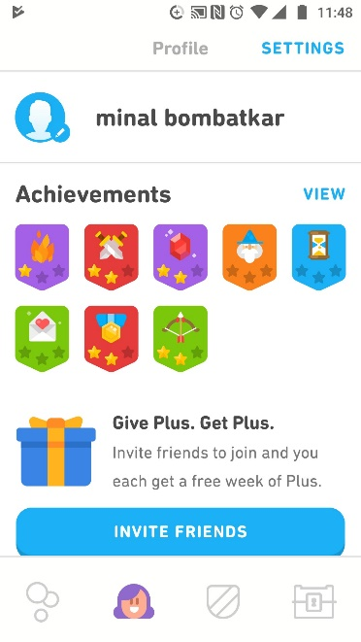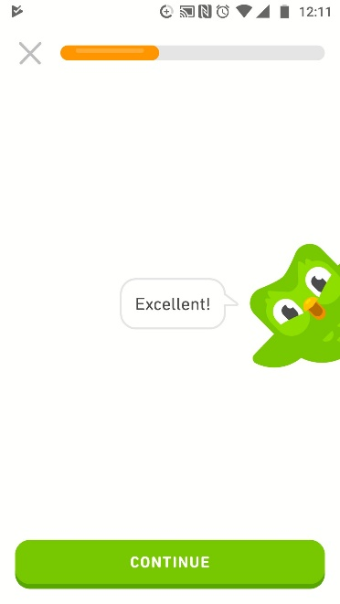

Summary

Motivational elements that user can achieve higher level crowns, power-ups, earn coins, it make

the user engaged. It’s User-friendly design make it best to paly with it. The mobile app is very with neutral design and without extra functionality, simplicity is the key. I am personally using it since one year. I think, it’s secrete of successes are learning method, theme, Appearance and to keep the user engaged.

Der Die Das

This app helps in learning German articles in this language. This application helps to find the articles and learn nouns.

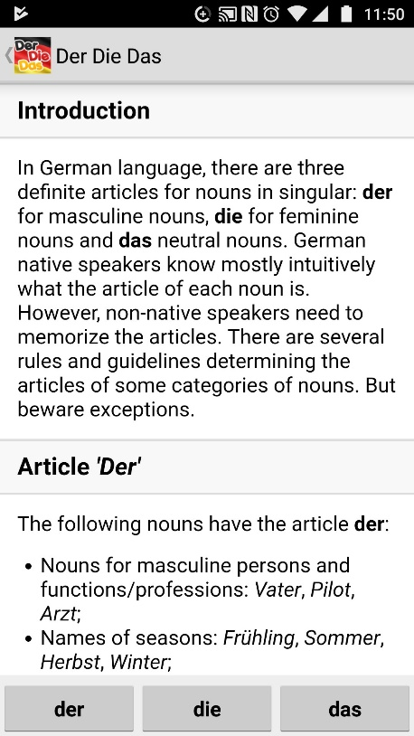Positive-

* Onboarding is simple with introduction
* It follow with the information and the articles
* Level of selection Beginner, Advance , Expert
* According the levels starts Vocabulary

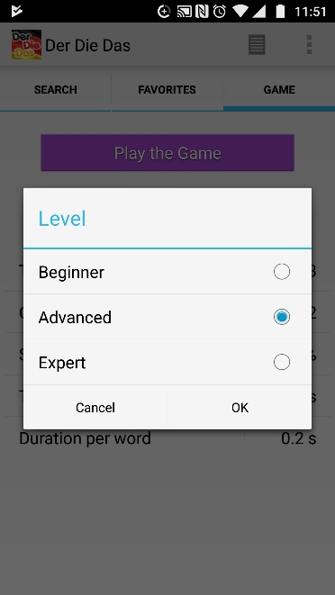

Negative-

* Very basic applications
* Its functionally is not so up to marked as compared to others learning apps
* It has some mistakes e.g. “das” restaurant not “die” restaurant
* It is not full filing it’s purpose i.e. learning of German articles and nouns

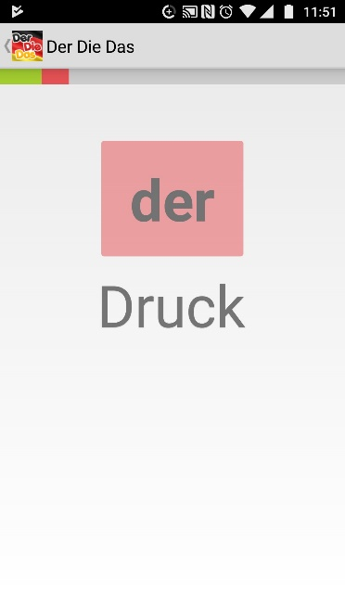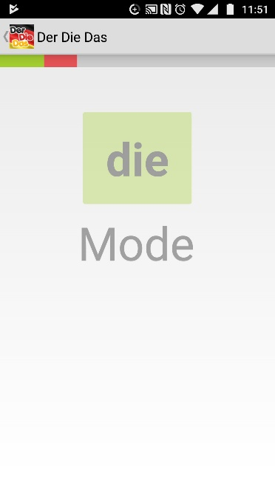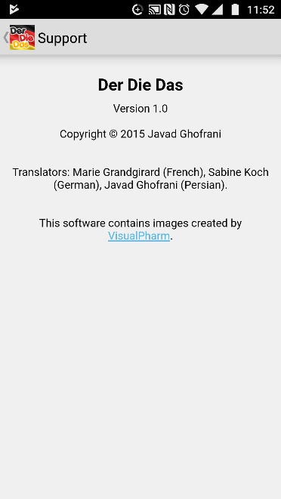

Summary-

Design is not so recognizable, only task bar with logo and very basic. Lack of sharing or follow ups buttons. Lack of practice area and fixes set of structure. Still this app has 4.3 reviews on google pay store. Just because of it’s simplicity. This require much more updating to be successful in todays race.