1.3: User Personas

#### **Introduction**

Great to see you back! How did your user interviews go? Were you able to glean some good information from your participants? Don’t stress too much if you found the process difficult or the conversations awkward—that’s normal! This is your first project, after all. It takes time and practice to perfect your technique. Focus on enjoying the learning process one step at a time.

By now, you should have a better understanding of the app you’re going to create. Your research of competitor apps and observational data from your interviews should have given you key insights regarding the direction you should take with your project, but we’re not quite done putting it all together. For that, we need to synthesize all that data you’ve collected into something meaningful. This leads us to the conceptualization phase of the design thinking process, where you take your inspirations and turn them into full-fledged ideas for your product, starting with “POV.” During this step, we’ll be looking even more closely at our potential users so as to fully understand their points of view.

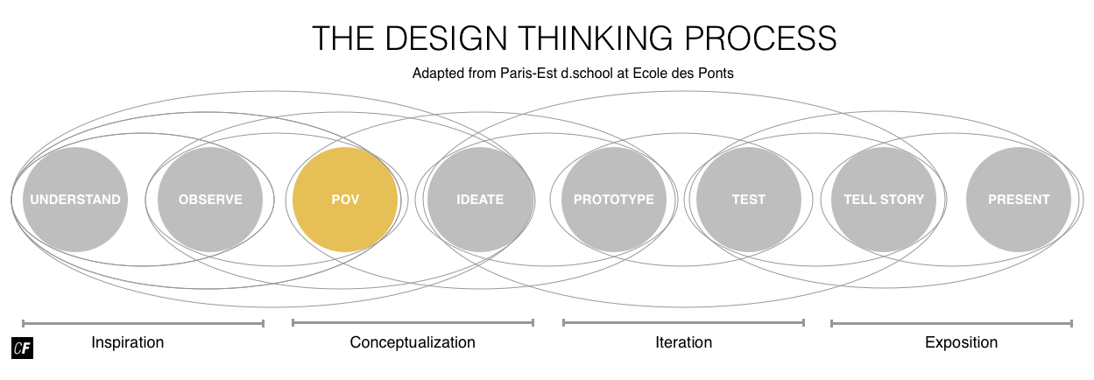

To do so, we’ll learn how to create user personas in this Exercise. User personas are a way of humanizing your potential users and highlighting their goals and behaviors. By bringing your customers’ perspectives to the forefront, you can give meaning to your research, which will, in turn, lead to more concrete ideas and strategies. Personas help you hypothesize clear actions your users might take while using your product or service.

As creating full-fledged personas can be a lengthy task, we’ll start by looking at proto-personas, a more basic version of the persona. Using these proto-personas, you’ll be able to craft meaningful user stories, problem statements, and hypotheses that will come in handy during the ideation phase further along in the design thinking process.

Let's start by looking closely at what makes up a user persona.

#### **User Personas**

A **user persona** is a representation of the goals, pain points, and behaviors of a hypothesized subset of users. Personas are informed by research, typically through exploratory user interviews at the beginning of a project, and continuously refined based on your users’ actual behaviors when interacting with your product or service.

Don’t you find it strange that the only person not present at company meetings is the person you’re designing for? This is where personas come in. Personas are a powerful tool for internal alignment to reconcile business, technical, and design capacities. They help designers and businesses maintain focus on their customers rather than their internal agendas.

The ultimate goal of a persona is to generate empathy for your potential users—those for whom you’re designing. Indeed, sometimes the term “user” doesn’t elicit the proper human response. It’s so easy to shrug them off as some nebulous concept rather than think of them as real human beings. By bringing these groups of customers to life in the form of an archetype, we humanize them, empathize with them, and ultimately, create better designs for them. We give them faces and names, allowing us to refer to them naturally—and prioritize their needs—when making design decisions.

When creating your persona, it’s important that he or she feels real to you and your team. On larger or more complex projects, you may even have more than one persona. In these cases, you should try and focus on the persona with the greatest impact on the project. This is commonly referred to as the **primary persona**. When creating a primary persona, consider the following elements:

* **Name and face.** Give your persona a name and face. You can either sketch out a character or find a convincing photograph.
* **Demographic information.** Outline your persona’s location, age range, education, ethnicity, family status, and job titles.
* **Needs and goals.** Identify goals and tasks your persona will want to achieve using your product or service.
* **Behaviors.** Take notes on your persona’s current behaviors or feelings towards your product, service, or industry.
* **Quotes.** Come up with relevant quotes that sum up your persona’s relationship with your product, service, or industry.

Personas are design deliverables in themselves. For an example of how this information might translate into a fully-fledged persona, [check out our primary persona Charlotte Sanders, Financial Analyst](https://coach-courses-us.s3.amazonaws.com/public/courses/ux-fundamentals/E3/image_03_user_persona.png).

After outlining the important elements above, feel free to get creative. If it helps imbue life into your persona, try sketching out an important scenario that might lead them to your service or product. You can either write this as a story or draw this as a series of images. Airbnb, founded by designers and well-known for their user-centered approach, enlisted the help of Pixar animators to bring their personas to life. By storyboarding real-life situations for their personas (and, likewise, their potential customers), they could not only empathize and relate to their personas, but discover real problems they could address via their service. As Airbnb co-founder Joe Gebbia put it: “Storyboards show us what words can't.”

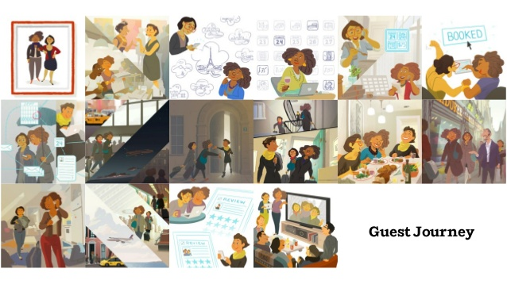

###### **Source:**[**Alexander Schwarz, Airbnb**](https://www.slideshare.net/TourismFastForward/tff2016-alexander-schwarz-airbnb)

##### **Proto-Personas**

In a business context, you’d create your personas based on extensive user and market research, then continue refining them as you learn more about them. You, however, are not necessarily part of a business right now (and some UX designers choose to stay this way). Without a big business to back you, that extensive user and market research is oftentimes unattainable. In these cases, you can get started with a more basic version of the persona called a proto-persona.

A **proto-persona** is a simple prototype of a persona. At the beginning of a project, it can feel uncomfortable (and a little unrealistic) to make big assumptions about a hypothesized target audience based on limited data. That’s not to say you shouldn’t make assumptions at all. It’s completely acceptable to make assumptions so long as those assumptions aren’t presented as fact. To stress that these are purely assumptions, we label these predecessors proto-personas. As projects progress and further research is conducted, the assumptions of these proto-personas can be validated, morphing the proto-personas into full-fledged personas. This is why proto-personas should contain the same basic elements as personas—a name, behaviors, demographics, needs, and goals.

Take a look at some examples of proto-personas. The images below are based on examples from product designer Steve Fisher’s [Know Thy Customer: Building Proto-Personas](http://www.startupequation.com/building-proto-personas/) and interaction designer Sebastian D’Amore’s [Boost Empathy Quickly With Proto-Personas](http://blog.mural.co/2016/05/06/boost-empathy-quickly-with-proto-personas). Check out these articles if you’d like to read more about proto-personas.

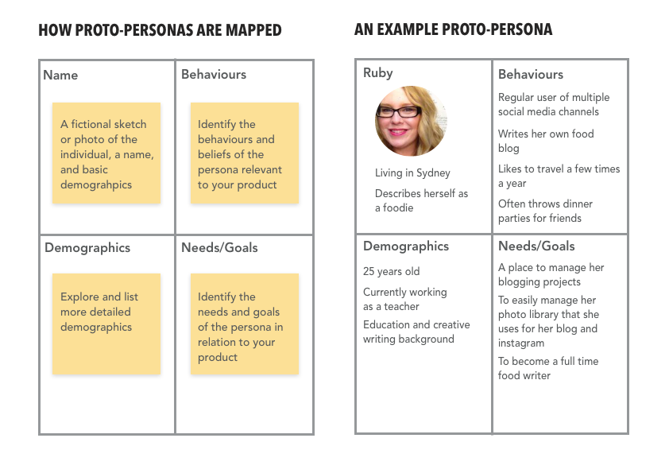

###### [**Click here**](https://coach-courses-us.s3.amazonaws.com/public/courses/ux-fundamentals/E3/image_03_protopersona1.png)**to zoom in**

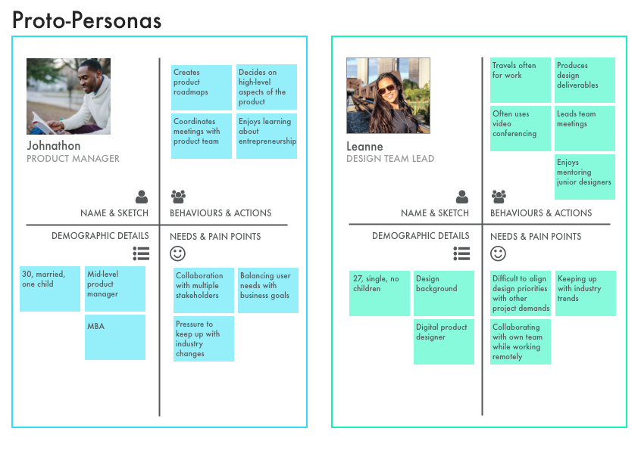

###### [**Click here**](https://coach-courses-us.s3.amazonaws.com/public/courses/ux-fundamentals/E3/image_03_protopersona2.png)**to zoom in**

Once you’ve fleshed out your user persona (or proto-persona), you can start using it to make design decisions. As was mentioned above, we’ll be focusing on proto-personas throughout this course, but that doesn’t mean you can’t work on fine-tuning your proto-persona as you collect more information. In fact, you will regularly revisit your proto-persona and iterate on it as you continue through the steps of the Design Thinking Process. When you reach completion of your project, you will even use the final version of your proto-persona as a means to communicate the story of your process to stakeholders.

#### **User Stories**

Once you’ve given your personas a face and a name, you can start using semantic frameworks to refer to them. Ideally, these frameworks will feel natural over time. One such framework is user stories. They can be used to determine what a persona wants to accomplish.

**User stories** allow you to focus on defining functions and solutions from a specific persona’s perspective. By translating human needs into functional requests for features, we can move forward with the design and development process, confident that we’re solving real problems for real people. Take a look at this example:

**As** [a persona], **I want** [some action] **so that** [outcome].

Now let’s put this into the context of [our persona, Charlotte](https://coach-courses-us.s3.amazonaws.com/public/courses/ux-fundamentals/E3/image_03_user_persona.png). We might create a user story like this:

**As** Charlotte (a financial analyst), **I want** to be able to view overall progress on my projects **so that** I can make sure my projects are being completed on time.

When writing user stories, make sure that you focus on a particular feature or functionality. This helps translate human needs into functional needs so we can build websites and applications accordingly. Essentially, it helps us think like robots, but in a human context. In summary, make sure you’re writing your user stories around specific functionality, such as “log in,” “add a team member to a shared document,” or “view project progress,” instead of overall human goals like “have fun working with team members.”

Ultimately, the goal of user stories is to develop a clear understanding of what the persona wants to accomplish. Once you’ve created your user stories, it’s time to focus further on the problem at hand by writing problem and hypothesis statements.

JOB STORIES  
Another framework for establishing what your users want to accomplish is job stories. Job stories focus on the context in which a persona wants to complete a particular action (i.e., a job). They can help a designer or design team focus on answering the question “why” in regards to a particular situation or motivation. See the example below:

“When I am working with multiple teams, I want to track all of my projects in a consistent way so I can make sure all teams are on the same page about project progress.”

You won’t be required to write job stories in the Task for this Exercise, but if you want to learn more about them, check out this article on [Replacing The User Story with the Job Story](https://jtbd.info/replacing-the-user-story-with-the-job-story-af7cdee10c27).

#### **Problem Statement and Hypothesis Statement**

The Tasks in Exercises 1 and 2 should have given you a basic understanding of existing vocabulary apps, as well as your target audience. Let’s go ahead and revisit your original project brief and state it in the context of your primary proto-persona. This is an opportunity to synthesize your research, your proto-persona, and your user stories to concisely state the problem you hope to solve with your design.

**Problem statements** help focus your project on the problem you’re trying to solve, as well as the people for which you’re trying to solve it (your potential users). Creating one only takes a few minutes and is a great way to bring your persona to life in the context of your project. A good problem statement is hyper-focused, to the point, and states the problem. It doesn’t attempt to outline a solution—that comes later.

##### **Problem Statement Format**

[The name of your proto-persona]

**needs a way to** [user’s need]

**because** [insight].

##### **Problem Statement Example**

Charlotte (Financial Analyst)

**needs a way to** regularly track details of projects that involve multiple teams

**because** she works remotely and asynchronously with her team.

Now that you’ve identified the problem, you’re ready to create a **hypothesis statement**. This is your first attempt at solving the primary problem of your persona. Don’t worry too much about getting the solution right the first time. It’s still early in the project. Simply use this as an opportunity to explore one potential solution.

##### **Hypothesis Statement Format**

**We believe that by** [doing this / building this feature / creating this experience]

**for** [the name of your proto-persona], **we will achieve** [this quantitative / qualitative outcome].

##### **Hypothesis Statement Example**

**We believe that by** creating a visually-oriented interface for project tracking across multiple teams instead of a text-based interface

**for** Charlotte, **we will achieve** having 20% more of Charlotte’s projects meet their deadlines.

#### **Summary**

Personas provide a way for designers to humanize their users and keep their goals, pain points, and behaviors in the foreground of all design decisions. Proto-personas are hypothesized personas created as a starting point when not enough information is available. As designers gather more user information and do additional testing, proto-personas are refined into personas.

Personas provide the foundation for creating more specific statements of user needs in the form of user stories. Taken together, personas and user stories can then be synthesized into a concise, clear statement of the problem along with a hypothesized solution.

Personas, user stories, and problem/hypothesis statements are methods to refine your thinking and position your project on solving real problems for real people. Companies that skip this step risk creating features or products that their users don’t need or want, or may put too much emphasis on business needs over the needs of their actual users. The depth, detail, and clarity of your personas and statements will evolve throughout the project along with your understanding of the people for which you’re designing.

#### **Resources**

* [Personas: Usability.gov](https://www.usability.gov/how-to-and-tools/methods/personas.html)
* [What's Your Problem?: Medium](https://medium.com/@MattPLavoie/what-s-your-problem-e45b31bf08dd#.mwf24hqdu)
* [7 Companies That Totally 'Get' Their Buyer Personas: HubSpot](https://blog.hubspot.com/blog/tabid/6307/bid/33749/7-Companies-That-Totally-Get-Their-Buyer-Personas.aspx#sm.0000ef4ij16gveonsni1o33yri09n)
* [B2B Buyer Personas Help Companies Exceed Lead Gen and Revenue Goals: KO Marketing](http://www.komarketingassociates.com/industry-news/study-buyer-personas-lead-to-b2b-marketing-success-2872/)
* [Seven Companies that Totally Get Their Buyer Personas](https://blog.hubspot.com/blog/tabid/6307/bid/33749/7-Companies-That-Totally-Get-Their-Buyer-Personas.aspx#sm.0000ef4ij16gveonsni1o33yri09n)
* I love to have fun when I’m leaning, I want to be able to feel like I’m playing a game
* We believe that making a vocabulary app that lets Kim create cards with more than just words and study them in quick but fun sessions will help her feel more excited and relaxed about studying, leading her to being 50% more successful in her learning journey.

Rework

I will rewrite Hypothesis statement using the template, it will be-

We believe that by building Dictionary that provides “’Pronunciation feature” and “Flash cards feature” for easy to memorise vocabulary with fun. Also “study remainder feature”, help her to manage the daily study schedule. For Kim, we will achieve having 50% the goal in learning vocabulary by engaging and retaining the information.