1.6: Usability Testing

#### **Introduction**

Welcome back! How’s your prototype coming along? Don’t worry if it seems rough around the edges—at this point, it should be! Remember the design squiggly? The process of design and creation is messy, chaotic, and constantly changing. As this is an introductory course, it’s not only acceptable, but expected that you remain on the left side of the diagram, exploring a squiggly mess of research, patterns, and insight. The goal of this course is to learn how to embrace this process without getting too caught up in delivering a perfect project or design.

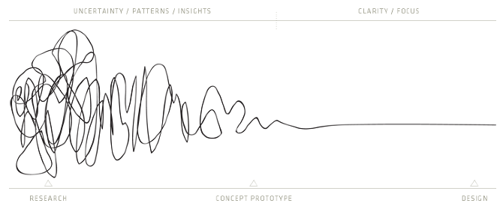

The ability to design with clarity and focus will come with practice. It’s important to first cultivate the ability to rapidly build incomplete prototypes, measure their usefulness, and develop concepts, even if it means pulling a one-eighty on an idea or doubling back on yourself. Wrong turns are inevitable; the key is learning to course-correct through a tight “build, measure, learn” feedback loop.

In the previous Exercise, you learned how to rapidly build wireframes and prototypes for your app. In this Exercise, we’ll be exploring the “test” phase of the design thinking process and learning to measure the usefulness of a prototype before making modifications based on feedback and observation.

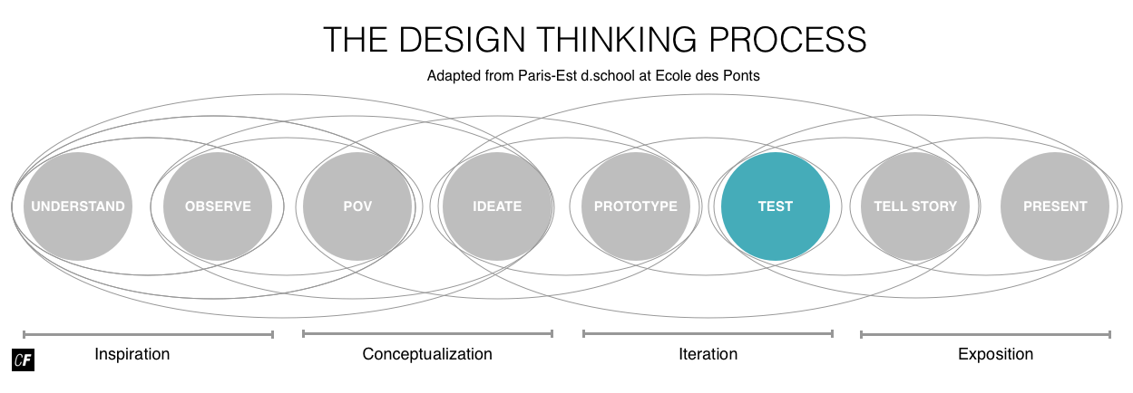

To do so, we’ll be looking at **usability testing**, or the testing of a product on users to evaluate its usefulness. Usability testing gives designers a means of seeing how real people interact with a product or service to determine whether it serves its intended purpose. We’ve got a lot to cover before sending you out on your first usability tests, so make sure you set aside enough study time for this Exercise, and don't forget that you'll need to find some actual testers to complete this Task. You may want to spread this Task out over a few days.

#### **What Is Usability Testing?**

**Usability testing** is an evaluative research method, in that it’s intended to evaluate a prototype or experience. By performing usability testing, you’re evaluating the ability or inability of users to complete specific tasks. Typically, test participants are asked to complete these tasks while testers watch, listen, and take notes. Results from the tests are then recorded and prioritized to provide direction on the next prototype iteration. This process is repeated until designers are satisfied with the utility, usability, and usefulness of their prototype.

The goal of usability testing is to directly observe another’s behavior and interaction with your prototype. This is opposed to user interviews, which are purely conversational and attitudinal in nature. Usability tests are therefore scripted to include specific tasks and scenarios. Direct observation of a user while performing these tasks is essential, either in-person or remotely using online tools. Keep in mind that basic usability testing can be conducted wherever and whenever is most convenient for both examiner and examinee.

TYPES OF RESEARCH  
Remember from Exercise 2 that designers practice two different types of basic research at various points in the design process: generative (exploratory) research and evaluative research.

**Generative research**, also known as **exploratory research**, is typically conducted up front and helps designers build a better understanding of the problem space. One such example is conducting **interviews** as a way to observe the thoughts and feelings of users regarding the identified problem.

**Evaluative research** is conducted throughout the design process to evaluate how well designers are solving a problem. Usability testing is an important example.

#### **Why Do We Conduct Usability Testing?**

The ultimate goal of usability testing is to build something that is **useful**. To be useful, our prototype needs to provide the appropriate **utility**, or features, as well as be **usable**—these features must be sufficiently simple and enjoyable to use. Let’s put this in the context of your project.

* **Utility** = the features and functionality needed to complete important tasks. Does your application provide the necessary functionality to allow people to sign up, log in, and input personal information? Does the application provide a logical pattern of navigation, as well as the ability to upload and study new words?
* **Usability** = how easy your project features are to use, as well as whether they bring satisfaction. Can people successfully navigate your application when asked to find a certain section? How long does it take them to upload a new word? Do they enjoy studying new words with the prototype you’ve built?
* **Useful = Usability + Utility.** For something to be useful, it must address the functional and emotional requirements expressed by your target audience during exploratory research. The only way to validate the usefulness of your prototype is to test it with real people using evaluative research methods such as usability testing.

Exploratory research methods like user interviews help designers “make the right thing” by allowing them to explore the problem space and understand their target audience. It’s critical to collect data and insight indirectly or directly from real people to define and validate your problem statement.

On the flip side, evaluative research methods help designers “make the thing right” by allowing them to test what they’re building.

"Usability and utility are equally important and together determine whether something is useful: it matters little that something is easy if it’s not what you want. It’s also no good if the system can hypothetically do what you want, but… is too difficult."  
JAKOB NIELSEN, [USABILITY 101: INTRODUCTION TO USABILITY](https://www.nngroup.com/articles/usability-101-introduction-to-usability/)

“Make the thing right” and “make the thing perfect” don’t necessarily equate to the same thing. By definition, prototypes are imperfect and have glaring errors and flaws, but this is normal (and the exact reason why we test!). Even skilled designers can oftentimes forget something as silly as a “back” button, or they’ll create labels and icons that fit their own personal mental model but don’t make sense to anyone else.

As this is an introductory course, your project will only require one round of usability testing. This will give you some practice with the process so you can see if it’s something you enjoy. If you decide to take on professional projects in the future, you’ll have many, many rounds of usability tests to look forward to. Repeated testing is what allows designers to catch both minor mistakes and catastrophic errors. Each time you want to validate a feature, you’ll conduct additional testing. Removing yourself from the building process and putting your designs in front of people is not only important, but absolutely essential, as this process will ensure your design decisions are based on real human behavior and feedback.

HOW MANY PEOPLE SHOULD YOU INCLUDE IN YOUR TESTS?  
The bigger the size and scope of your project, the more complex and nuanced its usability testing will be, but don’t let this intimidate you. Sometimes it’s entirely possible to dramatically improve your designs by speaking to just a few people. There’s an ongoing industry debate on the exact number, but it’s widely accepted that you can catch approximately 80% of errors by testing only five participants. Don’t believe us? Read up on the laws of diminishing returns in Jakob Nielsen’s “[Why You Only Need to Test with 5 Users](https://www.nngroup.com/articles/why-you-only-need-to-test-with-5-users/).”

#### **Components of Usability**

User interviews, as well as the project brief, provide guidance on the utility and functionality to focus on for your project. Let’s assess the usability of the navigation and features you’ve designed in your prototype.

One framework for examining usability is Jakob Nielsen’s **Five Components of Usability**, which covers learnability, efficiency, memorability, satisfaction, and errors. Some of the components require testing multiple times (such as memorability, which looks at whether your users are able to reestablish proficiency with your product after a period of time away) and can be tricky to measure (such as satisfaction). For this reason, we’ll be focusing in this course on one of the most important components: errors.

**Errors**: How many errors do users make, how severe are the errors, and how easily can users recover from the errors? There are various ways to categorize and rank the severity of errors, but for consistency and clarity’s sake, we’ll refer to an adapted version of Jakob Nielsen’s rating scale:

* **0** = I don't agree that this is a usability problem at all
* **1** = Cosmetic problem only: need not be fixed unless extra time is available on project
* **2** = Minor usability problem: fixing this should be given low priority
* **3** = Major usability problem: important to fix and should be given high priority
* **4** = Usability catastrophe: imperative to fix before product can be released

Cosmetic and minor problems can create some minor disruption in the look, feel, and structure of an app, but these types of problems don’t hinder test participants from completing prescribed tasks. If participants continually struggle with the same task, it’s likely there’s a major or catastrophic error, such as an issue with navigation that prevents users from locating important information or features. Try to identify these errors and categorize them according to the above rating system.

MORE ON ERROR SCALES  
Usability researchers have come up with many different scales to rank and prioritize usability issues and errors. For a more complete list, check out Jeff Sauro’s “[Rating The Severity Of Usability Problems](http://www.measuringu.com/blog/rating-severity.php).” If you feel inspired, feel free to use a different scale or come up with one of your own!

For more on the other components of usability, check out Jakob Nielsen’s [Usability 101](https://www.nngroup.com/articles/usability-101-introduction-to-usability/), but for now, let’s move on to how to actually conduct your usability tests.

#### **Moderated vs. Unmoderated Testing**

There are multiple ways to approach user testing. The methods and processes you choose will depend on the maturity of your project, as well as what you’re hoping to learn at a particular stage. Each and every project is unique (along with its participants), so creating a “universal test plan” would be nearly impossible; however, that’s part of what makes the design research process so interesting! That being said, there are two basic types of tests researchers use to gather feedback from real people: moderated and unmoderated.

**Moderated tests** require the direct presence of a researcher and/or observer to facilitate the test via a script. This typically creates more controlled tests with more specific results because a moderator is able to ask follow-up questions and can observe body language in addition to verbal responses. On the other hand, this kind of testing tends to be more time-consuming to set up and carry out as the moderator must be physically present, and this presence can change the way certain participants respond.

**When to Use:** Moderated tests are especially useful during the early stages of prototyping. At this stage, the prototype is likely missing certain functionality, and users might require guidance to complete the desired tasks. Moderated tests are particularly effective at digging deeper into the “why” behind a participant's behavior, which can be crucial in guiding design direction and feature priority in the early stages of a project.

Alternatively, if you have a very mature and complex prototype, a moderator can help keep test participants on track, only testing the current area and tasks of interest. While recruiting participants can be time- and cost-intensive, researchers often manage to find local participants to volunteer their time for little to no cost, especially if interest already exists for the product or service.

Here’s an example of well-known user experience designer and author Steve Krug conducting a usability test for a website. This video is a bit dated, but it’s a great walkthrough of how the process can look live: [Usability Demo](https://www.youtube.com/watch?v=QckIzHC99Xc).

**Unmoderated tests** don’t require the physical presence of a moderator and are, instead, conducted asynchronously online using a variety of specialized tools such as [UserTesting](https://www.usertesting.com/" \t "_blank), [Userzoom](http://www.userzoom.com/" \t "_blank), or [UsabilityHub](https://usabilityhub.com/" \t "_blank). The asynchronous nature of online tests means that researchers have more flexibility in recruiting participants and running tests, allowing for a higher volume of responses. On the other hand, researchers aren’t able to observe body language or ask follow-up questions, since they aren’t present.

**When to Use:** Unmoderated tests are most useful when testing very specific tasks for a mature project or platform. Increased granularity and a higher volume of responses can be useful when evaluating a specific task or feature. Unmoderated tests also mitigate geographic and scheduling differences between researchers and participants. Online tools can be expensive, so a certain level of funding will likely be required to conduct sophisticated unmoderated tests.

Here’s a quick example from UsabilityHub of what an unmoderated test might look like:

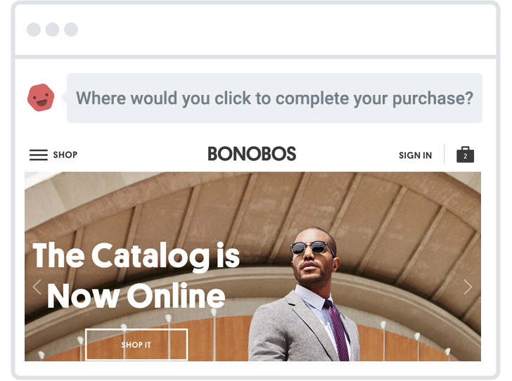

###### **Source: [UsabilityHub](https://usabilityhub.com/" \t "_blank)**

For your project, we’ll be focusing on moderated tests so that you can have more direct interactions with your testers. This will give you a better feeling for what your users like and don’t like about your prototype.

#### **Conducting Usability Tests**

Conducting a usability test consists of several different steps: writing your test tasks, creating a test plan, preparing a test script, and taking good notes. You’ll also want to prepare a test report upon completing your testing. Let’s take a look at each of these steps in greater detail.

##### **Creating Tasks for Usability Tests**

Usability test tasks are defined by design researchers via usability test scripts. They’re typically structured to evaluate a participant’s ability to complete specific tasks. Two common formats for tasks are **direct tasks** and **scenario tasks**. Depending on the test plan, as well as the goals of the researcher, these two formats can be used separately or in tandem. It’s important to have a basic understanding of each and to practice writing tasks in both formats. Before we start writing, let’s take a look at their basic definitions:

**Direct tasks** give specific instructions to complete a desired action without any additional context. For example:

* Add a vocabulary word to your list
* Edit the definition of one of the vocabulary words

**Scenario tasks** add real-world context to task instructions. Scenario tasks are more common, as they provide a realistic element to usability testing. For example:

* You have just finished an online lesson and have a long list of new vocabulary words. Pick a new word from the lesson and add it to your list.
* You keep forgetting the same word and would like to edit its definition to make it more memorable. Find the word and add a new, more personal definition.

The quality of your usability test results will depend on the quality of the tasks you write. Here are some top tips for writing effective tasks:

* **Start with direct tasks**: Direct tasks are more technical and clearly articulate the fundamental goals and actions the platform should facilitate.
* **Add context**: Direct tasks provide the functional foundation for your scenario tasks. If the situation in which participants use your product or service is important for your project, consider adding context to your direct tasks to create scenario tasks.
* **Don’t give it away**: When writing tasks, be careful not to use highly descriptive or technical language that gives away the answer. Convey only the most essential information when encouraging participants to complete the tasks—don’t give away literal clues on how to use the interface. Watch out for phrases like “find the plus sign,” “go to the website,” “click upload,” or “press this button.” Instead, use more natural language to frame tasks. For example: “You’ve just finished studying a set of vocabulary and would like to access a different set of vocabulary words. Return to your word lists and find another deck to study.”
* **Expect questions**: Encourage participants to think out loud and ask questions. If the question is relevant, keep asking “why” until you get to the root of their behavior or attitude regarding the topic. If they move off-topic, gracefully guide the participant back to the task at hand.
* **Keep it real**: Try to recruit participants from your target audience. The direct tasks and scenario tasks should be realistic and relatable to the project and participants.

##### **Elements of a Usability Test Plan**

Before beginning any test, it’s important to create a usability test plan that outlines the scope, goals, and logistical details of your session in advance. Test plans can be highly detailed or short and to-the-point depending on the research goals and maturity of the project. At the beginning of a project, it’s a good idea to keep things short. This will allow you to better allocate your time and perform many quick tests while iterating prototype improvements.

Usability.gov provides a solid framework outlining the [Elements of a Test Plan](https://www.usability.gov/how-to-and-tools/methods/planning-usability-testing.html). For your project, focus on the elements below to design and conduct your first usability tests. You’ll find a template with these elements already included in the Task directions at the bottom of the Exercise.

* **Scope**: What are you testing? Include the name of your app, as well as the specific area you’re testing (if applicable). For example: navigation or check-out flow.
* **Schedule**: Where and when will you meet with test participants? Contact them in advance to schedule a place and time. Make sure you have enough space and access to the technology you need to conduct your session.
* **Sessions**: Session times are variable depending on the complexity of the project, usability test, and tasks. For the purpose of your project, shoot for ten-minute sessions with five participants from your target audience.
* **Equipment:** What devices will you test? Are you using anything to record? For this test, simply write down the mobile device you’re using for your prototype and record via the worksheets provided. Video or audio recordings are optional and not required at this stage.
* **Metrics**: There are many ways to quantify feedback. For this project, you can use Jakob Nielsen’s error severity rating scale, which we discussed above.
* **Direct Tasks**: Direct tasks are a great way to state the most important user goals in a clear, technical, and actionable manner. You can then take things one step further and add context to your direct tasks to create scenario tasks.

#### **Kickstart the Conversation with a Usability Test Script**

It’s always a good idea to have a basic script to refer to while introducing yourself and the goals of the test to your participants. Put them at ease by explaining that you’re testing the prototype—not them!—and that they can’t make any mistakes. This is also a good time to let them know if you intend to record the session using audio or video, as they’ll need to sign a [Recording Consent Form](https://sensible.com/downloads-rsme.html).

To complete your script, add context to the direct tasks from your test plan to create scenario tasks. Feel free to write your own or use the template provided to kick-off the conversation with your test participants.



TIP!  
For a deeper dive into usability testing, check out Steve Krug’s book: [ROCKET SURGERY MADE EASY](http://www.sensible.com/rsme.html). In the meantime, feel free to dig into the book’s accompanying resources, which include templates for test plans, scripts, recording consent forms, and a checklist: [Rocket Surgery Made Easy Templates and Resources](https://sensible.com/downloads-rsme.html).

#### **Usability Test Notes**

It’s not uncommon for an interviewer and a note-taker to work in tandem to conduct usability tests. The interviewer focuses on engaging directly with the participant, while the note-taker jots down observations on the participant’s attitude and behavior. For your project, it’s likely that you’ll have to multitask—which is a great way to practice essential skills in user research!

To streamline the process, use the "Usability Test Notes" template provided in the Task directions to quickly jot down notes, quotes, and issues participants bump into during the test. Pay special attention to frustrations and roadblocks participants encounter when trying to complete your tasks. Take a few minutes after the test to restate and reorganize your notes in a meaningful way. You’ll want to print a separate copy for each participant to keep your notes organized.

#### **Usability Test Report**

One of the most difficult parts of conducting an effective usability test is articulating and prioritizing issues so that you can move forward with actionable prototype improvements. Use your test notes to identify and rank key issues according to Jakob Nielsen’s aforementioned error severity rating scale in the section about errors.

Follow up your severity ranking with recommendations on how to solve the problem. This is the first opportunity you’ll have to provide your opinion, as all the notes you took during the test should have been purely observational. These recommendations are essentially hypotheses for how to improve your prototype. In a real-world project, these hypotheses would be tested in the next round of usability testing, creating a continuous cycle of creation and validation through direct interaction with your target audience.

For a deeper deeper understanding of how to analyze your test results and turn them into a usability test report, take a look at the instructional video below. In it, your instructor, Claire, will identify key user pain points identified during a moderated usability test. She'll rank their severity using Jakob Nielsen's Error Severity Rating scale before making recommendations for how she could improve her designs. Enjoy!

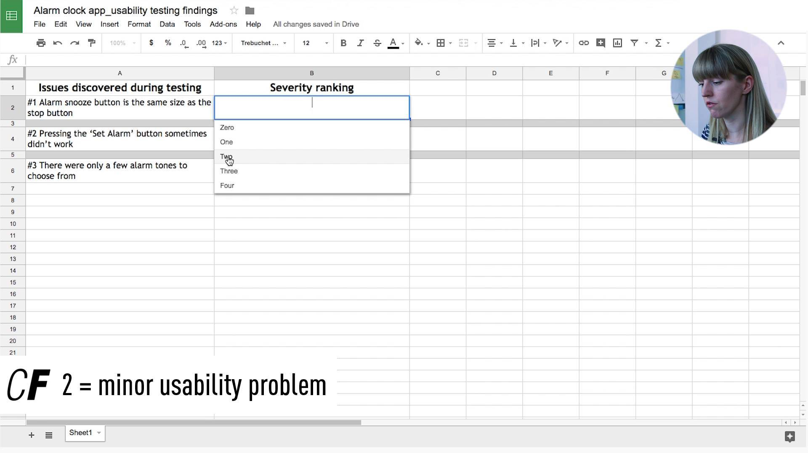

#### **Summary**

Usability testing allows designers to get real user feedback on their wireframes and prototypes before putting too much time and too many resources into developing high-fidelity, polished designs. It’s an essential part of the design process and is used multiple times to validate (or invalidate) decisions a designer has made. Depending on circumstances such as time, budget, and geographical location, a designer may choose to conduct either moderated or unmoderated usability tests with potential users.

It’s important to build a complete usability test plan before moving ahead, which includes writing out expected tasks, creating a test script, and having a clear idea of how and where to take notes. All the information gained from a usability test will be summarized as part of a usability test report. We’ll be following along with each of these steps in our Task below. It’s time to check how our prototypes are doing!

#### **Resources**

**Websites and Blogs**

* [Usability Hub](https://usabilityhub.com/)
* [Rating The Severity Of Usability Problems](http://www.measuringu.com/blog/rating-severity.php)
* [Severity Ratings for Usability Problems](https://www.nngroup.com/articles/how-to-rate-the-severity-of-usability-problems/)
* [Usability 101: Introduction to Usability](https://www.nngroup.com/articles/usability-101-introduction-to-usability/)
* [Usability Testing: How Do We Design Effective Tasks](https://design.canonical.com/2013/08/usability-testing-how-do-we-design-effective-tasks/)
* [8 Ways To Measure Satisfaction (and Improve UX)](https://conversionxl.com/8-ways-to-measure-ux-satisfaction/)

**Books**

* [Don’t Make Me Think by Steve Krug](https://www.amazon.com/Dont-Make-Me-Think-Usability/dp/0321344758)
* [Usable Usability: Simple Steps for Making Stuff Better by Eric Reiss](https://www.amazon.com/Usable-Usability-Simple-Making-Better/dp/1118185471)
* [The Guide to Usability Testing by UXPin](https://www.uxpin.com/studio/ebooks/guide-to-usability-testing/)
* [100 Things Every Designer Needs to Know About People by Susan Weinschenk](https://www.amazon.com/Things-Designer-People-Voices-Matter/dp/0321767535)