1.7: Presenting Your Work

#### **Introduction**

Welcome back! How did your usability testing from the previous Exercise go? Did you find any mistakes or errors in your prototype? If so, great! That’s the whole point of a prototype! As you go along, try and keep your prototype updated based on recommendations in your usability test report. Keep in mind that your goal should be learning the basic concepts and principles of UX design, not having a polished prototype. In the world of UX design, everything is about the process: keep sketching, keep testing, keep learning!

Now that you’ve got a few UX concepts under your belt, it’s time to discuss presenting your design decisions and telling your story. Designers must display their work, defend design decisions, and tell a story that resonates with the intended audience. In this Exercise, we’ll focus on how to tell a compelling story about your work.

Before we dig into the mechanics of solid presentations, it’s important to understand how designers defend their decisions and utilize storytelling to communicate those decisions to customers, clients, and colleagues. This brings us to the “Exposition” phase of the design thinking process, which includes “Tell Story” and “Present”—our final steps in this introductory course.

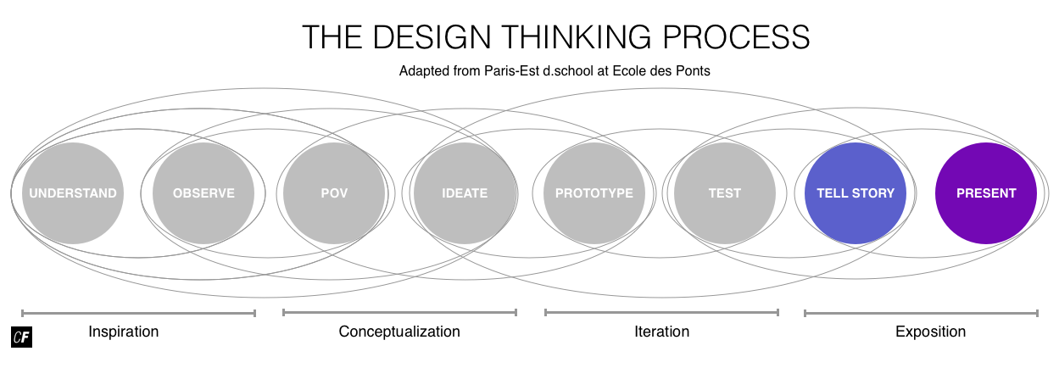

As a professional designer in a business setting, you'd continue through the entire implementation phase by working with development, marketing, and other teams to implement and pilot your designs and create a business model for your final product or service. We won’t be covering those steps here (not everyone has access to hordes of developers, after all!), but we encourage you to use what you’ve learned to propose new solutions to challenges in your personal and professional life and see where they take you. For now, let’s dig into how designers go about presenting solutions to stakeholders in a convincing, human-centered way.

#### **The Anatomy of a Good Story**

Humans have a natural ability to tell compelling stories, and they have been for centuries. From ancient hieroglyphics on cave walls to Pixar’s modern masterpieces of digital animation, humans’ stories may have changed in medium, but their overarching concepts have remained the same. Humans are hardwired to identify with the motivations, crises, tensions, and resolutions of other humans. Even our own lives are made up of millions of micro-stories, structured with surprising similarity.

Good professional design presentations are also built around a story, so understanding what makes a good story is your first step in creating an effective presentation. Like design, storytelling relies on constraints and structure to create compelling architectures and narratives.

The Story Spine, originally coined in 1991 by improviser Kenn Adams, provides the basic architecture of a good story and has since been adapted for a variety of storytelling contexts, from verbal to written and visual. You might find it helpful when thinking about how to construct your own stories for your design presentation. Below are some methods and techniques improvisers and storytellers use to create interesting stories.

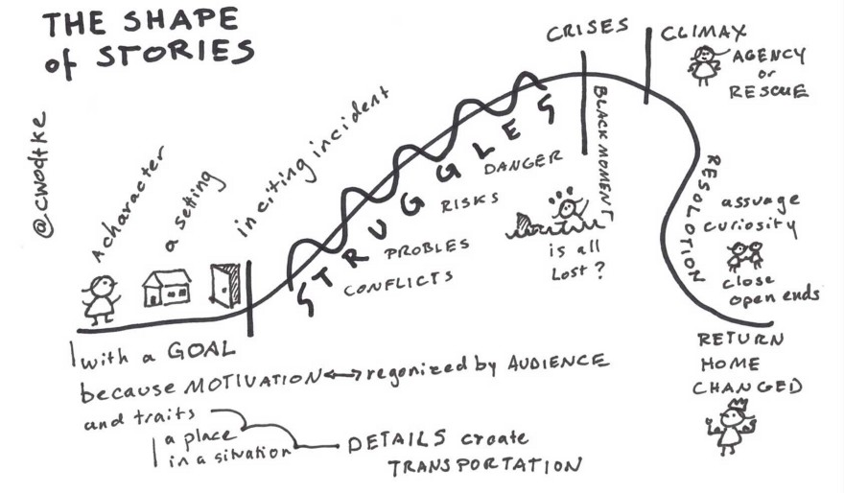

###### **Source:**[**Christina Wodtke**](https://www.linkedin.com/pulse/shape-story-christina-wodtke)

##### **The Story Spine Structure**

Let’s break Kenn Adams' Story Spine into its basic components.

**Introduction: Character with a Goal and Motivations**  
Every story starts with the world as it exists in its current state. A character is introduced, someone we can relate to, someone with a particular set of goals and motivations—our main character. In order to be engaging, this character must exhibit motivations that resonate with the audience’s own motivations. This is why most great movies and books focus on the fundamental motivations of the human condition: survival, security, love, and the quest for knowledge and achievement. In the context of your design project, this will be your primary persona.

**Setting/Situation**  
Where does your story take place? Describe the situations and details that help bring your character and their motivations to life. Make the audience feel as though they can step into the world your character inhabits.

**Inciting Incident**  
Your character needs to encounter a problem. What is it? How was it discovered? How will it affect the main character? You can [read more about this here](http://eleganthack.com/product-as-hero-storyboard/).

**Rising Action: Try/Fail Cycle**  
As always, the most interesting part of the story is the struggle. Failure is crucial to growth. A story without failure, without struggle, without some kind of conflict, would be a very boring story, indeed. As designers, we don’t intend to fail, but we inevitably make design decisions that fall short of our customer’s expectations and have to backtrack on our ideas. This is why it’s so crucial that we test our designs and embrace the “try/fail” cycle present in all good stories, designs, and products.

**Crisis**  
At one point during the try/fail cycle, a seemingly insurmountable obstacle will present itself. Something just isn’t working. In this “black moment,” the protagonist feels that all is lost, that the light at the end of the tunnel has disappeared. For your own story as a designer, this frustration could be from the perspective of either you or your persona, depending on who you’ve chosen as the protagonist.

**Climax**  
This is the moment the protagonist overcomes the obstacle and achieves their original goal. The world has changed (hopefully for the better), and the protagonist is (usually) happy.

**Resolution**  
This refers to how the protagonist’s life is changed by this success. Bear in mind, though, that resolutions are boring. This is why the resolution only occupies a short space at the end of most books and movies (and the “Shape of Stories” diagram above). Designers may be delighted with solutions, but they’re inspired by problems. The majority of their resources are allocated to finding solutions over celebrating solutions. For this reason, your presentation should spend more time articulating the problem (and how you overcame that problem) than on simply revealing the solution.

**Punchline**  
The punchline is your opportunity to tell the moral of the story. What did you learn, and what knowledge should you share?

STORYTELLING ABOUT STORYTELLING  
If you’re interested in learning more about storytelling, take a short break to check out this video by Christina Wodtke on [Story Cycles](https://www.youtube.com/watch?v=scLIlyT1omw).

In summary, a good presentation should contain each of the above story elements. It should describe the world as it exists currently, identify a real problem for real people, and propose a change that addresses that problem and improves the current situation. This adds a human element to your work and will make your presentation more engaging from a problem-solving perspective.

THE SHORT STORY SPINE  
In 2012, Pixar Story Artist Emma Coats created [Pixar’s 22 Rules of Storytelling](http://www.aerogrammestudio.com/2013/03/07/pixars-22-rules-of-storytelling/), including an adapted version of the Story Spine as Rule #4:

“Once upon a time there was _____. Every day, _____. One day _____. Because of that, _____. Because of that, _____, until finally _____.”

You can read more about it here: [The Story Spine: Pixar’s 4th Rule of Storytelling](http://www.aerogrammestudio.com/2013/03/22/the-story-spine-pixars-4th-rule-of-storytelling/).

#### **Writing Your Design Story**



Throughout this introductory course, you’ve been working on planning and designing an app that would better present vocabulary to learners in a useful and efficient way. Think about how your process could be told via the storytelling elements above. Your presentation should document the entire process—failures included!—as opposed to simply revealing your solution. Much of your value as a designer depends on your ability to use effective story structure and compelling narratives to communicate your triumphs over your problems to clients, colleagues, and customers to ensure they understand how you arrived at a particular design solution—and why it’s of value to them.

How does the story spine translate into an effective UX design presentation? Here’s an example that follows the presentation template we’ll be using to complete the Task for this Exercise. As you can see, we’ll be combining all the work you’ve completed throughout this course to create your presentation.

* **Slide 1:** Introduce your character. Introduce your persona along with their goals and motivations. For example, let’s think back to our example persona, Charlotte, from Exercise 3. What would we say to introduce her? She’s 29, lives in London, graduated from business school, etc. Include anything you think will give your audience a stronger connection with your persona.
* **Slide 2:** Setting and situation. State the details of your brief, as well as the problem statement, from your persona’s perspective. In Charlotte’s case, she’s a busy financial analyst who frequently has to coordinate remote projects among multiple teams, but she needs a better tool to do so.
* **Slide 3:** Inciting incident. What struggles do your personas encounter when trying to work in the problem space you defined? Feel free to use visuals and direct quotes to bring the persona and the problem to life. This is your motivation as a designer to solve the problem. In Charlotte’s case, she struggles to schedule and coordinate projects across remote teams, which slows her down and decreases her efficiency.
* **Slide 4:** Rising action: TRY! Think of the montage scene in a movie where the protagonist keeps trying and failing in their quest to improve. This is where you’ll document the prototyping process. Show us your sketches in their raw forms and add notes and annotations if useful.
* **Slide 5:** Rising action: FAIL! Creating prototypes and testing them for failure is the key behind building an effective design. In this slide, explain how you (planned to) put your ideas to the test via rigorous usability testing. This is a chance to explain how and why you performed each test on your designs.
* **Slide 6:** All is lost! Good stories don’t just include failures, they highlight those failures. Present early versions of your prototypes, explain how they failed, and give your hypotheses on how to fix them. Perhaps the original tool we made for Charlotte was too focused on recording data and didn’t improve the ability of team members to visually track progress. How could that be fixed?
* **Slide 7: Climax.** Showcase the highlights of your usability test report, including how you plan to improve your prototype, as well as what you’ve already done to improve it since conducting your tests. For Charlotte, we might plan to add more visual, progress-tracking elements that all team members can access.
* **Slide 8:** Resolution. Summarize what you’ve learned and include next steps for improving the experience for your persona. If you’ve already made some improvements to your prototype, show them off (but remember to be brief!).
* **Slide 9:** Moral of the story. Lastly, tell us what you, personally, learned during the project, as well as how you’ll use what you’ve learned to improve your designs. What did you do well? What did you enjoy? What did you not enjoy? Make a list of pros and cons you’ll be able to use for improving future projects. If you’re doing a professional presentation, you might want to tailor this section to retrospective learning (what went well, what didn’t go well, etc.) that can be used in addressing future project needs at your workplace.

#### **Giving Design Presentations**

The goal of UX design presentations is to introduce problems and explain the decisions designers made to solve those problems based on solid design fundamentals and direct feedback from real people. Many people shy away from giving presentations, but they’re an important part of a UX designer’s job and a skill that can be learned and improved with practice.

Convincing, well-thought-out presentations increase the chance that your design decisions will be accepted and adopted by key stakeholders. Your brilliant ideas and research might go to waste if you can’t convince your stakeholders that they’re an investment worth time and resources.

Remember, the goal of any presentation is to establish the existence of a real problem along with your ability to create value by solving it. We’ve already discussed adding an exciting human element to your presentation via storytelling methods to create the overall presentation structure. Now, let’s take a look at some additional tips for actually presenting your story.

##### **Putting the Presentation Together**

* **Know your audience.** If the motivations behind your story match the motivations of your audience, you’re more likely to keep them interested and engaged. Before starting, identify your audience and their motivations. Who are you speaking to? Convey a message that speaks to their specific goals, needs, and motivations. For example, you might use a different vocabulary palate when speaking to a fellow designer as opposed to someone with no experience in design. By the same token, your CEO will likely have different concerns than your teammates. Always consider the main interests and concerns of the audience you’re addressing.
* **Clearly establish the problem.** It’s crucial that you establish the real problem you worked to solve, whether by proposing a small feature for an existing project or a big idea for a new startup.
* **Keep it short.** While not a strict rule, we recommend keeping your presentation to no more than ten minutes and ten slides long. For context, a TED talk is limited to 18 minutes. Make sure your font is big enough (a 30+ point font often works well). The length and detail of your presentation will, of course, depend on your project, but the fundamental principle stands—get to the point! Researchers have found that audience’s attention spans [plummet around 10 minutes](http://www.forbes.com/sites/carminegallo/2014/04/30/why-powerpoint-presentations-always-die-after-10-minutes-and-how-to-rescue-them/#40c3cd9620ca).
* **Back up your decisions.** Explain how your decisions were influenced and inspired by direct observation of your target audience interacting with your product or prototype. If you simply offer your personal opinion as a designer, clients and colleagues will find it easy to object to your subjective position. Don’t make it about you—make it about your persona.
* **Show tangible value.** What design decisions did you make to deliver tangible value to real people? How did these decisions deliver value to the project or business?
* **Focus on the journey.** The meat of your presentation should be your process; the solution is just the icing on the cake. Too often in the past, designers have focused on “big reveals,” completely skipping the identification of the problem and rising action of the try/fail cycle.
* **Welcome critique.** Be vulnerable. Design is a meritocratic discipline. People, especially designers, can be brutal with their feedback and criticism. This is a great way to improve yourself as a designer, so be open to unseen possibilities and different opinions. Embrace the frustration of feeling “wrong” or encountering seemingly insurmountable problems.
* **Have a little fun.** It’s okay to be entertaining. Maybe you have a humorous tidbit to share about how you completely forgot to put in a menu button, or maybe you have an entertaining picture to spice up one of your slides. Being professional doesn’t mean you can’t have a little fun once in a while. Humor can put your audience at ease and keep their attention focused on your presentation.

##### **Making Compelling Slides**

Classic tools such as PowerPoint and Keynote (or the “lite” version, Google Slides) are fine choices for your presentation, though many other tools exist for making sharp, cleanly designed slides. Some designers prefer presenting off of PDFs or using programs like Visage. The program matters less than the way in which you set up your slides. If you're brand-new to using PowerPoint or other slide presentation software, head over to this comprehensive [video tutorial](https://www.youtube.com/watch?v=XF34-Wu6qWU) to get yourself up to speed. If you're already comfortable with the basic mechanics, however, let's move on to some tips for designing, organizing, and annotating your slides:

* **Make your outline first.** If you start with your slides, you risk getting carried away and creating a disorganized presentation. It’s better to figure out what you want to say (and in what order) before you start creating slides.
* **Make sure your images are relevant.** Images are powerful and help capture an audience’s attention, but they should be clearly related to what you’re presenting. Make sure the images you include support the point you’re trying to make. You might even want to pick your graphics before you start on your actual slides.
* **Don’t overload your slides with text.** Your slides exist to back up what you’re saying and provide a focal point for your main topic. Only include text that’s necessary (a user quote or a piece of data, for example), not a word-for-word transcription of your presentation.
* **Keep one focal point per slide.** Only focus on one topic per slide, even if it means a few additional slides. This will keep your audience more engaged and on-track.
* **Annotating designs** can be a good way to draw attention to details you’d like to highlight (for example, an arrow to or a box around an important element). Pictures or screenshots of your designs are more effective than walking an audience through the dynamic app itself. You might even consider showing off your pencil wireframes inside of a mock mobile frame to provide more visual context.

EXAMPLE PRESENTATIONS  
Need some inspiration for your slides?

* [Five Great UX Presentations on Slideshare](https://econsultancy.com/blog/62493-five-great-ux-presentations-on-slideshare/) by Econsultancy (While these have been up for a few years, they’re still good examples of UX presentations.)
* [From Paths to Sandboxes](http://www.slideshare.net/stephenpa/from-paths-to-sandboxes) by product strategy and design consultant Stephen Anderson
* [Design for User Experience](https://speakerdeck.com/libux/design-for-user-experience) by Amanda Goodman and Michael Schofield
* [SlideShare about the Cancer Treatment Centers of America](http://www.slideshare.net/effectiveui/effectiveui-ctca-forrester-cx-forum-new-york-2012)
* [This recording of a user experience for libraries presentation](http://guides.library.harvard.edu/ux) given by Matthew Reidsma, a librarian and UX workshop leader

Feeling inspired, yet? If not, consider looking around for some local UX meetups or events that you can attend that will feature presentations. They’re a great way to interact with and learn from other designers.

Once you’ve finished your slides, there are a few more steps to consider, especially if you'll be presenting somewhere else or with someone else’s equipment.

##### **Preparing for the Presentation**

* **Record yourself.** With presentations and pitches, you often only have one shot. Try recording yourself in advance. Make sure you keep to a specific time and observe your delivery. Everyone has idiosyncrasies in presentation style—this is fine; just make sure you can distinguish between parts that create confusion and parts that improve the personality and clarity of your delivery.
* **Tech check.** Ideally, you can send presentation visuals using PDFs. Fonts, videos, and animations can get tricky once transferred to a different computer, so be careful of these if you won’t be presenting on your own machine. If you’re presenting live, make sure to test the audio and visual equipment in advance. You might consider using something like a pointer and/or slide advancer to help you highlight content and engage with your audience—just make sure you’ve practiced with it in advance!
* **Always have a backup.** Sometimes, the internet or a computer just decides that it doesn’t want to work. If you’re presenting somewhere else, have an offline copy of your presentation ready to go on a thumb drive. You might even want to email yourself another copy in case something happens to your thumb drive.

As we mentioned above, presenting your ideas in front of an audience can be daunting, but it’s a skill that grows easier with practice and time. Armed with the above storytelling methods and a concise slide deck, you should be off to a great start. You’ll be called on to give presentations quite often as a designer, so let’s start practicing early with this Exercise’s Task.

#### **Summary**

Designers must be savvy storytellers and presenters in order to convince current and potential stakeholders that a particular design decision is not only correct, but worth their time and resources. As a designer, you’ll find yourself presenting on all variety of occasions, from initial research findings to testing results and final design decisions. This gives you many opportunities to share the exciting things you’ve uncovered about users and help others understand the needs, pain points, and solutions for real people impacted by a product or service. Thinking about it, that’s pretty cool! Designers act as a sort of emissary, sharing their success stories (and not-so-success stories) about the impact they’ve made on real human lives, which, in turn, teaches others how they can make experiences easier and better for their customers.

#### **Resources**

**Websites and Blogs**

Presentations

* [11 Design Tips for Beautiful Presentations](https://visage.co/11-design-tips-beautiful-presentations/)
* [The Secret to a Great Presentation](http://eleganthack.com/working-with-story/)
* [9 Tips to Help You Rock Your First Conference Presentation](http://blog.invisionapp.com/tips-for-conference-presentations/)
* [Pixar’s 22 Rules of Storytelling](http://www.aerogrammestudio.com/2013/03/07/pixars-22-rules-of-storytelling/)
* [10 Ways to Improve Your UX Presentations](http://www.uxforthemasses.com/improve-ux-presentations/)
* [Guy Kawasaki’s 10/20/30 Rule for PowerPoint Presentations](http://guykawasaki.com/the_102030_rule/)
* [Presenting Your Work to Executives: 8 Tips for UX Designers](https://www.usertesting.com/blog/2014/07/28/presenting-your-work-to-executives-8-tips-for-ux-designers/)
* [The Art of Presenting Creative Work](http://blog.invisionapp.com/how-to-present-design-work/)
* [7 Free PowerPoint Alternatives](http://www.makeuseof.com/tag/7-free-powerpoint-alternatives-presentation-needs/)

Storytelling

* [For Tinylipsum, With Love and Stories](http://eleganthack.com/for-tinylipsum-with-love-and-stories/)
* [The Shape of Story](http://eleganthack.com/the-shape-of-story/)

**Books**

* [Communicating the User Experience: A Practical Guide for Creating Useful UX Documentation by Richard Caddick](https://www.amazon.com/dp/1119971101/)
* [Communicating Design: Developing Web Site Documentation for Design and Planning by Dan M. Brown](https://www.amazon.com/dp/0321712463/)

Samples

<https://www.youtube.com/watch?v=X-Cyd3sYw0o&feature=youtu.be>

<https://www.youtube.com/watch?v=EcpATxyNHxM&feature=youtu.be>