Business Problem:

Morning Joe Coffee is interested in expanding their small business. As they already have a small operation near Toronto, they want to expand more into the city, specifically in Scarborough. However, they are at a loss as to the best location and borough to open their business up. They want to find a location that has some competitors as they don’t want to invest in trying to start a market where there isn’t one, but also ensures they don’t get into a hyper-competitive area. They would also like to be surrounded by venues that are relatively similar to their current business as well so they can attract similar clients.

Data:

Using the data pulled from Google and Foursquare, a k-nearest neighbor will be used to determine boroughs that have the most coffee shops and the venues in the area. This will allow for a bit of a scoring system to help gauge which boroughs are of interest. This draws a lot from a previous project that did something similar in Toronto, with the primary difference being the focus on Scarborough and seeing what the similarities and concerns are. This will drag in venue information as well which will come through FourSquare. The specific venues matter to find similar clients, however, there will be added weight put onto the coffee shops in the area. This data comes from a previous survey of customers to see what they generally shop at.

Combined, this information should provide some areas of interest for Morning Joe’s coffee company to find an area to operate. It should allow Morning Joe’s to make an informed decision on where best to look to move their company too within Scarborough.

Methodology:

The first step was to import the data from Wikipedia for the postal codes for the different Boroughs and Neighborhoods. This was done using the Beautiful Soup package. The next step with to match up those points using Geocoder to longitude and latitude coordinates. From there, data is pulled from FourSquare to show location data of key venues.

This is all combined and weighed against what Morning Joe’s wants to see in their area, focusing on specific venues including some coffee shops to compete against, other beverage services, as well as offices, stores, and train stations. For convenience this was just copied in from the FourSquare list.

From there, a point score was made to count the important factors and then score the various neighborhoods. A primary area was then determined and a secondary area was drawn up as well just in case. This report focuses on the primary point, but the secondary point will be listed as well.

Results:

The first location determined was Dorset Park, Scarborough Town Centre, and Wexford Heights as seen in the map figure represented by a blue dot.

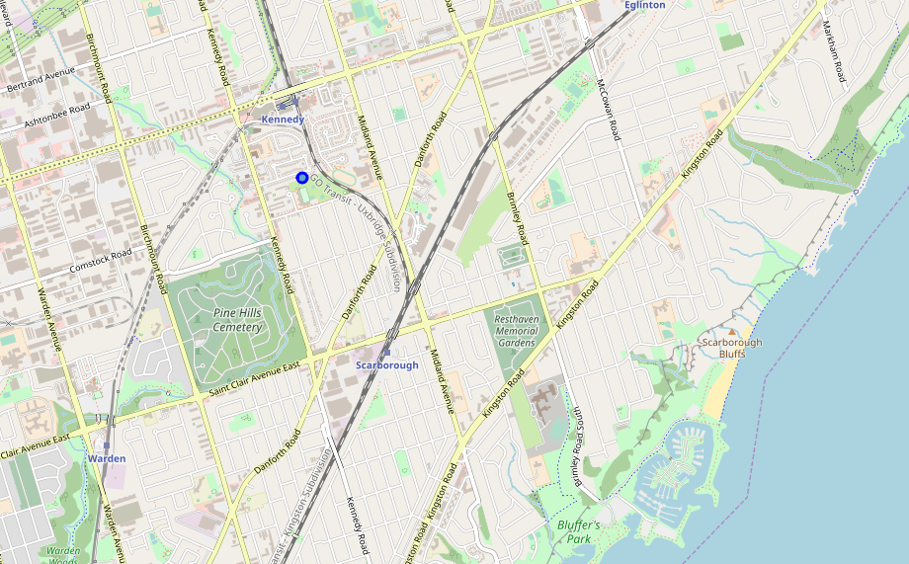

This isn’t much of a surprise as the area is very active being the town centre. That particular space scored a 22.00 due to the number of stores of interest in the immediate area.

The area that was chosen next was Agincourt scoring a 13.00. Given the lower score it might not be the best location, but the businesses of interest were highlighted in the report and can be run easily again. This is only highlighted because there were some significant differences in venue and if the analysis needs to be run again it can be refined from here.

Discussion:

The result was not surprising, the town centre had the most interest because it is one of the highest concentration of businesses Morning Joe’s wanted to focus on. However, the area could also be very expensive due to the concentration of businesses and people as well. Likewise there are three coffee shops in the radius which might be more than management would like to compete against.

This is why Agincourt was presented in this report as well. There was significant venue difference between these two areas so much so that despite the current point spread between the two, Agincourt could be a very different option. There is also only one coffee shop in the area to compete against directly which might be closer to what Morning Joe’s wanted.

A good follow up would be to see what the costs of opening a restaurant in either area is and then see what impact the competition from these other companies might be against Morning Joe’s which is opening as a new brand in an older market.

Conclusion:

Morning Joe’s has one good option to further investigate in Dorset Park, Scarborough Town Centre, and Wexford Heights. It seems as though the shopping in the area is similar to what Morning Joe’s desired in their company.

However, since the area is fairly competitive, another location was provided just in case. This is Agincourt which has only one coffee shop and a different variety of venues, particularly with differences in relaxation and activity venues here versus more shopping in Town Centre.

Morning Joe’s can look at the difference and make some minor changes, which means the report can be run again just in case they want to weigh things different. However, it is my recommendation to do some generally looking at opening a shop in the two areas and the costs associated plus the competitiveness of the other shops, and then to go from there.