Multimedia Project

Voice Calculator

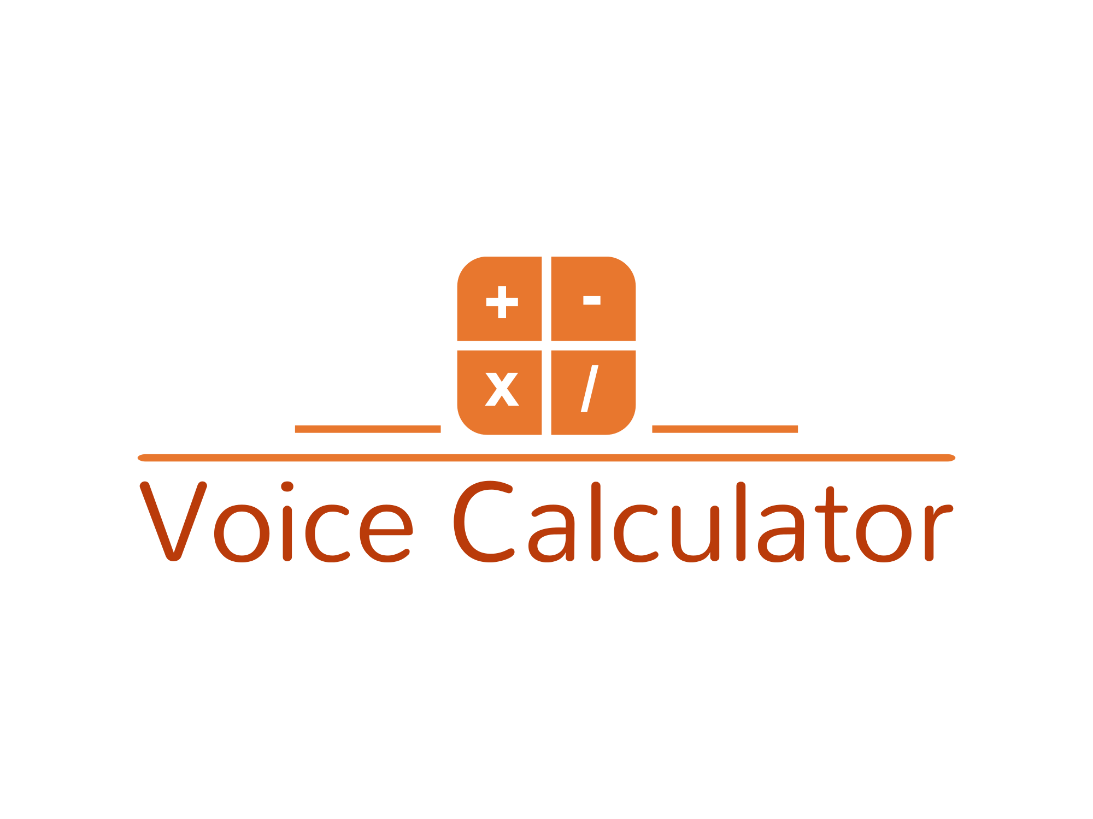

Students:

Ionel Mihai Alexandru 1103

Iordan Razvan Alexandru 1103

-2024-

Ionel Mihai Alexandru:

Index.html:

-define links, create containers and buttons for calculator

Style.css:

-style the index.hmtl elements using CSS not boostrap because I did this part before finding out we need bostrap so the boostrap is implemented in another .html file for login.

Script.js:

-calculatorEvents() function : this function gets the id of each element in the html page and classifies them as operators, digits or actions.

- for each operator(=,%,/,*,-,+) a click event will dictate it’s functionality

- we have a historyResult attribute that will remember all the commands that the user type on the keyboard and will save the result as a string. When the user will press the = sign the result will be evaluated mathematically and will print the current result.

-keep track of each digit and save it into currentResult in order to display the number on the calculator after pressing it.

-the actions events are clear and backspace. Clear will delete all data while backspace will delete only the last input.

-the microphone is situated in the right corner and will activate itselft after the user presses the button with the microphone logo. The voice recognition api window.speechRecongition will start and will listen for our command. Operations like “plus”, “minus” etc are converted into matchematical form for further processing. After the user stops speaking, the result will be transcripted and evaluated and then printed.

Iordan Alexandru:

Index.hmtl : - add canvas

WelcomePage.hmtl : - add boostrap to create a login from for the user. The user should log in with their email and password( hardcoded: email should include @stud.ase.ro and the passowrd is “project”) If the login in successful, the user is redirected to the index.html page with the calculator. If the log in is not successful, a warning pops us. The user can log in after writing credentials by pressing enter.

Script.js: - rain_numbers() function that creates a rain effect of numbers on a canvas. The numbers and letters are generated from a hardcoded string and saved into an array. The draw() function fills the canvas with orage color and the numbers color white and creates a rain effect by setting the interval to 30 miliseconds. A random element is selected from the matrix to be display at a given time. The colors and font are chosen to match the logo and the calculator and create a nice round background.