Task. Zabbix Tools
Testing Infrastructure:
Vagrantfile to spin up 2 VMs (virtualbox):
- zabbix server, provisioned by Vagrant provisioner
- Linux VM with zabbix agent, script for registration on zabbix server, all provisioned by Vagrant provisioner

Task:
1. Configure the agent for replying to the specific server in passive and active mode.

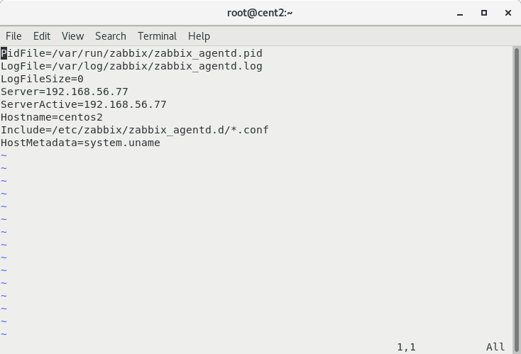

2. Use zabbix_sender to send data to server manually (use zabbix_sender with key –vv for maximal verbosity).

yum install zabbix-sender -y
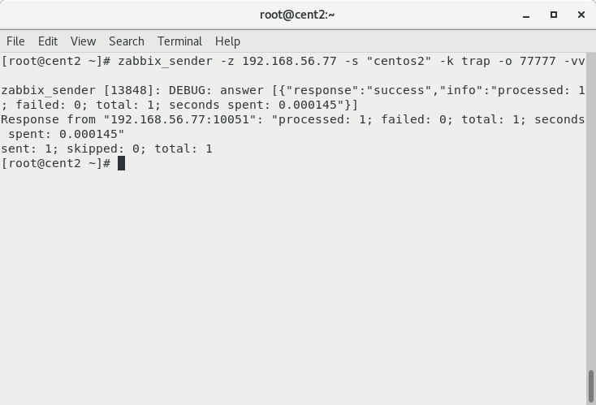

3. Use zabbix_get as data receiver and examine zabbix agent sending’s.
For both VMs use vagrant box “sbeliakou/centos-7.3-x86_64-minimal”

yum install zabbix-get -y

