Task. Java Monitoring with Java
Task:
You should install and configure Zabbix server and agents.
Testing Infrastructure:
Vagrantfile to spin up 2 VMs (virtualbox):
- zabbix server, provisioned by Vagrant provisioner
- Zabbix agents on both VMs, provisioned by Vagrant provisioner
- Install Tomcat 7 on 2nd VM

Tasks:
1. Configure Zabbix to examine Java parameters via Java Gateway (http://jmxmonitor.sourceforge.net/jmx.html)

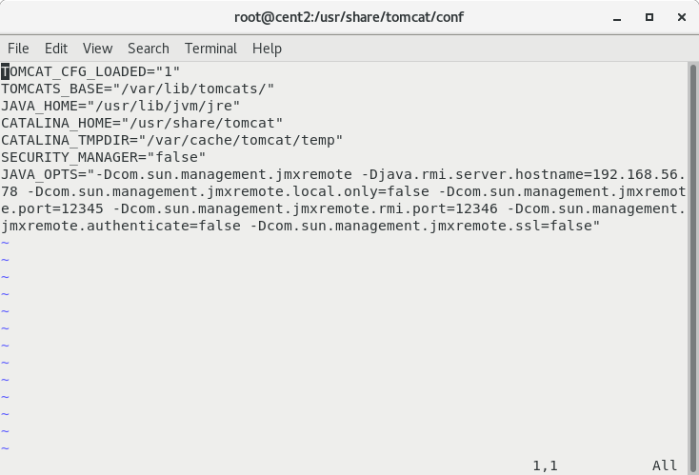
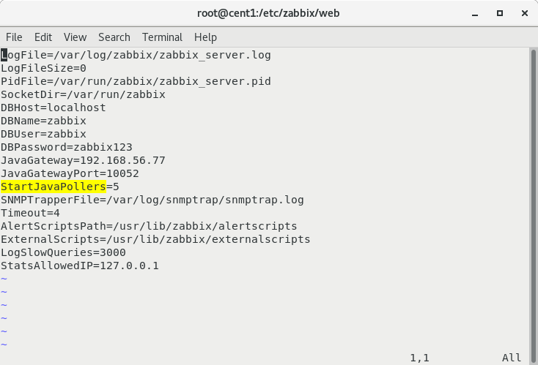
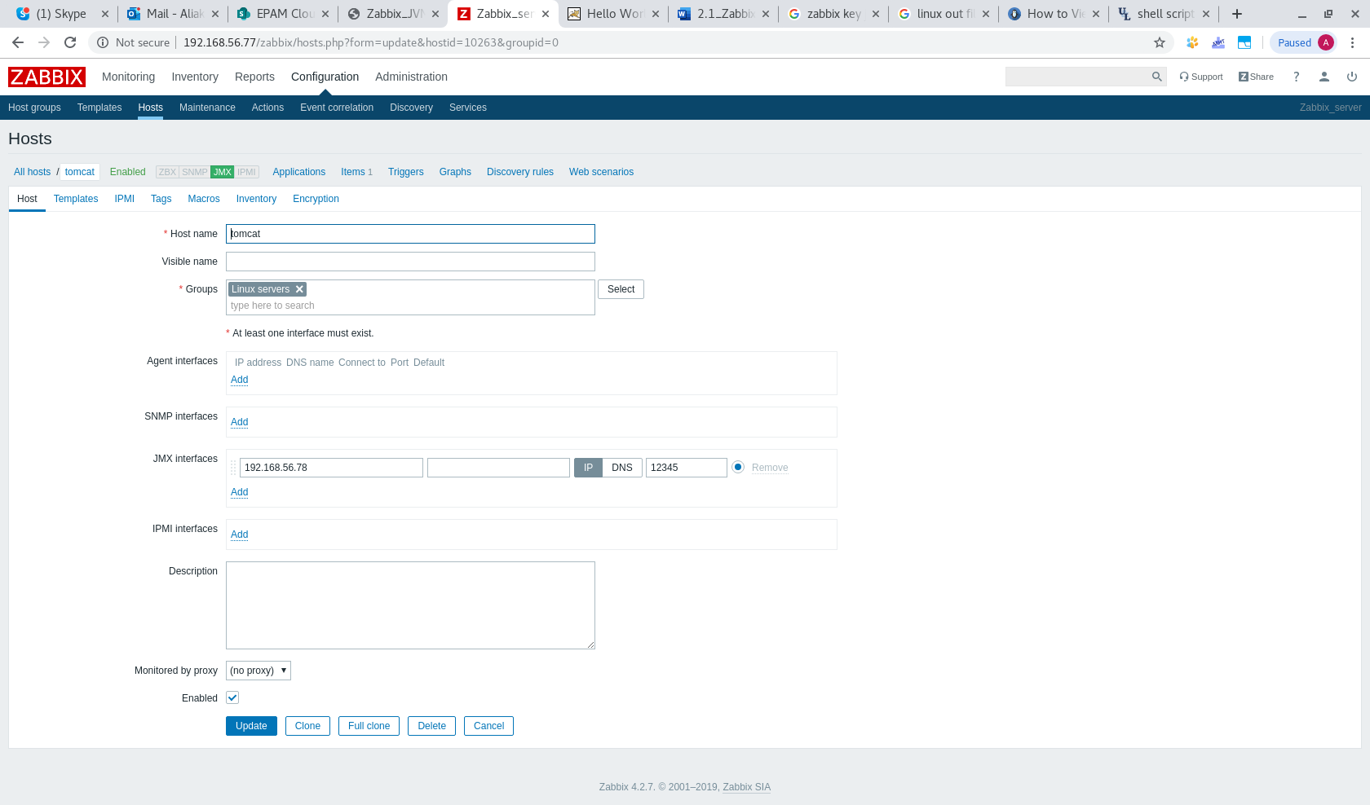

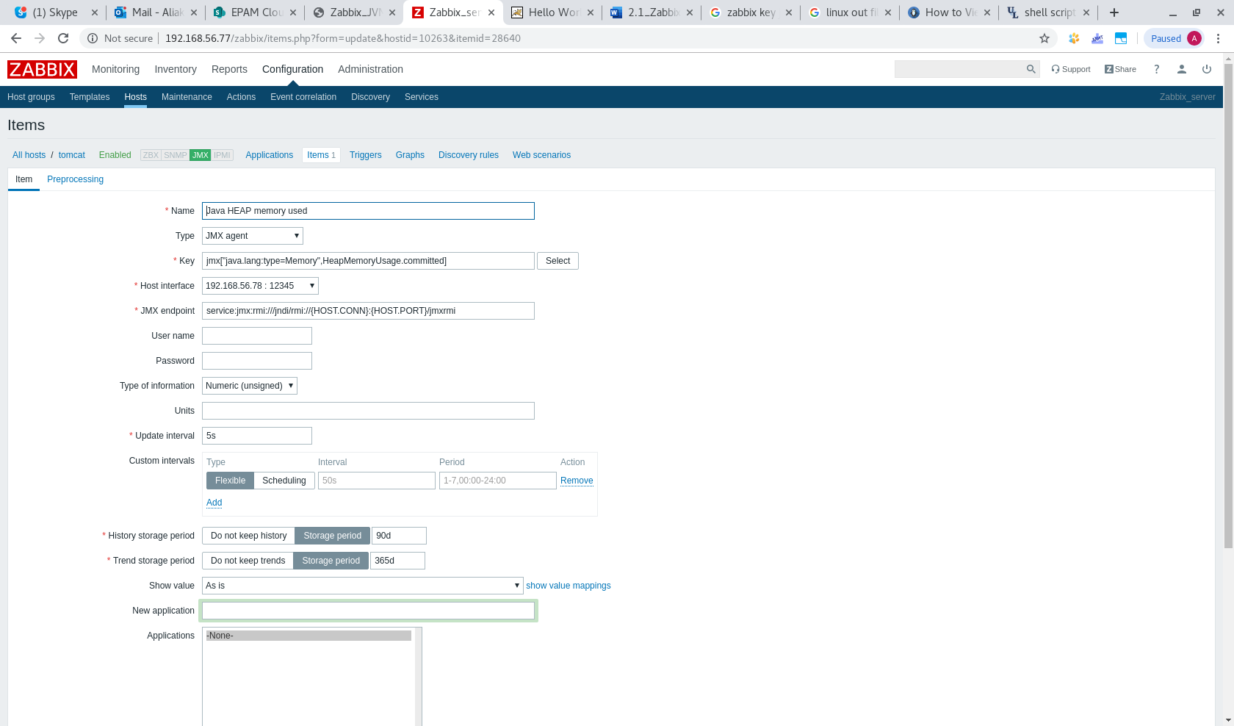
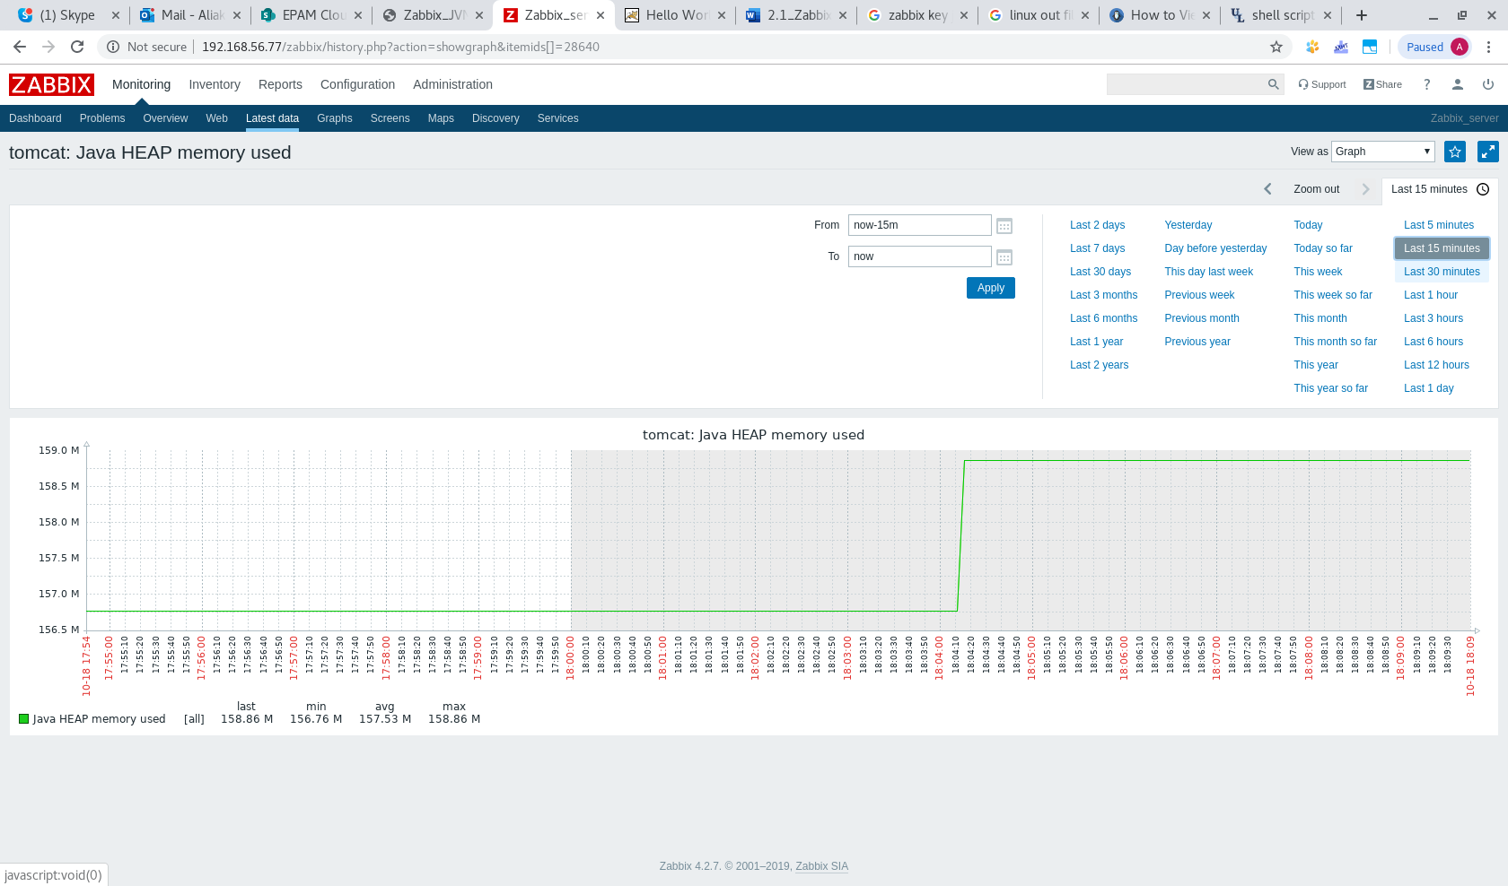

2. Configure triggers to alert once these parameters changed.

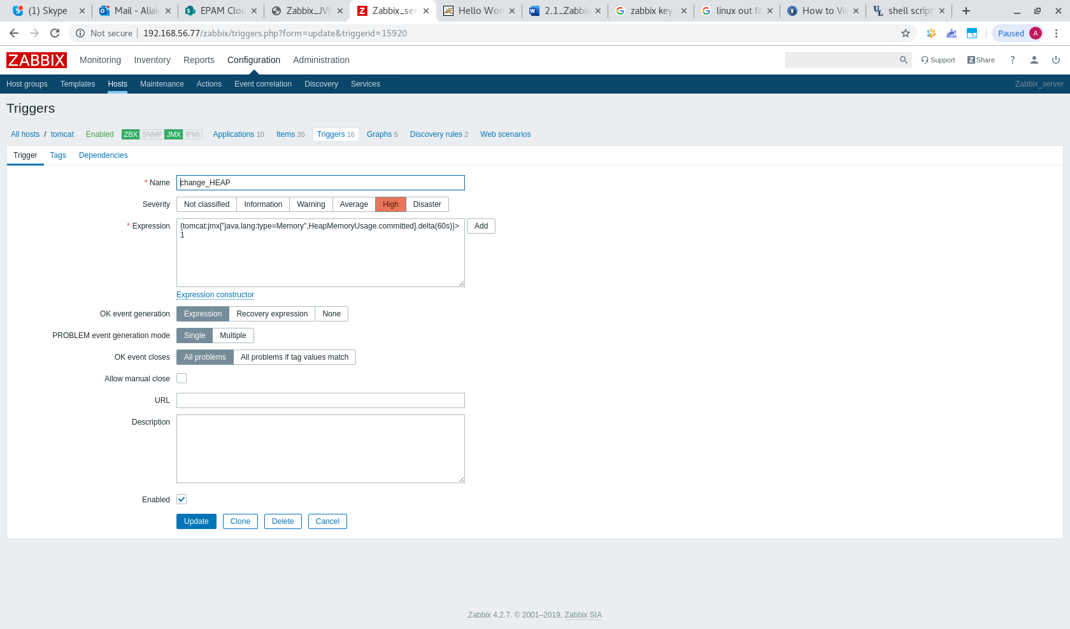
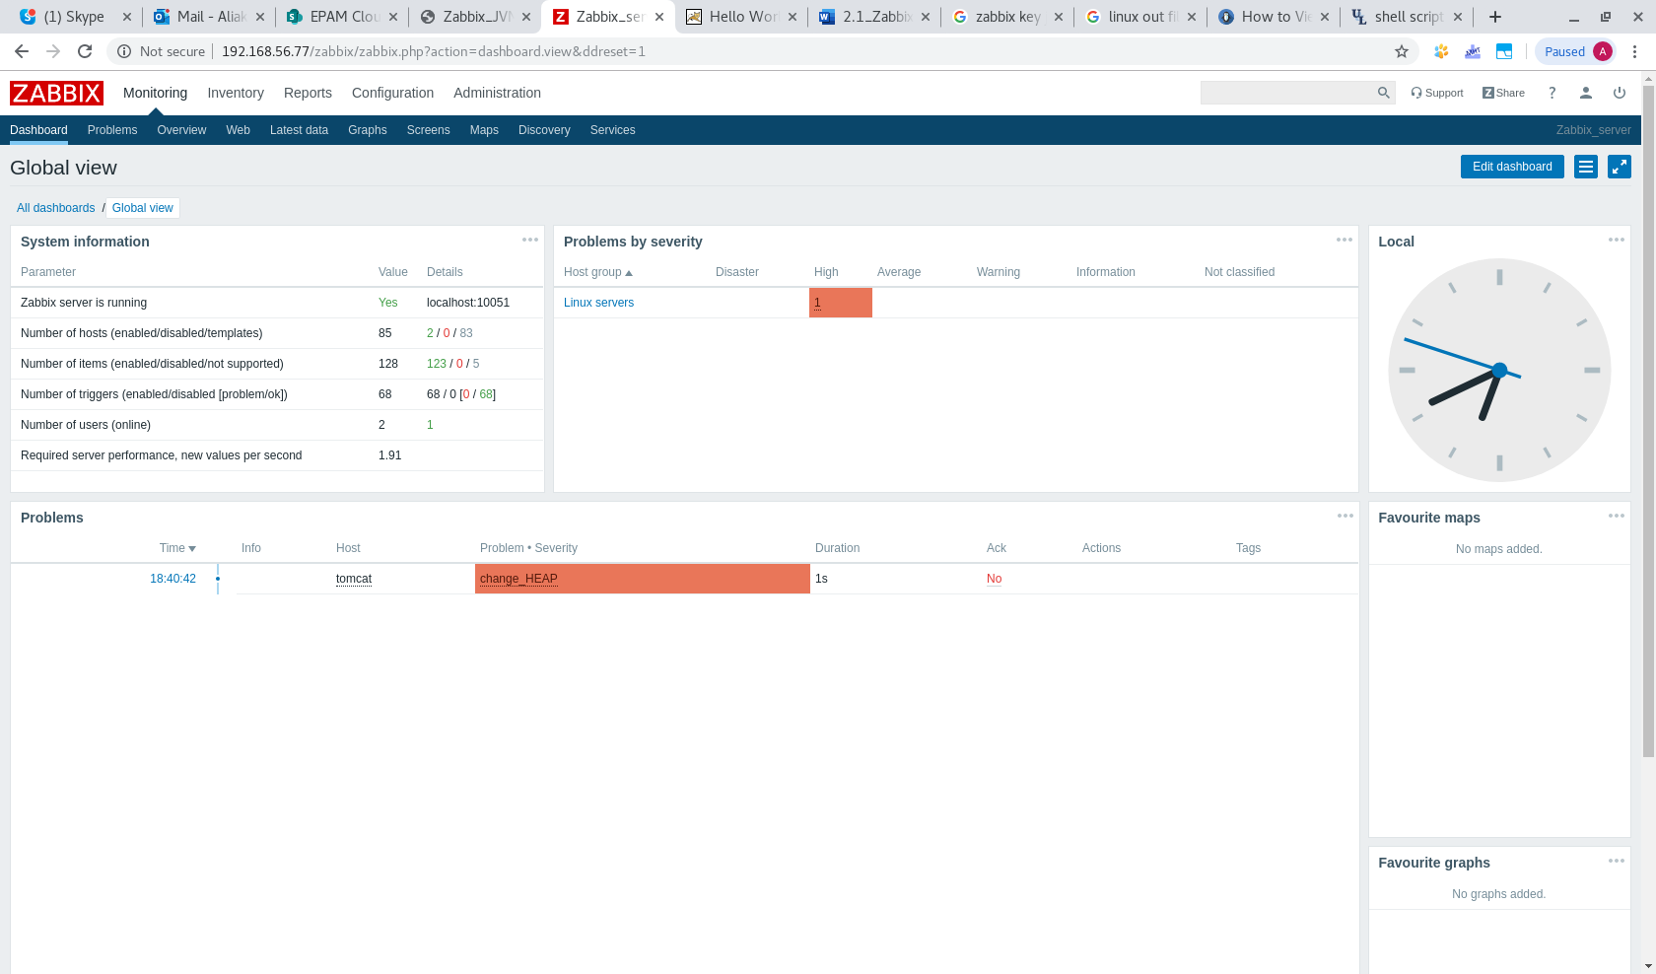

For both VMs use vagrant box “sbeliakou/centos-7.3-x86_64-minimal”

