Task. Web Monitoring with Zabbix
Testing Infrastructure:
Vagrantfile to spin up 2 VMs (virtualbox):
- zabbix server, provisioned by Vagrant provisioner
- Zabbix agents on both VMs, provisioned by Vagrant provisioner
- Install Tomcat 7 on 2nd VM, deploy any “hello world” application

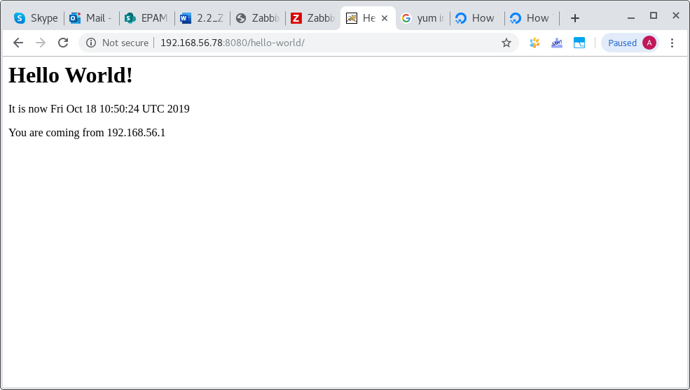

Tasks:
1. Configure WEB check:
• Scenario to test Tomcat availability as well as Application heath
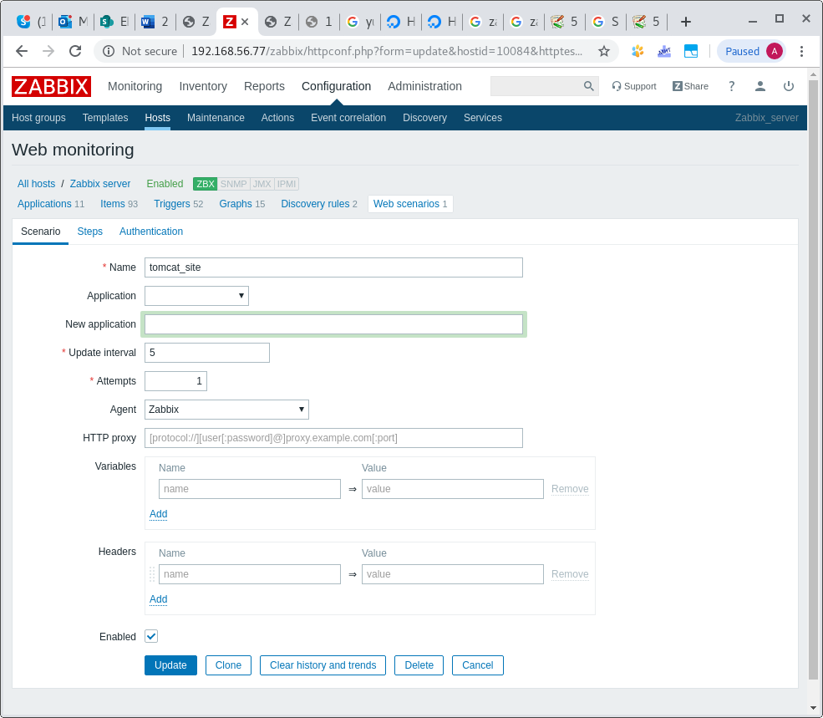

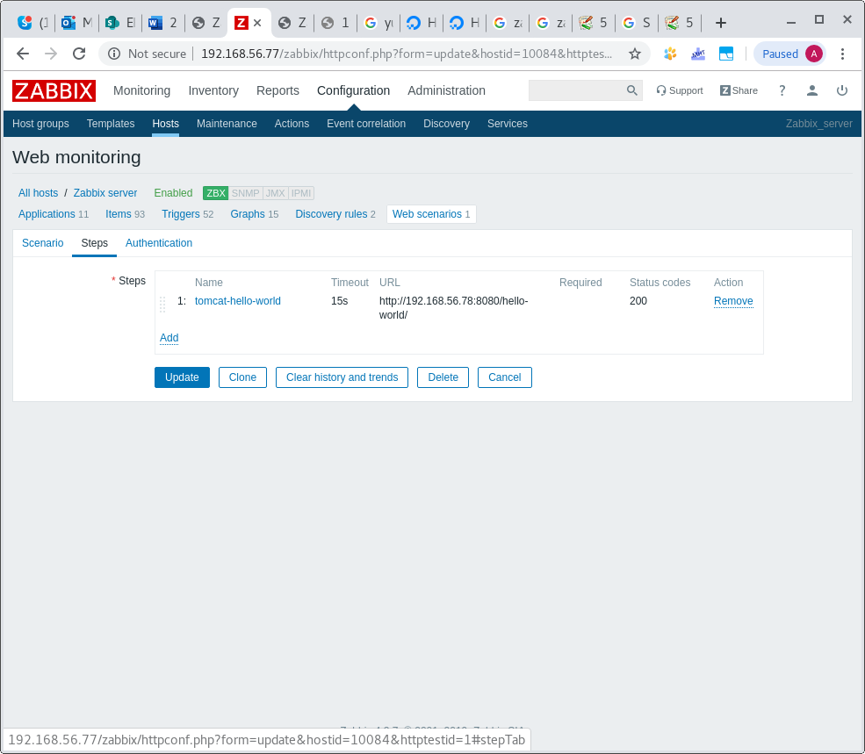
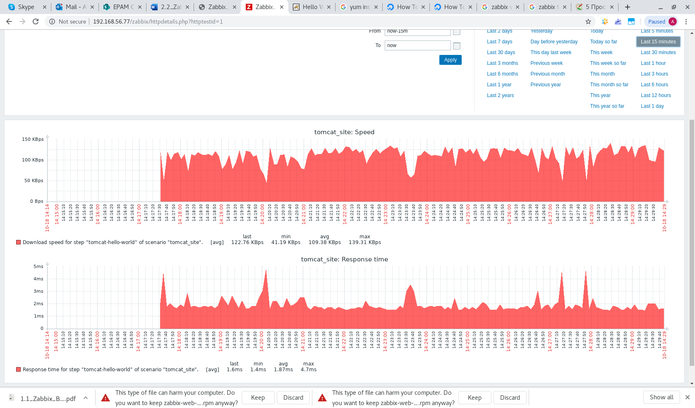

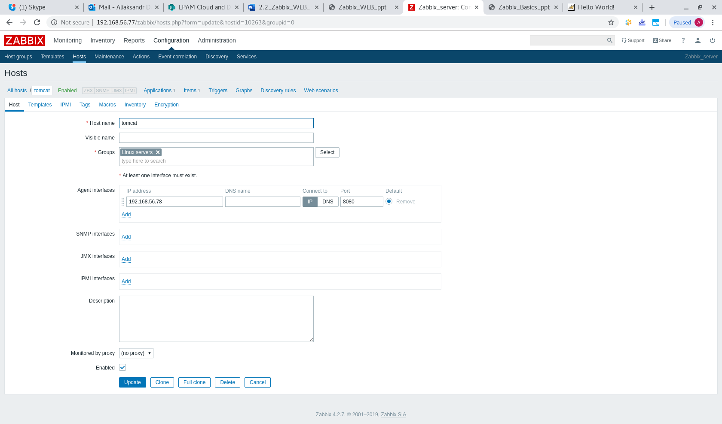
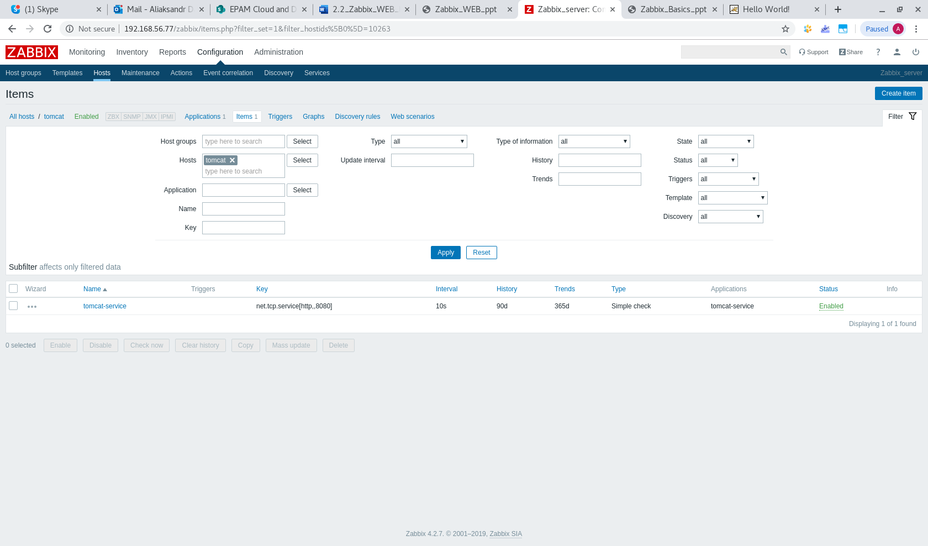
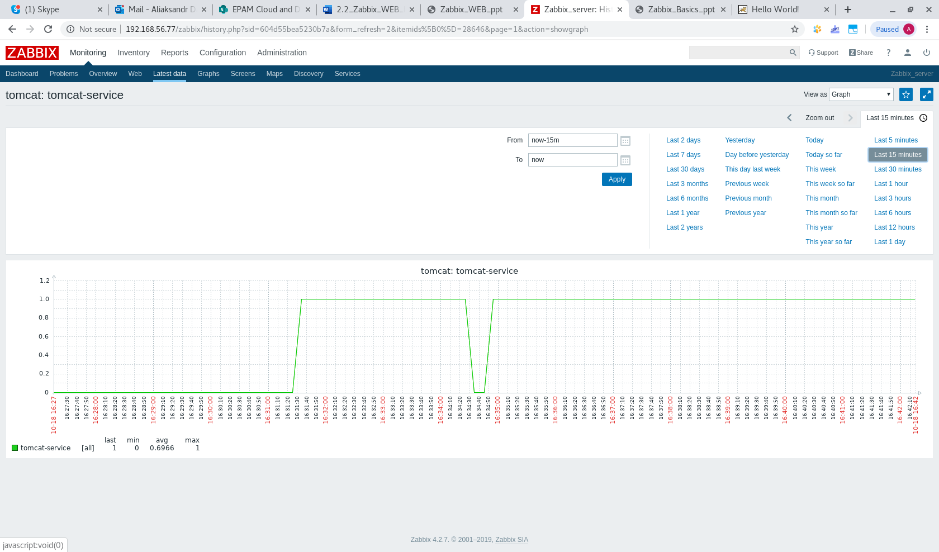

2. Configure Triggers to alert once WEB resources become unavailable
For both VMs use vagrant box “sbeliakou/centos-7.3-x86_64-minimal

