**110-1 Deep Learning for Computer Vision**

**NTU GICE R10942051 Alex Chen陳柏銉**

**【Data Preprocessing】**

* Import Necessary Library

* Read/Preprocessing Image File

1. (20%) Perform PCA on the training set. Plot the mean face and the first four eigenfaces.

**【Image Output for 1】**

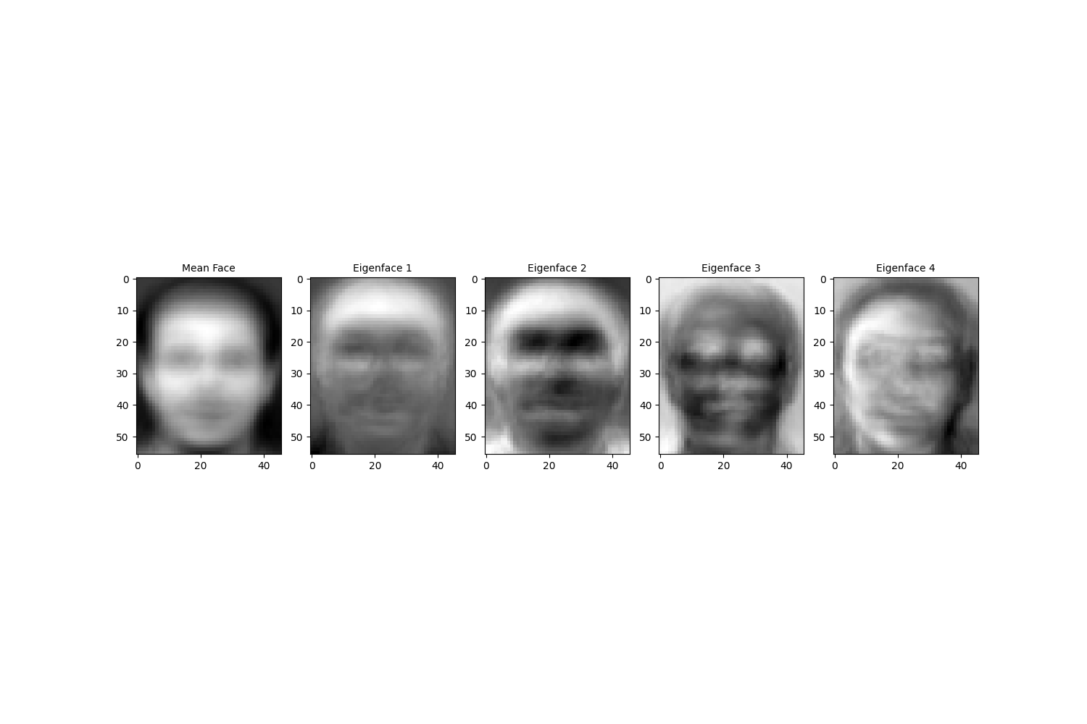

**【Code】**

First, calculate the mean of the features which can get the mean face. As for the first four eigenfaces, using the operation taught in class to realize PCA and fit the model onto the data.

1. (20%) If the last digit of your student ID number is odd, take **person2image1**. If the last digit of your student ID number is even, take **person8image1**. Project it onto the PCA eigenspace you obtained above. Reconstruct this image using the first eigenfaces. Plot the five reconstructed images.

*\*\*The last digit of my student ID is 1, so I am taking* ***person2image1****.\*\**

1. (20%) For each of the five images you obtained in 2., compute the mean squared error (MSE) between the reconstructed image and the original image. Record the corresponding MSE values in your report.

**【Code】**

**【Image Output for 2 & 3】**

|  |  |
| --- | --- |
| **N** | **MSE** |
| 3 | 746.800143 |
| 50 | 236.554273 |
| 170 | 46.717052 |
| 240 | 13.366569 |
| 345 | 0.215434 |

First, I normalized the image by subtracting the mean face from the original face, and then project the data onto the PCA space. Second, I use the PCA space dimensions 3, 50, 170, 240, 345 to reconstruct the image. Last, calculate the mean squared error between the original image and the reconstructed image but because of I’ve normalized in the first step, I need to times to obtain the desire MSE (*Hint*—When calculating MSE, your pixel values should be in the range of ).

1. (20%) Now, apply the *k*-nearest neighbors algorithm to classify the testing set images. First, you will need to determine the best and values by 3-fold cross-validation. For simplicity, the choices for such hyperparameters are and . Show the cross-validation results and explain your choice for

**【Code】**

**【Image Output for 4】**

First, I normalize and project the training data onto the PCA subspace and then configure with equals to 1, 3 and 5. Second, perform 3fold cross-validation and last, show the cross-validation results in terms of mean test score. My choice for will explain on 5.

1. (20%) Use your hyperparameter choice in 4., and report the recognition rate of the testing set.

**【Code】**

**【Image Output for 5】**

**<Accuracy on the testing set>**

|  |  |  |  |
| --- | --- | --- | --- |
| **k**  **n** | 1 | 3 | 5 |
| 3 | 0.725 | 0.65 | 0.575 |
| 50 | 0.925 | 0.9 | 0.875 |
| 170 | 0.95 | 0.875 | 0.9 |

My choice for the hyperparameters will be . The reason is that if we take a look at the accuracy on the testing set, we can find out that using being get a higher accuracy than being . However, we only get a 0.025 increase in accuracy, but we need to increase the dimension by 240% which I think it may be not cost-effective.

The accuracy on the testing set is **0.925** using the .